TASK: The Register File is implemented in module el2_dec_gpr_ctl and it is instantiated in module el2_dec (see Figure 7). Analyse both the Verilog code and the simulation of the main signals of module el2_dec_gpr_ctl (available in file [RVfpgaEL2Nexys VideoVideoNoDDRPath]/src/VeeRwolf/VeeR_EL2CoreComplex/dec/el2_dec_gpr_ctl.sv), in order to understand how it works.

Instantiation in module dec:

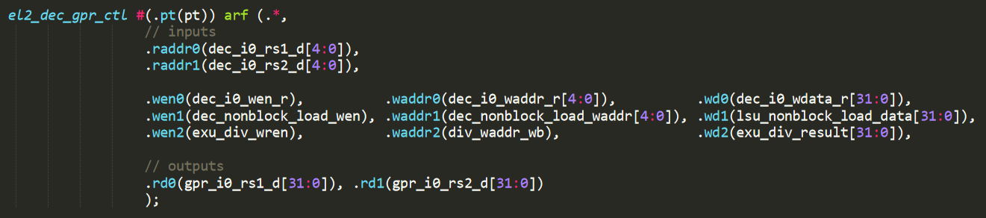

Implementation of the 32 registers in module dec_gpr_ctl:

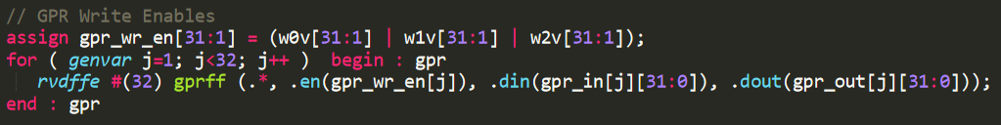

31 registers are implemented by instantiating 31 times module rvdffe (which you can find in file [RVfpgaEL2Nexys VideoVideoNoDDRPath]/src/VeeRwolf/VeeR_EL2CoreComplex/lib/beh_lib.sv). Note that the width of each rvdffe register is selected using a parameter, which in our case is 32 bits → rvdffe #(32). Register 0 is not necessary as RISC-V architecture forces it to be always 0.

Register reading:

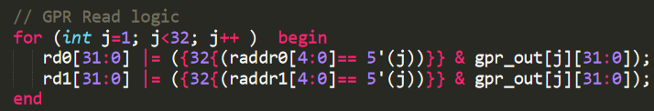

2 read ports are implemented. Each one is assigned in the rd0/rd1 signals with the value of the register indicated by the raddr0/raddr1 signals. Note that the initial value of j is 1, thus the reading of register 0 always returns the value 0.

Register writing:

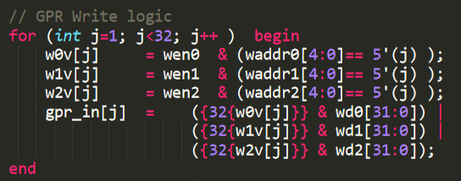

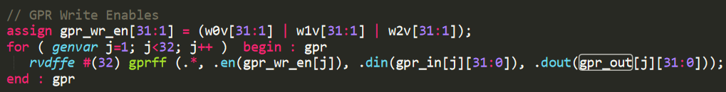

3 write ports are implemented. Each register is written with the value provided in signals wd0/wd1/wd2, depending on the register address waddr0/waddr1/waddr2. The wen0/wen1/wen2 signals enable/disable the writing. Note that the initial value of j is 1, thus there is no write of register 0.

TASK: Execute the program on the Nexys Video Video board as explained in the GSG. You should obtain the results shown in Figure 11 for the four measured events. Explain and justify the results.

The program is made up by a loop with 6 instructions, which performs 1.000.000 iterations. Ideally it would take 6.000.000 cycles to execute; however, 1 cycle is lost per iteration due to the misprediction of the loop branch (remember that the Branch Predictor is disabled in this example).

TASK: Execute the program on the RVfpgaEL2-ViDBo simulator. You should obtain the same results as those when the program is executed on the board.

Same solution as previous task.

TASK: Measure other events in the Hardware Counters for the same program. For this purpose, you must change in file Test.c the configuration of the events to be measured. Note that the different events (shown in Table 1) can be configured using the macros defined in the PSP file psp_performance_monitor_eh1.h. For example, if you want to measure the number of I$ misses instead of the number of branch misses, you must substitute in file Test.c line:
pspMachinePerfCounterSet(D_PSP_COUNTER3, D_BRANCHES_MISPREDICTED);
for line:
pspMachinePerfCounterSet(D_PSP_COUNTER3, D_I_CACHE_MISSES);

Solution not provided for this exercise.

TASK: Propose other programs in the Test_Assembly function and check if the different events provide the expected results. You can try other instructions such as loads, stores, multiplications, divisions… as well as hazards that provoke pipeline stalls.

Solution not provided for this exercise.

TASK: Test again the program provided at [RVfpgaEL2Nexys VideoVideoNoDDRPath]\Labs\Lab11\HwCounters_Example and used in the previous section. In this case, enable the Gshare branch predictor and explain the results. You can execute it both on the physical board and on RVfpgaEL2-ViDBo.

Execution on the board:

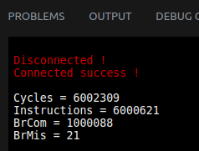

Execution on the RVfpgaEL2-ViDBo:

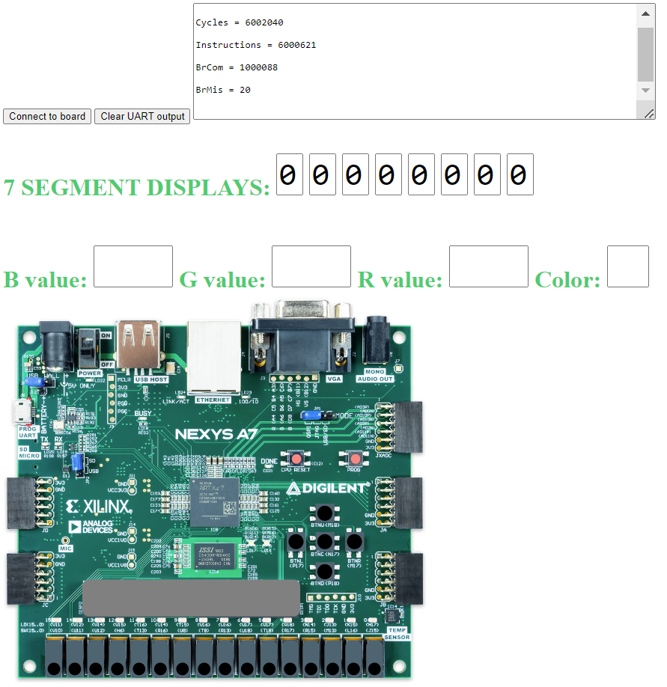

When the Gshare BP is enabled, IPC achieves its optimal value of 1.

