TASK: Remove all nop instructions in the example from Figure 2. Generate the trace with the RVfpga-Trace simulator, analyse the simulation on RVfpga-Pipeline, and then compute the IPC by using the Performance Counters while executing the program on the board (remember that you must uncomment all instructions in the main function, in file Test.c).

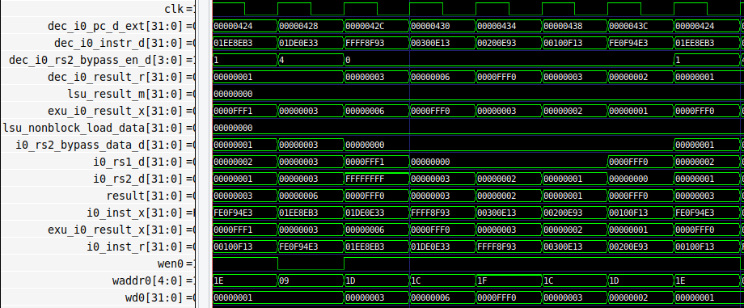

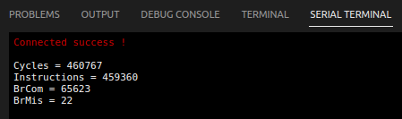

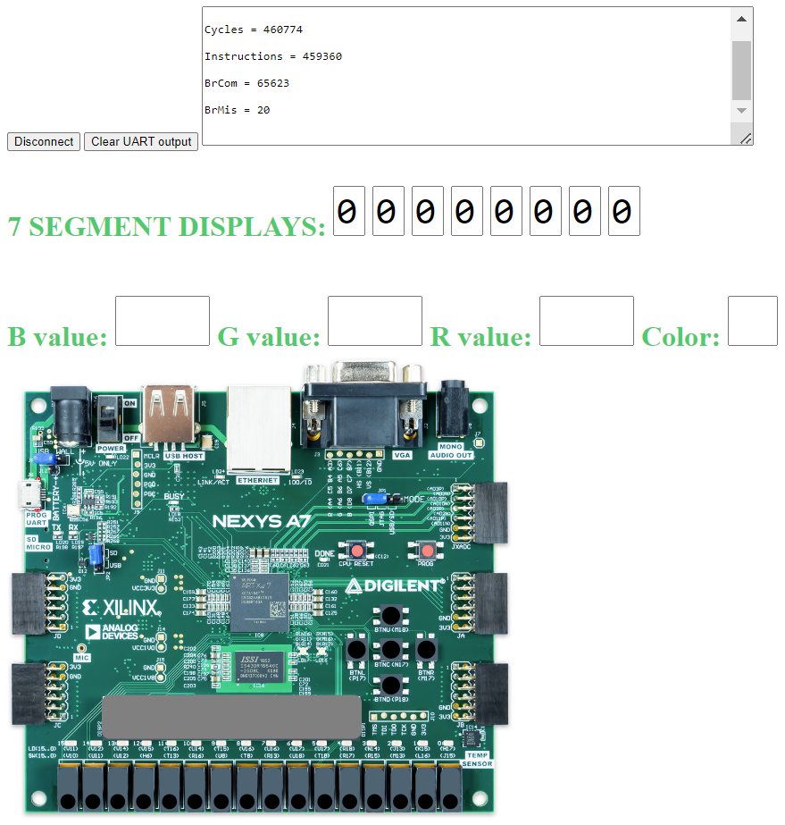

- The IPC = 1, thanks to the forwarding logic that allows the dependent instruction to not stall.
- The number of cycles is as expected 0xffff * 7 = 458745

Exercise 1: In the example from Figure 2, analyse and explain similar situations where you replace the dependent add instruction for other dependent instructions, such as:

- add t4,t4,t5
mul t3,t3,t4

- add t4,t4,t5
div t3,t3,t4

- add t4,t4,t5
lw t3, 0(t4)

Solution not provided for this exercise.

Exercise 2: Use the project called DataHazards_LW-AL to analyse a hazard between a load and an add instruction. Analyse the following two situations:

- DCCM: The load reads from the DCCM in a single cycle. You can use the tcl script called test_DCCM.tcl. For mapping the data to the DCCM, uncomment, in file Test_Assembly.S, line: .section .midccm, and comment line: .section .ram

- Main Memory: The load reads from Main Memory in several cycles. You can use the tcl script called test_MainMemory.tcl. For mapping the data to Main Memory, uncomment, in file Test_Assembly.S, line: .section .ram, and comment line: .section .midccm

Simulate the program both in RVfpga-Trace and RVfpga-Pipeline.

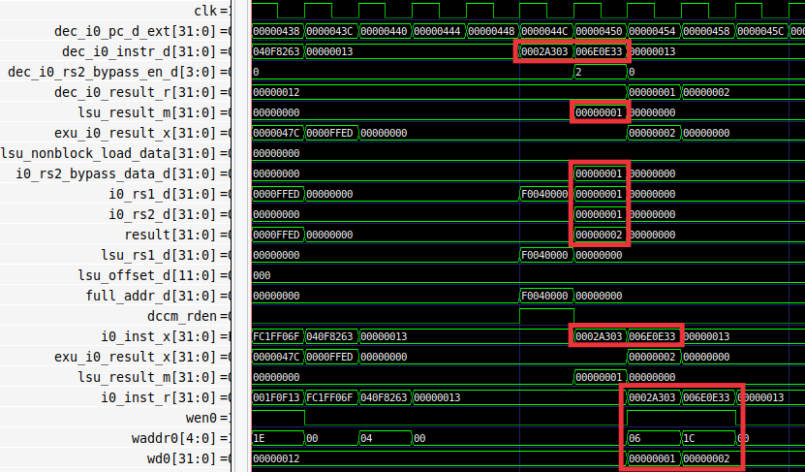
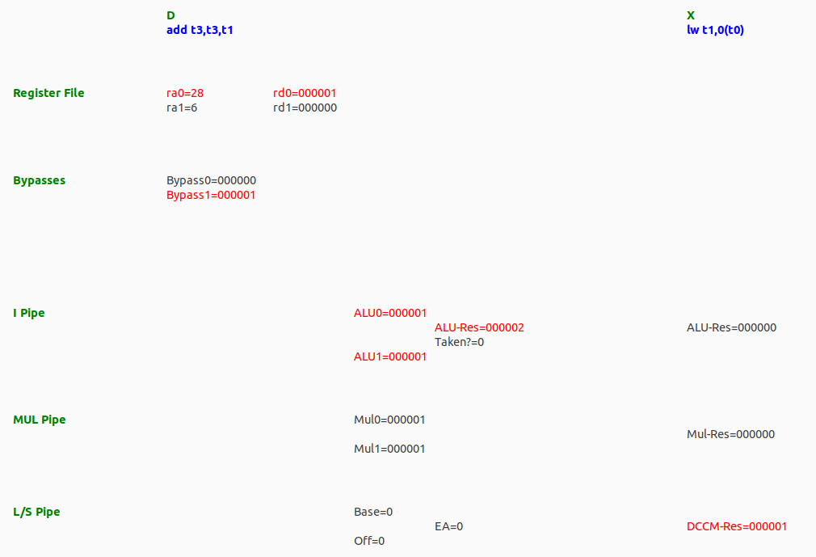

- The DCCM provides the data in one cycle.
- That data (0x1) is forwarded to the add instruction, which uses it as its second operand instead of the data read from the Register File, which is incorrect.
- There are no stalls thank sto the DCCM low-latency.

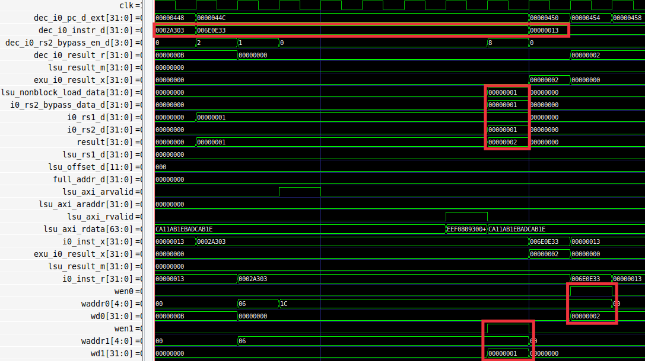
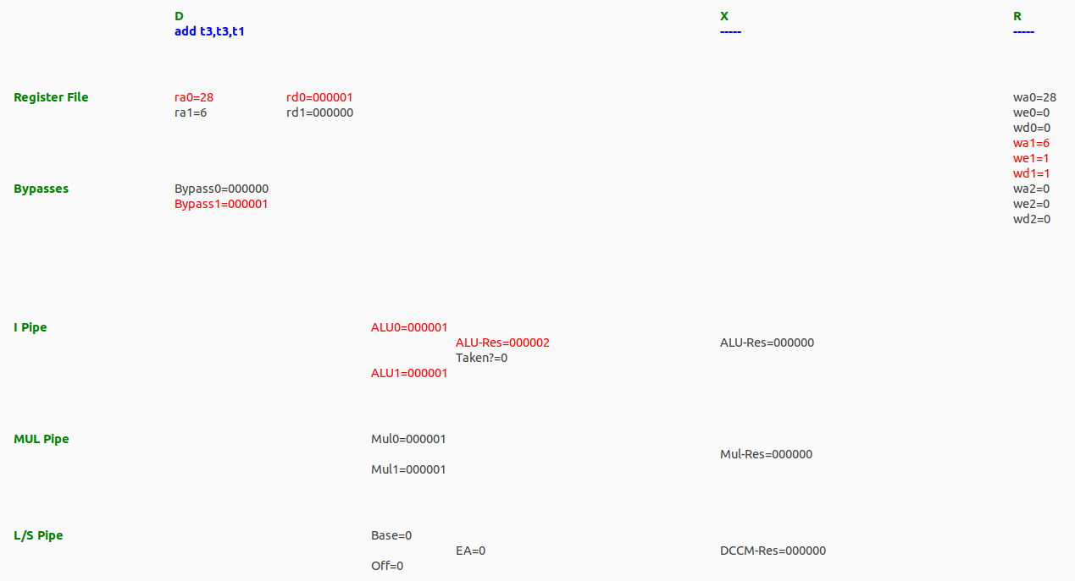

- The Main Memory needs several cycles for providing the result, due to the latency of the memory itself and the AXI bus protocol.
- When data is available, it is written to the RF and provided to the add instruction through forwarding, so that it can start right away.

