Crystal Long
Module 7.2 Movie: Table Queries
4/26/2025
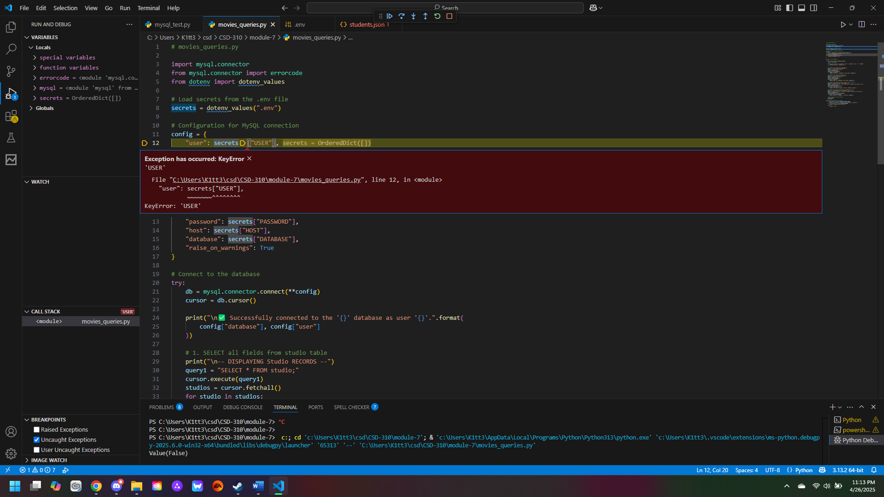
At first, I got this error when testing and running for bugs. Then I realized I had not moved the .env file into the module 7 folder, to which it could connect. After that, I reran it with debugging.
