Crystal Long
Module 5.2 MySQL Functions

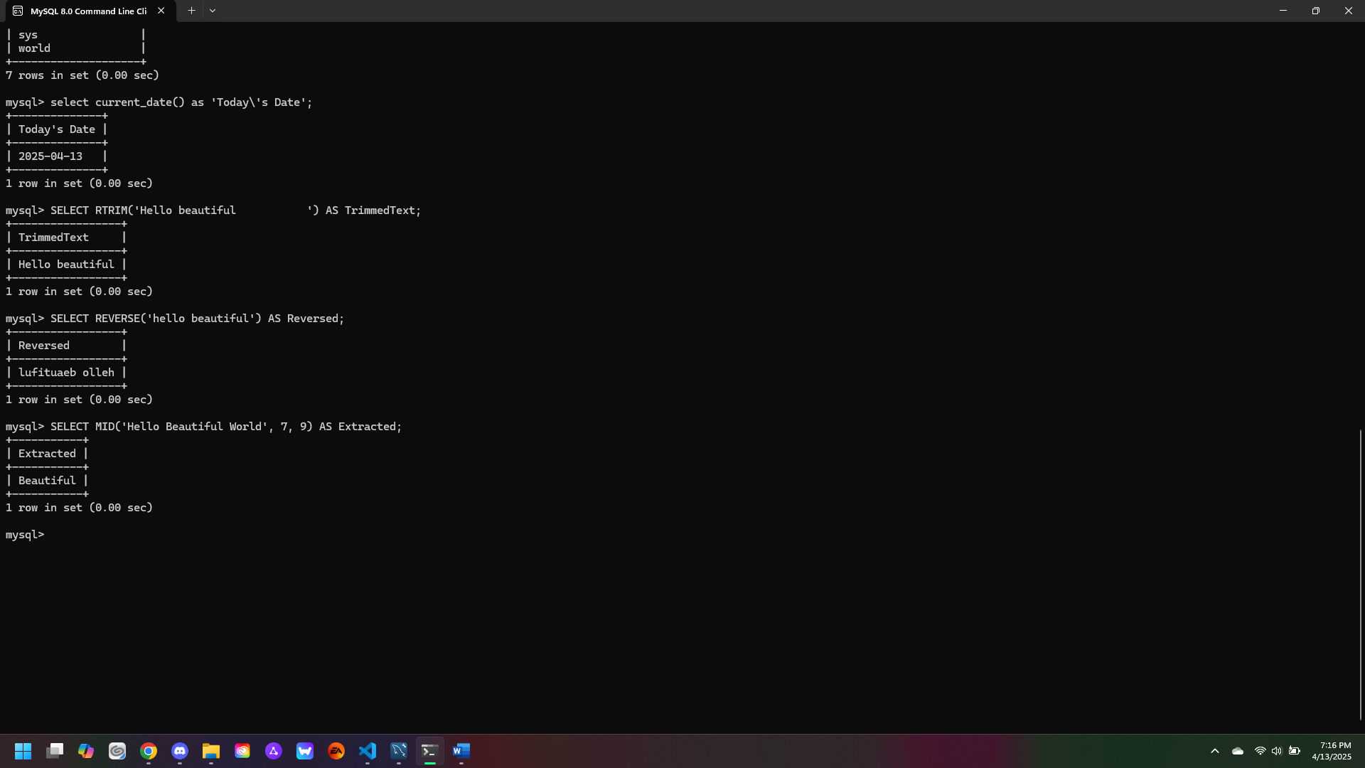
- RTRIM: this function can be used when too many spaces are in the codes output, it is good for cleaning up or formatting code.
- REVERSE: this function can be useful when you want to do something like rearrange numbers or can be paired with other functions to rearrange.
- MID: this function can be useful when you want to isolate or only call one part of a string from code.

