Crystal Long

Module 9.2 APIs

4/26/2025

Tutorial work

I originally kept getting an error, it wasn’t finding my python then it wasn’t connecting to pip so I had to figure out how to fix the connection so I could update pip and install requests. So I will post two screenshots for this part.

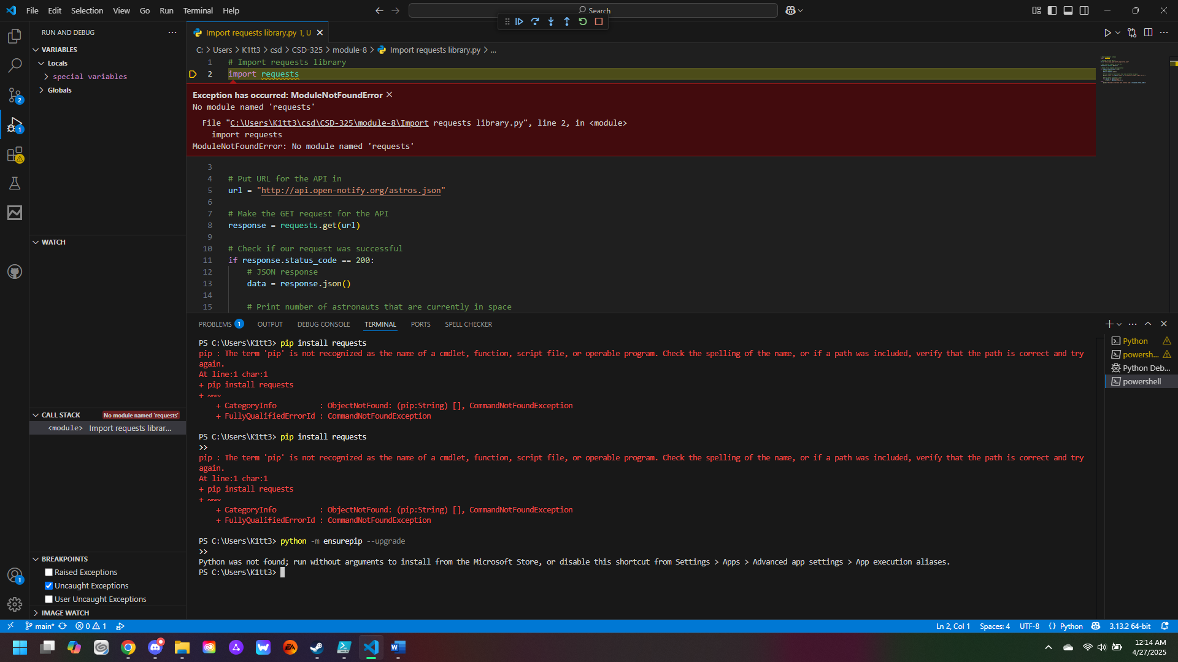

The one above is the one before fixing the connection. The second image is my screenshot after fixing it though I did not remove the debug error in the code.

