Project: Test Plan
Course: CSD 380
Description: Tests that need to cover specific Business Requirements
Date: 11-12-2025

To complete the test case plan, fill out the information for Project, Course, Description and Date in the header below.

TABLE OF CONTENTS

- Accesing URL & Custom 404
II. Mobile View Test
III. Adding Tasks and Blocking Empty Changes
IV. Edit Task and Blocking Empty Changes
V. Delete Tasks from List

For each test, the developer should: provide a test description, a test objective, the developer name and date tested. For each step, fill out the actions to be taken and describe the expected results, and indicate yes or no for each step depending upon the result. The peer tester should provide their name, date tested, indicate yes or no for each step depending upon the result, and a screenshot (thumbnail) of the result.

Test 1 | Accessing URL & Custom 404 (Incorrect URL)
 | Test Objective: Verify if URL works and if input is wrong, provide 404 message | Developer: Justin Marucci  Date tested: 2025/11/11 | Peer tester: Crystal Long  Date tested: <2025/11/15>
Step | Action | Expected results: | Developer pass/fail | Tester pass/fail  + Screenshot
1 | Navigate to the URL https://buwebdev.github.io/todo/ | Page loads without error | Yes | Yes  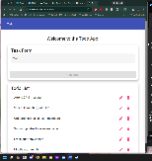
2 | Refresh the page | Page reloads sucessfully and useful | Yes | YES  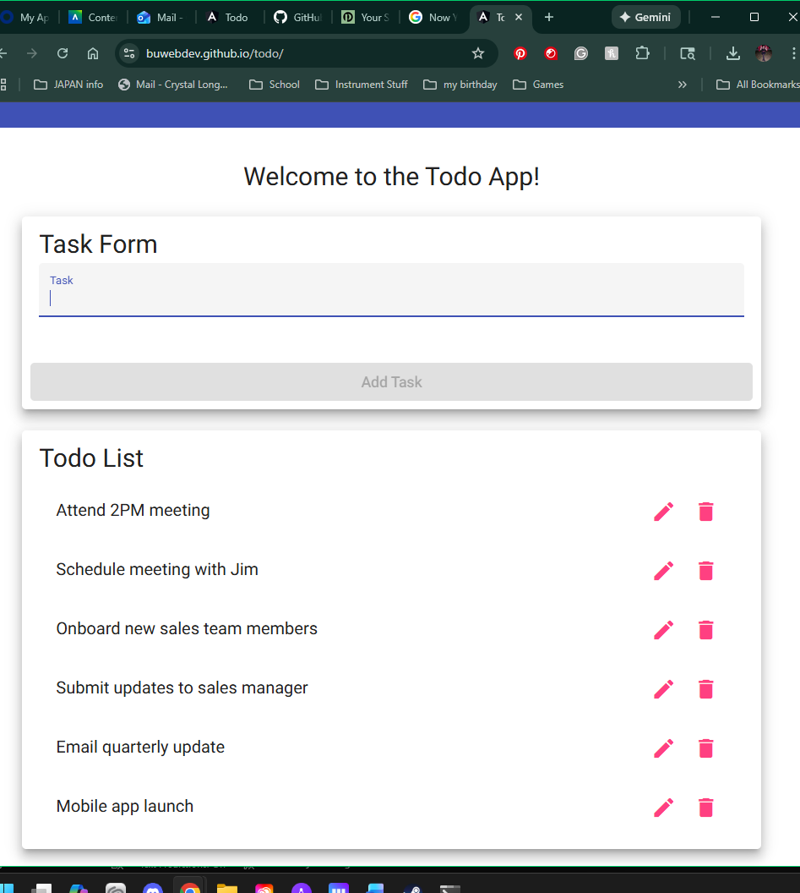
3 | Input the wrong URL | Custom 404 page appears | Yes | YES  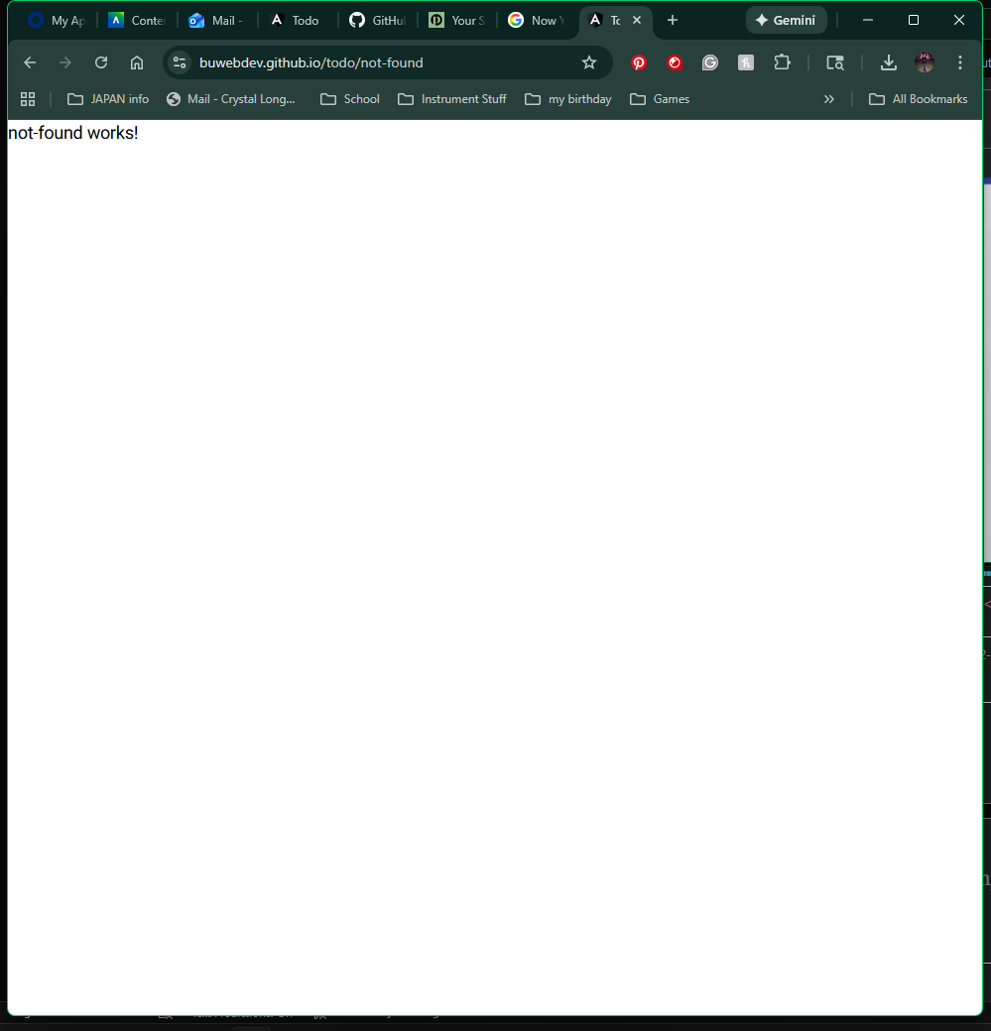
Comments | Comments should be substantive; this means there should be at least 2-3 well-structured sentences with constructive feedback.

Test 2 | Mobile View Test
 | Test Objective: Confirm UI works on mobile device | Developer: Justin Marucci  Date tested: 2025/11/11 | Peer tester: Crystal Long  Date tested: <2025/11/15>
Step | Action | Expected results: | Developer pass/fail | Tester pass/fail
1 | Open the Todo URL on your phone | The page loads and fits on the screen | Yes | Yes  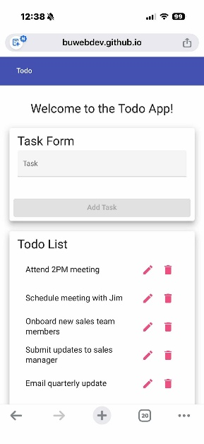
2 | Type a task into the box then add task | Task adds to Todo list with no issues | Yes | Yes  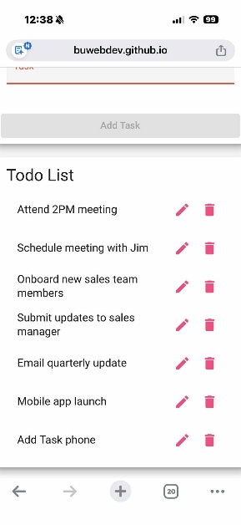
3 | Scroll up, down, left and right | Interface doesnt scroll left or right, application in “mobile mode” (only scrolls up and down) | Yes | No  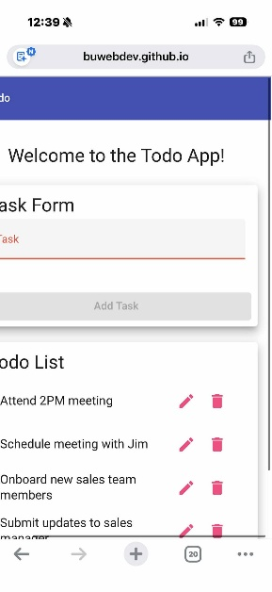
4 | Refresh page | Interface is still works and is able to use | Yes | Yes  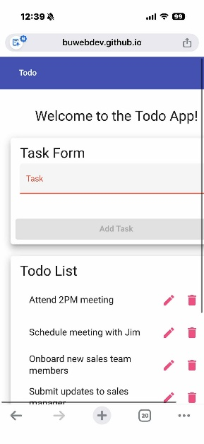
Comments | Comments should be substantive; this means there should be at least 2-3 well-structured sentences with constructive feedback.

Test 3 | Adding Tasks and Blocking Empty Changes
 | Test Objective: Verify we can create new tasks and block empty entries | Developer: Justin Marucci  Date tested: 11-11-2025 | Peer tester: Crystal Long  Date tested: <2025/11/15>
Step | Action | Expected results: | Developer pass/fail | Tester pass/fail
1 | Type “ 11am SCRUM Meeting” into task form and hit “Add Task” button | Item appears on todo list | Yes | Yes  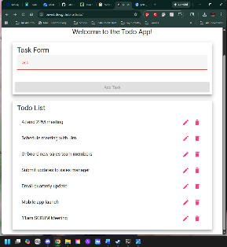
2 | Input nothing into the task form, try and add it to todo list and hit add task button | “Add” button remains greyed out and cannot add to todo list | Yes | Yes  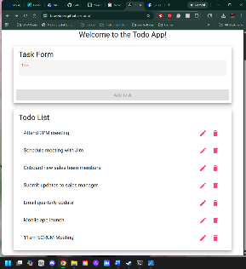
Comments | Comments should be substantive; this means there should be at least 2-3 well-structured sentences with constructive feedback.

Test 4 | Edit Task and Blocking Empty Changes
 | Test Objective: Verifies user can edit tasks on the todo list and saving an empty input is blocked | Developer: Justin Marucci  Date tested: 2025/11/11 | Peer tester: Crystal Long  Date tested: <2025/11/15>
Step | Action | Expected results: | Developer pass/fail | Tester pass/fail  + Screenshot
1 | Hit pencil (edit) icon on todo list | Edit window appears to update the list item | Yes | Yes  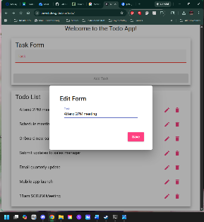
2 | Update list item in edit window and hit save | List item updates and is added to todo list | Yes | Yes  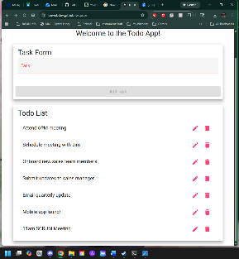
3 | Hit pencil icon, delete list item and hit save | Window pops up stating “Please enter task” with “OK” button | No | No  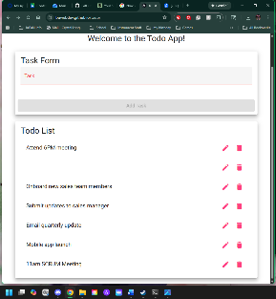
Comments | Comments should be substantive; this means there should be at least 2-3 well-structured sentences with constructive feedback.

Test 5 | Delete Task Item
 | Test Objective: Verifies a usr can delete a task item on the todo list | Developer: Justin Marucci  Date tested: 2025/11/11 | Peer tester: Crystal Long  Date tested: <2025/11/15>
Step | Action | Expected results: | Developer pass/fail | Tester pass/fail  + Screenshot
1 | Click garbage can icon (delete button) | Task Disappears from list | Yes | Yes  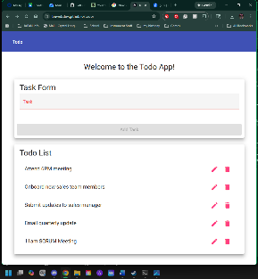
2 | Refresh Page | Item does not reappear | Yes | No  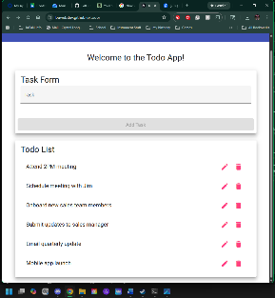
Comments | Comments should be substantive; this means there should be at least 2-3 well-structured sentences with constructive feedback.

