Crystal Long
Module 5.2 Value Stream Mapping Assignment
11/20/2025

Value Stream Mapping Assignment
Step 1: Identify the Process Steps (The Stream)
1. Choose the park and date
2. Check the weather and crowd expectations
3. Decide on Lightning Lane, Genie+, and extras
4. Make a list of priority rides and shows
5. Plan meals and snacks
6. Pack items for the day
7. Decide what time to head to the park and what time to go home
Step 2: Analyze Lean Metrics (Cycle Time Only)
Step | Cycle Time (CT)
1. Choose the park and date | 5–10 minutes
2. Check the weather and crowd expectations | 5–7 minutes
3. Decide on Lightning Lane, Genie+, and extras | 10–15 minutes
4. Make a list of priority rides and shows | 10–20 minutes
5. Plan meals and snacks | 10–15 minutes
6. Pack items for the day | 15–25 minutes
7. Decide what time to head to the park and what time to head home | 2–3 minutes
Step 3: Optimize the Process (Waste + Time Savings)
Choose the park and date
Estimated time saved: 3–5 minutes
Check the weather and crowd expectations
Estimated time saved: 2–3 minutes
Decide on Lightning Lane, Genie+, and extras
Estimated time saved: 5–7 minutes
Make a list of priority rides and shows
Estimated time saved: 5–10 minutes
Plan meals and snacks
Estimated time saved: 4–6 minutes
Pack items for the day
Estimated time saved: 8–12 minutes
Decide what time to head to the park and what time to head home
Estimated time saved: 1–2 minutes
Graphic VSM

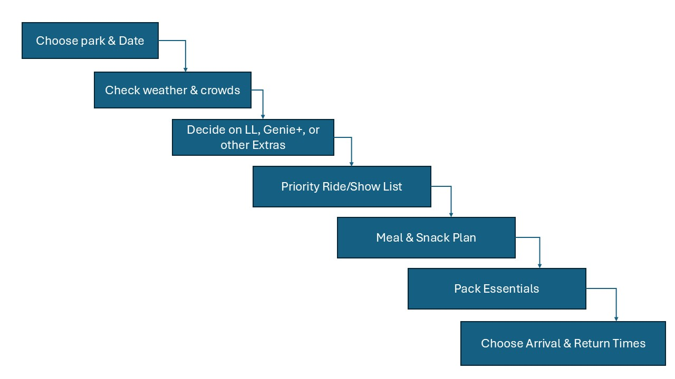
Resource:
ConnectALL. (2020, October 29). 3 easy steps for using VSM in everyday life. ConnectALL.
https://www.connectall.com/3-easy-steps-for-using-vsm-in-everyday-life/
Resource to format Citation:
OpenAI. (2025). ChatGPT (GPT-5) citation formatting assistance. OpenAI.

