Crystal Long
11-6-2025
Module 4.2 Assignment
Original Module 2.2
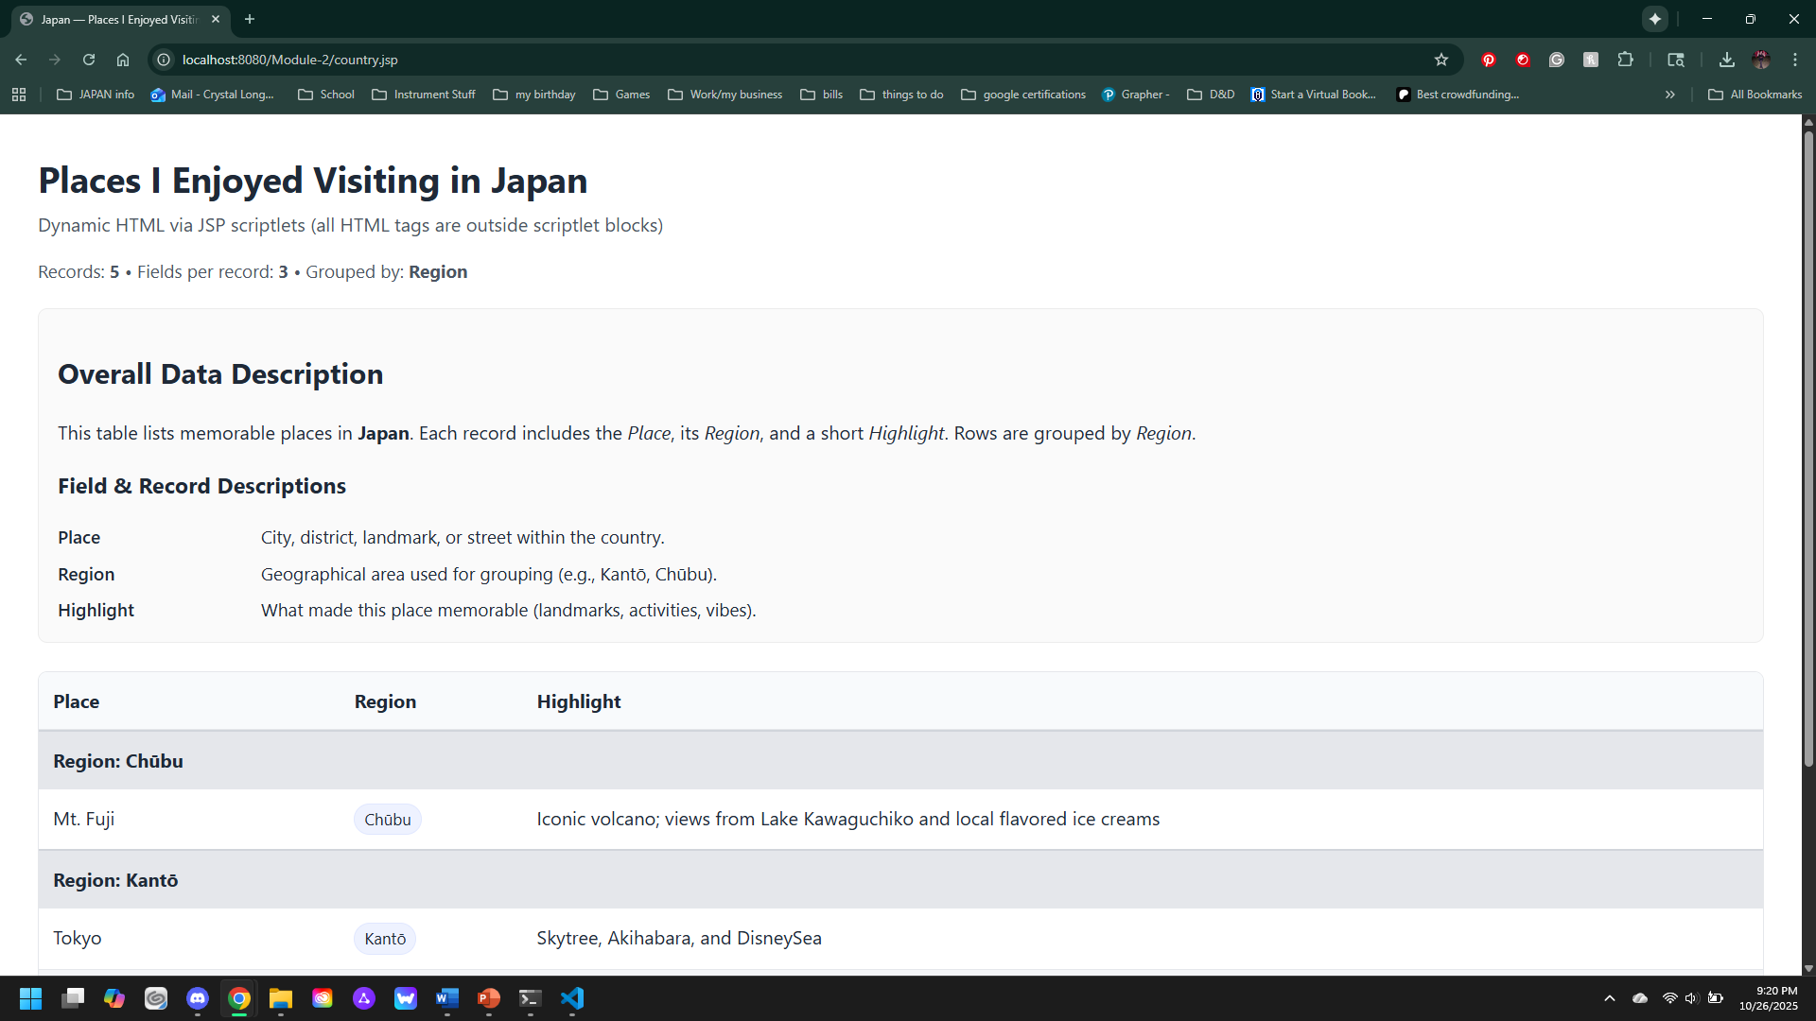
Module 4.2
