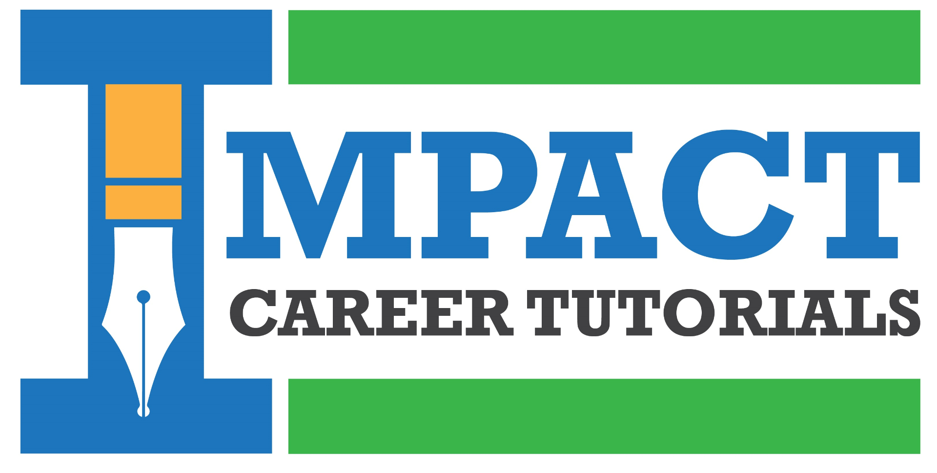

Digital growth platform
A responsive admissions, resources, physical-book commerce, library and staff-operations platform.
PROJECT INVESTMENT
₹37,500
Target delivery: five weeks from project commencement

What is included
Premium responsive experience | Courses and enquiries | Free resources
Mobile, iPad/tablet, laptop and desktop design with accessible, fast-loading pages. | Course discovery, details, calls to action, lead capture and staff follow-up. | Searchable PDFs, short access form, consent and fast Cloudflare R2 delivery.
Physical books | Library | Promotions
Catalogue, cart, Razorpay checkout, availability, orders, fulfilment and WhatsApp order updates. | Facilities, plans, rules, application form and staff review workflow. | Admin-controlled banners and campaign cards with schedule, targeting and measurement.

Staff control and measurement
- Admin dashboard for leads, resources, books, orders, library applications and promotions.
- One lead history: repeat forms are matched using normalized phone/email while every enquiry and campaign touch remains visible.
- WhatsApp messages for customer order confirmation and staff new-order notification; ICT's verified WhatsApp Business number required.
- PostHog owner dashboard for enquiries, resource unlocks, WhatsApp handoffs, promotions and cart-to-paid conversion.
- Search Console, technical SEO foundation, deployment, initial content population, training and 30 days of defect support.

Payment and delivery
50% to begin · 30% at working preview · 20% before production launch
The five-week schedule begins after scope acceptance, advance payment, required starting content and account access. Timely consolidated feedback is required at review points.

Not included in this phase
Guaranteed Google rankings, ongoing SEO operations, AI or automated WhatsApp assistant, online library payment, student accounts/LMS, courier operations, Classplus migration, photography, full copywriting, unlimited content entry, unlimited revisions, and third-party usage or transaction charges.

Next step
Confirm the scope and commercial terms, complete the detailed agreement, make the commencement payment, and provide the project content and account-access checklist.
This proposal is valid for 15 days.

