นายปัญญา ทองคำดี 5706021612072  
Lab6# IoTtweet

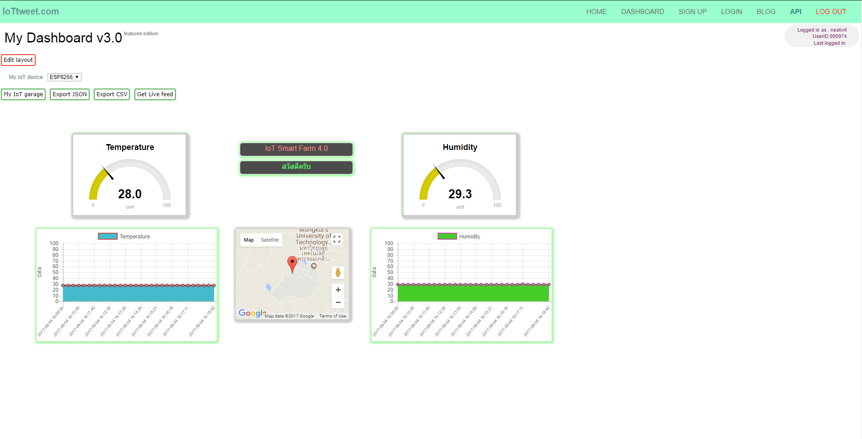รูปภาพ

Source code

// DHT Temperature & Humidity Sensor

// Unified Sensor Library Example

// Written by Tony DiCola for Adafruit Industries

// Released under an MIT license.

// Depends on the following Arduino libraries:

// - Adafruit Unified Sensor Library: https://github.com/adafruit/Adafruit_Sensor

// - DHT Sensor Library: https://github.com/adafruit/DHT-sensor-library

#include <Adafruit_Sensor.h>

#include <DHT.h>

#include <DHT_U.h>

#define DHTPIN 2 // Pin which is connected to the DHT sensor. (D4)

// Uncomment the type of sensor in use:

//#define DHTTYPE DHT11 // DHT 11

#define DHTTYPE DHT22 // DHT 22 (AM2302)

//#define DHTTYPE DHT21 // DHT 21 (AM2301)

// See guide for details on sensor wiring and usage:

// https://learn.adafruit.com/dht/overview

DHT_Unified dht(DHTPIN, DHTTYPE); //ส่งค่า 2 ตัว

uint32_t delayMS;

#include <ESP8266WiFi.h>

#include <IoTtweet.h>

const char *userid = "000974"; //IoTtweet account user ID (6 digits, included zero pre-fix)

const char *key = "74ac0a558dtz"; //IoTtweet registered device key in "MY IOT Garage"

const char *ssid = "itfitm"; //Your-WiFi-router-SSID

const char *password = ""; //Your-WiFi-password

float data0, data1, data2, data3; //Your sending data variable.

String private_tweet = "สวัสดีครับ"; //Your private tweet meassage to dashboard กดเลือก Tweet privaet panel

String public_tweet = "IoT Smart Farm 4.0"; //Your public tweet message to dashboard กดเลือก Tweet public panel

IoTtweet myiot; //naming your devices

void setup() {

Serial.begin(9600);

// Initialize device.

dht.begin();

Serial.println("DHTxx Unified Sensor Example");

// Print temperature sensor details.

sensor_t sensor;

dht.temperature().getSensor(&sensor);

Serial.println("------------------------------------");

Serial.println("Temperature");

Serial.print ("Sensor: "); Serial.println(sensor.name);

Serial.print ("Driver Ver: "); Serial.println(sensor.version);

Serial.print ("Unique ID: "); Serial.println(sensor.sensor_id);

Serial.print ("Max Value: "); Serial.print(sensor.max_value); Serial.println(" *C");

Serial.print ("Min Value: "); Serial.print(sensor.min_value); Serial.println(" *C");

Serial.print ("Resolution: "); Serial.print(sensor.resolution); Serial.println(" *C");

Serial.println("------------------------------------");

// Print humidity sensor details.

dht.humidity().getSensor(&sensor);

Serial.println("------------------------------------");

Serial.println("Humidity");

Serial.print ("Sensor: "); Serial.println(sensor.name);

Serial.print ("Driver Ver: "); Serial.println(sensor.version);

Serial.print ("Unique ID: "); Serial.println(sensor.sensor_id);

Serial.print ("Max Value: "); Serial.print(sensor.max_value); Serial.println("%");

Serial.print ("Min Value: "); Serial.print(sensor.min_value); Serial.println("%");

Serial.print ("Resolution: "); Serial.print(sensor.resolution); Serial.println("%");

Serial.println("------------------------------------");

// Set delay between sensor readings based on sensor details.

delayMS = sensor.min_delay / 1000;

String libvers = myiot.getVersion();

Serial.println("IoTtweet Library vesion : " + String(libvers));

//Connect WiFi

Serial.println("\nConnect wifi...");

bool conn = myiot.begin(ssid,password);

if(!conn)

{

Serial.println("WiFi connection failed.");

}else

{

Serial.println("WiFi connected !");

}

}

void loop() {

// Delay between measurements.

delay(delayMS);

// Get temperature event and print its value.

sensors_event_t event;

dht.temperature().getEvent(&event);

if (isnan(event.temperature)) {

Serial.println("Error reading temperature!");

}

else {

Serial.print("Temperature: ");

Serial.print(event.temperature);

Serial.println(" *C");

data0 = event.temperature ;

}

// Get humidity event and print its value.

dht.humidity().getEvent(&event);

if (isnan(event.relative_humidity)) {

Serial.println("Error reading humidity!");

}

else {

Serial.print("Humidity: ");

Serial.print(event.relative_humidity);

Serial.println("%");

data1 = event.relative_humidity;

}

//Example data generating

data2 = random(45,55);

data3 = random(67,99);

//Send data from your iot to Dashboard

String response = myiot.WriteDashboard(userid,key,data0,data1,data2,data3,private_tweet,public_tweet);

Serial.println(response); //Show response JSON from www.iottweet.com

//Waiting storage data on IoTtweet cloud 15 sec.

delay(15000);

}