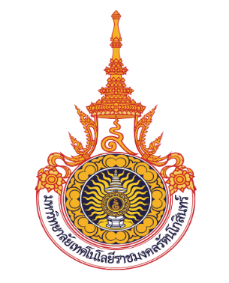

Development of an Online Maintenance Request System for Organizations

Ratchakit Kittichokthanawat

Banthit Wisatsing

A Project Report Submitted in Partial Fulfillment of the Requirements for the Degree of Bachelor of Technology in Information Technology and Digital Innovation

Faculty of Industry and Technology

Rajamangala University of Technology Rattanakosin Wang Klaikangwon Campus

Academic Year 2024