Table of Contents
1. Introduction 4
Dataset 4
Airbnb Data (Fact Tables and Snapshots) 4
Census Data (Dimension Tables) 5
Integration 5
2. Part 1: Loading Raw Data into Postgres (Bronze Layer) 6
2.1 Overview of Part 1 6
2.2 Setup Summary 6
2.3 Data Preparation 6
2.4 Bronze Schema Design 7
2.5 Airflow DAG Development 8
2.7 Issues and Fixes 9
2.8 Outcome Summary 10
3. Part 2: Data Warehouse Design with dbt (Silver and Gold Layers) 11
3.1 Overview of dbt Project Structure 11
Layer and purposes 11
3.2 Bronze Layer (Sources) 12
3.3 Silver Layer (Staging Models) 13
Main models 13
3.4 Snapshots 13
3.5 Gold / Star Layer (Conformed Dimensions) 14
3.6 Gold / Mart Layer (Analytical Views) 14
3.7 Issues and Fixes 15
3.8 Outcome Summary 15
4. Part 3: Load the Remaining Airbnb Data 17
4.1 Overview of Part 3 17
4.2 Environments and Schemas 17
4.3 Orchestration Flow in Airflow (Production) 17
4.4 dbt Runs and Build Order 18
4.5 Sequential Monthly Loads 19
4.6 Validation and Checks 20
4.7 Issues and Fixes 20
4.8 Outcome Summary 21
5. Part 4: Ad-hoc Analysis and Insights 22
Question 1 22
Method (SQL summary) 22
Results 22
Business Interpretation 22
Recommendations 23
Question 2 23
Method (SQL summary) 23
Results 23
Business Interpretation 24
Recommendations 24
Question 3 24
Method (SQL summary) 24
Results 25
Business Interpretation 25
Recommendations 25
Question 4 25
Method (SQL summary) 25
Results 26
Business Interpretation 26
Recommendations 26
Question 5 27
Method (SQL summary) 27
Results 27
Business Interpretation 27
Recommendations 27
6. Conclusion 28

1. Introduction
This report focuses on the analytical phase of the Airbnb Sydney data pipeline project, developed as part of the Big Data Engineering workflow. The project integrates Airbnb listings data with demographic and economic indicators from the Australian Census to explore spatial and behavioural patterns in the short-term rental market across Greater Sydney.
The primary objective of this analysis is to identify and interpret key business insights that can guide data-driven decision-making for Airbnb hosts, property managers, and policy stakeholders. Specifically, the report addresses five business questions related to host distribution, listing performance, demographic influence, and financial sustainability.
These insights are derived from a complete ETL-to-analytics pipeline deployed on Google Cloud Platform, using Airflow for orchestration, PostgreSQL for data storage, and dbt (Data Build Tool) for data modelling and transformation. The results presented in this report come from the production environment, triggered via Airflow, ensuring data reliability and process automation.

Dataset
The analysis is based on two main data sources integrated through the ETL process:

Airbnb Data (Fact Tables and Snapshots)
- Source: Monthly Airbnb public listings from May 2020 to April 2021.
- Structure: Processed through the Bronze → Silver → Gold data layers.
  - Bronze layer: Raw CSVs ingested from Google Cloud Storage into Postgres without transformations.
  - Silver layer: Cleaned and standardised staging tables such as stg_listing and stg_lga_suburb, ensuring consistent data types and location formats.
  - Snapshots: Implemented as snap_listing and snap_host to track historical attribute changes (e.g., price, availability, superhost status) using Slowly Changing Dimension Type 2 (SCD2) logic.
  - Gold layer: Analytical fact models designed for reporting, including:
    - dm_listing_neighbourhood: Monthly average revenue per active listing by neighbourhood.
    - dm_property_type and dm_host_neighbourhood: Aggregated KPIs by property type and host behaviour.
    - dim_listing_monthly: Expanded month-level listing fact table for time-based analysis.

Census Data (Dimension Tables)
- Source: 2016 Australian Bureau of Statistics (ABS) Census.
- Tables Used:
  - stg_census_g01: Demographic structure, including age group populations.
  - stg_census_g02: Socioeconomic metrics, such as median age, household size, and mortgage repayment.
- Purpose: Acts as the dimensional context for Airbnb data, enabling demographic and financial comparisons across LGAs.

Integration
Airbnb and Census datasets were connected through Local Government Area (LGA) mappings using lookup tables (dim_lga, dim_suburb, stg_lga_suburb). The final analytical layer (analytics_gold) was built and refreshed automatically through an Airflow-triggered dbt job, ensuring consistent data lineage, quality, and synchronisation between both data domains.
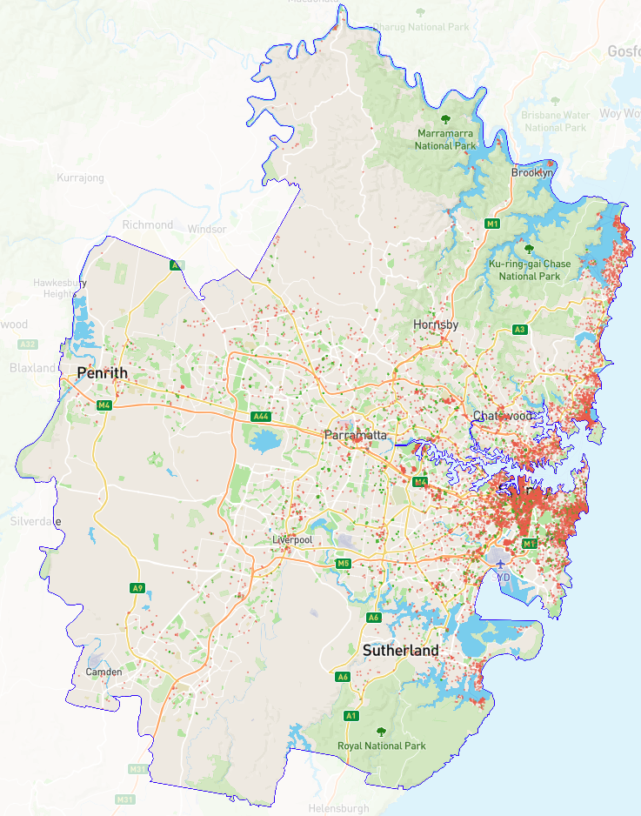

Figure 1. Airbnb Listings Density Map of Greater Sydney from Inside Airbnb

2. Part 1: Loading Raw Data into Postgres (Bronze Layer)

2.1 Overview of Part 1
The goal of Part 1 is to set up the first stage of the ELT pipeline: ingest raw CSV files into a Postgres “Bronze” schema in a reproducible way. This step establishes a stable landing zone for source data (Airbnb listings and reference Census/LGA tables) without applying business transformations. It prepares the project for later Silver/Gold modeling.

2.2 Setup Summary
- Platform: Google Cloud Platform (GCP).
- Services:
  - Cloud Composer (Airflow) to orchestrate ingestion tasks.
  - Cloud Storage (GCS) as the staging area for CSV files.
  - Cloud SQL (Postgres) as the data warehouse.
  - DBeaver to inspect schemas and run ad-hoc SQL.

2.3 Data Preparation
I uploaded the following files to the Cloud Storage bucket:
- Airbnb: data/facts/05_2020.csv (first month to bootstrap the pipeline).
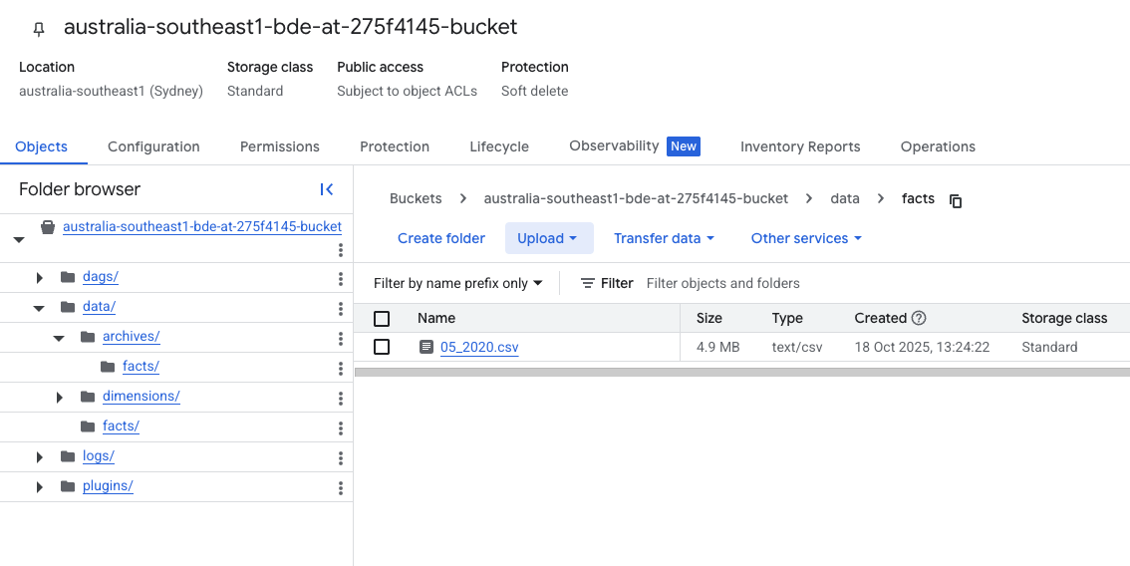
- Census reference: data/dimensions/2016Census_G01_NSW_LGA.csv, 2016Census_G02_NSW_LGA.csv, NSW_LGA_CODE.csv, NSW_LGA_SUBURB.csv.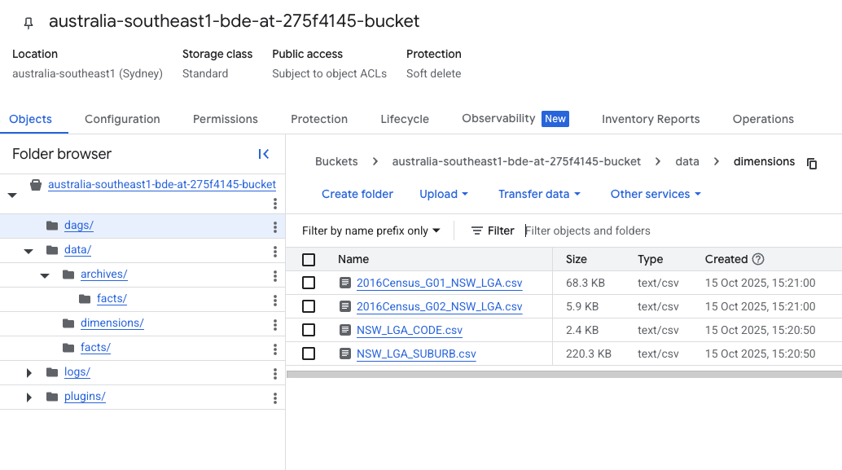
This layout keeps facts and dimensions separated and easy to automate from Airflow.

2.4 Bronze Schema Design
Using DBeaver, I created a dedicated Bronze schema to store raw tables with source-aligned column names and permissive types. The figure below is the confirmed table presence in information_schema.tables.
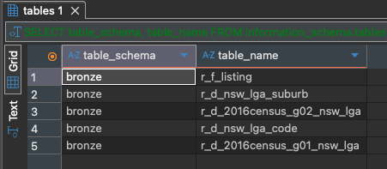
- bronze.r_f_listing: raw Airbnb listing snapshots for each month. Critical identifiers include LISTING_ID, SCRAPED_DATE, plus descriptive attributes (host details, property type, price, availability, reviews).
- bronze.r_d_2016census_g01_nsw_lga: G01 demographics by LGA.
- bronze.r_d_2016census_g02_nsw_lga: G02 medians/averages by LGA.
- bronze.r_d_nsw_lga_code: LGA code/name reference.
- bronze.r_d_nsw_lga_suburb: mapping between LGAs and suburbs.
Design choices: keep date-like fields as TEXT in Bronze to avoid early parsing errors, preserve raw casing, and load one month per file for idempotency.

2.5 Airflow DAG Development
I built an ingestion DAG named load_to_bronze_parallel_dbt_2 (no schedule, manual trigger).
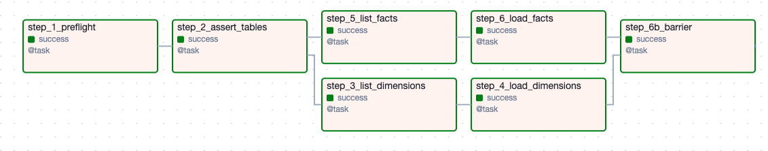
- Config & paths:
  - AIRFLOW_DATA=/home/airflow/gcs/data, with subfolders “dimensions”, “facts”, “archives”.
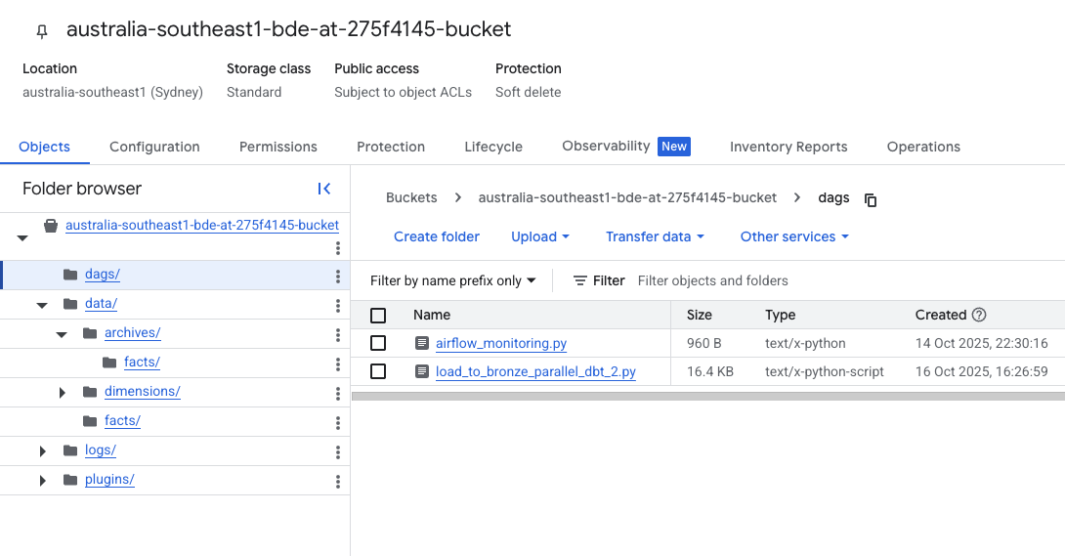
- Airflow UI:
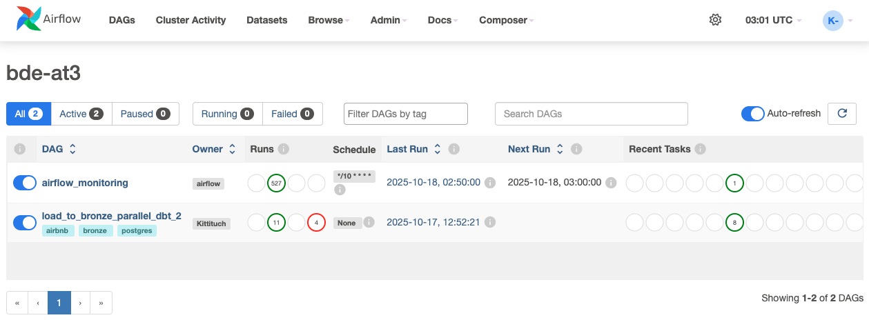
- Safety checks:
  - step_1_preflight validates directories and Postgres connectivity.
  - step_2_assert_tables confirms required Bronze tables exist and asserts SCRAPED_DATE and HOST_SINCE are TEXT.
- Dimensions branch:
  - step_3_list_dimensions enumerates available CSVs from data/dimensions/.
  - step_4_load_dimensions TRUNCATEs each target table then loads it via COPY with an explicit column list. It also standardises the two helper files: NSW_LGA_CODE.csv and NSW_LGA_SUBURB.csv (only the correct columns are retained and trimmed).
- Facts branch:
  - step_5_list_facts picks files that match MM_YYYY.csv.
  - step_6_load_facts cleans the file and inserts into bronze.r_f_listing.
    - Adds MONTH_YEAR from the filename and skips reloading if the month already exists (idempotent).
    - _clean_facts() keeps date strings ISO-like and strips currency symbols from PRICE.
    - Enforces non-empty PK fields (LISTING_ID, SCRAPED_DATE) and logs dropped rows if any.
    - Uses COPY ... (explicit columns) to avoid order/case issues, then archives the processed file to archives/facts/.
- Barrier and dbt Trigger:
  - step_6b_barrier: Acts as a synchronisation checkpoint to ensure both the dimensions and facts branches complete before dbt is triggered.

2.7 Issues and Fixes
- Date parsing pitfalls: To avoid mixed formats causing load failures, Bronze stores date-like fields as TEXT. A custom normaliser _to_iso_date_series_dayfirst standardises common day-first formats to ISO text, and anything unknown becomes an empty string (fail-soft).
- Column order/case mismatches: Using explicit column lists in COPY prevents errors when CSV order differs from the table definition.
- Re-runs & duplicates: The DAG checks the presence of MONTH_YEAR before inserting and archives processed files, making loads idempotent.
- Dimension schema mismatches: Helper functions reshape the two LGA helpers to the exact two columns expected by the Bronze tables and validate column counts before loading.

2.8 Outcome Summary
Part 1 successfully established a repeatable raw-ingestion pipeline. The Airbnb May 2020 file and the Census/LGA reference files were uploaded to Cloud Storage and loaded into Bronze tables in Postgres using a controlled Airflow DAG.
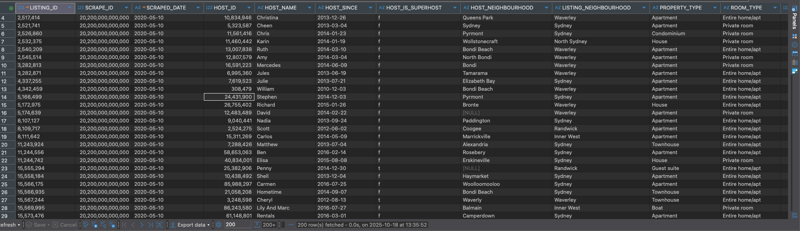

3. Part 2: Data Warehouse Design with dbt (Silver and Gold Layers)

3.1 Overview of dbt Project Structure
This part converts Bronze raw tables into Silver cleaned staging models and Gold analytical models. The project follows the Medallion architecture and uses dbt to manage SQL, tests, and lineage.

Layer and purposes
Layer | Schema | Purpose
Bronze | bronze | Raw source data loaded by Airflow.
Silver | silver | Cleaned and normalised staging tables with consistent types, keys, and names.
Snapshot | silver | Captures historical changes in key entities (listings and hosts) using Slowly Changing Dimension Type 2 (SCD2) for accurate time-based tracking.
Gold / Star | gold | Conformed dimensions and SCD2 entities built from snapshots.
Gold / Mart | gold | Analytical views that compute KPIs for reporting and insights.
All models, sources, and tests are defined in schema.yml for data quality and lineage tracking. Figure below shows the full dbt model lineage, where each box represents a dbt model or snapshot. It clearly shows the flow from Bronze sources through Silver staging into star and marts, confirming that every datamart depends on clean, versioned data.
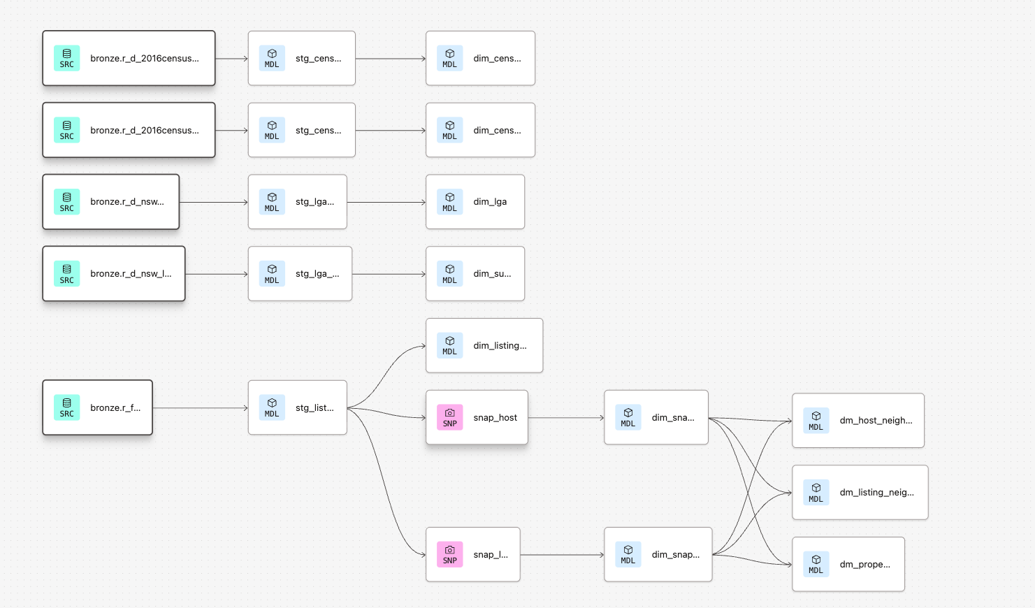

3.2 Bronze Layer (Sources)
The dbt project registers the external raw tables as sources. These are the inputs to all dbt models.
- r_f_listing
- r_d_2016census_g01_nsw_lga
- r_d_2016census_g02_nsw_lga
- r_d_nsw_lga_suburb and r_d_nsw_lga_code

3.3 Silver Layer (Staging Models)
Silver models standardise types, tidy text, and align keys so downstream joins are reliable. They also prepare date fields for month-based analysis of the May 2020 to April 2021 period.

Main models
Model | Description | Key transformations
stg_listing | Cleans Airbnb listings. | Parse date text to dates where safe, normalise booleans, uppercase location fields, convert price to numeric, derive month_date.
stg_census_g01 | Normalised Census G01. | Convert LGA_CODE_2016 to a 5 digit string, retain population and age buckets.
stg_census_g02 | Normalised Census G02. | Convert codes, cast numeric columns, expose median age, income, and create annual_median_mortgage.
stg_lga_code | LGA code to name lookup. | Trim and uppercase codes and names.
stg_lga_suburb | Suburb to LGA mapping. | Trim and uppercase, remove duplicates for a unique mapping.

3.4 Snapshots
Snapshots capture attribute changes over time so the Gold layer can implement SCD Type 2.
Snapshot | Unique key | Strategy | Purpose
snap_listing | listing_id | timestamp on scraped_date | Track changes to price, availability, and reviews.
snap_host | host_id | check on selected columns | Track changes to host neighbourhood and superhost status.
Each snapshot yields dbt_valid_from and dbt_valid_to, which are later converted into month windows for time-aware joins.

3.5 Gold / Star Layer (Conformed Dimensions)
Gold star models produce stable dimensions and a month-aligned listing table used by the marts.
Model | Description | Key columns
dim_census_g01 | Census G01 metrics by LGA. | lga_code, population and age attributes.
dim_census_g02 | Census G02 socio-economic metrics. | lga_code, median age, income, mortgage, household size.
dim_lga | Canonical LGA codes and names. | lga_code, lga_name.
dim_suburb | Suburb to LGA mapping. | suburb_name, lga_name or lga_code.
dim_snap_listing | Listing SCD2 dimension. | listing_version_sk, valid_from_month, valid_to_month, price, availability, reviews.
dim_snap_host | Host SCD2 dimension. | host_version_sk, host_neighbourhood, host_is_superhost, validity months.
dim_listing_monthly | Expanded listing by month. | month_date, listing_id, host_id, stays, price, review_scores_rating.
The dimensions are designed so any month in the facts table can be joined to the correct version of listing and host attributes that were valid in that month.

3.6 Gold / Mart Layer (Analytical Views)
The marts compute the KPIs required for the assignment. All views share the same building blocks:
- Active listing rate = active listings over total listings.
- Superhost rate computed on distinct hosts.
- Revenue = sum of stays * price for active listings.
Model | Grain | Main KPIs | Purpose
dm_listing_neighbourhood | Listing neighbourhood by month | Active rate, min, max, median, average price for active listings, distinct hosts, superhost rate, average review score, percent change for active and inactive, total stays, average estimated revenue per active listing | Identify top and bottom neighbourhoods and trends.
dm_property_type | Property type, room type, accommodates by month | Same KPI set as above | Compare performance by property and capacity.
dm_host_neighbourhood | Host neighbourhood LGA by month | Distinct hosts, total estimated revenue, estimated revenue per distinct host | Analyse host behaviour across areas.
These views follow SCD2 rules by joining facts to the correct time-valid dimension rows.

3.7 Issues and Fixes
During the transformation process, a few technical issues were identified and resolved:
- Data type mismatches: Some columns in the Bronze tables were stored as text, requiring explicit casting in Silver models (for example, converting price and numerical census fields).
- Inconsistent LGA codes: Different Census files used mixed numeric and text formats for LGA_CODE_2016. This was fixed by padding all codes to a consistent five-digit string.
- Null or blank values: Certain listings had missing host information or neighbourhood names. These were cleaned and replaced with “Unknown” to preserve referential integrity.
- Snapshot validity errors: Early snapshot tests produced invalid date ranges. Adjusting timestamp conversions and ensuring proper use of dbt_valid_from and dbt_valid_to solve this issue.
These fixes ensured smooth model execution and accurate joins between Silver and Gold layers.

3.8 Outcome Summary
Part 2 successfully implemented the Silver and Gold layers of the data warehouse using dbt. The transformations cleaned, standardised, and structured the Airbnb and Census datasets into analysis-ready models. Snapshots were created for listings and hosts, enabling Slowly Changing Dimensions (SCD Type 2) tracking. The Gold layer now contains stable dimension tables and three key analytical datamarts: dm_listing_neighbourhood, dm_property_type, and dm_host_neighbourhood.

4. Part 3: Load the Remaining Airbnb Data

4.1 Overview of Part 3
Process the remaining Airbnb CSVs from May 2020 to April 2021 in strict month order, load them into Bronze, and materialise Silver and Gold through dbt runs. Use two environments: development for terminal runs and production triggered by Airflow.

4.2 Environments and Schemas
- Production (Airflow-triggered): results land in analytics_silver and analytics_gold.
- Development (manual dbt): results land in development_silver and development_gold.
- Snapshot: results land in silver
- Evidence: Figure below shows all schemas in Postgres, including bronze, silver, analytics_*, and development_*.
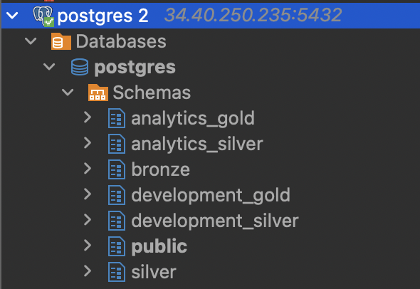

4.3 Orchestration Flow in Airflow (Production)
The DAG load_to_bronze_parallel_dbt_2 manages ingestion and triggers dbt Cloud after Bronze loads as figure below.
Task flow
- step_1_preflight checks folders and Postgres connection.
- step_2_assert_tables verifies Bronze tables and confirms date columns are TEXT.
- Parallel branches:
  - Dimensions: step_3_list_dimensions to step_4_load_dimensions (truncate then copy).
  - Facts: step_5_list_facts to step_6_load_facts (validate, insert, archive).
- step_6b_barrier synchronises both branches.
- step_7_trigger_dbt calls dbt Cloud to run freshness, snapshots, Silver, and Gold.
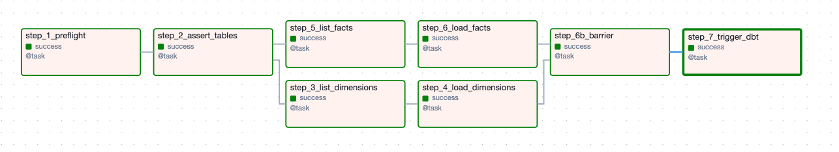

4.4 dbt Runs and Build Order
- Development (terminal):
I ran the same sequence from the terminal against the dev target before running into the production side in order to test the model.
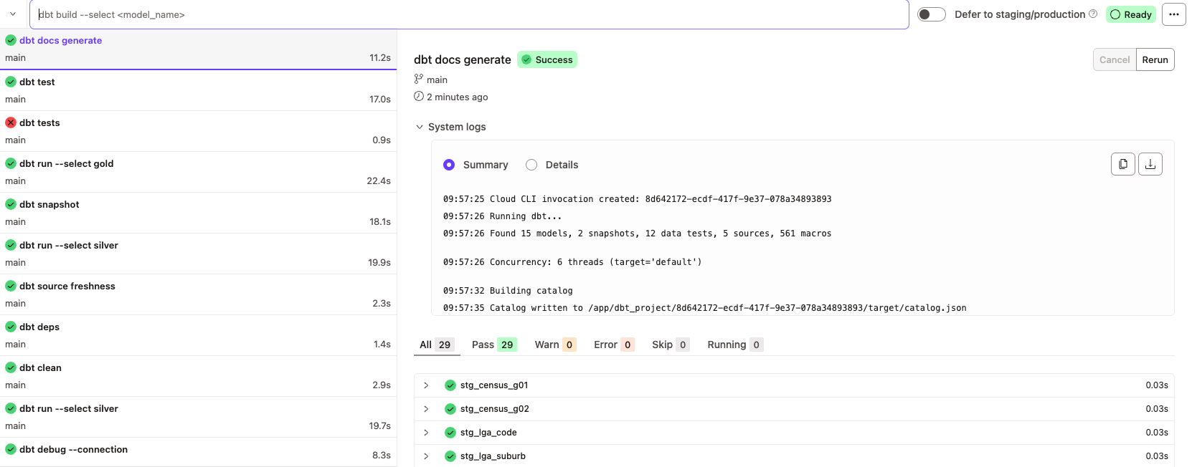
- Production (Airflow to dbt Cloud):
The job executes in this order: deps, source freshness, dbt run --select silver, dbt snapshot, dbt run --select gold, tests, docs.
- 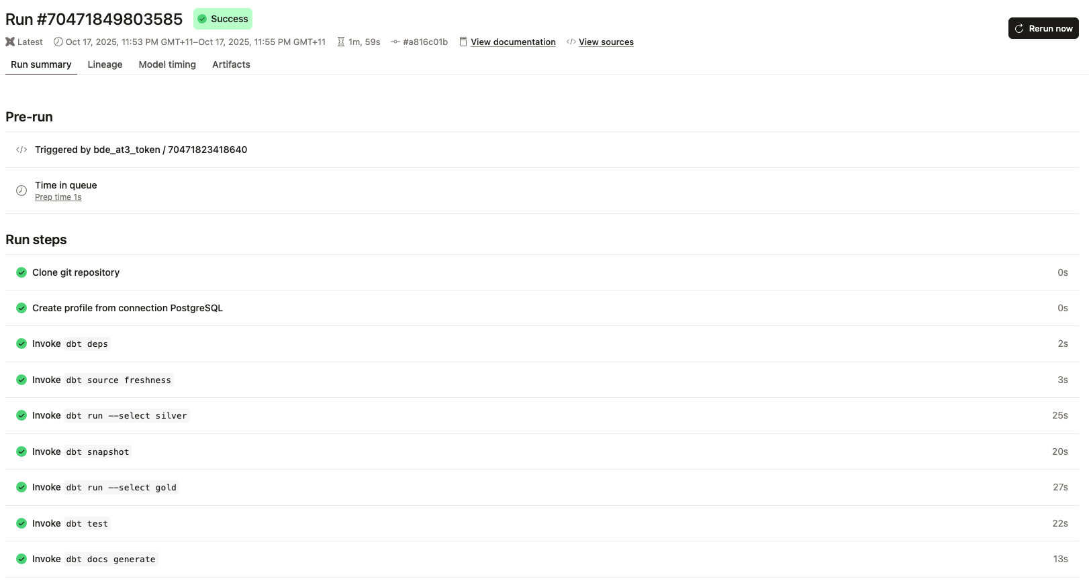

4.5 Sequential Monthly Loads
Each monthly file MM_YYYY.csv is placed under data/facts/. The DAG enforces idempotency:
- It derives MONTH_YEAR from the filename.
- It checks for existing rows for that month and skips duplicates.
- It archives processed files to archives/facts/.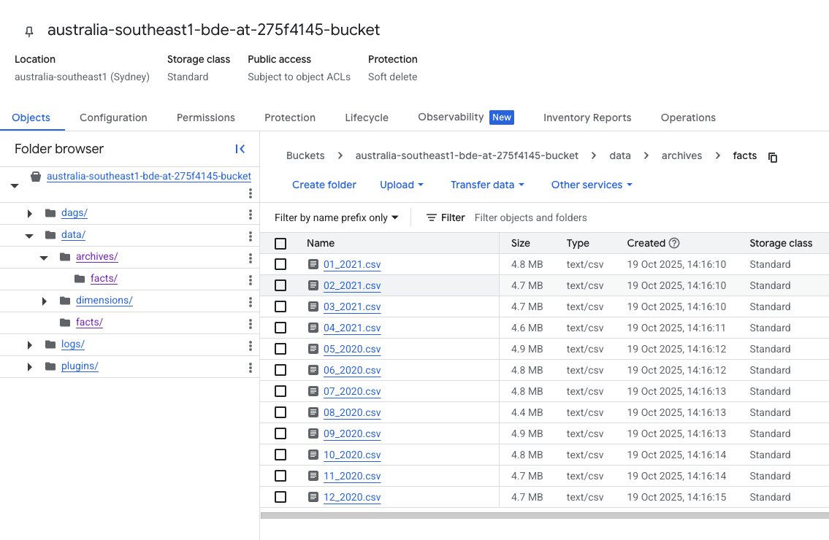
This guarantees chronological processing and avoids double loads.

4.6 Validation and Checks
- Airflow logs: confirm row counts, sample ISO date strings, and archive moves.
- Postgres checks: quick COUNT(*) by MONTH_YEAR to verify completeness.
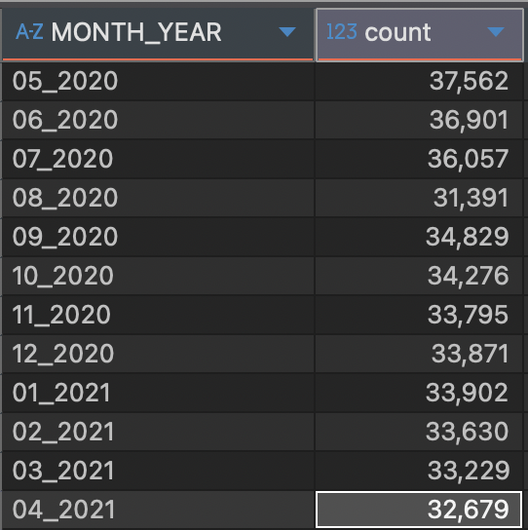
- dbt tests: not_null, unique, and relationships on key fields pass after each production build.
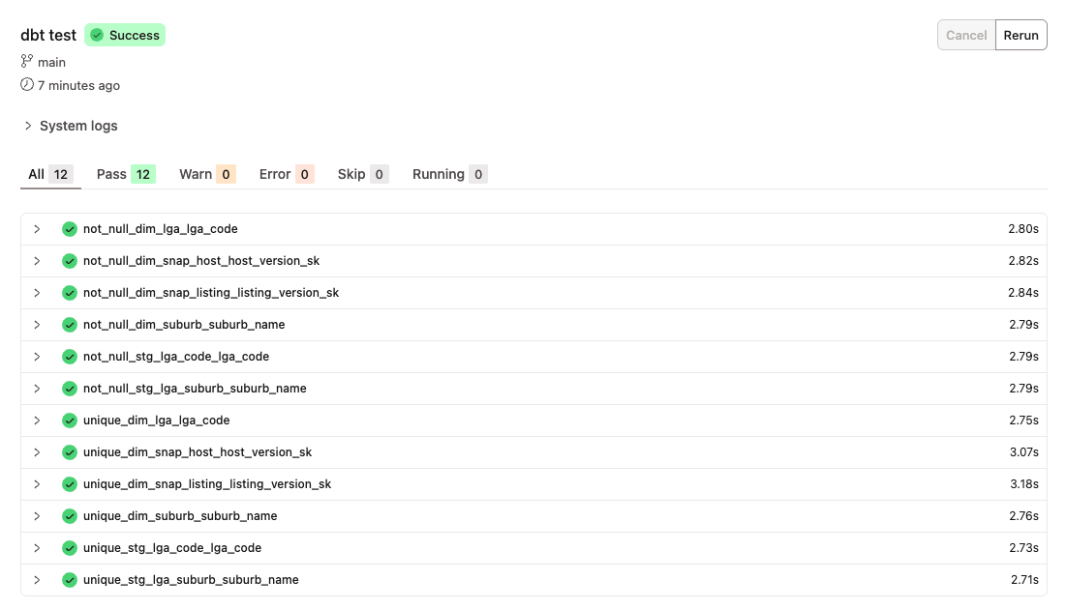

4.7 Issues and Fixes
- Occasional re-run collisions: The archive guard and MONTH_YEAR existence check prevented duplicates when a month was uploaded twice.
- Date format variation in facts: Normalised in the DAG and kept as TEXT in Bronze. Silver handles type casting safely.
- Schema drift between dev and prod: Isolated by using separate targets (development_* vs analytics_*) and running the same dbt selection in both.

4.8 Outcome Summary
All remaining months were ingested to Bronze in order, validated, and archived. Production builds were triggered by Airflow and materialised to analytics_silver and analytics_gold. Development builds were run from the terminal and materialised to development_silver and development_gold. dbt tests passed, and the marts are ready for Part 4 analysis.

5. Part 4: Ad-hoc Analysis and Insights

Question 1
Compare demographics of the top 3 and bottom 3 performing LGAs based on average estimated revenue per active listing over the last 12 months. Focus on median age, average household size, and age group distribution.

Method (SQL summary)
- Pull the latest month from analytics_gold.dm_listing_neighbourhood.
- Take the last 12 months window.
- Map each listing_neighbourhood to an LGA using dim_lga, dim_suburb, and staging lookups.
- Aggregate to LGA: AVG(avg_est_rev_per_active) as the ranking metric.
- Select Top 3 and Bottom 3 LGAs.
- Join with the Census staging tables stg_census_g01 and stg_census_g02 to compute age-band shares and pick median age and household size.

Results

Business Interpretation
- Who’s driving high revenue?
The top 3 LGAs (Mosman, Woollahra, Northern Beaches) represent older, smaller-household markets (median age ~40, household size 2.3–2.7). They attract affluent travelers and couples seeking premium short stays, where location, comfort, and aesthetics justify higher nightly rates.
- What limits revenue in the bottom tier?
The bottom 3 LGAs (Blacktown, Fairfield, Canterbury-Bankstown) are younger (median age ~33–36) with larger households (3.0–3.3) and more family occupants. These areas show price-sensitive demand, focused on space, functionality, and affordability rather than luxury.
- Product–market fit by area
Top LGAs perform best with 1–2 bedroom premium apartments or townhouses, marketed for comfort and exclusivity. Bottom LGAs benefit from larger, budget-friendly homes appealing to families or long-term guests.

- Seasonality and stay patterns
Premium coastal LGAs thrive on short, high-value stays year-round, while outer LGAs rely more on longer bookings during school holidays and family travel periods.

Recommendations
- Expand premium coastal listings in Mosman, Woollahra, and Northern Beaches with strong photography and shorter-stay flexibility.
- Position outer LGAs (Blacktown, Fairfield, Canterbury-Bankstown) for families, offer multi-bedroom homes, weekly discounts, and child-friendly amenities.
- Pricing: Apply dynamic pricing premium surge pricing for top LGAs and length-of-stay discounts for bottom LGAs.
- Marketing: Segment campaigns by traveler type, luxury couples vs. family value-seekers, to improve booking conversion and occupancy consistency.

Question 2
Assess whether there is a statistical relationship between the median age of residents in a neighbourhood and the average estimated revenue per active Airbnb listing over the last 12 months.

Method (SQL summary)
- Extracted the latest 12-month window from dm_listing_neighbourhood.
- Mapped each neighbourhood to an LGA using dim_lga and dim_suburb.
- Averaged the estimated revenue per active listing for each neighbourhood.
- Joined with Census G02 data to obtain the median age per LGA.
- Calculated the Pearson correlation coefficient between median age and revenue.

Results
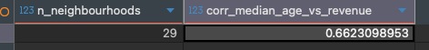

Business Interpretation
The correlation coefficient of 0.66 indicates a moderately strong positive relationship between median age and listing revenue. This suggests that neighbourhoods with older populations tend to have higher Airbnb earnings per active listing.
Several business implications emerge:
- Older demographics often correlate with wealthier, established suburbs such as Mosman or Woollahra. These areas attract premium visitors who value comfort, location, and exclusivity.
- In contrast, younger areas, often denser and more affordable, tend to host price-sensitive guests or longer stays with lower nightly rates.
- This reinforces a pattern observed in Q1: age structure mirrors spending power and hence revenue potential.

Recommendations
- Prioritise expansion in older, higher-income neighbourhoods with proven revenue performance.
- Target new hosts in mature, coastal, or inner-city LGAs by promoting Airbnb as a high-return opportunity.
- Adjust marketing segmentation: tailor premium branding and dynamic pricing in older, affluent areas while keeping competitive rates in younger, family-heavy suburbs.
- Use demographic insights to forecast new high-value markets, areas showing ageing trends could signal future premium potential.

Question 3
For the top 5 neighbourhoods by average revenue per active listing (12-month average), identify the best performing type tuple (property_type, room_type, accommodates) by total stays in the same window.

Method (SQL summary)
- Take the latest 12-month window from dm_listing_neighbourhood.
- Rank neighbourhoods by avg_est_rev_per_active and keep Top 5.
- Build a month-grained fact from dim_listing_monthly and join to dim_snap_listing with SCD2 validity to bring attributes per month.
- Aggregate stays and revenue by (property_type, room_type, accommodates) within each top neighbourhood.
- Select the tuple with max total_stays_12m per neighbourhood.

Results
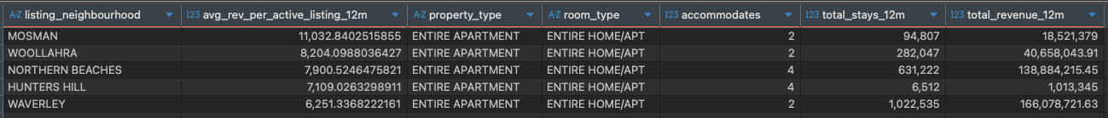

Business Interpretation
Format fit is clear: In top-revenue neighbourhoods, guests overwhelmingly choose entire apartments rather than private rooms. Privacy and self-contained amenities drive bookings and revenue.
Two demand cores:
- Couples/duos (accommodates 2) dominate Mosman, Woollahra, and Waverley, short premium breaks near the coast/CBD.
- Small families/groups (accommodates 4) lead in Northern Beaches and Hunters Hill, longer leisure stays with space needs.
Revenue mechanics: The 4-person stock generates the largest stays and revenue totals in beachside family markets, while 2-person stock monetises well via higher ADRs and short-stay churn in prestige suburbs.

Recommendations
- Supply: Prioritise onboarding entire apartments in these five neighbourhoods. Balance mix toward 2-pax in Mosman, Woollahra, Waverley and 4-pax in Northern Beaches, Hunters Hill.
- Pricing:
  - 2-pax: short-stay premiums, weekend/event uplift, fewer long-stay discounts.
  - 4-pax: length-of-stay discounts at 7+/14+ nights, family-bundle add-ons (parking, laundry, kids’ packs).
- Listing quality: Invest in pro photography, kitchens, climate control, outdoor space; these raise conversion more than adding extra bedrooms in top areas.

Question 4
Determine whether hosts with more than one listing operate within a single LGA or across multiple LGAs over the last 12 months.

Method (SQL summary)
- Selected the latest 12-month window from dim_listing_monthly.
- Joined to dim_snap_listing with validity filters to get the correct neighbourhood per month.
- Mapped neighbourhoods to LGAs using dim_lga, dim_suburb, and the staging mapping table.
- For each host, count distinct listings and distinct LGAs.
- Kept hosts with n_listings ≥ 2 and classified spread:
  - Concentrated if n_lgas = 1
  - Distributed if n_lgas ≥ 2
- Aggregated counts and percentages.

Results
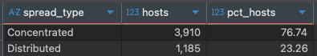

Business Interpretation
Most multi-listing hosts concentrate within a single LGA. This shows a strong pattern of local specialisation where hosts scale by replicating a known product and operations in one area. It implies lower operational complexity, tighter vendor networks, and better local pricing knowledge. A smaller segment runs distributed portfolios across LGAs, likely professional operators or investors seeking diversification and exploiting seasonality differences. Both groups are valuable, but they need different support and incentives.

Recommendations
- Concentrated hosts (77%)
  - Provide area-specific pricing guidance, neighbourhood playbooks, and bulk quality upgrades to standardise listings quickly.
  - Offer loyalty incentives for adding more supply within the same LGA and for adopting pro photography and cleaning SLAs.
- Distributed hosts (23%)
  - Enable multi-LGA tooling: calendar sync, portfolio analytics by LGA, and centralised messaging.
  - Create cross-LGA growth incentives and early access to new features that help manage compliance and rate strategy across markets.
- Growth experiments
  - Pilot an adjacent-LGA expansion program for top concentrated hosts to test whether diversification increases annual revenue stability.
  - Run operator scorecards to benchmark occupancy, ADR, and guest ratings by spread type and share best practices.

Question 5
Assess whether hosts with a single Airbnb listing generate sufficient 12-month revenue to cover the annualised median mortgage repayment in their local LGA. Identify LGAs where hosts are most likely to achieve this financial coverage.

Method (SQL summary)
- Extracted the latest 12-month window from dim_listing_monthly.
- Identified single-listing hosts (COUNT(DISTINCT listing_id) = 1).
- Mapped each host’s listing to an LGA via multiple lookups (dim_lga, dim_suburb, stg_lga_suburb).
- Calculated 12-month total revenue per host (SUM(stays * price) where has_availability = true).
- Joined with Census G02 data to retrieve median monthly mortgage repayment, annualised by multiplying by 12.
- Counted hosts whose revenue ≥ annual mortgage value and calculated the coverage rate (%) per LGA.

Results

Business Interpretation
High-value coastal and inner-city LGAs, Northern Beaches, Mosman, Waverley, Woollahra, Randwick, and Sydney, show that around 80% or more of single-listing hosts generate annual revenue sufficient to cover the average mortgage. These areas attract premium visitors, command high nightly rates, and benefit from consistent occupancy.
In contrast, outer-metro areas such as Blacktown, Penrith, and Fairfield show far lower coverage rates (~50–60%), reflecting lower average ADRs and weaker tourism demand. This suggests a strong geographic concentration of profitable single-host markets in Sydney’s affluent and tourism-dense LGAs.

Recommendations
- Focus host acquisition and marketing campaigns in premium LGAs with proven mortgage coverage potential, these are low-risk, high-return zones for single-property investors.
- Educate hosts in mid-tier LGAs on revenue optimisation, dynamic pricing, minimum-night strategies, and seasonal promotions, to close the gap between revenue and mortgage cost.
- Inform local councils and investors that Airbnb income can offset or fully cover mortgage repayments in 80%+ of listings across top LGAs, useful for policy and investment planning.

6. Conclusion
This project successfully built an end-to-end ELT pipeline for Airbnb and Census data using Airflow, PostgreSQL, and dbt. The workflow automated data ingestion, transformation, and model creation across Bronze, Silver, and Gold layers, ensuring data consistency and analytical reliability.
The analysis revealed clear patterns in Sydney’s Airbnb market. High-revenue areas like Mosman, Woollahra, and Northern Beaches attract older, wealthier guests and maintain strong occupancy, while outer LGAs such as Blacktown and Fairfield show lower returns. Revenue is positively correlated with median age, and entire apartments remain the top-performing property type. Most multi-listing hosts operate within one LGA, showing local specialisation, and over 80% of single-listing hosts in premium LGAs earn enough to cover annual mortgage costs.
Overall, the project demonstrates how a cloud-based, automated data pipeline can generate actionable insights for Airbnb hosts, investors, and policymakers to guide market strategy, pricing, and regional development.

