Cau 1: 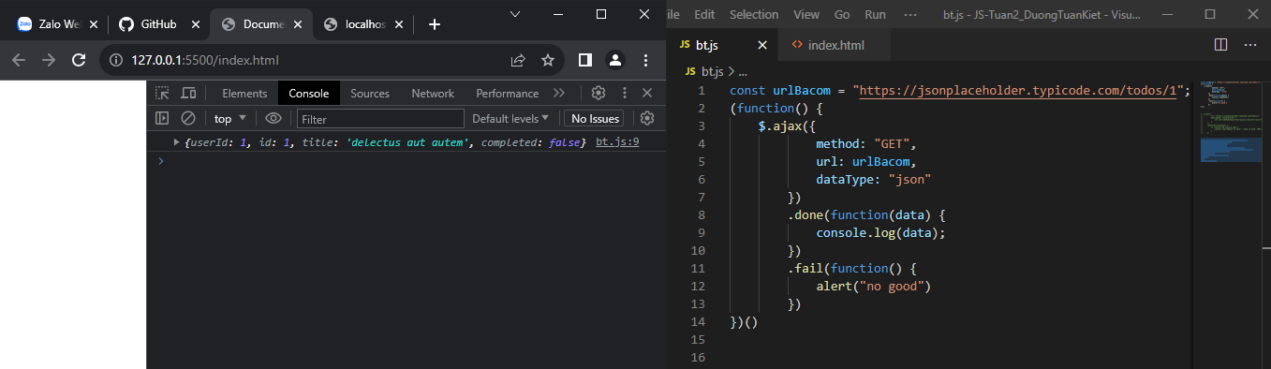

Cau 2: 