Design 01 — Void Terminal Dark mode · Monospaced · Hacker-precision aesthetic---
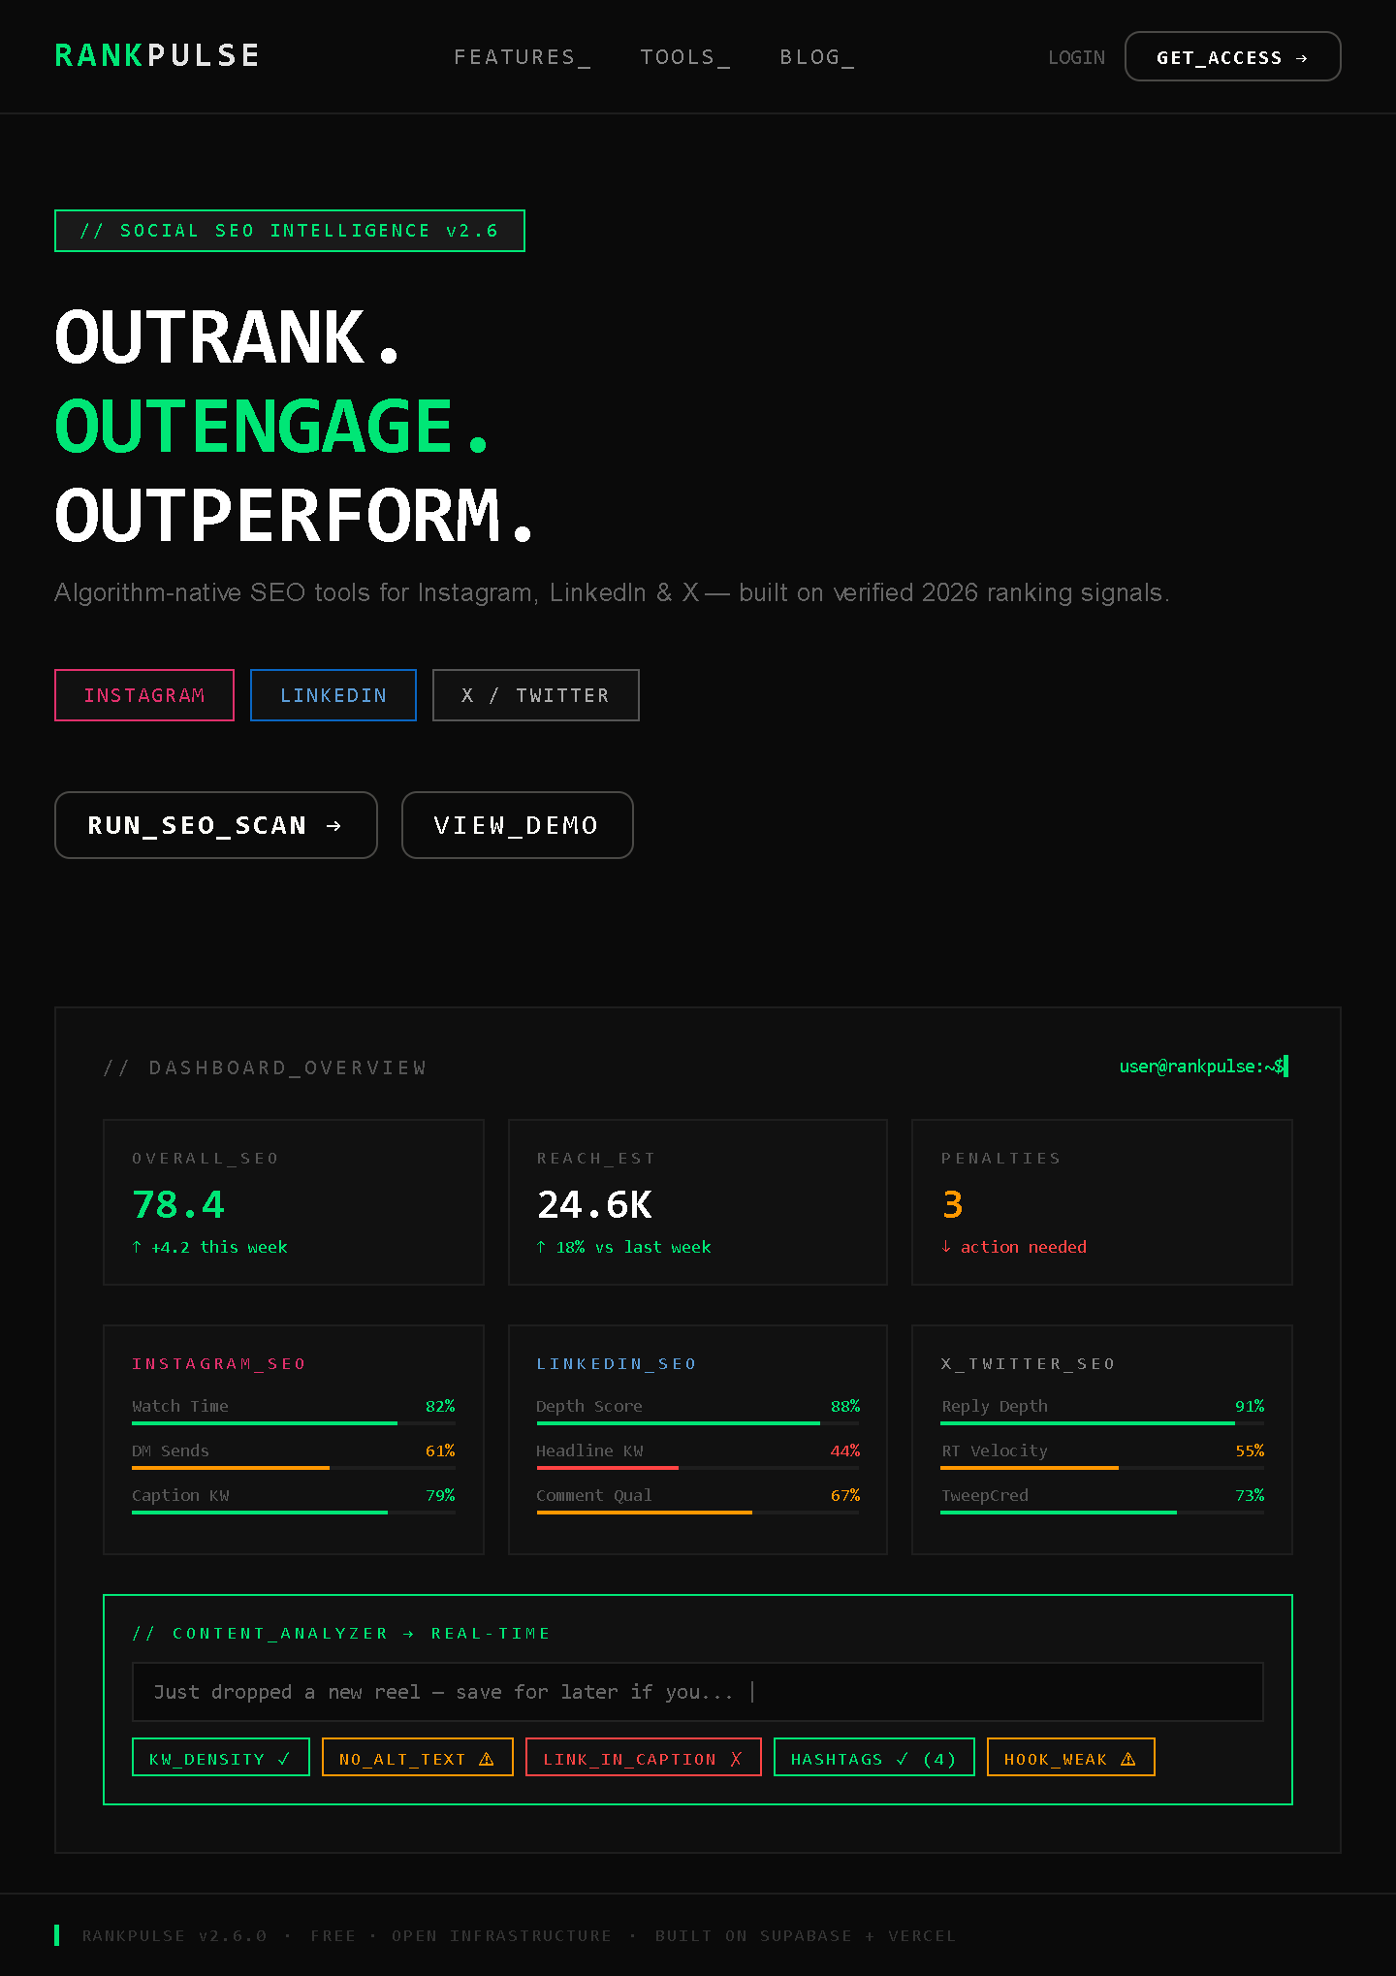
Design 02 — Arctic Clarity Ultra-minimal · Editorial white · Surgical whitespace---

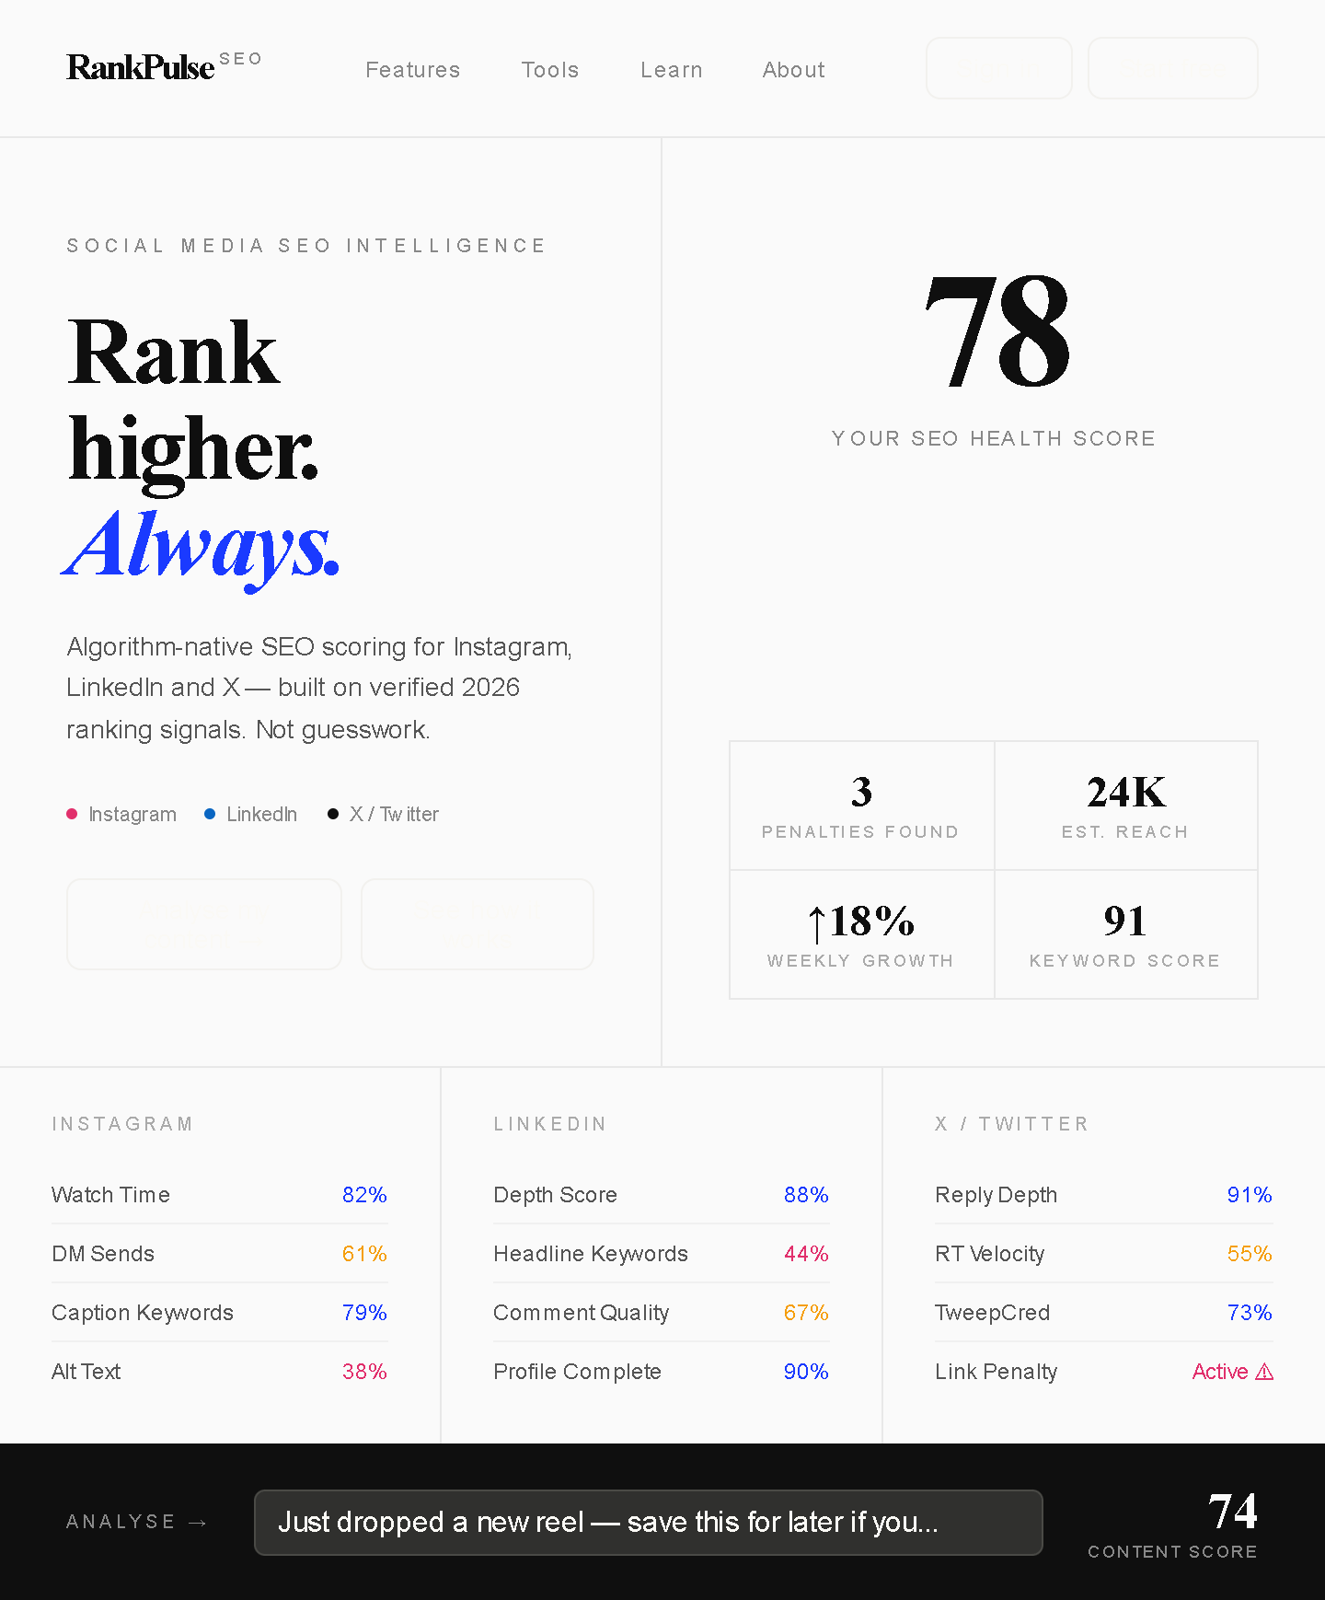

Design 03 — Bento Grid Trendy 2026 bento layout · Bold type · Modular cards---

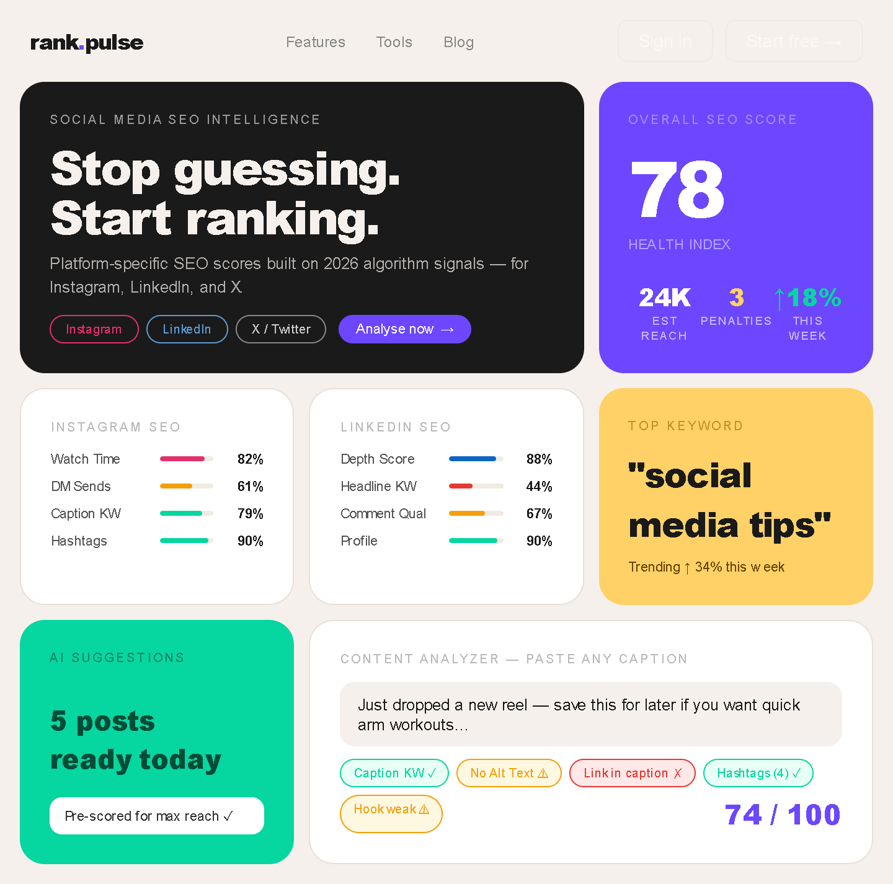

Design 04 — Neo-Brutalist Raw grid · Black borders · Anti-polish on purpose---
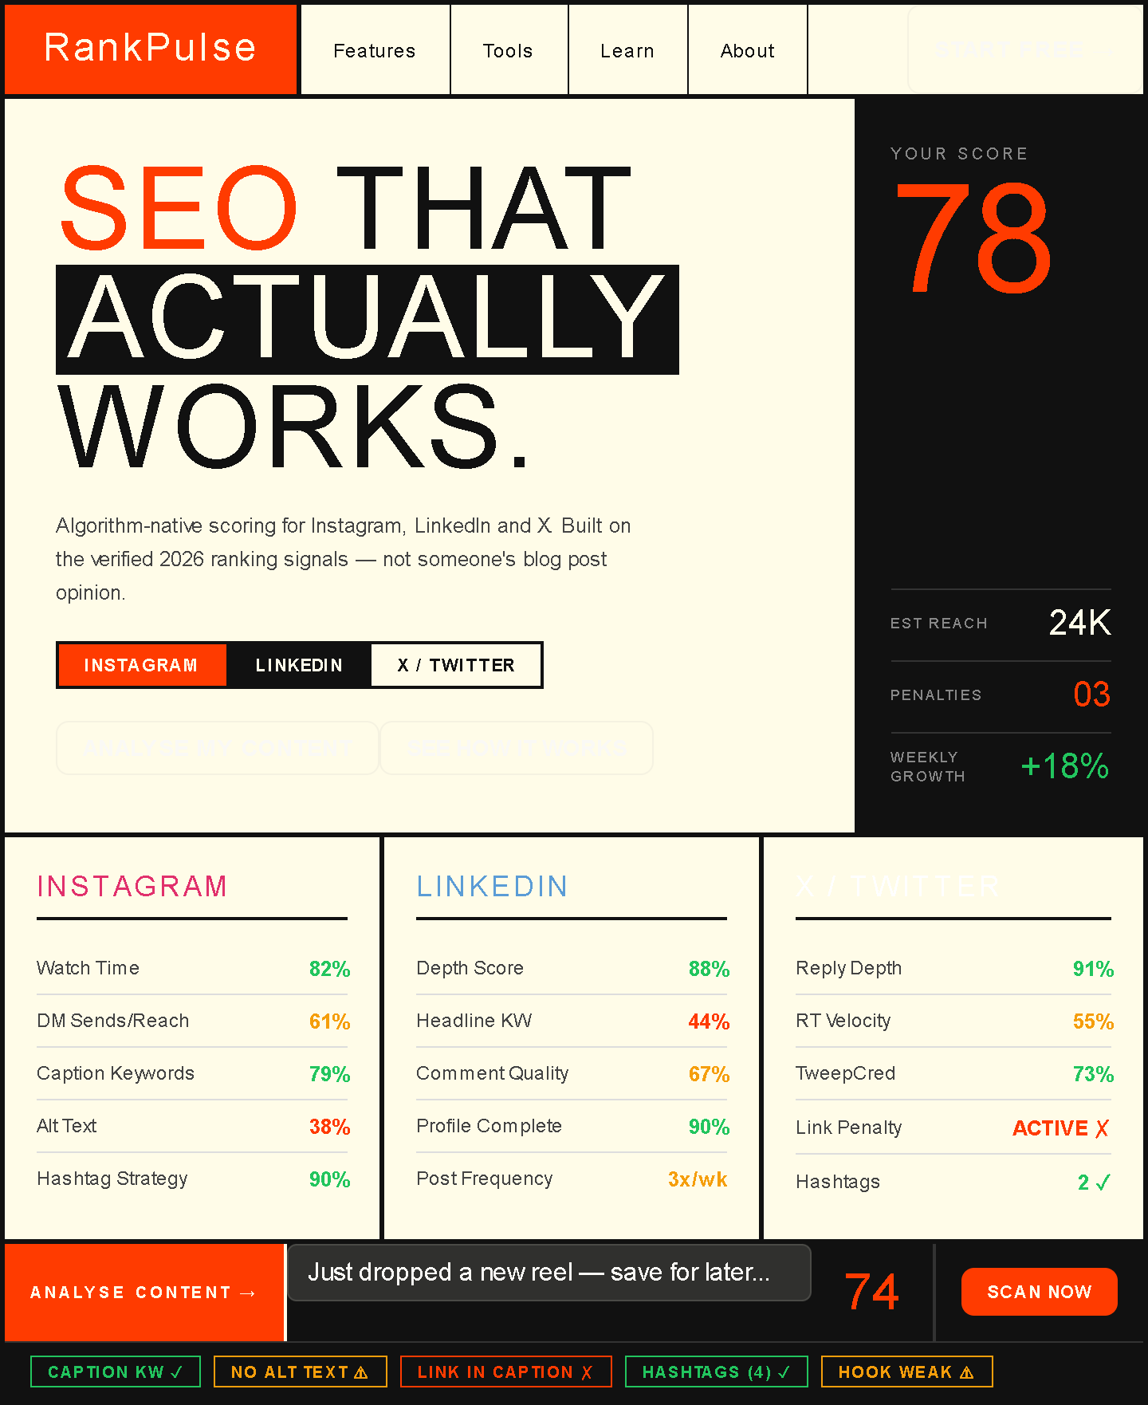

Design 05 — Indigo Lab Deep indigo · Scientific precision · Data-dense dashboard---
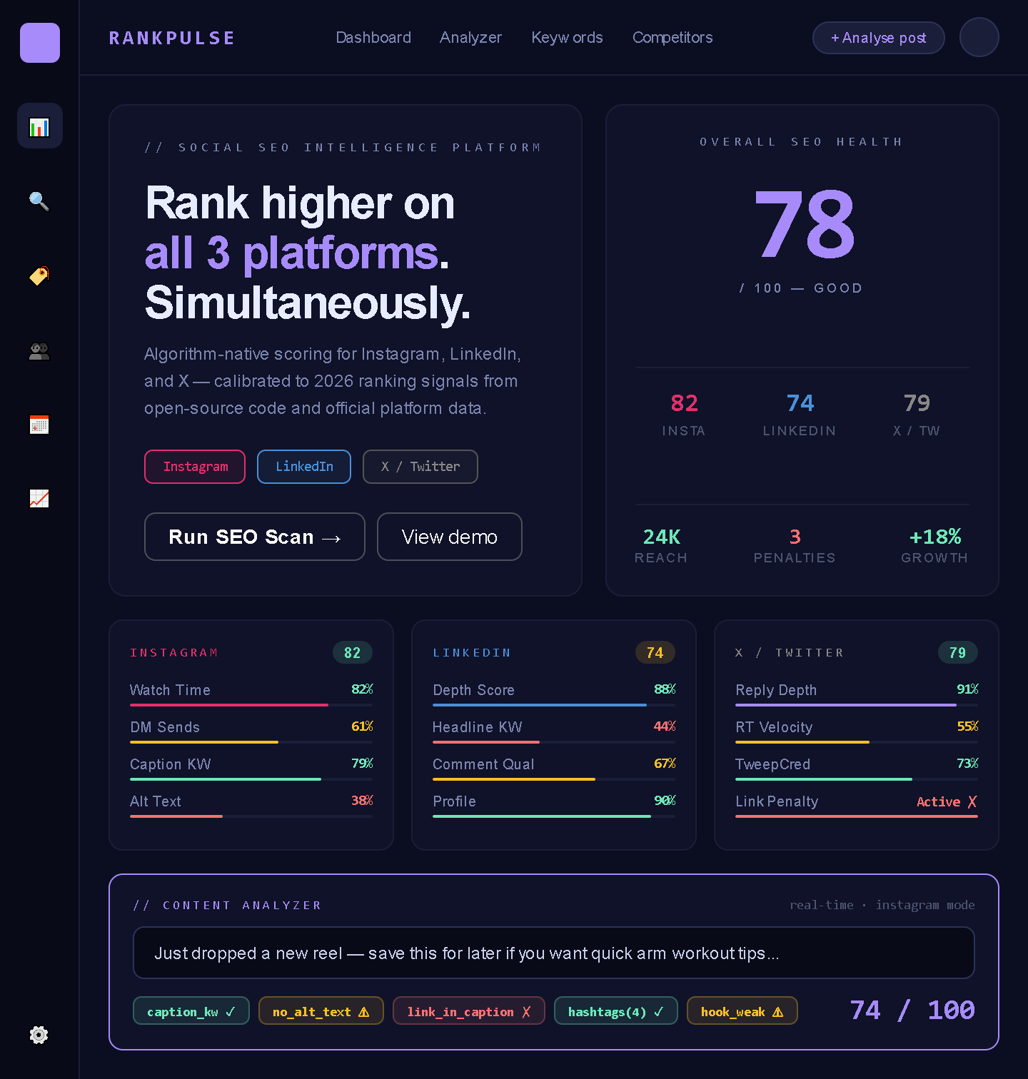

Design 06 — Solar Warmth Warm amber tones · Bold organic type · Energetic---
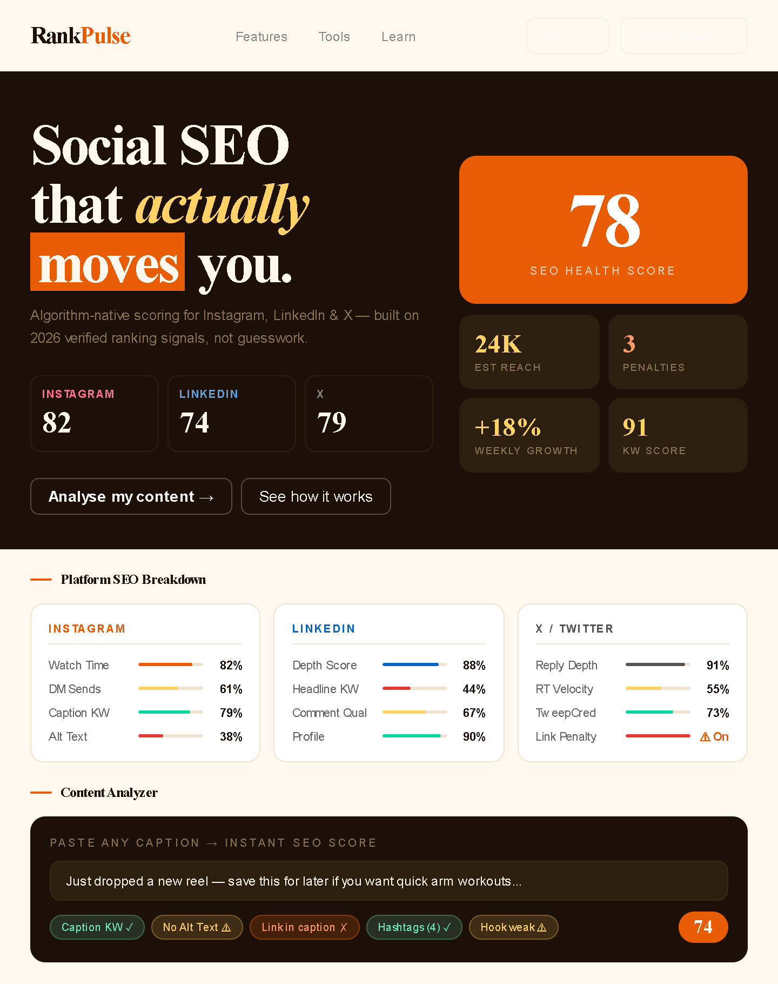

Design 07 — Ink & Signal Editorial newspaper DNA · Chunky dividers · Monochrome with signal red---
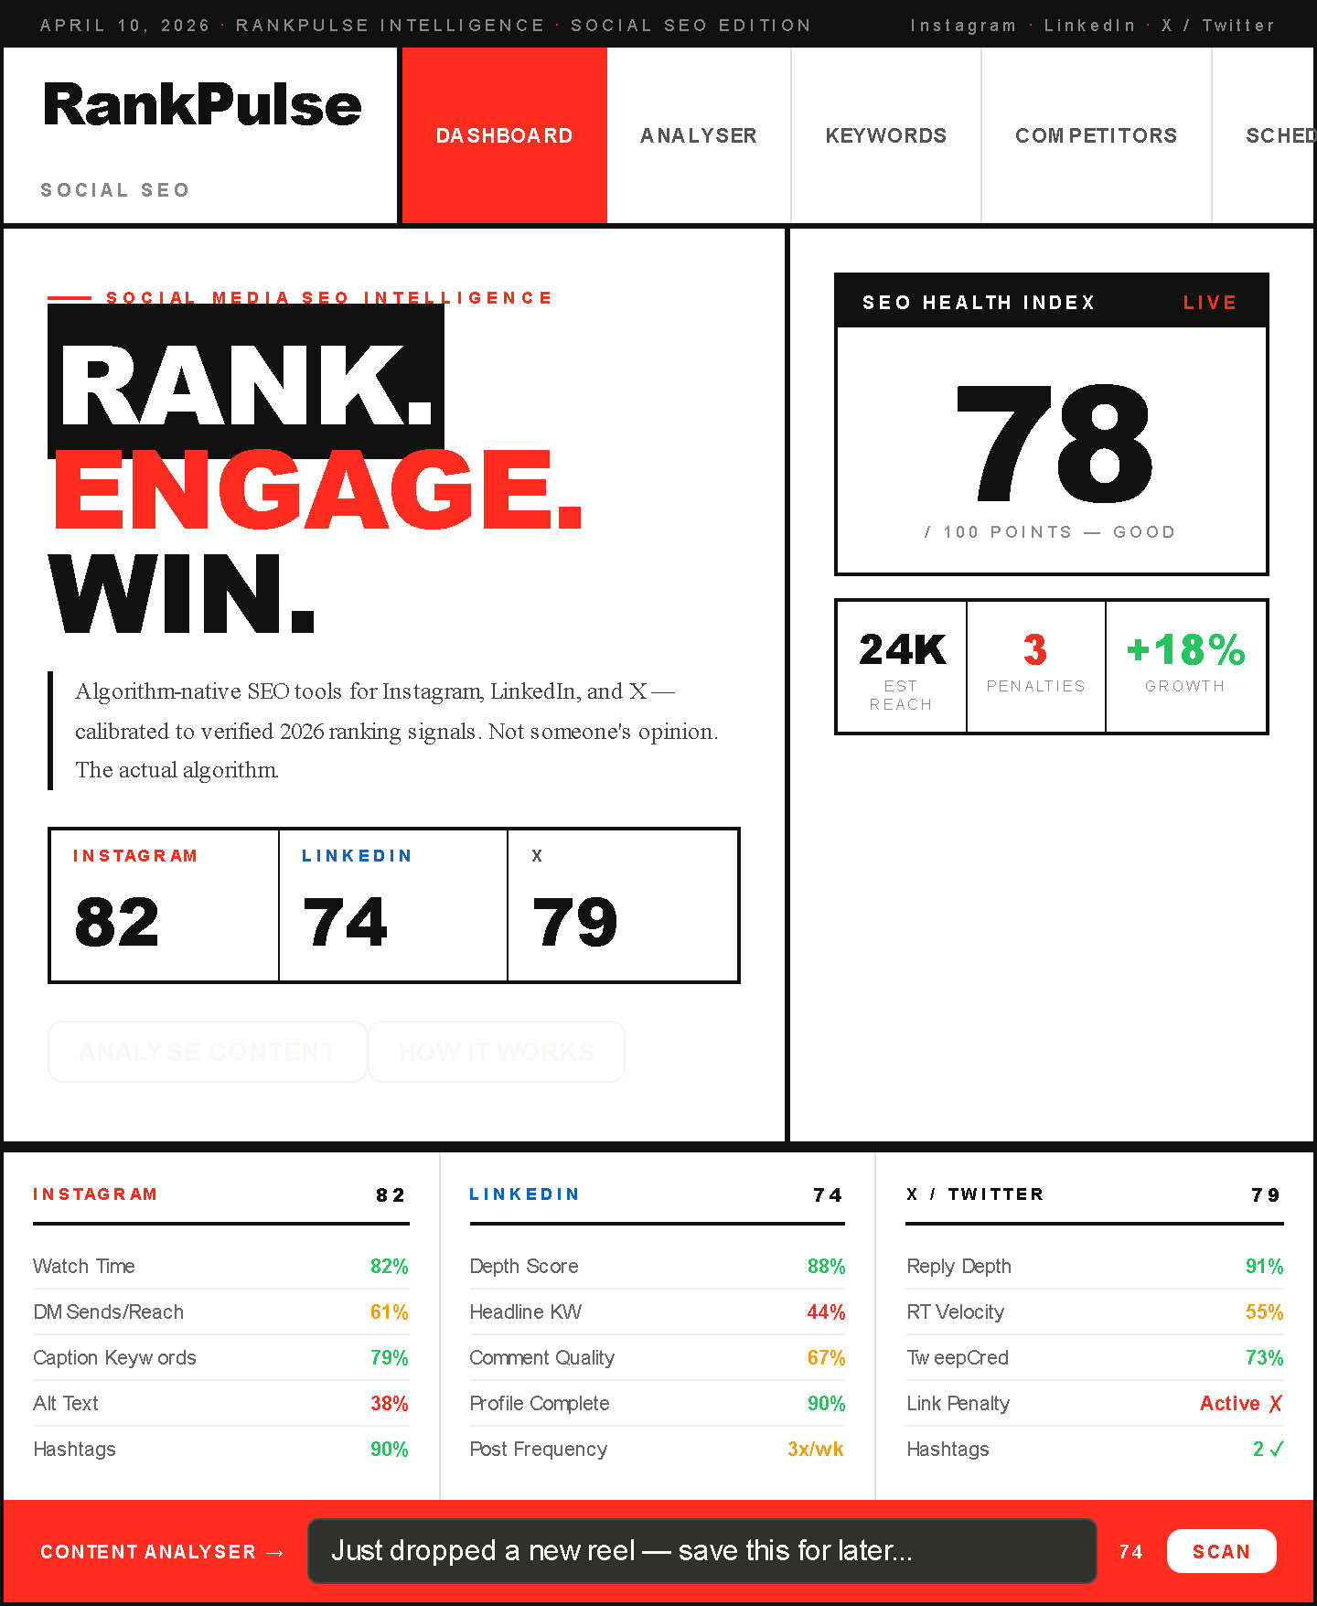

Design 08 — Obsidian Elite Premium dark · Muted slate · Pure data-forward---
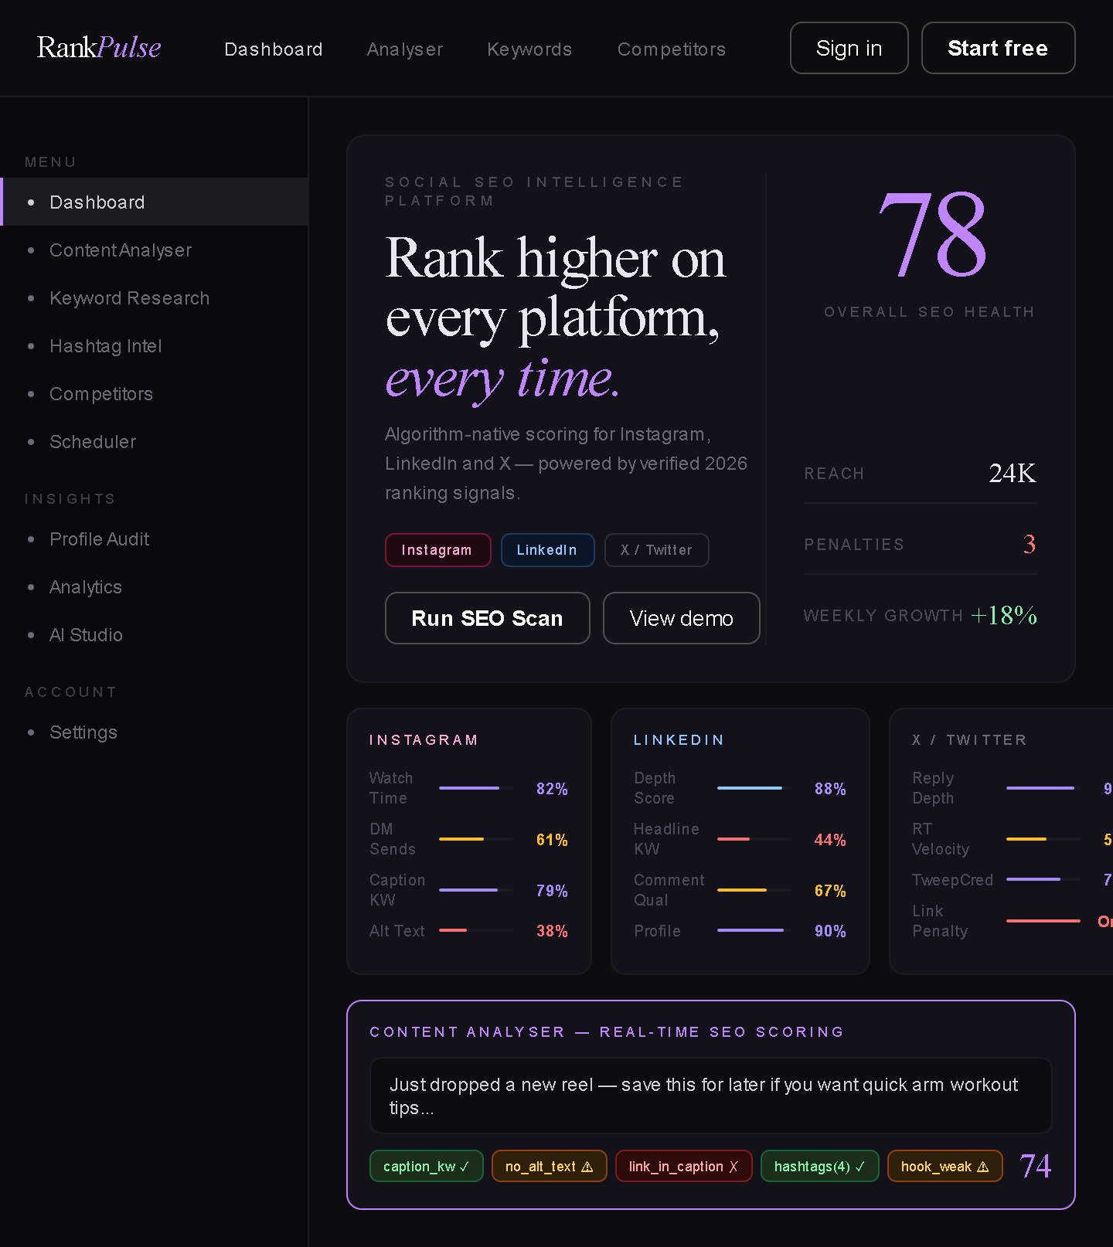

Design 09 — Mint Precision Clean white + mint green · Clinical precision · Linear-inspired---
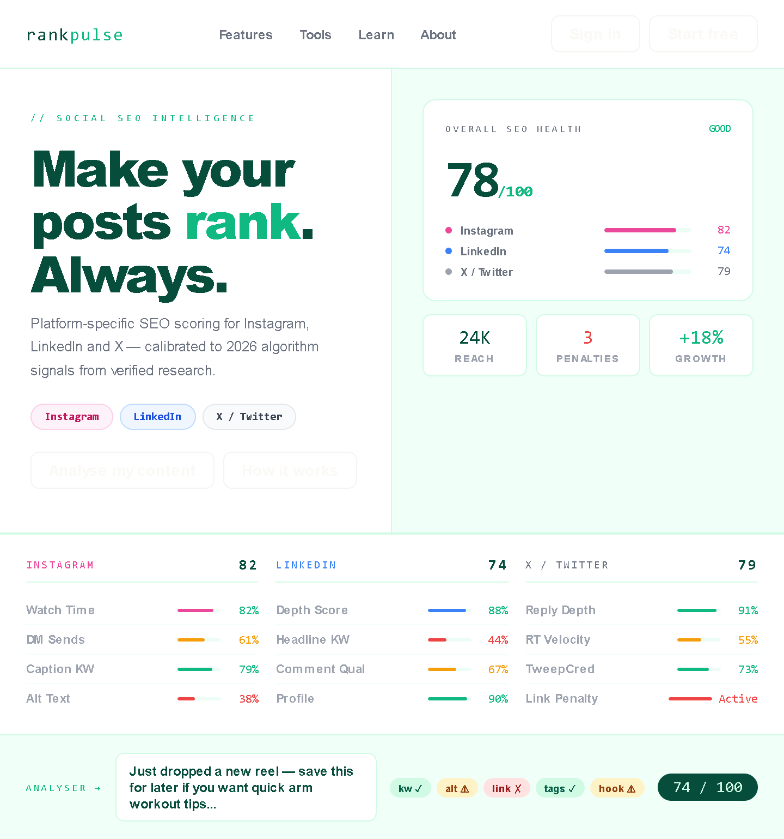

Design 10 — Carbon Signal Charcoal base · High-contrast white type · Tactical dashboard feel---

