1. Missing splash UI

Give this splash screen



2. Mising header & Gallery in home screen

See this UI. A header text “Explore” at the Top middle and “My gallery” at the bottom right side. Need these 2 things

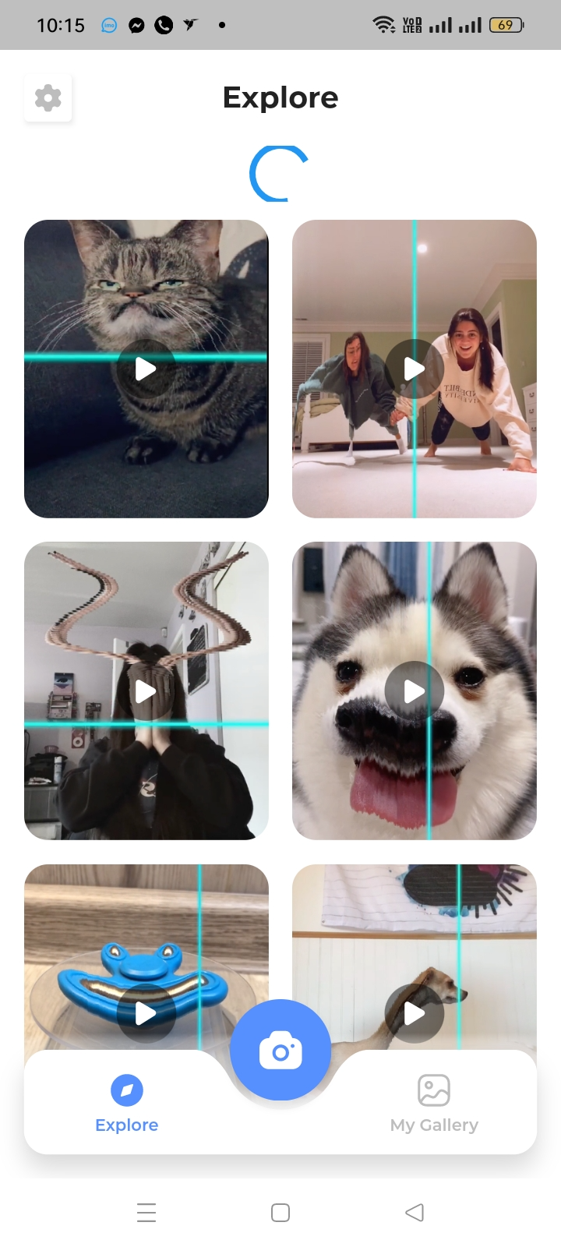

3. Client is asking for video recording of the scan like his previous app. Put video recording button like this. Right side of the image button.

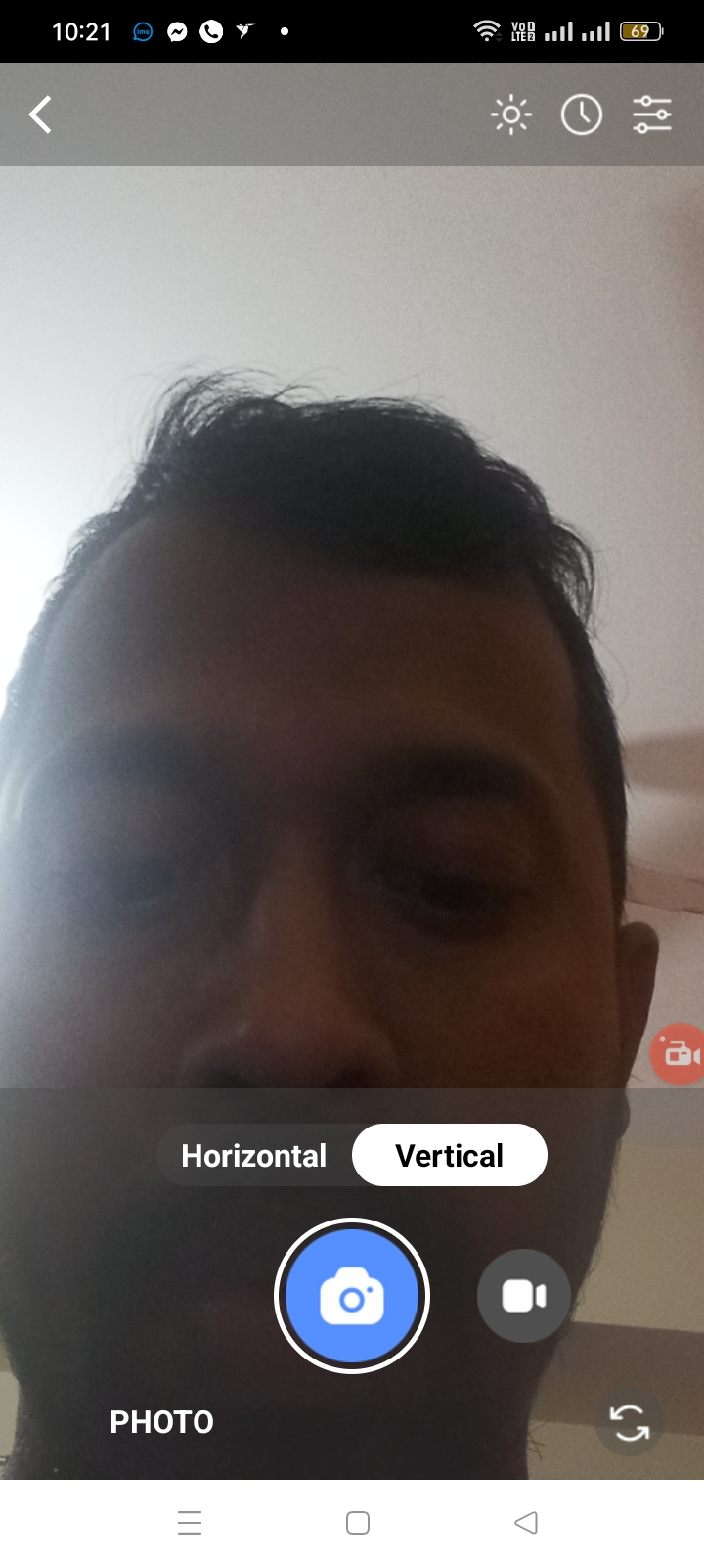

5. when I play demo videos then it ask for to choose another media player from the phone to play. It should be played in the app itself.

6. Don’t need Reset Button in the app to be ready for next scan. When image is saved then app should be ready itself for next scan like other timewarp app.

7. App scan line need to match with scan 100%. At your last debug apk, back camera line is fine but you have to find way to match front camera horizontal and vertical line

8. Please test the previous developer built apk . This is the previous developer apk link

<https://drive.google.com/file/d/1lYdhnTfzmqQreM640f5SITKrvFUPj7d_/view>

When scan is done then scanned image should be saved auto and it should show as preview as well.

Preview image should show like this

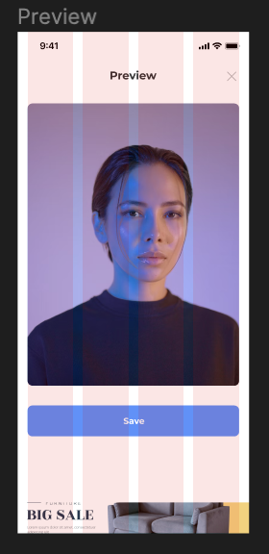

9. There is a simple setting button at the previous app also. It has just social media share, privacy & terms of use

I am sending you a video which shows both preview option and setting . Follow this link for the video

<https://drive.google.com/file/d/1p3EuwPL3WYWoaEXz-e_2yuzVLt8-hvp6/view?usp=sharing>

Client is unhappy and app is very much imperfect and not good quality. This client is potential, he gave me another job before. He will give me more project as well but we have to finish it well to make him happy.

You built a low quality app but I gave you many reviews for it. 4 reviews. Now its your job to finish my project with quality so that I can give you many projects all the year.

I will give you $50 as bonus if you can finish with quality. Please do it so that we can maintain a good long term relationship.

Thanks