**Waterfall Method**

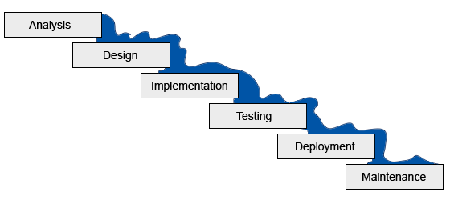The waterfall method can be used for the development life cycle for software engineering. It is often considered the classic approach to the systems development life cycle. It describes a development method that is linear and happens in sequences. This type of development has distinct goals for each of the phases of development.

Once the development process has started, much like an actual waterfall, it cannot turn back, it continues on its journey to the next phase

**Agile Method**

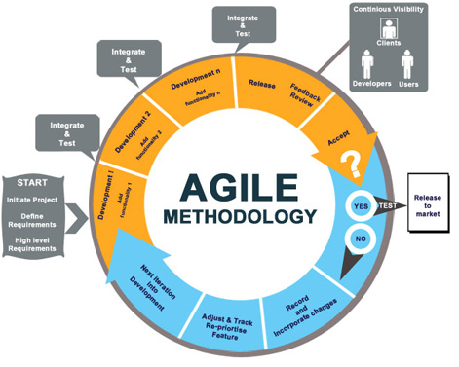

The agile method is also typically used in software development. This method helps teams to respond to unforeseen problems through incremental, iterative work cadences. These are known as sprints. The agile method is an alternative method to the waterfall method.

The agile method provides the opportunity to assess the direction of a project throughout its development lifecycle. This is achieved through the sprints or iterations, which the teams, at the end of them, must show a potentially shippable product increment.

The result of the “inspect and adapt” approach this method has, it greatly reduces development costs and time to market. Due to this, the phenomenon known as “analysis paralysis” is less likely to occur.

**Comparison**

*Advantages of the waterfall method*

Is that it stresses on record keeping the whole way through. Having these records allows for the ability to improve upon the existing program in the future.

The client knows what to expect with the waterfall method. This means that they will have an idea of the size, cost and timeline for the project.

*The disadvantages of the waterfall method*

Is that when once one step has been completed, the developers cant go back to a previous stage and make changes