RTest Version 1.0

Regression Testing Tool

Introduction
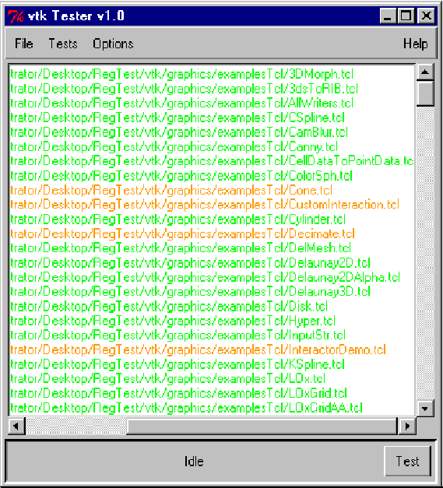

Figure 1. RTest application.
RTest is a regression-testing tool based on the open source Visualization Toolkit (VTK) software. RTest can be used to test hardware (e.g., 3D graphics cards), software (e.g., drivers), system configurations, and VTK executables.

RTest takes advantage of the over 525 regression tests currently available in the VTK system. These tests were originally designed as a regression test suite for VTK, and are used daily as developers continually improve the software. Because the tests are portable, stable, and make extensive use of system resources—especially graphics resources—they are ideal for testing graphics systems.

To find out more about VTK, see http://www.kitware.com/vtk.html.

How RTest Works

The basic idea behind RTest’s regression testing process is simple. A valid image is maintained that is accepted as “correct” for a given example. The same script that was used to generate the valid image is later run and the output image is compared against the valid image. The comparison is made with an image difference routine that takes into account (limited) effects due to dithering and aliasing. Depending on the size of the difference between the valid image and the generated image, the test is said to pass or fail. (Passing is a difference of 10 pixels or less for 3D tests, 0 pixels for imaging tests.) If a test fails, a difference image is also output and is useful for identifying regions in the images that are different from each other. The regression tests were originally designed to track problems due to software changes in VTK. However, the tests are also useful for tracking problems in computer systems, especially graphics systems. In this case, the software stays the same, but as new hardware, drivers, etc. are introduced, RTest can be used to insure their correctness.

Using RTest

RTest is designed to load and test regression test suites. A suite consists of a list of Tcl scripts with an associated valid image for each script. Using RTest, you can load a single script, a suite, or an entire VTK test directory suite. Once loaded, you can test all scripts in the suite, interrupting the test process at any time. As the suite runs, the scripts are color coded according to pass, fail, or warning. By left-mouse-clicking on the script, you can view the valid image, generated image, and/or image difference. You can also right-mouse-click to manually test a single script. Once you’ve executed a suite, you can remove tests that you do not want to run in the future. For example, you might load the VTK graphics directory test suite (hundreds of tests) and then per-form an initial test on all of them. Then, you may wish to remove all the “passed” tests, and keep the remaining “failed” tests as a suite. This suite can then be run again in the future. In this way, you can build custom suites to test only the problems you are interested in.

An Example

Step 0: Running the program
If you have a regression test CD on a PC, double-click RTest.bat. A splash screen should appear, followed by the GUI. If you have an installed VTK distribution, execute RTest.tcl (Note: if RTest cannot find one of the following directories (vtk, vtkdata, vtkbaseline), it will exit with an error message. See the comments in RTest.tcl for more information.)

Step 1: Create The Working Directory
The first time you run RTest, the program searches for a directory to store regression test images and error logs. By default, this is in the directory $VTK_ROOT/rtResults (PC) or ../../../rtResults (Unix). The program will notify you of this, and give you a choice to create another directory. Wherever you create the directory, make sure that there is at least 300 MBytes available.

Step 2: Load Test Suite
The best way to begin is select “Tests/Add VTK Kits/Graphics” from the application menu bar. This will read in several hundred tests from this suite. You can also load other VTK suites, or select your own files. Another useful feature is the ability to load regression tests containing a particular class. For example, if you are modifying the class vtkImplicitModeller, select “Tests/Add VTK Tests With Classname…” and enter vtkImplicitModeller into the popup. Hit return and only those tests with that class will be loaded (taken from all the VTK tests in common, graphics, imaging, and patented).

Step 3: Test The Test Suite
Hit the “Test” button on the lower right corner of the application, or choose “Tests/Test Files”. Images will start appearing on the screen one at a time as each script is run. Make sure that the rendering window is not occluded—this will affect the generated image and the regression test will fail.

The testing process can take hours for large suites. You can “Cancel” the testing at any time. Testing can be resumed by hitting “Test” again, or choosing “Tests/Resume Testing Files” from the application menu bar. If you choose “Tests/Test Files,” the testing starts all over again. Any test can be run manually by right-mouse-clicking on it.

Step 4: View Results
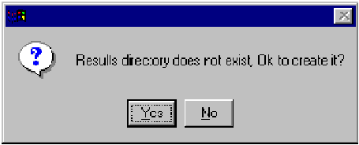

Figure 2. You must create a working directory for saving test images and log files.
If you wish to view results, left-mouse-click on an executed test. Depending on whether the test passed (color-coded green), failed (color-coded red), or warned (color-coded orange), a popup will appear showing the valid image, the generated image, and the difference image (see Figure 3). (Passed and Warned tests will only show the valid image.) The popup will also show the text from the error log. (Notes: Warnings occur when there is no valid image, or a test has been purposely excluded from testing. Non-executed tests are colored black.)

Step 5: Cull The Test Suite
Once you’ve executed your tests, you can use filters to eliminate tests of various types to create your own custom suite. For example, use “Tests/Remove Passed Tests” to eliminate all tests that passed. Then use “Tests/Remove Warning Tests” to eliminate all tests that resulted in warnings.

Step 6: Save Suite
If you wish to save your suite, choose “File/Save” to create the suite. You can then use “File/Open” next time you run RTest to load it back in.
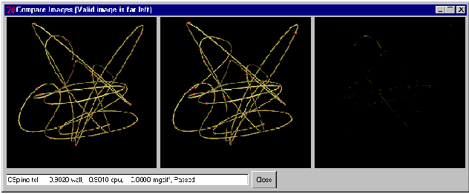

Figure 3. Image comparison window. The valid image is on the left,the generated image is in the center, and the image difference is on the right. (Notice the minor difference between the two images.)

Other Features

Browsing Images — use left-mouse-click on the test.

Manual Test Execution — use right-mouse-click on the test

“Options/View Errors Immediately” — if this is turned on, then when a regression test fails, the error browser pops up immediately, and stays up until dismissed.

Acknowledgments

The tests and regression-testing tools were developed by the VTK community. In particular, Bill Lorensen and Jim Miller were instrumental in creating the nightly VTK dashboard http://public.kitware.com/vtk/quality/MostRecentResults and the continuous dashboard http://public.kitware.com/vtk/quality/ContinuousResults/solaris/ContinuousResults.html.
These dashboards are essential to maintaining VTK quality. RTest builds on this work, and is a convenient tool for individual developers to test their own VTK installation or modifications.

For More Information

Contact Kitware,Inc. at kitware@kitware.com or at 518-371-3971. Kitware provides support, consulting, training, and commercial products based on VTK. We also work with our customers to integrate tools like RTest into their products and services. See
http://www.kitware.com for more information, including an on-line store to purchase products.

Author: William J. Schroeder, Kitware, Inc.
E-Mail: will.Schroeder@kitware.com

