### Web-based Registration Tools Based on ITKElastix
Dženan Zukić↓, Matt McCormick
Kitware Inc., Carrboro, N.C., USA.
Introduction: Registration is frequently needed for many image analysis purposes. Not all the researchers who need it are equipped with proper software tools. And when they are, maintenance of those tools is a burden they would like to avoid.

Aims: Web-browser based application for 3D image registration.

Methods: We leveraged existing open source tools as much as possible and provided an easy-to-use graphical user interface delivered through a zero-install web page or single-file native executable. We rely primarily on Elastix and ITKWidgets for registration and visualization and Voila for application delivery. Elastix [1] is a toolbox for rigid and nonrigid registration of images. ITKWidgets [2] are interactive Jupyter widgets to visualize images, point sets, and meshes in 2D and 3D. Both Elastix and ITKWidgets are based on the Insight Toolkit [3], an open-source, cross-platform toolkit for N-dimensional scientific image processing, segmentation, and registration. All these tools are tied together in a Jupyter notebook, which has browser-based interface and can be served over the Internet. While the raw notebook provides a hackable interface that registration researchers can customize, Voila [4] packages the web application.

Results: The application is simple and effective since all components are focused on the registration task. Buttons enable selection of a fixed and moving image file. Interactive, 3D visualization is possible on the images prior to registration and after the moving image has been registered and resampled to understand the inputs and registration effectiveness. Registration parameters, such as the type of registration, i.e. rigid, affine, or b-spline, can be selected graphically.

Conclusions: This tool makes registration easier to use for a broad range of researchers and clinicians. New registration methods available in Python can be delivered to end users similarly to increase the impact of registration research on the practice of scientific image analysis.

Acknowledgements: This work was funded by United States National Institutes of Health under grant number 1R44AR074375-01A1.

References: [1] S. Klein, M. Staring, K. Murphy, M.A. Viergever and J.P.W. Pluim, "elastix: a toolbox for intensity based medical image registration," IEEE Transactions on Medical Imaging, vol. 29, no. 1, pp. 196 - 205, January 2010.
[2] McCormick, M. Musy, M, Mader, K, Chen, D, Sullivan, B, Chandradevan, R … Haberthür, D. (2020, February 27). InsightSoftwareConsortium/itkwidgets: itkwidgets 0.26.0 (Version v0.26.0). Zenodo. http://doi.org/10.5281/zenodo.3688857
[3] McCormick M, Liu X, Jomier J, Marion C, Ibanez L. ITK: enabling reproducible research and open science. Frontiers Neuroinform. 2014;8:13. February 2014.
[4] Corlay, S, Breddels, M, et. al. Voilà: Turn Jupyter notebooks into standalone web applications. https://github.com/voila-dashboards/voila. Accessed March, 2020.

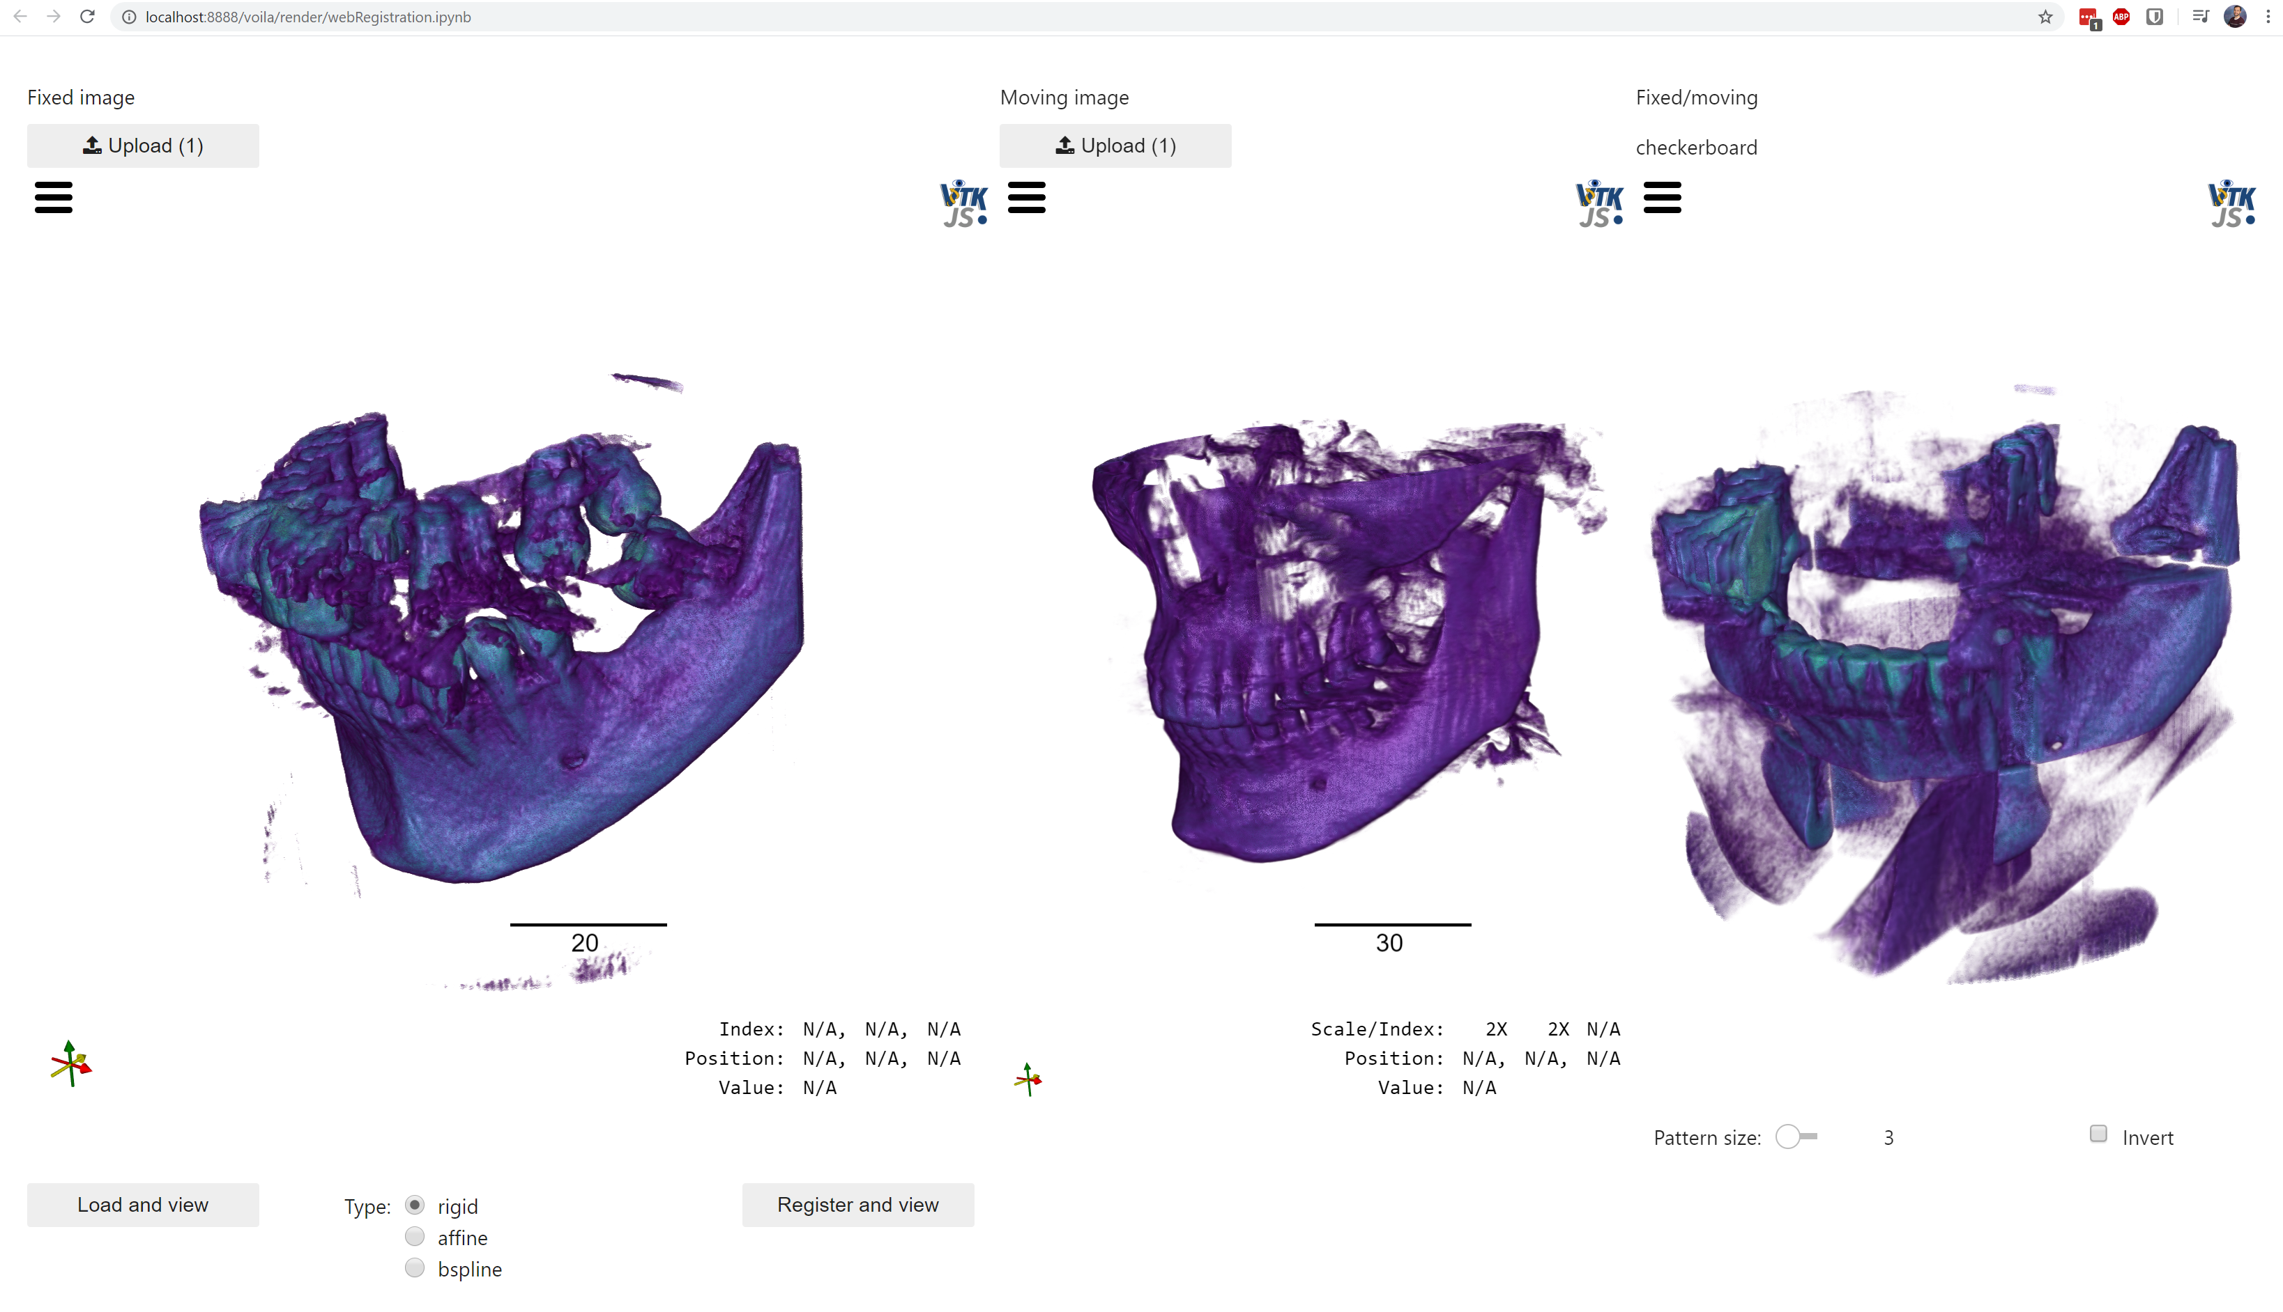
Figure A screenshot of the web application after loading images.

