itkSymmetricEllipsoidInteriorExteriorSpatialFunctionExample.cxx

 | Robert J. Tamburo  August 28, 2001  University of Pittsburgh  749 Benedum Hall  Pittsburgh, PA 15261  rjtst21@pitt.edu

Summary
------------------------------------------------------
This example demonstrates how to create a geometrical shape within an itkImage using Spatial Functions. Specifically, this example will use itkSymmetricEllipsoidInteriorExteriorSpatialFunction to create an itkImage consisting of a symmetric ellipsoid along an orientation vector. An n-dimensional symmetric ellipsoid is one, which has m axes of equal length and 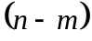 unique axes lengths. Specifically, itkSymmetricEllipsoidInteriorExteriorSpatialFunction creates a symmetric ellipsoid for the case where 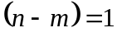 and the ellipsoid’s major axis is oriented along a single orientation vector.

Description
------------------------------------------------------
First, an itkImage (dimension of 3, size of 50x50x50, spacing of (1,1,1), and origin (0,0,0)) is created and completely filled with pixels of intensity value 128. Then, itkFloodFilledSpatialFunctionConditionalIterator is used to iterate through the image and set pixels to 256 if itkSymmetricEllipsoidInteriorExteriorSpatialFunction returns 1, meaning that it is within the interior of the ellipsoid. The ellipsoid is defined by its axes lengths (from edge-to-edge of the ellipsoid) as well as the orientation of its unique axis. This example is restricted to 3D to allow for the visualization of the resulting image, which is done via a VTK image file. The volume of the ellipsoid is measured by counting the number of interior pixels of the ellipsoid. This measure can be used to verify the resulting ellipsoid by comparing it against the calculated volume (percent difference) of the ellipsoid given by:

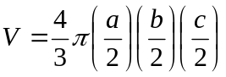, where a, b, and c are the lengths of the ellipsoid axes.

The ellipsoid is also validated by checking that the center of the ellipsoid has been labeled as an interior pixel (a function value of 1) by evaluating the spatial function at the origin of the ellipsoid.

To Use This Example
------------------------------------------------------
Build and run itkSymmetricEllipsoidInteriorExteriorSpatialFunctionExample.cxx from the workspace generated from CMake. The resulting VTK image file is stored as:

"Insight\Examples\SymmetricEllipsoidInteriorExteriorSpatialFunction\ellipsoid.vtk"

Default settings should result in an image of an ellipsoid with its unique axis of length 45 oriented along the (1,1,0) direction and symmetric axes of length 30. The origin of the ellipsoid is sampled and evaluated by the spatial function and returns function value, which is 1 since the origin of the ellipsoid is within the ellipsoid.

Results of the example (with defaults):
calculated ellipsoid volume | 21205.8 pixels
measured ellipsoid volume | 21197 pixels
volume error | 0.04126%
function value | 1

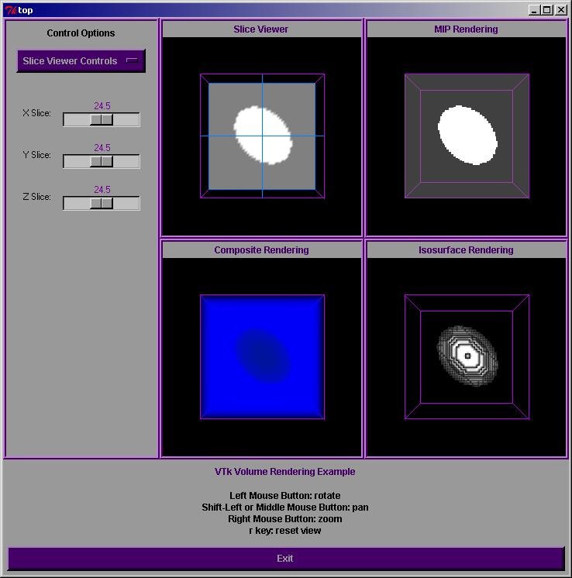
Fig. 1: Resulting Image Containing an Ellipsoid From This Example*

*See "Insight\Examples\SymmetricEllipsoidInteriorExteriorSpatialFunction\symmetricEllipsoid.jpg" for snapshot of resulting image.

Insight Classes Used
------------------------------------------------------
These are the Insight classes used for this example with a brief description. They appear in order of first use:
- itkImage.h: generates a physical image.
- itkImageRegionIterator.h: iterates through the pixels in the physical image and sets them to 128.
- itkSymmetricEllipsoidInteriorExteriorSpatialFunction.h: evaluates pixels in the image and determines whether they are within the symmetric ellipsoid or not.
- itkFloodFilledSpatialFunctionConditionalIterator.h: iterates the image and sets them to 256 if they are within the ellipsoid.

Possible Uses Of Ellipsoids
------------------------------------------------------
The ellipsoid images created by SymmetricEllipsoidInteriorExteriorSpatialFunction are useful for testing imaging algorithms, pixel-sampling routines, establishing geometric domains of influence, etc. Symmetric ellipsoids are useful where only one orientation vector is known and minor axes of equal lengths are tolerable.

Non-ITK Requirements
------------------------------------------------------
A VTK image viewer is needed to visualize the output file symmetricEllipsoid.vtk.

Copyright
------------------------------------------------------
Copyright (c) 2001 Insight Consortium All rights reserved.

Redistribution and use in source and binary forms, with or without modification, are
permitted provided that the following conditions are met:

* Redistributions of source code must retain the above copyright notice,
this list of conditions and the following disclaimer.

* Redistributions in binary form must reproduce the above copyright notice,
this list of conditions and the following disclaimer in the documentation
and/or other materials provided with the distribution.

* The name of the Insight Consortium, nor the names of any consortium members,
nor of any contributors, may be used to endorse or promote products derived
from this software without specific prior written permission.

* Modified source versions must be plainly marked as such, and must not be
misrepresented as being the original software.

THIS SOFTWARE IS PROVIDED BY THE COPYRIGHT HOLDER AND CONTRIBUTORS ``AS IS'' AND ANY EXPRESS OR IMPLIED WARRANTIES, INCLUDING, BUT NOT LIMITED TO, THE IMPLIED WARRANTIES OF MERCHANTABILITY AND FITNESS FOR A PARTICULAR PURPOSE ARE DISCLAIMED. IN NO EVENT SHALL THE AUTHORS OR CONTRIBUTORS BE LIABLE FOR ANY DIRECT, INDIRECT, INCIDENTAL, SPECIAL, EXEMPLARY,
OR CONSEQUENTIAL DAMAGES (INCLUDING, BUT NOT LIMITED TO, PROCUREMENT OF SUBSTITUTE GOODS OR SERVICES; LOSS OF USE, DATA, OR PROFITS; OR BUSINESS INTERRUPTION) HOWEVER CAUSED AND ON ANY THEORY OF LIABILITY, WHETHER IN CONTRACT, STRICT LIABILITY, OR TORT (INCLUDING NEGLIGENCE OR OTHERWISE) ARISING IN ANY WAY OUT OF THE USE OF THIS SOFTWARE, EVEN IF ADVISED OF THE POSSIBILITY OF SUCH DAMAGE.

