insert into Schools values (NEWID(), 'Tallinn', 'TTHK')



insert into Employees values(NEWID(), 'A', 'Teacher', 'F', '735D6965-0BA0-4109-8424-5A4721D615D9')

insert into Employees values(NEWID(), 'B', 'Teacher', 'M', '735D6965-0BA0-4109-8424-5A4721D615D9')

insert into Employees values(NEWID(), 'C', 'Teacher', 'M', '735D6965-0BA0-4109-8424-5A4721D615D9')

insert into Employees values(NEWID(), 'D', 'Teacher', 'F', '735D6965-0BA0-4109-8424-5A4721D615D9')

insert into Employees values(NEWID(), 'E', 'Teacher', 'F', '735D6965-0BA0-4109-8424-5A4721D615D9')

insert into Employees values(NEWID(), 'F', 'Teacher', 'M', '735D6965-0BA0-4109-8424-5A4721D615D9')

insert into Employees values(NEWID(), 'G', 'Teacher', 'M', '735D6965-0BA0-4109-8424-5A4721D615D9')

insert into Employees values(NEWID(), 'H', 'Teacher', 'F', '735D6965-0BA0-4109-8424-5A4721D615D9')

insert into Employees values(NEWID(), 'I', 'Teacher', 'F', '735D6965-0BA0-4109-8424-5A4721D615D9')

insert into Employees values(NEWID(), 'J', 'Teacher', 'M', '735D6965-0BA0-4109-8424-5A4721D615D9')

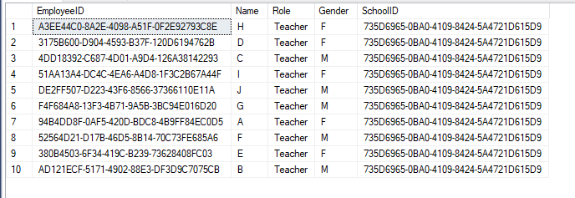

insert into Classes values(NEWID(), 'TARpe22', '10', 'A3EE44C0-8A2E-4098-A51F-0F2E92793C8E', '735D6965-0BA0-4109-8424-5A4721D615D9')

insert into Classes values(NEWID(), 'TARpe22', '10', '3175B600-D904-4593-B37F-120D6194762B', '735D6965-0BA0-4109-8424-5A4721D615D9')

insert into Classes values(NEWID(), 'TARpe22', '10', '4DD18392-C687-4D01-A9D4-126A38142293', '735D6965-0BA0-4109-8424-5A4721D615D9')

insert into Classes values(NEWID(), 'TARpe22', '10', '51AA13A4-DC4C-4EA6-A4D8-1F3C2B67A44F', '735D6965-0BA0-4109-8424-5A4721D615D9')

insert into Classes values(NEWID(), 'TARpe22', '10', 'DE2FF507-D223-43F6-8566-37366110E11A', '735D6965-0BA0-4109-8424-5A4721D615D9')

insert into Classes values(NEWID(), 'TARpe22', '10', 'F4F684A8-13F3-4B71-9A5B-3BC94E016D20', '735D6965-0BA0-4109-8424-5A4721D615D9')

insert into Classes values(NEWID(), 'TARpe22', '10', '94B4DD8F-0AF5-420D-BDC8-4B9FF84EC0D5', '735D6965-0BA0-4109-8424-5A4721D615D9')

insert into Classes values(NEWID(), 'TARpe22', '10', '52564D21-D17B-46D5-8B14-70C73FE685A6', '735D6965-0BA0-4109-8424-5A4721D615D9')

insert into Classes values(NEWID(), 'TARpe22', '10', '380B4503-6F34-419C-B239-73628408FC03', '735D6965-0BA0-4109-8424-5A4721D615D9')

insert into Classes values(NEWID(), 'TARpe22', '10', 'AD121ECF-5171-4902-88E3-DF3D9C7075CB', '735D6965-0BA0-4109-8424-5A4721D615D9')

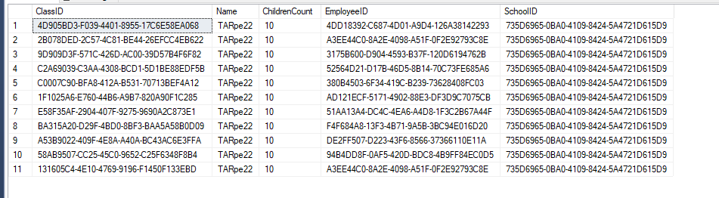

insert into Cupongs values(NEWID(), 1.20, 'True')

insert into Cupongs values(NEWID(), 1.20, 'True')

insert into Cupongs values(NEWID(), 1.20, 'True')

insert into Cupongs values(NEWID(), 1.20, 'True')

insert into Cupongs values(NEWID(), 1.20, 'True')

insert into Cupongs values(NEWID(), 1.20, 'True')

insert into Cupongs values(NEWID(), 1.20, 'True')

insert into Cupongs values(NEWID(), 1.20, 'True')

insert into Cupongs values(NEWID(), 1.20, 'True')

insert into Cupongs values(NEWID(), 1.20, 'True')

insert into Cupongs values(NEWID(), 1.20, 'True')

insert into Cupongs values(NEWID(), 1.20, 'True')

insert into Cupongs values(NEWID(), 1.20, 'True')

insert into Cupongs values(NEWID(), 1.20, 'True')

insert into Cupongs values(NEWID(), 1.20, 'True')

insert into Cupongs values(NEWID(), 1.20, 'True')

insert into Cupongs values(NEWID(), 1.20, 'True')

insert into Cupongs values(NEWID(), 1.20, 'True')

insert into Cupongs values(NEWID(), 1.20, 'True')

insert into Cupongs values(NEWID(), 1.20, 'True')

insert into Cupongs values(NEWID(), 1.20, 'True')

insert into Cupongs values(NEWID(), 1.20, 'True')

insert into Cupongs values(NEWID(), 1.20, 'True')

insert into Cupongs values(NEWID(), 1.20, 'True')

insert into Cupongs values(NEWID(), 1.20, 'True')

insert into Cupongs values(NEWID(), 1.20, 'True')

insert into Cupongs values(NEWID(), 1.20, 'True')

insert into Cupongs values(NEWID(), 1.20, 'True')

insert into Cupongs values(NEWID(), 1.20, 'True')

insert into Cupongs values(NEWID(), 1.20, 'True')

insert into Cupongs values(NEWID(), 1.20, 'True')

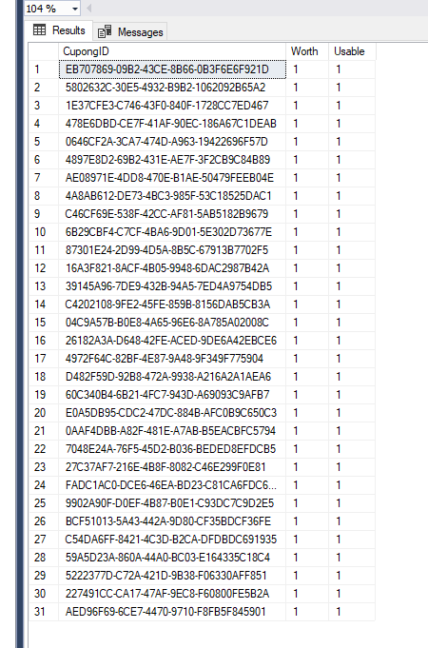

insert into Students values(NEWID(), 'AA', 'M', '4D905BD3-F039-4401-8955-17C6E58EA068', '1E37CFE3-C746-43F0-840F-1728CC7ED467')

insert into Students values(NEWID(), 'BB', 'M', '4D905BD3-F039-4401-8955-17C6E58EA068', '4897E8D2-69B2-431E-AE7F-3F2CB9C84B89')

insert into Students values(NEWID(), 'CC', 'F', '4D905BD3-F039-4401-8955-17C6E58EA068', 'AE08971E-4DD8-470E-B1AE-50479FEEB04E')

insert into Students values(NEWID(), 'DD', 'F', '4D905BD3-F039-4401-8955-17C6E58EA068', '87301E24-2D99-4D5A-8B5C-67913B7702F5')

insert into Students values(NEWID(), 'FF', 'F', '4D905BD3-F039-4401-8955-17C6E58EA068', '39145A96-7DE9-432B-94A5-7ED4A9754DB5')

insert into Students values(NEWID(), 'GG', 'M', '4D905BD3-F039-4401-8955-17C6E58EA068', 'C4202108-9FE2-45FE-859B-8156DAB5CB3A')

insert into Students values(NEWID(), 'HH', 'M', '4D905BD3-F039-4401-8955-17C6E58EA068', '4972F64C-82BF-4E87-9A48-9F349F775904')

insert into Students values(NEWID(), 'II', 'F', '4D905BD3-F039-4401-8955-17C6E58EA068', '27C37AF7-216E-4B8F-8082-C46E299F0E81')

insert into Students values(NEWID(), 'JJ', 'F', '4D905BD3-F039-4401-8955-17C6E58EA068', '9902A90F-D0EF-4B87-B0E1-C93DC7C9D2E5')

insert into Students values(NEWID(), 'KK', 'M', '4D905BD3-F039-4401-8955-17C6E58EA068', 'BCF51013-5A43-442A-9D80-CF35BDCF36FE')

insert into Students values(NEWID(), 'LL', 'M', '4D905BD3-F039-4401-8955-17C6E58EA068', 'AED96F69-6CE7-4470-9710-F8FB5F845901')

insert into Students values(NEWID(), 'AB', 'M', '2B078DED-2C57-4C81-BE44-26EFCC4EB622', '04C9A57B-B0E8-4A65-96E6-8A785A02008C')

insert into Students values(NEWID(), 'BB', 'M', '2B078DED-2C57-4C81-BE44-26EFCC4EB622', '26182A3A-D648-42FE-ACED-9DE6A42EBCE6')

insert into Students values(NEWID(), 'CB', 'M', '2B078DED-2C57-4C81-BE44-26EFCC4EB622', '4972F64C-82BF-4E87-9A48-9F349F775904')

insert into Students values(NEWID(), 'DB', 'M', '2B078DED-2C57-4C81-BE44-26EFCC4EB622', '60C340B4-6B21-4FC7-943D-A69093C9AFB7')

insert into Students values(NEWID(), 'AC', 'F', '9D909D3F-571C-426D-AC00-39D57B4F6F82', '0AAF4DBB-A82F-481E-A7AB-B5EACBFC5794')

insert into Students values(NEWID(), 'BC', 'F', '9D909D3F-571C-426D-AC00-39D57B4F6F82', '27C37AF7-216E-4B8F-8082-C46E299F0E81')

insert into Students values(NEWID(), 'CCC', 'F', 'C2A69039-C3AA-4308-BCD1-5D1BE88EDF5B', '9902A90F-D0EF-4B87-B0E1-C93DC7C9D2E5') --

insert into Students values(NEWID(), 'AAA', 'F', 'C0007C90-BFA8-412A-B531-70713BEF4A12', 'BCF51013-5A43-442A-9D80-CF35BDCF36FE')

insert into Students values(NEWID(), 'BBB', 'F', 'C0007C90-BFA8-412A-B531-70713BEF4A12', '59A5D23A-860A-44A0-BC03-E164335C18C4')

insert into Students values(NEWID(), 'BCB', 'F', '1F1025A6-E760-44B6-A9B7-820A90F1C285', '5222377D-C72A-421D-9B38-F06330AFF851')

insert into Students values(NEWID(), 'BCA', 'F', 'E58F35AF-2904-407F-9275-9690A2C873E1', 'AED96F69-6CE7-4470-9710-F8FB5F845901')

insert into Students values(NEWID(), 'BCL', 'F', 'E58F35AF-2904-407F-9275-9690A2C873E1', '60C340B4-6B21-4FC7-943D-A69093C9AFB7')

insert into Students values(NEWID(), 'BCR', 'F', 'BA315A20-D29F-4BD0-8BF3-BAA5A58B0D09', 'E0A5DB95-CDC2-47DC-884B-AFC0B9C650C3')

insert into Students values(NEWID(), 'BCW', 'F', 'BA315A20-D29F-4BD0-8BF3-BAA5A58B0D09', '0AAF4DBB-A82F-481E-A7AB-B5EACBFC5794')

insert into Students values(NEWID(), 'BCQ', 'F', 'A53B9022-409F-4E8A-A40A-BC43AC6E3FFA', '7048E24A-76F5-45D2-B036-BEDED8EFDCB5')

insert into Students values(NEWID(), 'BCS', 'F', 'A53B9022-409F-4E8A-A40A-BC43AC6E3FFA', '27C37AF7-216E-4B8F-8082-C46E299F0E81')

insert into Students values(NEWID(), 'BCK', 'F', '58AB9507-CC25-45C0-9652-C25F6348F8B4', 'FADC1AC0-DCE6-46EA-BD23-C81CA6FDC6A7')

insert into Students values(NEWID(), 'BCV', 'F', '58AB9507-CC25-45C0-9652-C25F6348F8B4', '9902A90F-D0EF-4B87-B0E1-C93DC7C9D2E5')

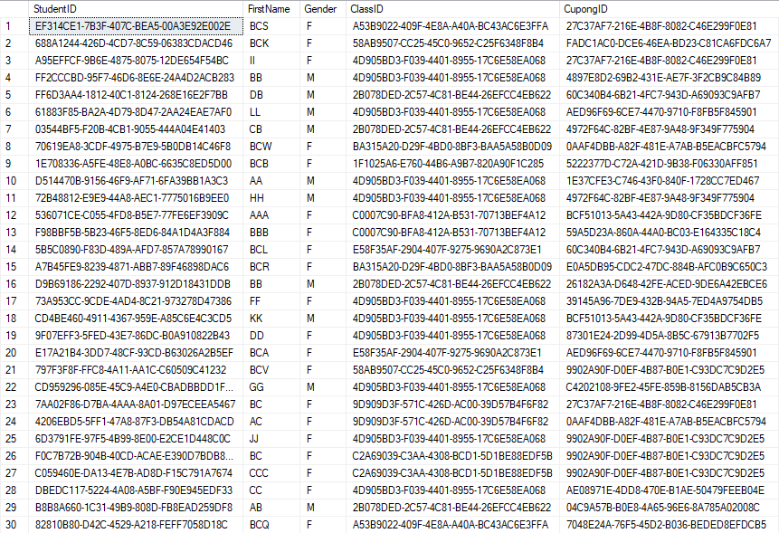

Create procedure spGetEmployees

@Gender nvarchar(20)

as begin

select Name, Gender from Employees

Where Gender = @Gender

end

spGetEmployees 'M'

spGetEmployees 'F'

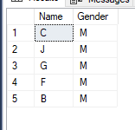

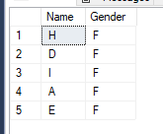

CREATE PROCEDURE spGetStudentByClass

@ClassID UNIQUEIDENTIFIER

AS

BEGIN

SELECT FirstName, Gender, ClassID

FROM Students

WHERE @ClassID = @ClassID;

END

spGetStudentByClass '4D905BD3-F039-4401-8955-17C6E58EA068'

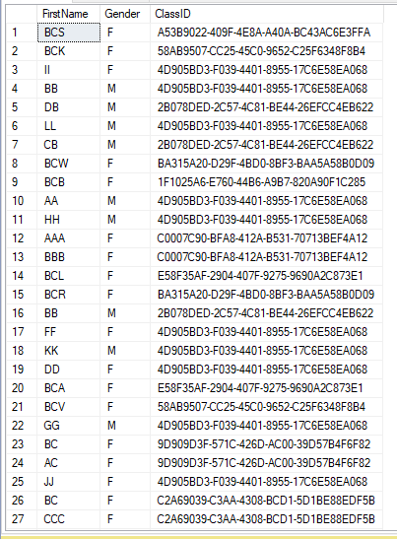

SELECT *

FROM Employees

INNER JOIN Classes

on Employees.EmployeeID = Classes.ClassID

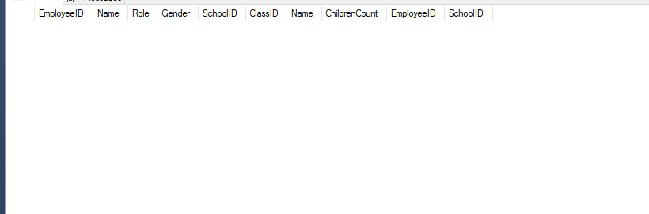

select *

FROM Employees

Left join Students

on Employees.EmployeeID = students.StudentID

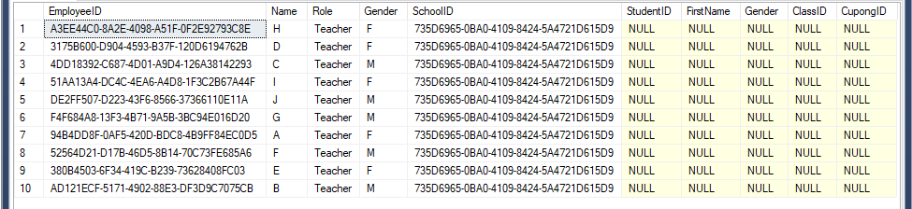

select *

FROM Cupongs

Left join Students

on Cupongs.CupongID = Students.StudentID

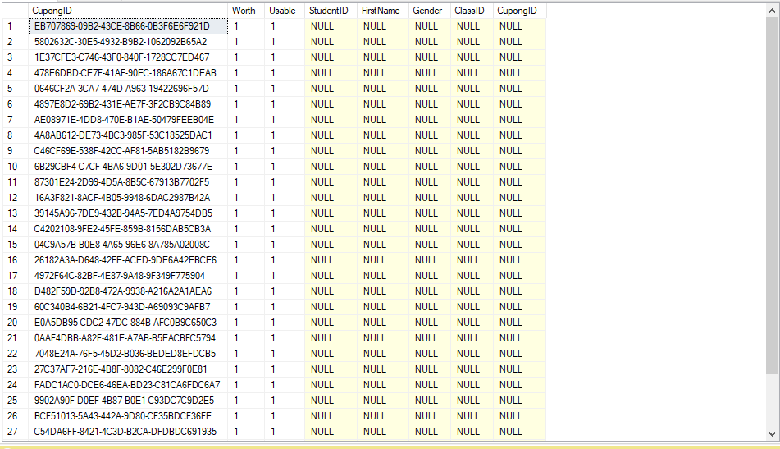

—> SIIN on terve kood eraldi, juhul kui midagi jäi minul puudu, siis saan hiljem ise otsida:

Create database HARJUTUSSCHOOL

Select * from Employees --+

Select * from Classes --+

Select * from Schools --+

Select * from Students ---

S

insert into Schools values (NEWID(), 'Tallinn', 'TTHK')

insert into Employees values (NEWID(), 'A', 'Teacher1', 'M')

sp_helpconstraint Employees

insert into Employees values(NEWID(), 'A', 'Teacher', 'F', '735D6965-0BA0-4109-8424-5A4721D615D9')

insert into Employees values(NEWID(), 'B', 'Teacher', 'M', '735D6965-0BA0-4109-8424-5A4721D615D9')

insert into Employees values(NEWID(), 'C', 'Teacher', 'M', '735D6965-0BA0-4109-8424-5A4721D615D9')

insert into Employees values(NEWID(), 'D', 'Teacher', 'F', '735D6965-0BA0-4109-8424-5A4721D615D9')

insert into Employees values(NEWID(), 'E', 'Teacher', 'F', '735D6965-0BA0-4109-8424-5A4721D615D9')

insert into Employees values(NEWID(), 'F', 'Teacher', 'M', '735D6965-0BA0-4109-8424-5A4721D615D9')

insert into Employees values(NEWID(), 'G', 'Teacher', 'M', '735D6965-0BA0-4109-8424-5A4721D615D9')

insert into Employees values(NEWID(), 'H', 'Teacher', 'F', '735D6965-0BA0-4109-8424-5A4721D615D9')

insert into Employees values(NEWID(), 'I', 'Teacher', 'F', '735D6965-0BA0-4109-8424-5A4721D615D9')

insert into Employees values(NEWID(), 'J', 'Teacher', 'M', '735D6965-0BA0-4109-8424-5A4721D615D9')

insert into Classes values(NEWID(), 'TARpe22', '10', 'A3EE44C0-8A2E-4098-A51F-0F2E92793C8E', '735D6965-0BA0-4109-8424-5A4721D615D9')

insert into Classes values(NEWID(), 'TARpe22', '10', '3175B600-D904-4593-B37F-120D6194762B', '735D6965-0BA0-4109-8424-5A4721D615D9')

insert into Classes values(NEWID(), 'TARpe22', '10', '4DD18392-C687-4D01-A9D4-126A38142293', '735D6965-0BA0-4109-8424-5A4721D615D9')

insert into Classes values(NEWID(), 'TARpe22', '10', '51AA13A4-DC4C-4EA6-A4D8-1F3C2B67A44F', '735D6965-0BA0-4109-8424-5A4721D615D9')

insert into Classes values(NEWID(), 'TARpe22', '10', 'DE2FF507-D223-43F6-8566-37366110E11A', '735D6965-0BA0-4109-8424-5A4721D615D9')

insert into Classes values(NEWID(), 'TARpe22', '10', 'F4F684A8-13F3-4B71-9A5B-3BC94E016D20', '735D6965-0BA0-4109-8424-5A4721D615D9')

insert into Classes values(NEWID(), 'TARpe22', '10', '94B4DD8F-0AF5-420D-BDC8-4B9FF84EC0D5', '735D6965-0BA0-4109-8424-5A4721D615D9')

insert into Classes values(NEWID(), 'TARpe22', '10', '52564D21-D17B-46D5-8B14-70C73FE685A6', '735D6965-0BA0-4109-8424-5A4721D615D9')

insert into Classes values(NEWID(), 'TARpe22', '10', '380B4503-6F34-419C-B239-73628408FC03', '735D6965-0BA0-4109-8424-5A4721D615D9')

insert into Classes values(NEWID(), 'TARpe22', '10', 'AD121ECF-5171-4902-88E3-DF3D9C7075CB', '735D6965-0BA0-4109-8424-5A4721D615D9')

insert into Cupongs values(NEWID(), 1.20, 'True')

insert into Cupongs values(NEWID(), 1.20, 'True')

insert into Cupongs values(NEWID(), 1.20, 'True')

insert into Cupongs values(NEWID(), 1.20, 'True')

insert into Cupongs values(NEWID(), 1.20, 'True')

insert into Cupongs values(NEWID(), 1.20, 'True')

insert into Cupongs values(NEWID(), 1.20, 'True')

insert into Cupongs values(NEWID(), 1.20, 'True')

insert into Cupongs values(NEWID(), 1.20, 'True')

insert into Cupongs values(NEWID(), 1.20, 'True')

insert into Cupongs values(NEWID(), 1.20, 'True')

insert into Cupongs values(NEWID(), 1.20, 'True')

insert into Cupongs values(NEWID(), 1.20, 'True')

insert into Cupongs values(NEWID(), 1.20, 'True')

insert into Cupongs values(NEWID(), 1.20, 'True')

insert into Cupongs values(NEWID(), 1.20, 'True')

insert into Cupongs values(NEWID(), 1.20, 'True')

insert into Cupongs values(NEWID(), 1.20, 'True')

insert into Cupongs values(NEWID(), 1.20, 'True')

insert into Cupongs values(NEWID(), 1.20, 'True')

insert into Cupongs values(NEWID(), 1.20, 'True')

insert into Cupongs values(NEWID(), 1.20, 'True')

insert into Cupongs values(NEWID(), 1.20, 'True')

insert into Cupongs values(NEWID(), 1.20, 'True')

insert into Cupongs values(NEWID(), 1.20, 'True')

insert into Cupongs values(NEWID(), 1.20, 'True')

insert into Cupongs values(NEWID(), 1.20, 'True')

insert into Cupongs values(NEWID(), 1.20, 'True')

insert into Cupongs values(NEWID(), 1.20, 'True')

insert into Cupongs values(NEWID(), 1.20, 'True')

insert into Cupongs values(NEWID(), 1.20, 'True')

insert into Students values(NEWID(), 'AA', 'M', '4D905BD3-F039-4401-8955-17C6E58EA068', '1E37CFE3-C746-43F0-840F-1728CC7ED467')

insert into Students values(NEWID(), 'BB', 'M', '4D905BD3-F039-4401-8955-17C6E58EA068', '4897E8D2-69B2-431E-AE7F-3F2CB9C84B89')

insert into Students values(NEWID(), 'CC', 'F', '4D905BD3-F039-4401-8955-17C6E58EA068', 'AE08971E-4DD8-470E-B1AE-50479FEEB04E')

insert into Students values(NEWID(), 'DD', 'F', '4D905BD3-F039-4401-8955-17C6E58EA068', '87301E24-2D99-4D5A-8B5C-67913B7702F5')

insert into Students values(NEWID(), 'FF', 'F', '4D905BD3-F039-4401-8955-17C6E58EA068', '39145A96-7DE9-432B-94A5-7ED4A9754DB5')

insert into Students values(NEWID(), 'GG', 'M', '4D905BD3-F039-4401-8955-17C6E58EA068', 'C4202108-9FE2-45FE-859B-8156DAB5CB3A')

insert into Students values(NEWID(), 'HH', 'M', '4D905BD3-F039-4401-8955-17C6E58EA068', '4972F64C-82BF-4E87-9A48-9F349F775904')

insert into Students values(NEWID(), 'II', 'F', '4D905BD3-F039-4401-8955-17C6E58EA068', '27C37AF7-216E-4B8F-8082-C46E299F0E81')

insert into Students values(NEWID(), 'JJ', 'F', '4D905BD3-F039-4401-8955-17C6E58EA068', '9902A90F-D0EF-4B87-B0E1-C93DC7C9D2E5')

insert into Students values(NEWID(), 'KK', 'M', '4D905BD3-F039-4401-8955-17C6E58EA068', 'BCF51013-5A43-442A-9D80-CF35BDCF36FE')

insert into Students values(NEWID(), 'LL', 'M', '4D905BD3-F039-4401-8955-17C6E58EA068', 'AED96F69-6CE7-4470-9710-F8FB5F845901')

insert into Students values(NEWID(), 'AB', 'M', '2B078DED-2C57-4C81-BE44-26EFCC4EB622', '04C9A57B-B0E8-4A65-96E6-8A785A02008C')

insert into Students values(NEWID(), 'BB', 'M', '2B078DED-2C57-4C81-BE44-26EFCC4EB622', '26182A3A-D648-42FE-ACED-9DE6A42EBCE6')

insert into Students values(NEWID(), 'CB', 'M', '2B078DED-2C57-4C81-BE44-26EFCC4EB622', '4972F64C-82BF-4E87-9A48-9F349F775904')

insert into Students values(NEWID(), 'DB', 'M', '2B078DED-2C57-4C81-BE44-26EFCC4EB622', '60C340B4-6B21-4FC7-943D-A69093C9AFB7')

insert into Students values(NEWID(), 'AC', 'F', '9D909D3F-571C-426D-AC00-39D57B4F6F82', '0AAF4DBB-A82F-481E-A7AB-B5EACBFC5794')

insert into Students values(NEWID(), 'BC', 'F', '9D909D3F-571C-426D-AC00-39D57B4F6F82', '27C37AF7-216E-4B8F-8082-C46E299F0E81')

insert into Students values(NEWID(), 'CCC', 'F', 'C2A69039-C3AA-4308-BCD1-5D1BE88EDF5B', '9902A90F-D0EF-4B87-B0E1-C93DC7C9D2E5') --

insert into Students values(NEWID(), 'AAA', 'F', 'C0007C90-BFA8-412A-B531-70713BEF4A12', 'BCF51013-5A43-442A-9D80-CF35BDCF36FE')

insert into Students values(NEWID(), 'BBB', 'F', 'C0007C90-BFA8-412A-B531-70713BEF4A12', '59A5D23A-860A-44A0-BC03-E164335C18C4')

insert into Students values(NEWID(), 'BCB', 'F', '1F1025A6-E760-44B6-A9B7-820A90F1C285', '5222377D-C72A-421D-9B38-F06330AFF851')

insert into Students values(NEWID(), 'BCA', 'F', 'E58F35AF-2904-407F-9275-9690A2C873E1', 'AED96F69-6CE7-4470-9710-F8FB5F845901')

insert into Students values(NEWID(), 'BCL', 'F', 'E58F35AF-2904-407F-9275-9690A2C873E1', '60C340B4-6B21-4FC7-943D-A69093C9AFB7')

insert into Students values(NEWID(), 'BCR', 'F', 'BA315A20-D29F-4BD0-8BF3-BAA5A58B0D09', 'E0A5DB95-CDC2-47DC-884B-AFC0B9C650C3')

insert into Students values(NEWID(), 'BCW', 'F', 'BA315A20-D29F-4BD0-8BF3-BAA5A58B0D09', '0AAF4DBB-A82F-481E-A7AB-B5EACBFC5794')

insert into Students values(NEWID(), 'BCQ', 'F', 'A53B9022-409F-4E8A-A40A-BC43AC6E3FFA', '7048E24A-76F5-45D2-B036-BEDED8EFDCB5')

insert into Students values(NEWID(), 'BCS', 'F', 'A53B9022-409F-4E8A-A40A-BC43AC6E3FFA', '27C37AF7-216E-4B8F-8082-C46E299F0E81')

insert into Students values(NEWID(), 'BCK', 'F', '58AB9507-CC25-45C0-9652-C25F6348F8B4', 'FADC1AC0-DCE6-46EA-BD23-C81CA6FDC6A7')

insert into Students values(NEWID(), 'BCV', 'F', '58AB9507-CC25-45C0-9652-C25F6348F8B4', '9902A90F-D0EF-4B87-B0E1-C93DC7C9D2E5')

drop proc spGetStudentByClass

Create procedure spGetEmployees

@Gender nvarchar(20)

as begin

select Name, Gender from Employees

Where Gender = @Gender

end

spGetEmployees 'M'

spGetEmployees 'F'

CREATE PROCEDURE spGetStudentByClass

@ClassID UNIQUEIDENTIFIER

AS

BEGIN

SELECT *

FROM Students

WHERE @ClassID = @ClassID;

END

CREATE PROCEDURE spGetStudentByClass

@ClassID UNIQUEIDENTIFIER

AS

BEGIN

SELECT FirstName, Gender, ClassID

FROM Students

WHERE @ClassID = @ClassID;

END

spGetStudentByClass '4D905BD3-F039-4401-8955-17C6E58EA068'

SELECT *

FROM Employees

INNER JOIN Classes

on Employees.EmployeeID = Classes.ClassID

select *

FROM Employees

Left join Students

on Employees.EmployeeID = students.StudentID

select *

FROM Cupongs

Left join Students

on Cupongs.CupongID = Students.StudentID