When system in Kernel mode？

1. beginning
2. interrupt

eg disable interrupt

cd space：

to the home dir

exit:

closed and the previous shell

file define by file descriptor including offset permission…

every file has its specific inode include link and symbolic link

file system structure:

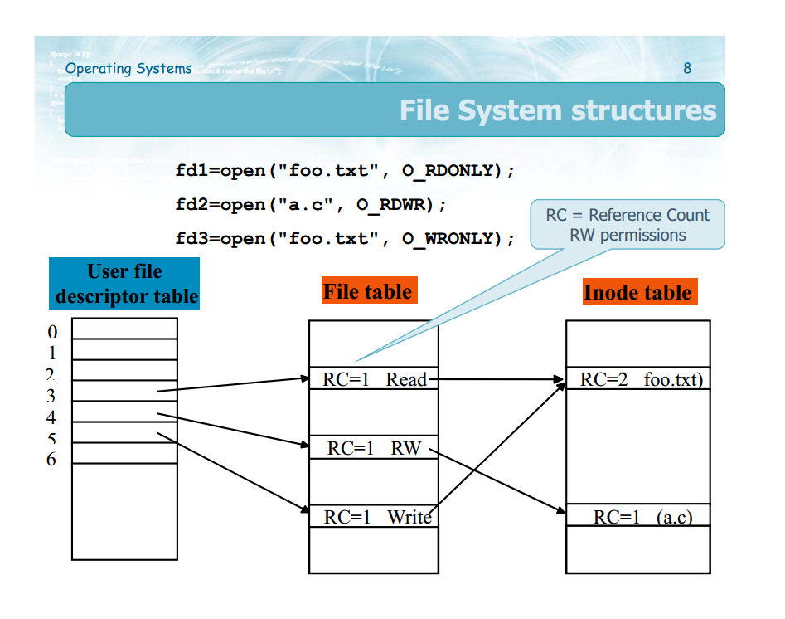

User file descripter table

1 for a process

RC:

How many reference now to one file

If file is close RC--

Why use file table?

1 different off set for UFDT and FT

2 duplicate for redirect function