TeamName
DC_TDC
Title
Prophetic Granger Causality with Heat Diffusion Prior
Authors+Affiliations
Daniel Carlin, Evan Paull, Chris K Wong, Kiley Graim, Adrian Bivol, Artem Sokolov – UC Santa Cruz
Summary Sentence
Our method is an extension of L-1 penalized Granger Causality to consider future data at each time point, combined with a biological prior that uses heat diffusion to derive a measure of closeness on known biological pathways.
Introduction
Our approach has two aspects; the prior that is based solely on curated publicly available biological pathways, and the computational approached that uses the HPN DREAM8 data. For part 1B, only the computational part of the method was used.

The motivation for the prior was two-fold; first, the winners of previous contest of this sort have made good use of what was already known about the genes in question. Biological knowledge about breast cancer pathways is well established and documented in Pathway Commons (Certami et al., 2011), so this was used as our source. We also wanted to include some sense of how “close” genes were in interaction space, since genes were more likely to be perturbed by inhibition of their neighbours in the interaction graph than by distant genes far up a biochemical path. Heat diffusion on a graph has been shown, e.g. in Bader et al., to provide a biologically useful metric of distance on an interaction graph that takes into account multiple paths between genes.

The integration of the HPN challenge data was approached with a modification of L1 penalized Granger Causality. Granger Causality a well established method for extracting causal information from time series data in general, and has found use in systems biology. The L1 version is especially relevant because it can be used in irregular time series such as the HPN DREAM8 data where the data is spaced at increasing intervals (Bahadori and Liu 2012). Granger causality works by regressing on all past data and finds any exogenous variables that account for variance beyond that accounted for by autoregression terms. Variables with extra explanatory power beyond the autoregressive terms are then assumed to be causal.

The novel approach in our application of the L1 penalized Granger algorithm is to consider future time points as well as past ones. We term this strategy Prophetic Granger Causality (PGC). The idea is to use all available data (i.e. both past and future) for each regression task, and only declare the direction of causation based on the temporality between variables, rather than their role as the response or explanatory variable. The autoregressive terms to be zeroed out are also both from the future and the past of the response variable. The zeroing of the contribution from the autoregression terms is accomplished by choosing a L1 penalty just large enough to nullify all of the autoregression terms, and any remaining non-zero contributions from other probes are assumed to indicate a causal relationship with the response variable.

Methods
We derived the prior by treating each pathway in PathwayCommons that contained two or more of the proteins in the HPN DREAM8 data (263 pathways) in the following manner; first, each pathway was reduced to a simple, undirected graph where each node was a gene and each edge was an interaction. For proteins that act in a complex, each of the constituents of the complex was assigned an edge to the targets of the complex. On this graph, we calculated a single heat kernel for the pathway. Let L_p laplacian of the graph pathway. Then the heat kernel corresponding to a 0.1 time unit diffusion, as suggested by Bader et al. (2008) was calculated as:
H_p=exp(-L_p *0.1)
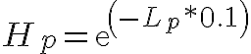

Where exp() is the matrix exponential. Then each H_p was a collected into a single biological prior matrix B by entrywise update. That is,

B<-0
for each pathway p
for m,n in interogated genes
if H_p(m,n) exists and m does not equal n
B(m,n) <- H_p(m,n)
end
end
The diagonal B(n,n) remains zero here, precluding self links. All probes assigned to the same gene were assumed to have the same biological prior information.

No preprocessing was performed on the data before we applied our method. Cell lines were treated independently, so genes that appeared in some but not all cell lines only contributed to the solutions of the lines where they appeared. For the in silico part of the challenge, replicates were treated by summarizing each probe by the median value of the replicates.
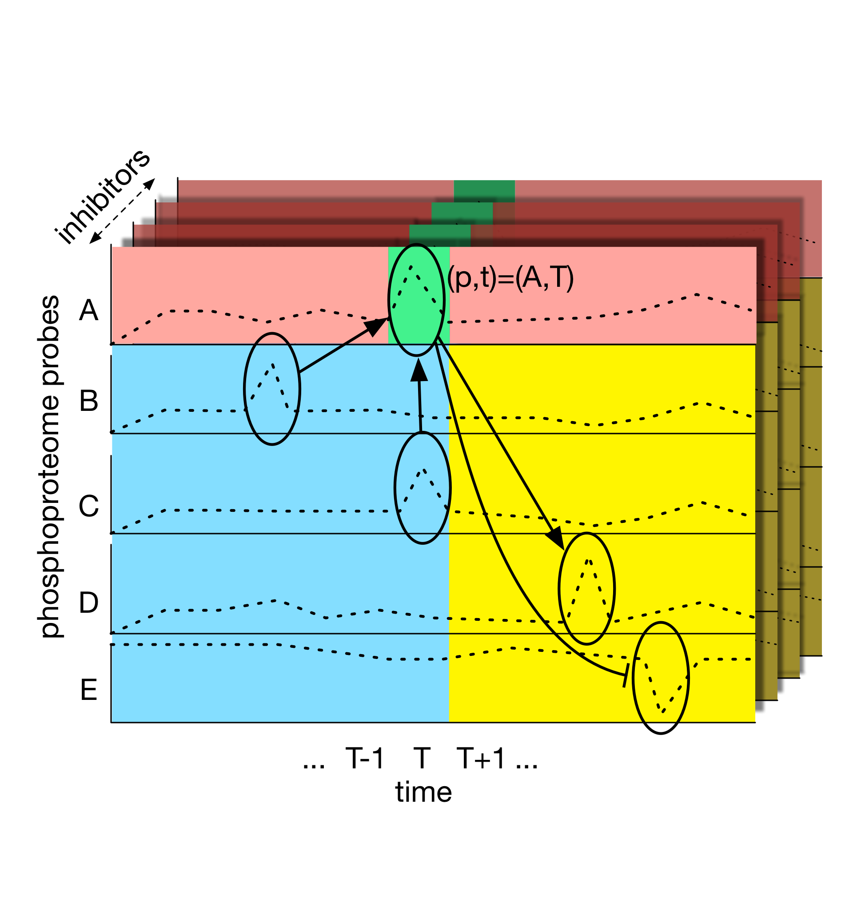Figure 1- An illustration of the Prophetic Granger Causality method. Each target probe value at each time is considered (green) as a regressed linear combination of all other feature times and probes. The L1 penalty provides a sparse solution, and is chosen so that the target probes past and future contributions (red) are zero, accounting for autoregression. Any remaining non-zero regression coefficients for other probes suggests causality; if the occur in past or concurrent time points (blue), these probes are causal of the target, and if they appear in future time points, then the target is causal of the feature probe. The different inhibitor conditions are treated as different examples of the regression task. This process was repeated for each time and probe, with each regression contributing to the final connectivity matrix.

For the Prophetic Granger Solution, we can consider our data as a function of five variables: time t, cell line l, condition c, inhibitor i, and phosphoprotein probe p. We chose to derive an independent network for each of stimulus-cell line pair, encoded as a directed weighted connectivity matrix with real values on [-1,1], where a value of -1 is the most inhibitory and 1 is most promotive, called C_l,c. Let D_l,c be the 3D data cube corresponding to a cell line-condition pair (l,c). Each probe-time pair (p,t) is treated as an independent regression task with N_i (the number of inhibitors) examples. For every regression task, D_l,c is divided into three parts; a response vector Y made up of D_l,c(p,t), an autoregression explanatory vector A made up of D_l,c(p,t”) for all times t” not equal to t and an exogenous explanatory matrix X made up of D_l,c(p’, t’), for all probes p’ not equal to p and all times t’. For clarity, we will drop the (p,t) subscripts which should appear in the following regression equations.
Then, following standard regression, we seek to find an estimate of Y that is a linear combination of A and X.
\hat{y_i}(\vec{a}_{auto},\vec{a}_{ex},a_0,A_i,X_i)= \sum_{t'' \ne t}(a_{auto,t''}A_{i,t''})+\sum_{p' \ne p,t’}(a_{ex,p',t’ }X_{i,p',t’})+a_0
We define a loss function based on the root mean squared error plus a regularization term. The regularization is chosen to force all contributions from the autoregression terms to zero.

L = \sum_i((y_i-\hat{y_i})^2)-\lambda(\sum_{t'' \ne t}|a_{auto,t''}|+\sum_{p' \ne p,t’}|a_{ex,t',p'}| )
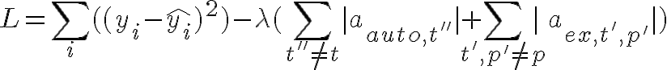
Lambda here is a meta-parameter, to be chosen be the smallest value such that all of the a_{auto} are zero. Lambda is bounded by zero and

\max(mean(|(y_i-\bar{y_i})X_i|), mean(|(y_i-\bar{y_i})A_i)|))

This regression problem is solved by gradient descent (Fiedman et al., 2010).
We find lambda’s value by binary search. First we set lambda equal to the mean of labda_min and lambda_max. Then we iteratively solve the optimization problem for a given lambda and then set lambda_min to lambda if there are non-zero autoregression term, or set lambda_max to lambda if all autoregression terms are zero. This is repeated 20 times, leaving us with an approximation of the optimal lambda.
This may leave us with some non-zero a_{ex,p’,t’} terms for the pair (p,t) indicating a causal relationship between the response probe p at time t and the explanatory probe p’ at time t’. We will now indicate this term as a_{ex,p’,t’,p,t}. If not, there is no evidence of causality from this regression. The non-zero a_{ex} regression terms contribute their weight toward the final connectivity matrix C_l,c. We normalize the sum of the absolute values of the regression terms to one so that each regression task has the same voting power in the final connectivity matrix. We determine which direction to update in C_l,c by the temporality relationship between the response probe and the explanatory probe in question. Define C_l,c(a,b) as the belief that probe a causes probe b. For the regression task on target probe p at time t, if there is a non-zero a_{ex,p’,t’} term corresponding to explanatory probe p’ at time t’, we update C_l,c with the following rule.:

if t’ <= t:
C_{l,c}(p',p) \leftarrow C_{l,c}(p',p) + \frac{a_{ex,p',t',p,t}}{\sum|a_{ex,p,t}|}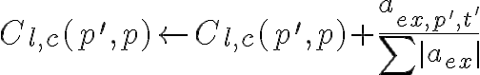
if t’ > t:
C_{l,c}(p,p’) \leftarrow C_{l,c}(p,p’) + \frac{a_{ex,p',t',p,t}}{\sum|a_{exp,p,t}|}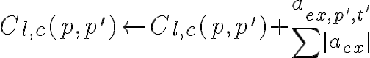
After each probe and time pair has been addressed with regression, C_l,c is complete. For the purpose of the DREAM competition, we then took the absolute value of the final connectivity matrix (since calling each link as an inhibitor or promoter was not part of the challenge). In the in silico part of the contest, C was the final answer. In the experimental portion, the final answer was a combination with the biological prior by a simple average of the entries after scaling to [0,1] by dividing by the maximum entry in B and C.

Discussion
This section should include a short summary and any insights gained. You can include future directions. You may also add some discussion on the general performance of your methodology and if there were pitfalls, what were they? If you tried any other methodologies before settling on your final method, you may briefly mention them here and offer any insights into why these methods did not perform as well as your final method (assuming this was indeed the case!).
Note that the heat kernel prior uses no information about the training data in its calculation. Nonetheless, this matrix by itself achieved second place in the DREAM challenge 1A (entry name limax). The performance of this entry by itself in the DREAM challenge can be seen as a confirmation that the contest recapitulates known biology, and is an important reminder that prior biological knowledge should always be taken into account in practical applications of machine learning to biology.

L1 penalized Granger in its usual form combined with the prior was attempted as well (entry name freya), but it also did not perform as well as the prophetic version of the algorithm. This show the utility of using all available data in the regression task, and assigned causality based on the temporal relationships between observations. One point to note about our solution is that the power of the individual regression tasks is weak, since there were only 4 inhibitor treatments to drive each regression task. However, this is balanced by the large number of regression tasks performed, so our solution has a boosting quality of a large number of weak learners.
References

Cerami, Ethan G., et al. "Pathway Commons, a web resource for biological pathway data." Nucleic acids research 39.suppl 1 (2011): D685-D690.

Bahadori, Mohammad Taha, and Yan Liu. "Granger Causality Analysis in Irregular Time Series." SDM. 2012.

Friedman, Jerome, Trevor Hastie, and Rob Tibshirani. "Regularization paths for generalized linear models via coordinate descent." Journal of statistical software 33.1 (2010): 1.

Qi, Yan, et al. "Finding friends and enemies in an enemies-only network: a graph diffusion kernel for predicting novel genetic interactions and co-complex membership from yeast genetic interactions." Genome research 18.12 (2008): 1991-2004.

Authors Statement
Daniel Carlin- PGC algorithm development
Evan Paull- Heat diffusion on pathways
Chris K Wong- PathwayCommons wrangling
Kiley Graim- normal Granger comparison and prior testing
Adrian Bivol- other techniques comparison and prior testing
Artem Sokolov- PGC algorithm development and implementation

