BCSE497J - Project-I

AI-ASSISTED GENERATION OF CUDA-BASED MOLECULAR DYNAMICS SIMULATIONS FROM NATURAL-LANGUAGE DESCRIPTIONS
(Times New Roman 16, Bold, Upper Case, Line spacing 1.5)

23BDS0085 | SHIVANI SRIVASTAVA
Reg. No. 2 | Student Name 2
Reg. No. 3 | Student Name 3
(Times New Roman 13, Bold, Upper Case, Line spacing 1.5)
(mention the particulars sorted on Register number)

Under the Supervision of

Dr. Vijayasherly V
Designation
School of Computer Science and Engineering (SCOPE)
(Line spacing 1.5)

B.Tech.
in
Computer Science and Engineering
(Specialization if any)

School of Computer Science and Engineering



September 2026

/****** Sample*******/
BCSE497J Project-I

ROLE OF MACHINE LEARNING AND ARTIFICIAL INTELLIGENCE IN CYBER SCEURITY

21BCI00001 | ABI. S
21BCI00002 | BABU. K
21BCI00003 | CHANDRU. D

(Mention the particulars sorted on Register number)

Under the Supervision of

Dr. XXXXXXX B
Assistant Professor Senior Grade 1
School of Computer Science and Engineering (SCOPE)

B.Tech.
in
Computer Science and Engineering

School of Computer Science and Engineering

(Specialization Information Security)

September 2026
ABSTRACT
(Times New Roman 14, Bold, Upper Case, Line spacing 1.5)
<Contents, Times New Roman 12, Line spacing 1.15>
One page and not exceeding 300 words

/****** Sample*******/
ABSTRACT

Setting up a molecular dynamics (MD) simulation traditionally demands both deep computational-physics knowledge and low-level, high-performance programming expertise — a combination that puts GPU-accelerated MD out of reach for many students and researchers who understand the science but not the systems programming underneath it. This project proposes an AI-assisted molecular dynamics framework in which a local Small Language Model (SLM) reads a plain-English description of a desired simulation, extracts the physical parameters and settings it implies, and automatically configures a simulation accordingly — letting a researcher focus on the scientific question rather than the mechanics of setting one up.

The language-understanding component's role is deliberately restricted to interpreting intent and extracting structured parameters; it never generates or modifies simulation physics itself, which remains the responsibility of a fixed, independently verifiable simulation engine. This separation is the framework's central design principle: natural language lowers the barrier to entry without lowering trust in the result. The proposed computational direction for the framework is GPU/CUDA acceleration, so that the accessibility gained through natural-language configuration extends to large-scale, high-performance simulation.

As a working demonstration of this concept, a CPU-based prototype has been implemented, validating the complete pipeline — natural-language or manual input, automatic parameter extraction and validation, simulation configuration, execution, and interactive 3D visualization of the real resulting trajectory — end to end. The prototype supports Lennard-Jones and Hard-Sphere interaction models, multiple boundary conditions, and physically distinct solid/liquid/gas states, and establishes the architecture on which the full, GPU-accelerated framework is intended to be built.

Keywords - Molecular Dynamics, Small Language Model, Natural-Language Interface, Automated Simulation Configuration, GPU/CUDA Acceleration, Accessible Scientific Computing.

TABLE OF CONTENTS
(Times New Roman 14, Bold, Upper Case, Line spacing 1.5,
Remove Border in Table)
<Contents, Times New Roman 12, Line spacing 1.5>
Sl.No | Contents | Page No.
 | Abstract < Capitalize Each Word, Bold> | 1
1. | INTRODUCTION <Uppercase, Bold> | 1
 | 1.1 Background <Capitalize Each Word, Normal> | 1
 | 1.2 Motivation | 1
 | 1.3 Scope of the Project | 1
2. | PROJECT DESCRIPTION AND GOALS | 1
 | 2.1 Literature Review | 1
 | 2.2 Research Gap | 1
 | 2.3 Objectives | 1
 | 2.4 Problem Statement | 1
 | 2.5 Project Plan | 1
3. | TECHNICAL SPECIFICATION | 1
 | 3.1 Requirements | 1
 | 3.1.1 Functional | 1
 | 3.1.2 Non-Functional | 1
 | 3.2 Feasibility Study | 1
 | 3.2.1 Technical Feasibility | 1
 | 3.2.2 Economic Feasibility | 1
 | 3.2.3 Social Feasibility | 1
 | 3.3 System Specification | 1
 | 3.3.1 Hardware Specification | 1
 | 3.3.2 Software Specification | 1
4. | DESIGN APPROACH AND DETAILS | 1
 | 4.1 System Architecture | 1
 | 4.2 Design | 1
 | 4.2.1 Data Flow Diagram | 1
 | 4.2.2 Use Case Diagram | 1
 | 4.2.3 Class Diagram | 1
 | 4.2.4 Sequence Diagram | 1
5. | REFERENCES | 1

1. INTRODUCTION
(Times New Roman 14, Bold, Upper Case, Line spacing 1.5)
<Contents, Times New Roman 12, Line spacing 1.15>

1.1 Background
(Times New Roman 13, Bold, Title Case, Line spacing 1.5)
<Contents, Times New Roman 12, Line spacing 1.15>
<To provide the reader with the necessary context to understand the project> <Not more than 200 words>
/** Sample **/
Molecular dynamics (MD) simulation is a well-established computational technique for studying how atoms and particles move and interact over time, with applications spanning materials science, drug design, and condensed-matter physics. Running a meaningful MD simulation — particularly a GPU-accelerated one — requires a researcher to translate a scientific question into simulation code and configuration: choosing an interaction model, initializing a system correctly, setting boundary conditions, and writing or configuring numerical integration, often in a low-level, high-performance language such as C++ or CUDA.

This technical overhead is largely independent of the scientific question being asked. Two researchers investigating very different physical systems still have to solve the same configuration and implementation problems before either can begin producing results. Mature MD packages such as LAMMPS and GROMACS reduce some of this burden through configuration scripting, but scripting remains a technical skill distinct from the physics itself, and neither offers a natural-language entry point.

This project explores whether a locally-run, language-understanding component can remove that overhead: reading a plain-English description of a desired simulation, extracting the parameters it implies, and configuring a simulation automatically — so that the researcher's time and attention go to the scientific question, not the setup work surrounding it.

1.2 Motivation
(Times New Roman 13, Bold, Title Case, Line spacing 1.5)
<Contents, Times New Roman 12, Line spacing 1.15>
< To explain why the project is important and what inspired it> <Not more than 200 words>
/** Sample **/
The motivation for this project comes from direct, personal experience. During a summer internship in the Biotech Department at IIT Bombay (25th May – 11th July 2024), under the guidance of Prof. Ranjith Padinhateeri, I hand-wrote and debugged a Lennard-Jones molecular dynamics simulation in C++, and then attempted to port that same simulation to CUDA to take advantage of GPU acceleration. The C++ implementation worked correctly, reproducing the expected energy-conservation behaviour of an NVE simulation. The CUDA port, however, ran into real, unresolved problems — an incorrect memory-allocation cast, unsupported double-precision atomic operations on the target GPU architecture, and incomplete host/device memory management — that I was ultimately unable to fully resolve within the internship's timeframe, given my limited CUDA experience at the time.

That experience directly motivated this project. It made two things clear. First, that a large share of the effort in building a GPU-accelerated MD simulation lies not in the physics itself — which is comparatively well-established and reusable — but in the systems-programming work of correctly wiring together initialization, force calculation, memory management, and numerical integration, particularly on the GPU. Second, that this repetitive, pattern-following configuration work is exactly the kind of task a language-understanding system could reasonably absorb, provided it is kept strictly separate from the parts of the problem — the physics, and the CUDA implementation itself — that genuinely require verified correctness, the way my own CUDA debugging did.

This also motivated the choice of a local SLM over a cloud-based AI assistant: it keeps the system self-contained, explainable, reproducible, and usable without an internet connection or ongoing external dependency — properties that matter for a tool meant to be understood, verified, and demonstrated end to end, in the same spirit as the hand-verified C++ engine it configures, rather than trusted as a black box.

1.3 Scope of the Project
(Times New Roman 13, Bold, Title Case, Line spacing 1.5)
<Contents, Times New Roman 12, Line spacing 1.15>
<To define the boundaries and extent of the project> <Not more than 200 words>
/** Sample **/
The proposed system is a natural-language and manual-input interface, backed by a local SLM restricted to parameter extraction, driving a GPU/CUDA-accelerated molecular dynamics engine, with interactive visualization of results. This project's scope covers a structured parameter schema (particle count, density/temperature or speed, interaction model, state of matter, boundary/container configuration), a local natural-language parameter-extraction component and an equivalent manual-entry path, both checked by one shared feasibility validator.

It further covers a simulation engine implementing two interaction models (Lennard-Jones, Hard-Sphere), two boundary types (periodic, and a real cuboidal/spherical container), and three states of matter represented as genuine physical differences rather than cosmetic presets, plus an interactive 3D visualization of the real simulated trajectory and its energy behaviour over time, as evidence the simulation is physically correct.

GPU/CUDA execution is the framework's intended computational direction but is not implemented at this project stage — demonstrated instead via a CPU-based prototype covering the same pipeline, given the hardware available for development and demonstration. A full local SLM is the framework's intended language component; this stage validates the same pipeline position with a lighter, rule-based extractor. Both are future extensions of this same architecture, not separate unfinished features.

2. PROJECT DESCRIPTION AND GOALS
(Times New Roman 14, Bold, Upper Case, Line spacing 1.5)
<Contents, Times New Roman 12, Line spacing 1.15>
2.1 Literature Review
(Times New Roman 13, Bold, Title Case, Line spacing 1.5)
<Contents, Times New Roman 12, Line spacing 1.15>

< This section of a project report provides a comprehensive overview of existing research, theories, and knowledge relevant to the project>

< Maximum of 50 journal papers are required.>
Foundations of molecular dynamics. Frenkel and Smit’s Understanding Molecular Simulation [1] remains the standard reference for the algorithms this project's simulation engine is built on: the Lennard-Jones potential, Verlet-family integrators, and periodic boundary conditions. These form the physical and numerical basis for any MD engine, including the one implemented here, and ground the project's parameter schema in established, well-understood physics rather than an ad hoc simplification.
Accessibility: The system should not require the user to write or understand simulation source code to run a simulation.
Machine learning inside molecular simulation. A separate line of research applies machine learning within the physics itself — Behler and Parrinello’s neural-network potential energy surfaces [7] are the seminal example, learning interatomic potentials that approach quantum-mechanical accuracy at MD-compatible speed. Butler et al. [8] and Noé et al. [9] survey this broader intersection of machine learning and molecular/materials science. This project takes a deliberately different position: rather than using learned models to approximate physics, it keeps machine learning entirely outside the physics, restricted to interpreting a user's intent. Reviewing this literature clarifies that distinction rather than undermining it — the surveys in [8, 9] confirm that natural-language interfaces to simulation setup remain comparatively unexplored relative to ML-for-physics work.
Language models, structured extraction, and tool-restricted scientific agents. White et al.’s prompt-pattern catalog [10] and related structured-output/function-calling techniques underpin the decision to constrain this project's language component to a fixed, validated parameter schema rather than free-form generation. Most directly relevant are two recent systems that apply this “language model as intent-interpreter, verified tool as executor” pattern to real science: ChemCrow [11], where an LLM agent calls verified chemistry tools rather than generating chemistry itself, and Coscientist [12], where an LLM plans and orchestrates real experimental/computational workflows through external tools. Both demonstrate, in a different domain, the same architectural principle this project applies to molecular dynamics — natural language for intent, verified computation for execution — and support the claim that this is a credible, active research direction rather than a novel but untested idea.

2.2 Research Gap
(Times New Roman 13, Bold, Title Case, Line spacing 1.5)
<Contents, Times New Roman 12, Line spacing 1.15>

<To identify the areas or aspects where existing research is lacking or incomplete, which your project aims to address.>
Mature, high-performance MD tools (LAMMPS, GROMACS, OpenMM, HOOMD-blue) solve the performance problem but not the accessibility problem — all remain script- or API-configured, with no natural-language entry point. General-purpose large language models can generate simulation code directly, but nothing constrains that generated code to be physically correct; unconstrained LLM-generated low-level, parallel code is documented to be unreliable (race conditions, incorrect memory semantics, silent numerical errors). Recent LLM-tool-use systems in adjacent scientific domains (ChemCrow, Coscientist) demonstrate that restricting a language model to intent-interpretation, backed by verified tools, is a workable and trustworthy pattern — but this pattern has not been applied to GPU-accelerated molecular dynamics specifically. This project addresses that gap directly: a language-understanding component restricted to parameter extraction only, paired with a fixed, independently verifiable simulation engine, with GPU/CUDA acceleration as the framework's intended computational direction.

2.3 Objectives

(Times New Roman 13, Bold, Title Case, Line spacing 1.5)
<Contents, Times New Roman 12, Line spacing 1.15>
< To clearly define what the project aims to achieve. List the primary goals of the project. These should be specific, measurable, achievable, relevant, and time-bound (SMART).>
Parameter Schema: Design a structured parameter schema capturing a complete molecular dynamics simulation request — particle count, density/temperature (or particle speed), interaction model, state of matter, and boundary/container configuration.
Local Language Understanding: Build a local, natural-language parameter-extraction component that converts a plain-English simulation description into this schema without relying on any external AI service.
Validation: Implement a validation layer that checks extracted or manually entered parameters for physical feasibility before any simulation is configured or run.
Pipeline Demonstration: Demonstrate the complete pipeline — natural language or manual input, automatic configuration, execution, and visualization — end to end on a working prototype, as evidence the pipeline design itself is sound.
Future Extensibility: Structure the simulation engine's core computation so that it can be extended to GPU/CUDA acceleration in future work, carrying the accessibility gains demonstrated here to large-scale, high-performance simulation.

2.4 Problem Statement

(Times New Roman 13, Bold, Title Case, Line spacing 1.5)
<Contents, Times New Roman 12, Line spacing 1.15>

< Clearly define the issue or challenge that the project will address. This should be specific and focused.>
Running a molecular dynamics simulation currently requires a researcher to already possess the systems-programming expertise to translate a physical scenario into correct simulation code and configuration — a requirement unrelated to understanding the underlying physics, and one that excludes many students and early researchers who understand what they want to simulate but not how to implement it, particularly for GPU-accelerated simulation. Existing MD tools do not accept a natural-language description of a desired simulation. This project addresses the problem of providing a natural-language (and manual) interface to molecular dynamics simulation, without compromising the physical correctness of the underlying computation by allowing a language component to generate or influence simulation logic directly — validating this approach with a CPU-based prototype ahead of the framework's intended GPU-accelerated implementation.

2.5 Project Plan
(Times New Roman 13, Bold, Title Case, Line spacing 1.5)
<Contents, Times New Roman 12, Line spacing 1.15>
<A Gantt chart helps in organizing tasks, setting deadlines, and tracking progress, making it easier to manage the project and communicate the plan to stakeholders.>
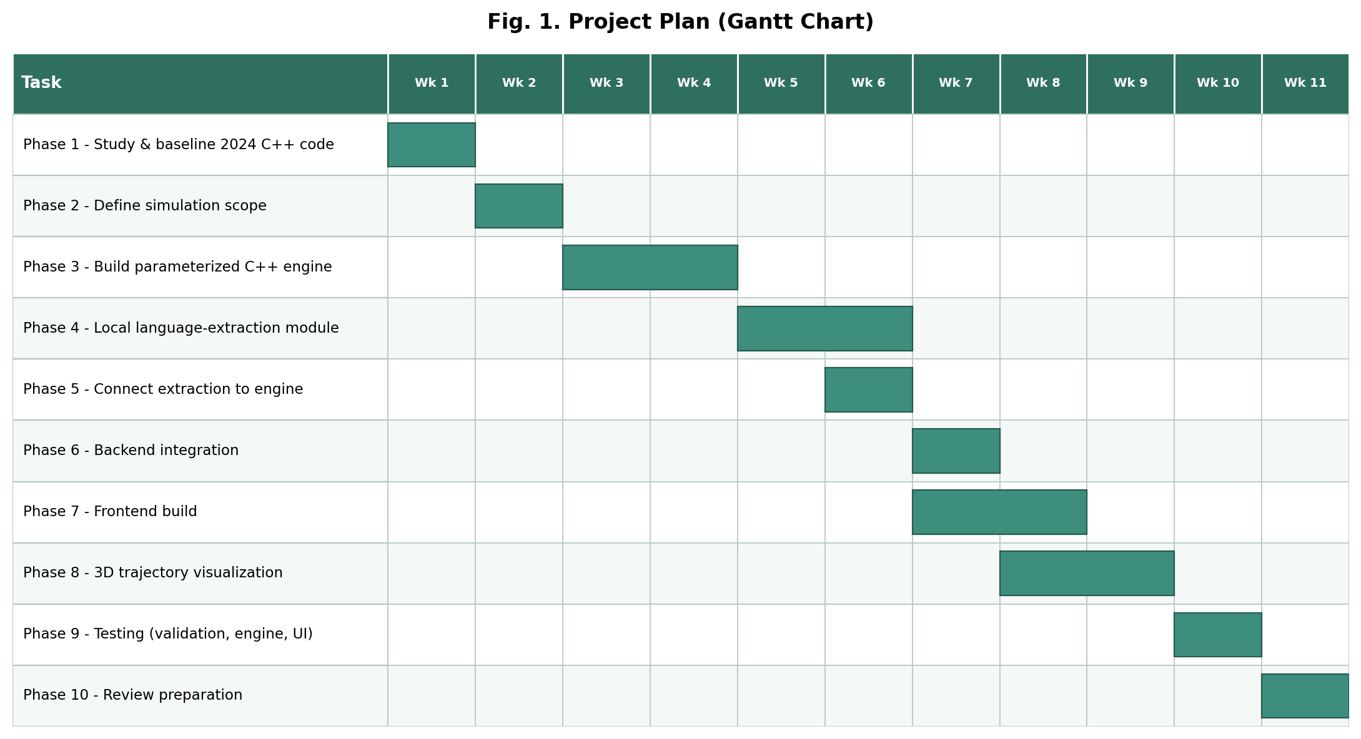
/** Sample **/
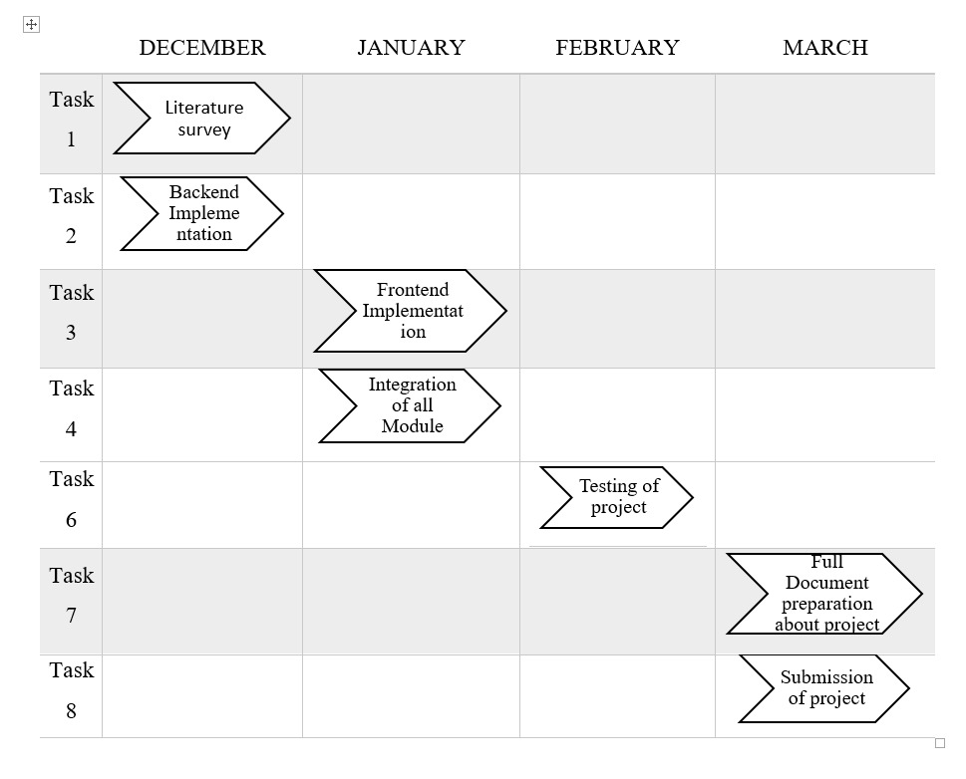
Fig. 1. Gantt chart
3. TECHNICAL SPECIFICATION
(Times New Roman 14, Bold, Upper Case, Line spacing 1.5)
<Contents, Times New Roman 12, Line spacing 1.15>
3.1 Requirements
(Times New Roman 13, Bold, Title Case, Line spacing 1.5)
<Contents, Times New Roman 12, Line spacing 1.15>
3.1.1 Functional
(Times New Roman 12, Bold with Italic, Title Case, Line spacing 1.5)
<Contents, Times New Roman 12, Line spacing 1.15>
/** Sample **/
- Natural-Language Input: The system shall accept a plain-English description of a desired simulation and extract structured parameters from it using a local language-understanding component, with no external AI API.
- Manual Parameter Input: The system shall accept manually entered parameters as an equivalent alternative input path.
- Parameter Validation: The system shall validate all parameters, from either input path, against physical feasibility before configuring a simulation, and communicate specific, human-readable reasons for any rejection.
- Automatic Configuration: The system shall translate validated parameters into a complete, ready-to-run simulation configuration automatically, requiring no manual simulation coding from the user.
- Simulation Execution: The system shall execute the configured simulation and produce real particle trajectory and energy data. The current prototype executes on CPU, supporting Lennard-Jones and Hard-Sphere interaction models with periodic or container (cuboidal/spherical) boundaries.
- State-of-Matter Representation: The system shall represent solid, liquid, and gas states through distinct initial particle arrangement, density, and motion.
- Trajectory and Energy Output: The system shall record real particle positions over time and system energy values for playback and verification.
- Interactive 3D Visualization: The system shall present the resulting trajectory through an interactive 3D visualization, alongside an energy-versus-time view for verifying physical correctness.
3.1.2 Non-Functional
(Times New Roman 12, Bold with Italic, Title Case, Line spacing 1.5)
<Contents, Times New Roman 12, Line spacing 1.15>
/** Sample **/
- Performance: The system should process and analyze data in real-time with minimal latency.
- Locality and Privacy: The system should perform all language understanding and simulation computation on the local machine, without depending on an external AI API or network connection.
- Reliability: The simulation engine’s physics should remain fixed and independently verifiable, so its correctness never depends on the reliability of the language-understanding component.
- Security: The system should ensure data integrity and confidentiality, with strong access controls and encryption mechanisms.
- Usability: The interface should present extracted or entered parameters for review and confirmation before any simulation runs.
- Maintainability: The system should be organized into clearly separated modules (language understanding, validation, simulation execution, visualization), each independently understandable and replaceable.
- Extensibility: The simulation configuration format and engine should be structured so the execution backend can be upgraded to GPU/CUDA, and the language component upgraded to a full local SLM, without redesigning the surrounding system.
3.2 Feasibility Study
(Times New Roman 13, Bold, Title Case, Line spacing 1.5)
<Contents, Times New Roman 12, Line spacing 1.15>
/** Sample **/
3.2.1 Technical Feasibility
- Technology Availability: The prototype uses well-documented, freely available technologies (standard C++, Python, plain web frontend technologies), keeping the current implementation stage low-risk and reproducible on ordinary hardware.
- Technical Expertise: The proposed GPU/CUDA-accelerated execution backend is technically well-precedented but requires NVIDIA GPU hardware not available during this project stage — a hardware-driven, not conceptual, limitation.
- Infrastructure: The current prototype requires only standard laptop-class computing resources. The framework's proposed GPU-accelerated backend would require access to CUDA-capable GPU hardware, which is increasingly available through university computing clusters or cloud GPU providers where local hardware is not available, keeping the full framework's infrastructure requirement realistic.
- Integration: The frontend, backend, and simulation engine communicate through a small, well-defined set of local interfaces and configuration formats, keeping integration straightforward and easy to verify.
3.2.2 Economic Feasibility
- Cost-Benefit Analysis: The framework is built entirely on free and open-source tools; implementation cost is limited to development time, with no recurring service, licensing, or API cost.
- Budget: No paid infrastructure, cloud services, or external AI API subscriptions are required to build, run, or demonstrate this project.
- Return on Investment (ROI): The primary return is educational and research-enabling — a reusable, extensible framework that reduces the setup cost of future MD studies, rather than a one-off deliverable.
- Funding: No external funding is required for this project stage; all development was carried out using freely available tools.

3.2.3 Social Feasibility
- User Acceptance: Lowering the technical barrier to GPU-accelerated MD is intended to benefit students and early researchers specifically — the audience most limited by systems-programming expertise rather than by scientific understanding.
- Training and Support: The project’s documentation records installation, usage, and the reasoning behind each design decision, so a new user or reviewer can understand and run the system without additional support.
- Ethical Considerations: Running entirely locally, with no data leaving the user's machine, avoids the privacy and data-governance concerns associated with cloud-based AI research tools.
- Impact on Workforce: The project is an educational and research-enabling tool; it does not replace or displace any existing workflow or role.

3.3 System Specification
(Times New Roman 13, Bold, Title Case, Line spacing 1.5)
<Contents, Times New Roman 12, Line spacing 1.15>
/** Sample **/
3.3.1 Hardware Specification
(Times New Roman 12, Bold with Italic, Title Case, Line spacing 1.5)
<Contents, Times New Roman 12, Line spacing 1.15>
- Processor: A modern multi-core CPU (Intel/AMD, x64) to run the local language-understanding component and orchestrate simulation execution.
- Memory (RAM): 8 GB or more recommended, to run language understanding, simulation, and visualization concurrently.
- Storage: Under 500 MB for source code, dependencies, and a local language model.
- Graphics Processing Unit (GPU): An NVIDIA GPU with CUDA support (Compute Capability 6.0 or higher recommended) — the core computational requirement for the framework's GPU-accelerated simulation execution, and the primary hardware this project's architecture is designed around.
- Monitor: A standard display capable of rendering a web browser, for the interactive 3D visualization.
- Note: the prototype demonstrated for this review was developed and run on CPU-only hardware; the GPU listed above is the target hardware requirement for the full framework this project is building toward, not a component of the current demonstration.
3.3.2 Software Specification
(Times New Roman 12, Bold with Italic, Title Case, Line spacing 1.5)
<Contents, Times New Roman 12, Line spacing 1.15>
- Operating System: Windows, Linux, or macOS.
- Programming Languages: C++ (simulation engine prototype), Python (backend/orchestration), HTML/CSS/JavaScript (interface); CUDA C++ for the proposed GPU-accelerated execution backend.
- Development Environment: A standard code editor with a C++ compiler and Python 3.10+ (a CUDA toolkit for the proposed GPU backend).
- Libraries and Frameworks: A lightweight local web framework for backend orchestration; no external frontend framework is used.
- Database: None — the system exchanges structured parameters and simulation results directly, with no persistent storage layer.
- Security Tools: Not applicable at this stage — the system runs entirely locally with no external network exposure.

<Please include appropriate hardware & software is required to your project.>
4. DESIGN APPROACH AND DETAILS
(Times New Roman 14, Bold, Upper Case, Line spacing 1.5)
<Contents, Times New Roman 12, Line spacing 1.15>

4.1 System Architecture
(Times New Roman 13, Bold, Title Case, Line spacing 1.5)
<Contents, Times New Roman 12, Line spacing 1.15>
/** Sample **/
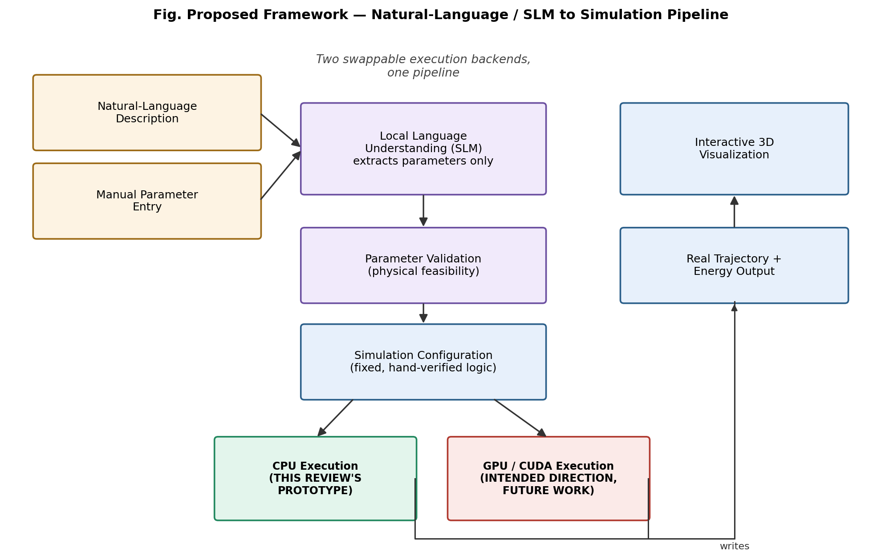
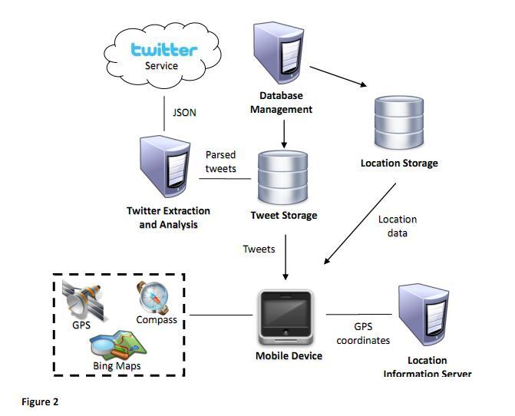

Fig. 2. System Architecture
Figure 2 shows the proposed system architecture. A user's request — natural language or manually entered — reaches a local language-understanding component whose role is strictly limited to extracting structured parameters; it never generates or influences simulation logic. Validated parameters are passed to a fixed simulation-configuration stage, which is backend-agnostic by design: the same configuration can drive either a CPU execution engine or a GPU/CUDA-accelerated engine without modification to any earlier stage. This project stage implements and demonstrates the CPU path; GPU/CUDA execution is the framework's proposed computational direction. Both paths converge on the same real trajectory and energy output, visualized identically regardless of which backend produced it.

4.2 Design
(Times New Roman 13, Bold, Title Case, Line spacing 1.5)
<Contents, Times New Roman 12, Line spacing 1.15>
4.2.1 Data Flow Diagram <Mandatory>
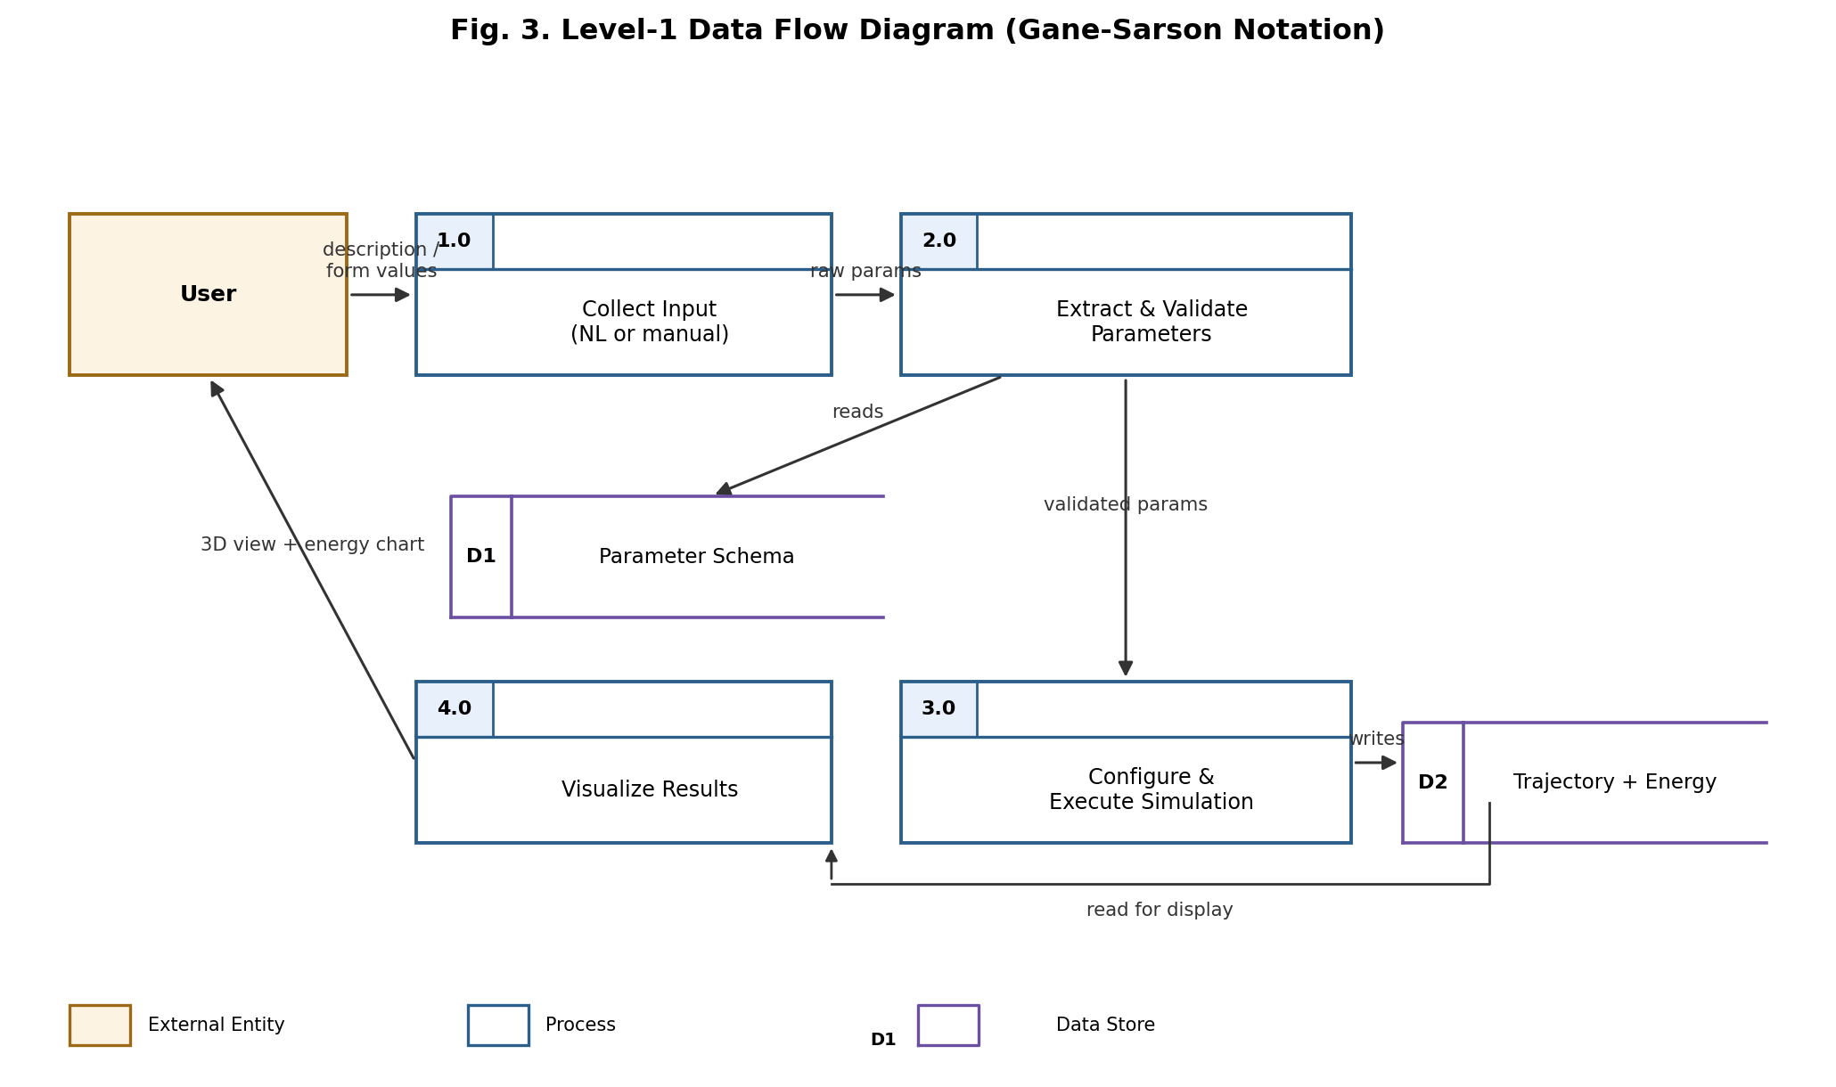
4.2.2 Use Case Diagram <Mandatory>
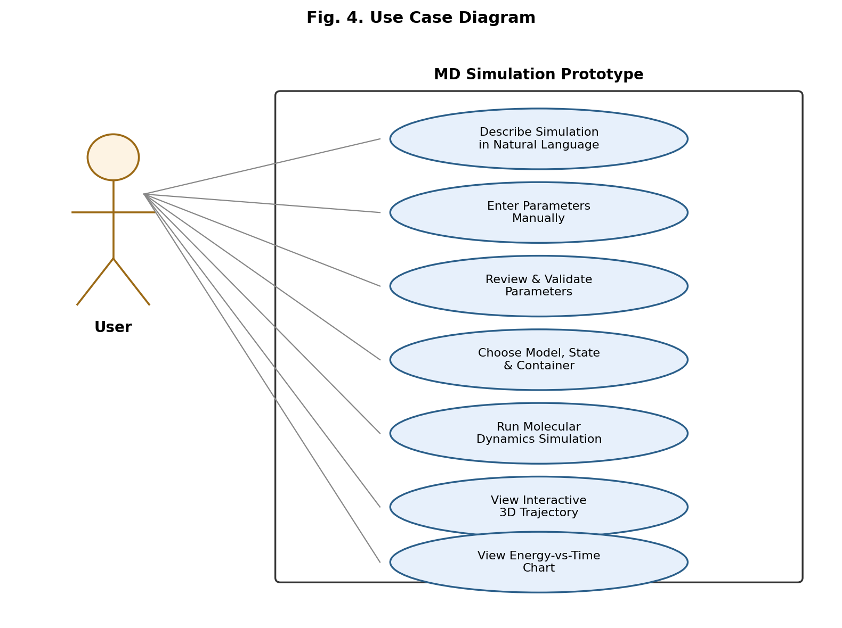
4.2.3 Class Diagram <Optional>
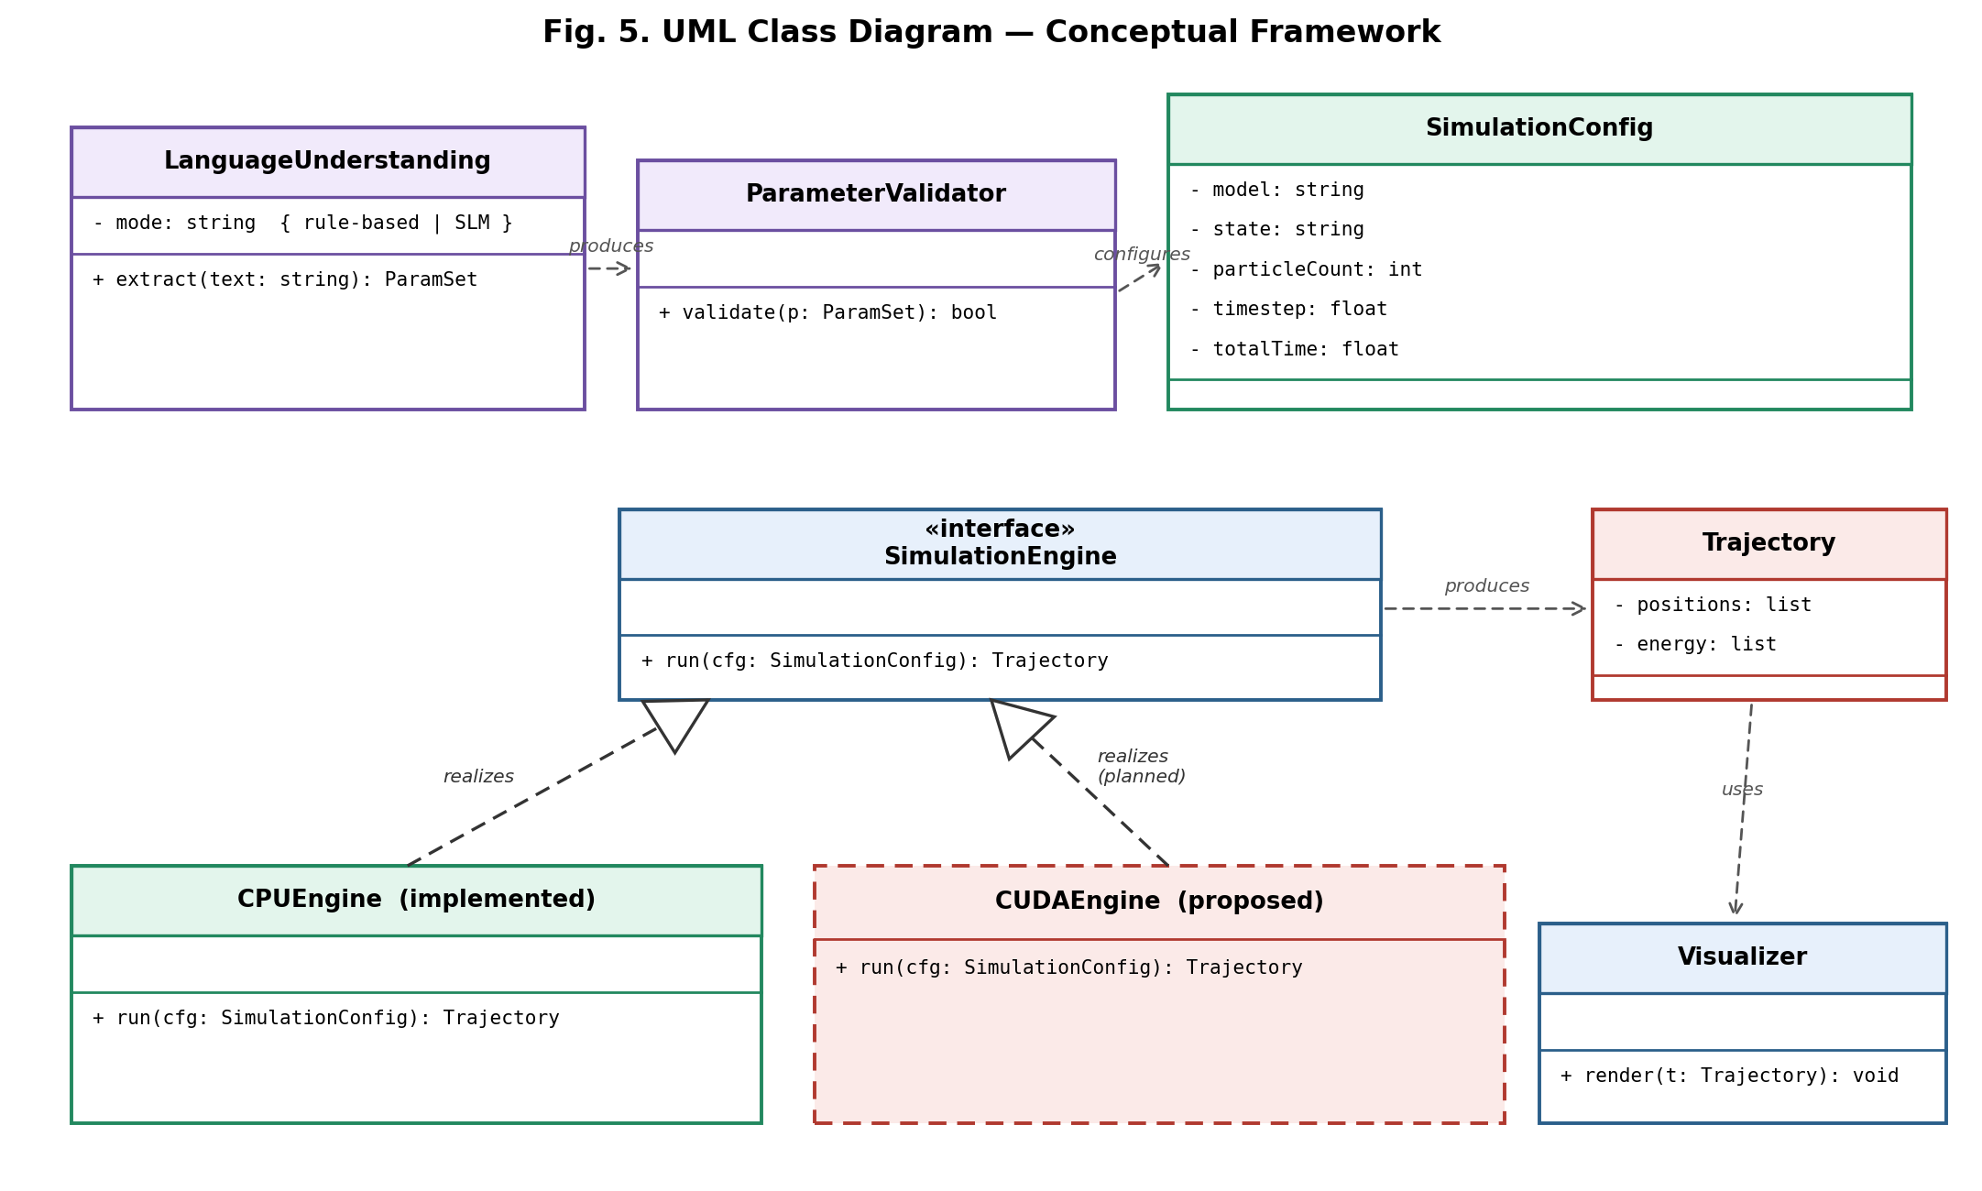
4.2.4 Sequence Diagram <Optional>
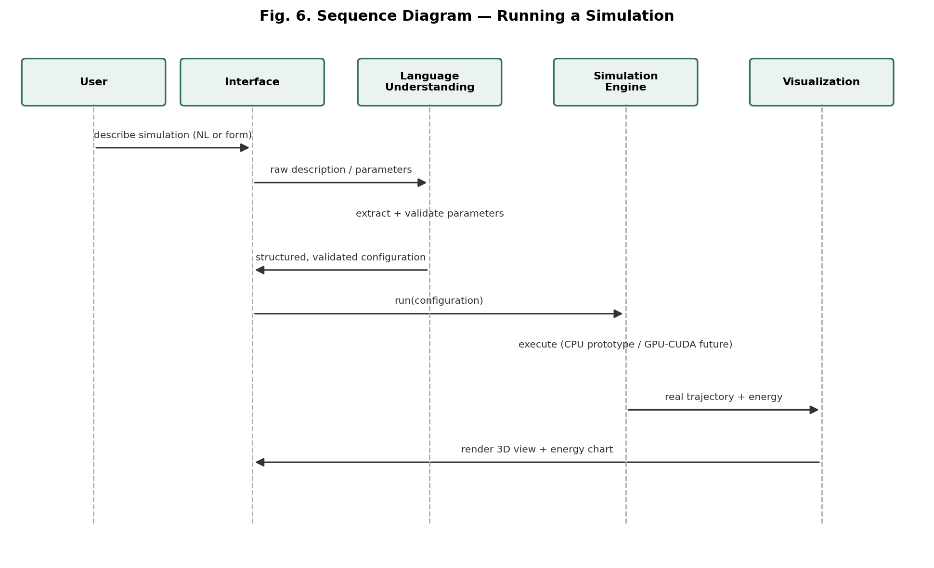
<Please include whichever diagram is applicable to your project.>
5. REFERENCES
(Times New Roman 14, Bold, Upper Case, Line spacing 1.5)
<Contents, Times New Roman 12, Line spacing 1.15>
Weblinks:
- https://github.com/Kiwi-Supreme/Molecular-Dynamics-Simulation-of-Particles-in-a-Box
- https://platform.openai.com/docs/guides/function-calling

Journals: <IEEE Format>
- S. Plimpton, “Fast parallel algorithms for short-range molecular dynamics,” J. Comput. Phys., vol. 117, no. 1, pp. 1-19, 1995. M. J. Abraham et al., “GROMACS: High performance molecular simulations through multi-level parallelism from laptops to supercomputers,” SoftwareX, vol. 1-2, pp. 19-25, 2015.
- J. E. Stone et al., “Accelerating molecular modeling applications with graphics processors,” J. Comput. Chem., vol. 28, no. 16, pp. 2618-2640, 2007.

- J. A. Anderson, C. D. Lorenz, and A. Travesset, “General purpose molecular dynamics simulations fully implemented on graphics processing units,” J. Comput. Phys., vol. 227, no. 10, pp. 5342-5359, 2008.
- P. Eastman et al., “OpenMM 7: Rapid development of high performance algorithms for molecular dynamics,” PLOS Comput. Biol., vol. 13, no. 7, 2017.
- J. Behler and M. Parrinello, “Generalized neural-network representation of high-dimensional potential-energy surfaces,” Phys. Rev. Lett., vol. 98, 146401, 2007.
- K. T. Butler, D. W. Davies, H. Cartwright, O. Isayev, and A. Walsh, “Machine learning for molecular and materials science,” Nature, vol. 559, pp. 547-555, 2018.
- F. Noé, A. Tkatchenko, K.-R. Müller, and C. Clementi, “Machine learning for molecular simulation,” Annu. Rev. Phys. Chem., vol. 71, pp. 361-390, 2020.
- J. White et al., “A prompt pattern catalog to enhance prompt engineering with ChatGPT,” arXiv:2302.11382, 2023.
- A. M. Bran, S. Cox, O. Schilter, C. Baldassari, A. D. White, and P. Schwaller, “Augmenting large language models with chemistry tools,” Nature Machine Intelligence, 2024.
- D. A. Boiko, R. MacKnight, B. Kline, and G. Gomes, “Autonomous chemical research with large language models,” Nature, vol. 624, pp. 570-578, 2023.

Book:
- D. Frenkel and B. Smit, Understanding Molecular Simulation: From Algorithms to Applications, 2nd ed. San Diego, CA: Academic Press, 2002.
- NVIDIA Corporation, CUDA C++ Programming Guide, Release 12.5, NVIDIA, 2024.

