**Problem Setup**

1. What is the coordinate frame? Where do we define the origin, and what is the positive X and Y direction?
2. Label these target entities in the diagram below.

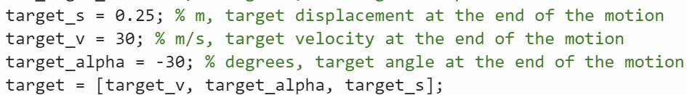

1. Label the 6 decision variables (X) in the diagram below.

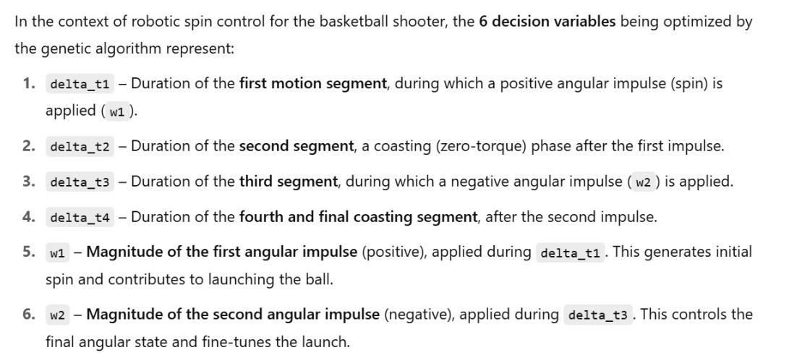

1. Why simulate robotic arm’s motion? It makes more sense to simulate the ball’s trajectory from when the robotic arm gives it an initial velocity vector, that consecutively curved by gravity, and reaches the hoop as its final destination.

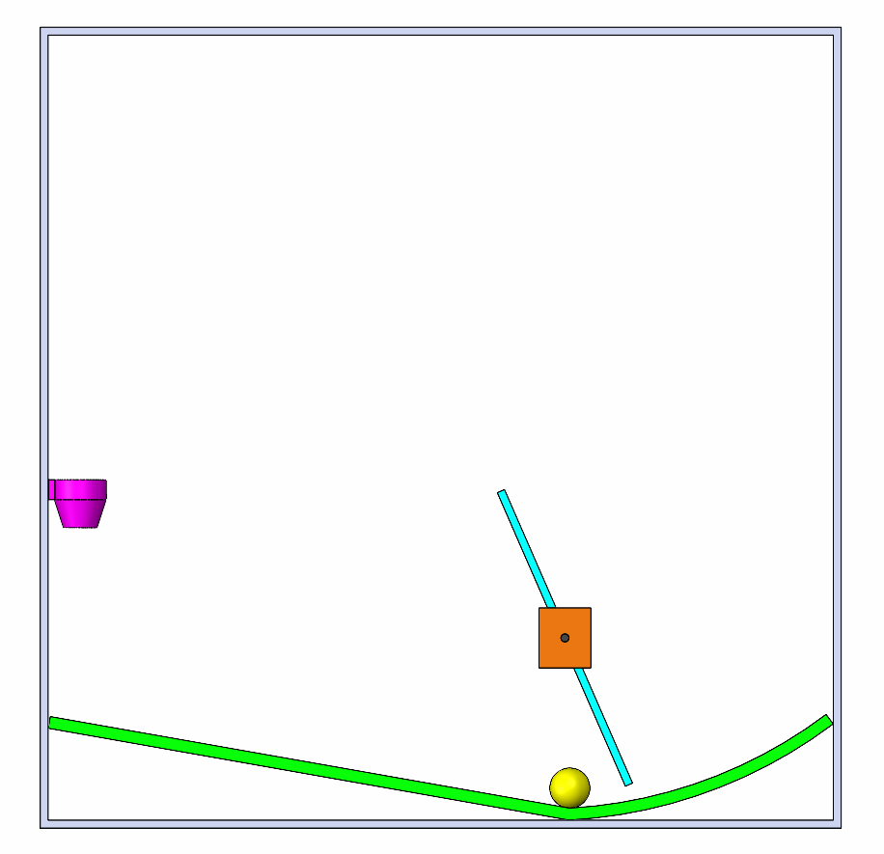

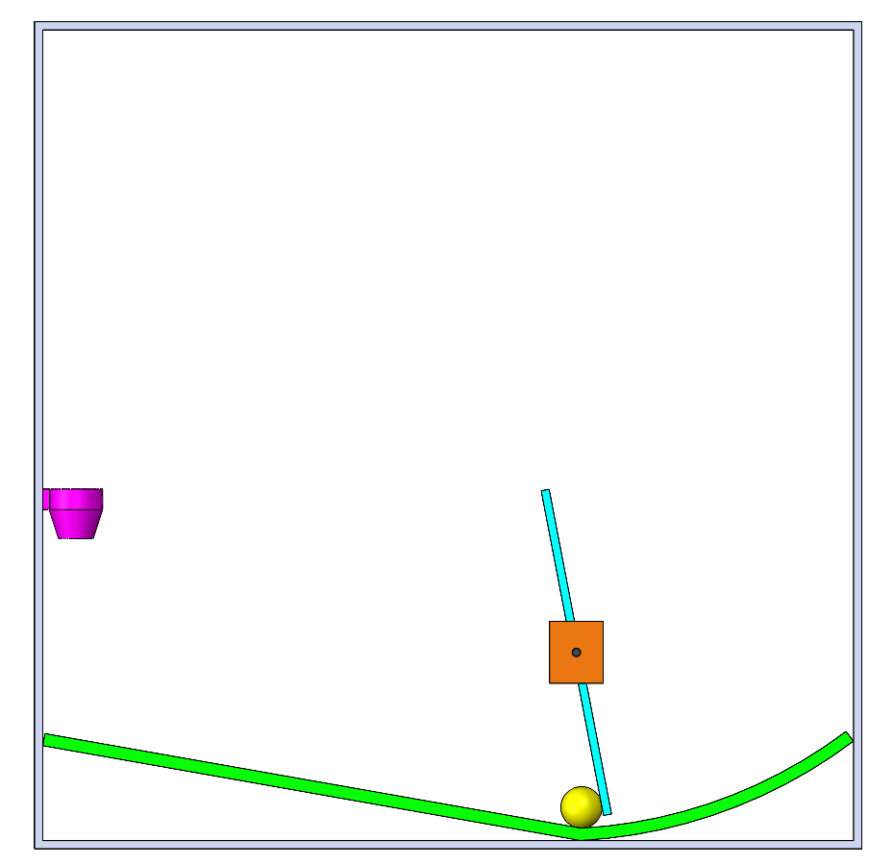

**Target Velocity**

**(m/s)**

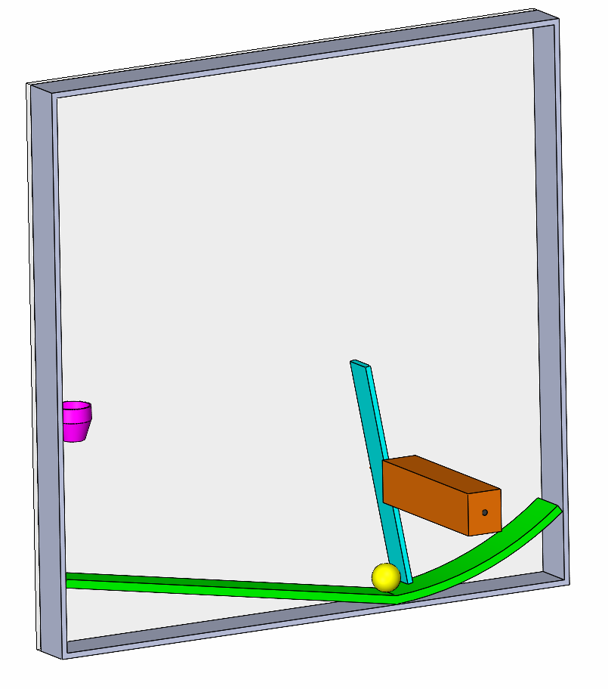

3D view of the physics space