analyzing optimizer space
- Reconstruction MSE for different signal types
- Constraint violation rates
- Convergence stability (oscillations, plateaus)
- Gradient signal-to-noise ratio
- Weight sensitivity distributions

Phase 1: Foundation Analysis
- Activation function comparison - Start here as it's fundamental
- Basic optimizer comparison - the existing SGD/Adam/etc. framework
- Learning rate sensitivity - Critical for understanding convergence
Pick 3-4 activation functions (ReLU, Tanh, Linear, Sigmoid), ReLU vs no activation: exploring the "activation function dimension" of optimizer space
Train your autoencoder with each one using your existing code
Compare final reconstruction errors - pick the winner
Test 3-4 learning rates (0.0001, 0.001, 0.01, 0.1) with the best activation
Compare 2-3 optimizers (Adam, SGD, Momentum) with best activation + learning rate

Phase 2: Constraint Analysis
- Implement lossless constraints - This is unique to your application
- Measure constraint satisfaction rates
- Analyze trade-offs between compression ratio and reconstruction quality

Phase 3: Deep Landscape Analysis
- Selective weight variation - Understand which weights matter most
- Gradient noise analysis - Critical for neural signal processing
- Multi-scale perturbation testing

Step 1: Use Best Weights
After training your model with a certain optimizer (like SGD or Adam), save the model’s weights at the point where it performs best on the validation data.
This gives you a “baseline” — the known good configuration to compare with.

Step 2: Add Small Random Noise
Take those good weights and add small random noise to them (e.g., ±0.01 or ±0.001). Try this layer-by-layer.
- To see how sensitive each layer is to changes.
- If a small change drastically worsens performance, that layer is very sensitive.
- Robust models shouldn’t collapse from tiny noise.
You can then compare:
- “This layer dropped performance by 10%”
- “This one barely changed”
→ Tells you which layers matter most.

Step 3: Identify Sensitive Weights
After doing noise tests on different parts (layers or parameter groups), measure how much performance drops.
- Sensitive weights are the ones optimizers need to treat carefully (smaller step sizes).
- Some optimizers (like Adam) are better at handling such cases.
🎯 Result: You get a map of which weights are fragile and influence overall performance the most.
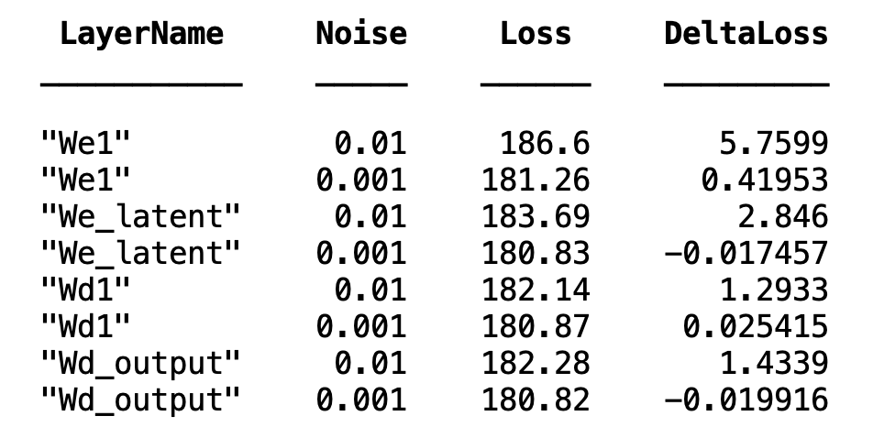
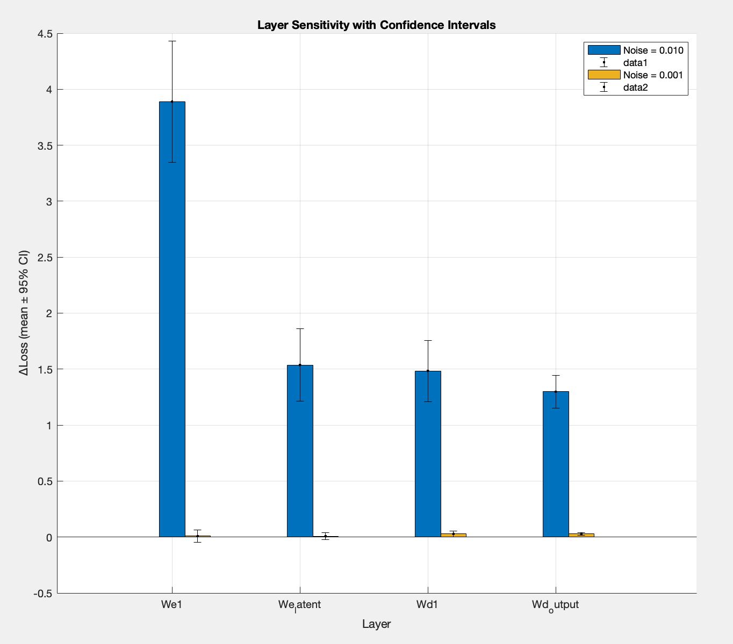
% Compute baseline loss once
baseline_loss = evaluate_model_loss(original_weights, original_bias, X_train_original);

% Initialize table with DeltaLoss included
results = table('Size', [0 4], ...
'VariableTypes', {'string', 'double', 'double', 'double'}, ...
'VariableNames', {'LayerName', 'Noise', 'Loss', 'DeltaLoss'});

% Loop and compute everything in one pass
for i = 1:length(Layer_Names)
for j = 1:length(Noise_Levels)
current_layer = Layer_Names(i);
current_noise = Noise_Levels(j);

W = original_weights.(current_layer);
noisy_W = W + current_noise * randn(size(W));

temp_weights = original_weights;
temp_weights.(current_layer) = noisy_W;

current_loss = evaluate_model_loss(temp_weights, original_bias, X_train_original);
delta_loss = current_loss - baseline_loss;

results = [results; {current_layer, current_noise, current_loss, delta_loss}];
end
end

Step 4: Test Gradient Consistency
Take two different mini-batches of data, and compute the gradient (direction of steepest descent) for each.
Then, compare how similar the gradients are (using cosine similarity, for example).
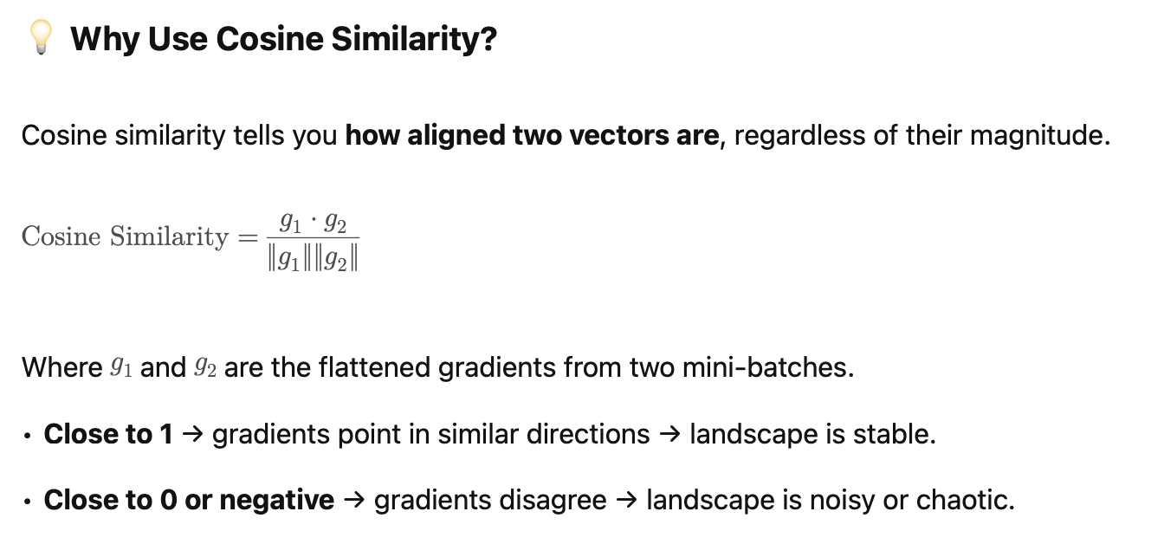
- If gradients vary wildly between batches, your optimization landscape is noisy or unstable.
- Optimizers like Adam or RMSprop are designed to work better in noisy environments.
Insight: You understand how “reliable” the gradients are for training.

Step 5: Map Landscape Roughness
Now, you test how the loss changes when you move slightly in random directions around your current weight values.
You perturb weights a bit in random directions and plot the loss. This gives you a 1D curve (or 2D surface) of the loss landscape.
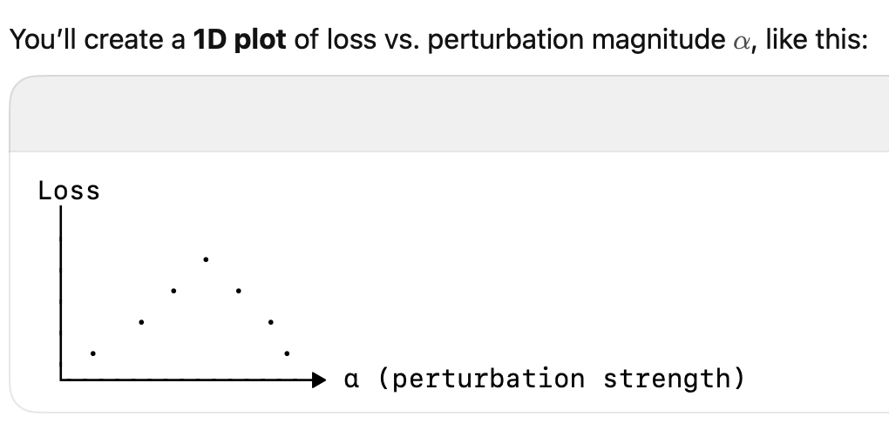
- If the loss increases smoothly → the landscape is smooth → SGD works well.
- If it jumps erratically → the landscape is rough → adaptive optimizers (Adam, RMSprop) help more.
📈 Plotting the curve helps you visualize if you’re in a sharp valley or a flat bowl.

🎯 Final Outcome:
After all of this, you’ll have a clearer sense of:
- Which weights are critical,
- How noisy your gradients are,
- What your local landscape looks like,
- And why a specific optimizer might work better than another.

Phase 4: Advanced Optimization
- Implement cosine annealing (easy win)
- Test simulated annealing if needed
- Custom hybrid approaches based on your findings

more optimizers to add:
Cosine Annealing (Easier to implement)
This would be particularly straightforward. Cosine annealing adjusts the learning rate during training using a cosine decay schedule:
% Add this to your training loop
initial_lr = learning_rate;
current_lr = initial_lr * 0.5 * (1 + cos(pi * epoch / num_epochs));
Benefits for your autoencoder:
- Helps escape local minima by periodically increasing the learning rate
- Often leads to better final convergence
- Works well with Adam, Momentum, etc. (you'd just modify their learning rates)
- Simple to implement with your existing optimizers

Simulated Annealing (More complex but potentially powerful)
% Simulated annealing parameters
initial_temp = 1.0;
cooling_rate = 0.95;
temperature = initial_temp;

% In your training loop, accept/reject weight updates based on temperature
if new_loss < current_loss || rand() < exp(-(new_loss - current_loss)/temperature)
% Accept the update
weights = new_weights;
end
temperature = temperature * cooling_rate;
Benefits for your signal processing application:
- Excellent for avoiding local minima (crucial for neural signal reconstruction)
- Can help find globally better solutions
- Particularly good when the loss landscape is complex (common with autoencoders)

Evaluation
- Does the optimizer navigate the optimization space well?

✅ Signs of Good Navigation:
- Loss decreases consistently (no wild oscillations)
- Training converges in reasonable steps
- Final solution has low loss and high task performance
- Trajectory follows smooth descent, not stuck early
does the optimizer navigates well?
    - plot loss vs Epoch
plot(epochs, trainLoss, 'b', epochs, valLoss, 'r');
legend('Train Loss', 'Validation Loss');
title('Loss Curve');
Flat or diverging curve → poor navigation
Zigzagging curve → unstable or bad step sizes

  - Does the optimizer converge (finds the true reconstruction of the signal)
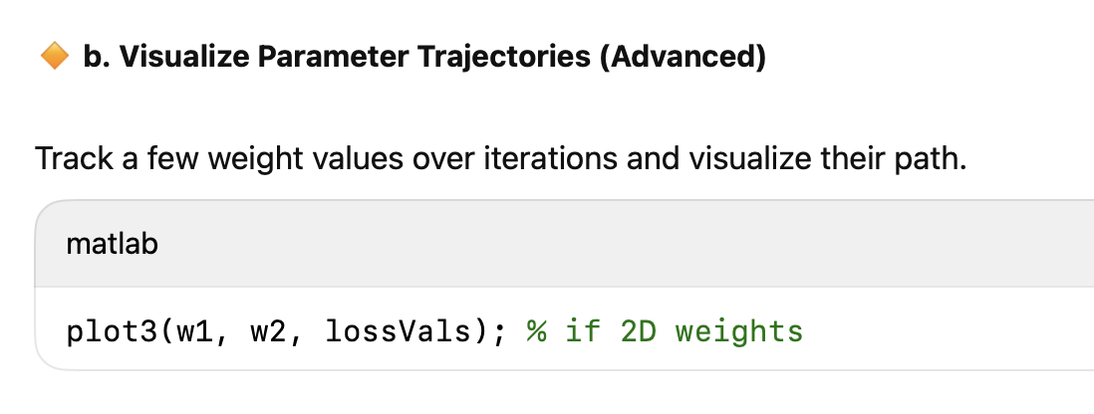
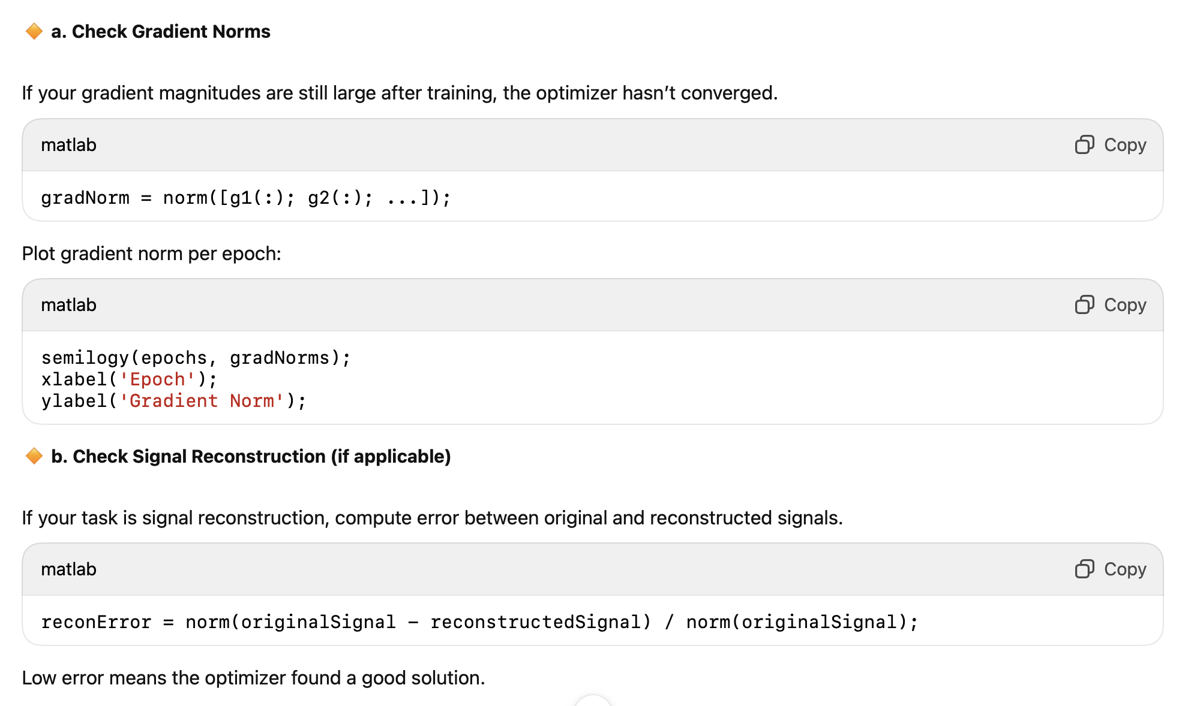

  - Does it find the global maximum/minimum or only the local one
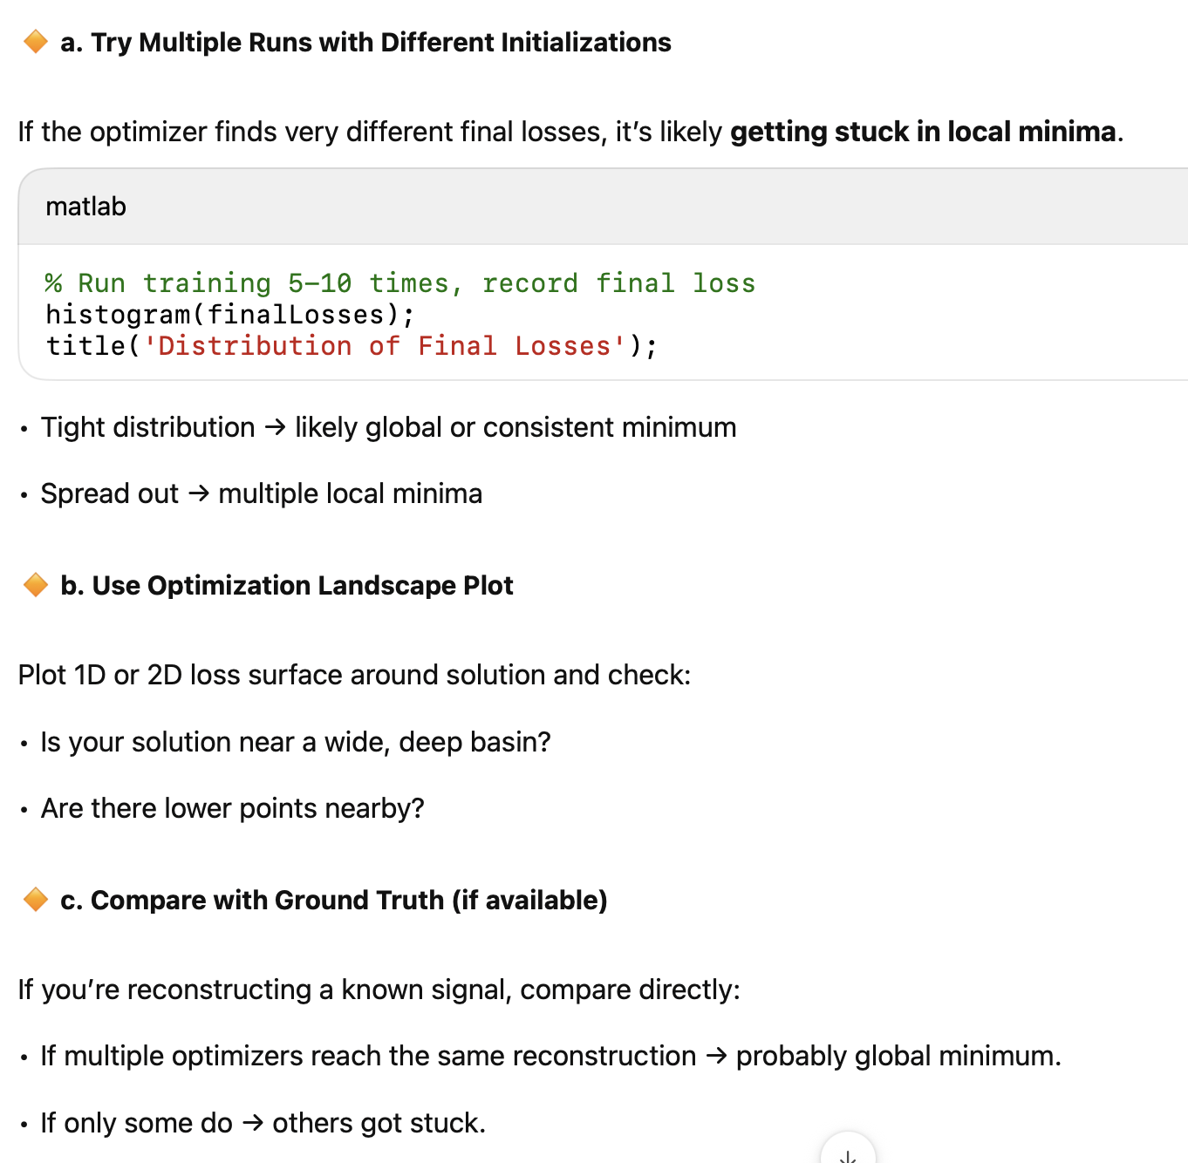
- Why do we use gradient based optimization?
- Why are Neural networks not simple Optimizers
- Evaluate whether the Optimizer is good
  - Is the optimization space noisy
  - Does the optimizer converge (finds the true reconstruction of the signal)
  - Does it find the global maximum/minimum
  - use a SSIM metric in our loss function, build a feature extractor

figure;
hold on;
for i = 1:length(Noise_Levels)
rows = abs(results.Noise - Noise_Levels(i)) < 1e-6;
bar_data = results.DeltaLoss(rows);
ci = results.ConfInterval(rows);
x = 1:sum(rows);

% Bar plot
b = bar(x + (i-1)*0.2, bar_data, 0.2, 'DisplayName', sprintf('Noise = %.3f', Noise_Levels(i)));

% Error bars
errorbar(x + (i-1)*0.2, bar_data, ci, 'k.', 'LineStyle', 'none');
end

% Sort based on DeltaLoss at noise = 0.1
target_noise = 0.1;
row_filter = abs(results.Noise - target_noise) < 1e-6;
[~, sort_idx] = sort(results.DeltaLoss(row_filter), 'descend');
sorted_layers = results.LayerName(row_filter);
sorted_layers = sorted_layers(sort_idx);

xticks(1:length(Layer_Names));
xticklabels(Layer_Names);
xlabel('Layer');
ylabel('ΔLoss (mean ± 95% CI)');
legend show;
legend(arrayfun(@(x) sprintf('Noise = %.4f', x), Noise_Levels, 'UniformOutput', false), ...
'Location', 'northwest');
title('Layer Sensitivity with Confidence Intervals');
grid on;
hold off;

