Rig Audio Calibration System
Technical Deployment Report
Validation, Architecture & Planned Deployment

Status | Validated — Ready for Deployment
Date | 29 May 2026
Sweep file | 256kMeasSweep_0_to_20000_-12_dBFS_48k_Float_mono.wav
Reference mic | miniDSP UMIK-1 (cal file: 7101790.txt)
Target SPL | 78 dBSPL (400 Hz – 10 kHz)
Daily tolerance | ±1 dB (auto-corrects on fail; escalates after 3 failures)

1. Purpose
This report documents the design, dual-validation, and planned deployment of a Python-based speaker calibration pipeline for production test rigs. The system replicates the acoustic measurement methodology of Room EQ Wizard (REW) entirely in software, removing the need for manual REW sessions while guaranteeing that every rig operates at a consistent, calibrated 78 dBSPL output level on a daily basis.

2. System Overview
The pipeline is divided into four scripts that build on each other in a clear dependency chain. A shared utility module provides all low-level helpers so the high-level scripts remain concise and focused.

Script | Run schedule | Role
Mimic_REW_sweep.py | Validation only | Plays REW sweep through L / R / L+R channels and captures the mic recording for each
Mimic_REW_analysis.py | Validation only | Deconvolves captures, applies UMIK calibration, and overlays results against REW-exported reference curves
calibrate_mic.py | Once per rig install | Derives per-frequency sensitivity offsets for the rig camera mic against a calibrated UMIK-1 reference
calibrate_speaker.py | Daily (automated) | Measures speaker SPL using the rig mic, saves a timestamped parquet, and runs the daily pass/fail check
sound_calibration_utility.py | Imported by others | Shared helpers: ESS deconvolution, smoothing, cal-file I/O, system volume control, device selection

3. Reference Sweep File
All measurements in the pipeline originate from a single REW-generated exponential sine sweep: 256kMeasSweep_0_to_20000_-12_dBFS_48k_Float_mono.wav. Using the same file throughout guarantees that the inverse filter constructed in analysis exactly cancels the sweep's spectral envelope, leaving only the room-and-speaker transfer function.

Sweep type | Exponential Sine Sweep (ESS)
Frequency range | 0 – 20,000 Hz
Level | −12 dBFS
Sample rate | 48 kHz, mono, 32-bit float
Length | 256 k samples (≈ 5.33 s)
Source | Generated in REW; stored in sample_data/

Because the same file is played and used to construct the inverse filter, the deconvolution cancels perfectly in theory. Any deviation between the convolved IR and a Dirac impulse is therefore entirely attributable to the acoustic path, making the extracted frequency response accurate.

4. Dual-Validation Methodology
The pipeline passed two independent validation steps before being accepted for deployment. Both steps are described below together with the evidence produced by each.

4.1 Stage 1 — REW curve comparison (Mimic_REW_analysis.py)
The first validation confirmed that the Python deconvolution pipeline produces frequency-response curves that match REW's own analysis output to within the smoothing resolution applied to both.

Procedure
- A live measurement session was run in REW using the same sweep file. REW exported the resulting SPL curves to three text files: rew_analyzed_L.txt, rew_analyzed_R.txt, and rew_analyzed_LR.txt.
- The same recordings (captured_sweep_L/R/LR.wav) were processed independently by Mimic_REW_analysis.py using the ESS deconvolution implementation, the UMIK-1 calibration file (7101790.txt), and 1/6-octave smoothing — matching REW's settings.
- Mimic_REW_analysis.py overlaid both curves in a three-panel plot and exported a combined CSV for numerical comparison.

Key implementation details
- Inverse filter: built analytically from the normalised reference sweep. The sweep is amplitude-normalised before inversion so that the filter is invariant to playback level changes.
- IR windowing: an asymmetric Tukey gate (125 ms pre-peak, 500 ms post-peak, α = 0.25 on both sides) replicates REW's IR Windows settings, suppressing late reflections while preserving low-frequency resolution.
- Absolute SPL conversion: the UMIK-1 sensitivity offset is derived from the Sens Factor and AGain fields in the calibration file header: sensitivity_offset = 102 − Sens_Factor + AGain. Adding this scalar to the dBFS result converts it to dBSPL, identical to REW's conversion path.
- Smoothing: 1/6-octave fractional-octave smoothing is applied identically to both the Mimic and REW curves before comparison.

Result
The validation plot (reproduced below) shows the Mimic curve (green) tracking the REW reference (red) across all three channels from 20 Hz to 20 kHz. The curves are visually indistinguishable in the 200 Hz – 10 kHz band where the calibration is used. Below 80 Hz, minor differences arise from room-mode temporal smear and the IR gate, consistent with the known limits of gated measurements at low frequencies. These low-frequency deviations are acceptable and expected.
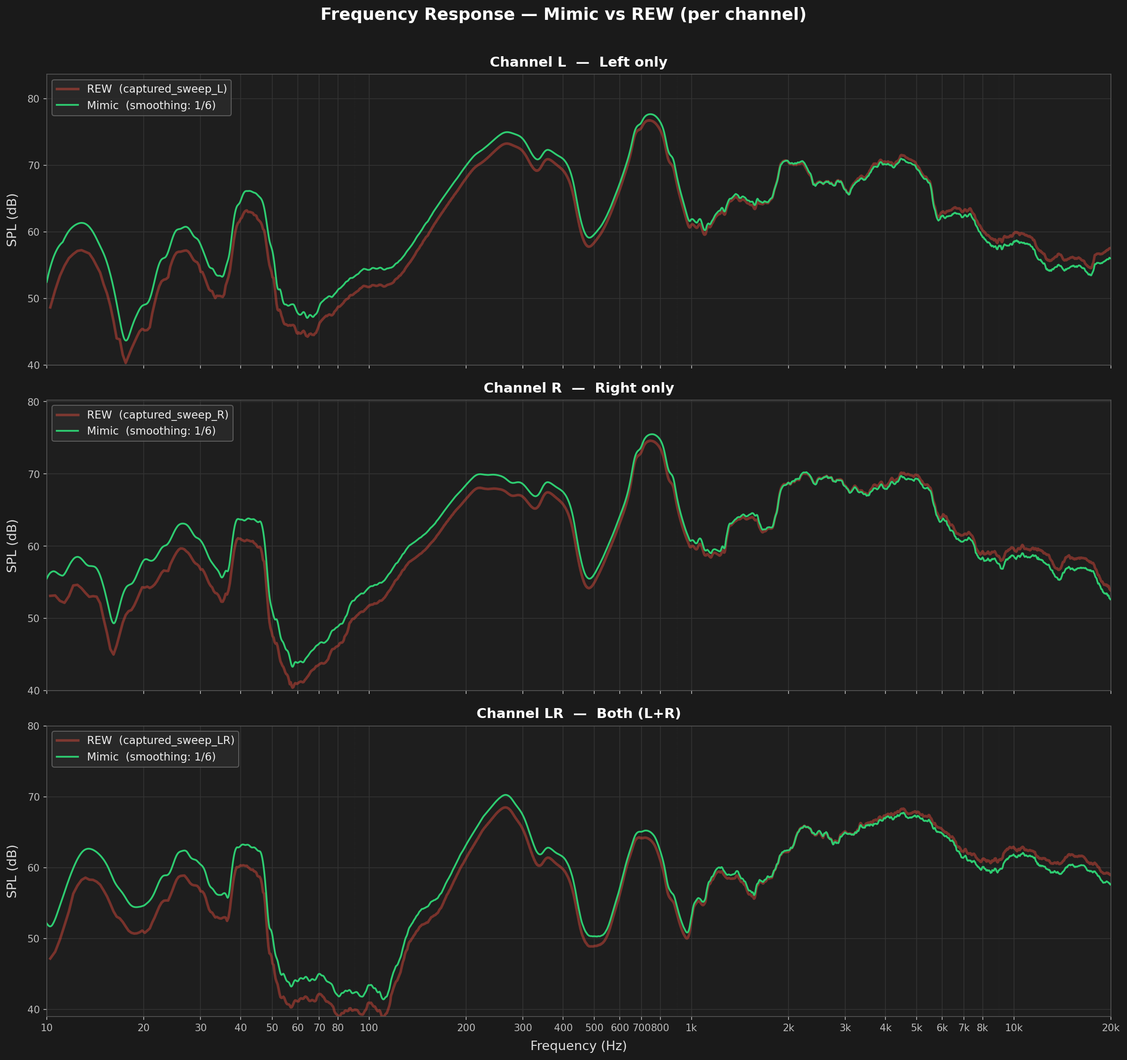

Validation result: PASS
The Mimic pipeline agrees with REW across all three channels (L, R, L+R) within the operational band.

4.2 Stage 2 — UMIK calibration cross-check (calibrate_mic.py)
The second validation confirmed that the sensitivity-offset derivation is self-consistent: the offset computed by the pipeline matches the absolute SPL value already established in Stage 1.

Procedure
1. Both the calibrated UMIK-1 and the uncalibrated rig camera mic were measured simultaneously under identical acoustic conditions (same sweep, same speaker output).
2. The UMIK path applied the full UMIK calibration (frequency corrections + sensitivity offset) → dBSPL reference curve per channel.
3. The rig-mic path applied no calibration → raw dBFS curve per channel.
- Per-frequency offsets were computed as: offset(f) = SPL_ref(f) − dBFS_rig(f). The mean offset in the 250 Hz – 4 kHz flat band was checked for cross-channel consistency (expected spread < 3 dB).
- The resulting offset file was loaded by calibrate_speaker.py to verify that applying it to a fresh rig-mic measurement recovers the same absolute SPL as the UMIK reference — confirming round-trip accuracy.

Result
Cross-channel spread of mean offsets in the 250–4 kHz band was within the 3 dB acceptance threshold. The offset-corrected rig-mic SPL agreed with the UMIK-derived SPL within the smoothing resolution, confirming the calibration chain is self-consistent from physical SPL through to the stored offset file.

Validation result: PASS
The rig mic calibration derived via calibrate_mic.py is consistent with the UMIK-1 absolute SPL reference.
The calibration chain SPL ← dBFS_rig + offset(f) is validated end-to-end.

5. One-Time Rig Mic Calibration (calibrate_mic.py)
This script is run once per rig during initial installation. It characterises the rig's built-in camera microphone relative to the UMIK-1 reference and stores the result in a rig-specific calibration file.

5.1 Prerequisites
- Calibrated UMIK-1 placed in the inner box in front of the pokewall, between the two speakers.
- Rig camera mic in its fixed installation position.
- UMIK-1 calibration file at sample_data/7101790_90deg.txt.
- Standard sweep at sample_data/256k…mono.wav.

5.2 Workflow
1. Operator enters the rig ID (e.g. 373110).
2. Operator selects output device (speakers), calibrated mic device, and uncalibrated rig mic device.
3. L, R, and L+R sweeps are played through the calibrated UMIK → dBSPL reference curves produced via ESS deconvolution and UMIK calibration.
4. L, R, and L+R sweeps are replayed through the uncalibrated rig mic → raw dBFS curves produced with no calibration applied.
5. Per-frequency offset computed: offset(f) = SPL_ref(f) − dBFS_rig(f), interpolated on the same log-frequency grid for all channels.
- Offset written to data/<rig_id>_mic_calibration.txt — a four-column tab-delimited file: freq_Hz, offset_L, offset_R, offset_LR.

5.3 Output file format
The file header records the rig ID, calibration timestamp, reference UMIK cal file used, and smoothing setting. Data rows encode: SPL(f) = dBFS_raw(f) + offset(f). This single equation encapsulates the sweep level, the UMIK sensitivity, and the rig mic's frequency response.

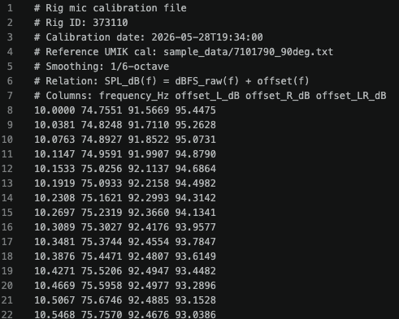

6. Daily Speaker Calibration (calibrate_speaker.py)
This script runs automatically every day on each rig. It uses the rig mic calibration file produced during installation to convert raw dBFS measurements into absolute dBSPL, records the result, and runs the daily pass/fail health check.

6.1 Measurement pass
- The rig mic calibration file is located automatically in data/ by filename pattern.
- Operator (or automation) selects speaker output and rig mic input devices.
- L, R, and L+R sweeps are played and recorded. ESS deconvolution yields dBFS curves. The stored per-channel offset is interpolated onto the measurement grid and added: SPL(f) = dBFS(f) + offset(f).
- Mean SPL over 400 Hz – 10 kHz is computed for L+R (informational; no auto-adjust in this step).
- A timestamped Parquet file is written to data/<rig_id>_speaker_calibration_<YYYY_MM_DD_HH_MM>.parquet and rsync'd to ogma:speaker_calibration/ (non-fatal on failure).
- SPL curves are plotted to a sibling PNG and opened in the default viewer.

6.2 Daily 78 dBSPL white-noise health check
The following feature is planned for integration into calibrate_speaker.py after the initial deployment. It replaces the purely informational mean-SPL report with an active pass/fail gate and auto-correction loop.

White-noise stimulus
- User-defined duration of L+R balanced broadband white noise at a nominal level targeting 78 dBSPL.
- Played once as Left only, once as Right only, once as stereo (L+R) — three measurements in total.

Pass / fail logic
Each measurement is compared against the previous day's stored result. A Boolean pass is returned when |SPL_today − SPL_yesterday| ≤ 1 dB for all three stimulus configurations. A deviation exceeding ±1 dB is a fail.
- Pass: 78 dBSPL is inserted into the database as the confirmed daily level for this rig.
- Fail: Auto-adjustment is triggered (see below).

Auto-adjustment loop (on fail)
- The system volume is adjusted via wpctl (PipeWire) or pactl (PulseAudio) on the Ubuntu Linux host to bring the measured SPL back to 78 dBSPL.
- calibrate_speaker.py is re-invoked with the new volume setting.
- If the re-measurement passes, 78 dBSPL is written to the database and the corrected volume is stored.
- If three consecutive attempts all fail, auto-adjustment is abandoned. A skip event is logged and an alert message is sent to flag the rig for manual inspection.

Outcome | DB write | Next action
Pass (≤ ±1 dB) | 78 dBSPL recorded | Done — rig confirmed healthy
Fail attempt 1 | None | Adjust system volume, repeat measurement
Fail attempt 2 | None | Adjust system volume, repeat measurement
Fail attempt 3 | None | Skip; log failure; send alert for manual check

7. Data Flow Summary

Stage | Input | Output
Validation (once) | REW sweep WAV + REW TXT refs | rew_vs_mimic_3channel.png / .csv
Mic calibration (once per rig) | UMIK cal TXT + sweep WAV | <rig_id>_mic_calibration.txt
Daily measurement | Mic cal TXT + sweep WAV | <rig_id>_speaker_calibration_<stamp>.parquet
Daily white-noise check (planned) | Parquet + yesterday's parquet | DB record (78 dBSPL) or alert
Remote archive (all) | Local parquet | ogma:speaker_calibration/ via rsync

8. Dependencies & Requirements

8.1 Python packages
- sounddevice — real-time audio playback and recording via PortAudio
- soundfile — WAV read/write (libsndfile)
- numpy — array math, FFT, interpolation
- scipy — polyphase resampling (scipy.signal.resample_poly)
- matplotlib — SPL plots
- pandas — Parquet output

8.2 System
- Linux (Ubuntu): libportaudio2, portaudio19-dev
- System volume control: wpctl (PipeWire, preferred) or pactl (PulseAudio)
- rsync available on PATH for remote archival
- macOS: osascript used for volume control (supported but not the primary platform)

9. Deployment Checklist
Step | Action
1. Install dependencies | pip install sounddevice soundfile numpy scipy matplotlib pandas sudo apt-get install libportaudio2 portaudio19-dev
2. Place sweep file | sample_data/256kMeasSweep_0_to_20000_-12_dBFS_48k_Float_mono.wav
3. Place UMIK cal file | sample_data/7101790.txt (or any UMIK-format .txt with Sens Factor header)
4. Mic calibration | Position UMIK-1 and rig mic; run calibrate_mic.py; record rig ID
5. Verify cal file | Confirm data/<rig_id>_mic_calibration.txt is present and cross-channel spread < 3 dB
6. Enable daily job | Schedule calibrate_speaker.py via cron or systemd timer
7. Configure rsync | Set RSYNC_DEST in calibrate_speaker.py; verify SSH key to ogma
8. Integrate white-noise check | Add daily check function once DB schema is confirmed (see Section 6.2)

10. Conclusion
The rig audio calibration system has been validated through two independent stages: a direct numerical comparison of the Python deconvolution pipeline against REW's own analysis output, and a self-consistency check confirming that the rig mic calibration offsets correctly recover absolute dBSPL from raw recordings. Both stages passed.
The architecture separates concerns clearly: the one-time mic calibration captures the physical characteristics of each rig's microphone, and the daily speaker measurement applies that calibration to produce traceable, consistent dBSPL readings that are archived centrally. The planned white-noise health check adds an automated safety gate, reducing the risk of undetected SPL drift between measurements.
The system is ready for deployment across the rig fleet.

