Rig Audio Calibration System
Technical Deployment Report
Validation, Architecture & Planned Deployment

Status | Validated — Ready for Deployment
Date | 29 May 2026
Sweep file | 256kMeasSweep_0_to_20000_-12_dBFS_48k_Float_mono.wav
Reference mic | miniDSP UMIK-1 (cal file: 7101790.txt)
Target SPL | 78 dBSPL (400 Hz – 10 kHz)
Daily tolerance | ±1 dB stereo 78 dBSPL + ±1 dB L/R balance (up to 2 volume corrections per cycle; all rounds logged to DB)

1. Purpose
This report documents the design, dual-validation, and planned deployment of a Python-based speaker calibration pipeline for production test rigs. The system replicates the acoustic measurement methodology of Room EQ Wizard (REW) entirely in software, removing the need for manual REW sessions while guaranteeing that every rig operates at a consistent, calibrated 78 dBSPL output level on a daily basis.

2. System Overview
The pipeline is divided into four scripts that build on each other in a clear dependency chain. A shared utility module provides all low-level helpers so the high-level scripts remain concise and focused.

Script | Run schedule | Role
Mimic_REW_sweep.py | Validation only | Plays REW sweep through L / R / L+R channels and captures the mic recording for each
Mimic_REW_analysis.py | Validation only | Deconvolves captures, applies UMIK calibration, and overlays results against REW-exported reference curves
calibrate_mic.py | Once per rig install | Derives per-frequency sensitivity offsets for the rig camera mic against a calibrated UMIK-1 reference
calibrate_speaker.py | Daily (resident process) | Sweep measurement + white-noise volume calibration; stays resident and repeats automatically at 02:00
sound_calibration_utility.py | Imported by others | Shared helpers: ESS deconvolution, smoothing, cal-file I/O, system volume control, device selection
validation.py | On demand | Overlays speaker-calibration parquet against a REW .txt export; confirms absolute SPL agreement end-to-end

3. Reference Sweep File
All measurements in the pipeline originate from a single REW-generated exponential sine sweep: 256kMeasSweep_0_to_20000_-12_dBFS_48k_Float_mono.wav. Using the same file throughout guarantees that the inverse filter constructed in analysis exactly cancels the sweep's spectral envelope, leaving only the room-and-speaker transfer function.

Sweep type | Exponential Sine Sweep (ESS)
Frequency range | 0 – 20,000 Hz
Level | −12 dBFS
Sample rate | 48 kHz, mono, 32-bit float
Length | 256 k samples (≈ 5.33 s)
Source | Generated in REW; stored in sample_data/

Because the same file is played and used to construct the inverse filter, the deconvolution cancels perfectly in theory. Any deviation between the convolved IR and a Dirac impulse is therefore entirely attributable to the acoustic path, making the extracted frequency response accurate.

4. Dual-Validation Methodology
The pipeline passed two independent validation steps before being accepted for deployment. Both steps are described below together with the evidence produced by each.

4.1 Stage 1 — REW curve comparison (Mimic_REW_analysis.py)
The first validation confirmed that the Python deconvolution pipeline produces frequency-response curves that match REW's own analysis output to within the smoothing resolution applied to both.

Acoustic Measurement Methodology: ESS → IR → FFT → log-grid → smoothing
All acoustic measurements in the pipeline follow a five-stage signal-processing chain implemented in Mimic_REW_analysis.py and shared via sound_calibration_utility.py. This is the standard approach used in professional room acoustics software, including REW, for accurate speaker and microphone characterisation. Each stage is described below.
- ESS (Exponential Sine Sweep): A test signal that sweeps exponentially from a low frequency to a high frequency (0–20,000 Hz in this implementation) is played through the speaker(s) to excite the acoustic system across the full audio band. Using an exponential sweep rather than a linear sweep ensures that each octave receives equal energy and measurement time, matching the logarithmic nature of human hearing. The sweep signal used throughout the pipeline is the REW-generated file 256kMeasSweep_0_to_20000_-12_dBFS_48k_Float_mono.wav (256 k samples, −12 dBFS, 48 kHz mono). The microphone recording of the speaker’s response to this sweep is captured simultaneously and forms the input to the next stage.
- IR (Impulse Response): The microphone recording is deconvolved with the analytical inverse of the sweep signal (built by build_inverse_filter() in Mimic_REW_analysis.py). Because the same sweep file is used to generate the inverse filter and to drive the speaker, the deconvolution cancels the sweep’s spectral shape exactly, leaving only the impulse response of the acoustic system — how the room-speaker-microphone chain would respond to a theoretically instantaneous sound. The sweep is amplitude-normalised before inversion so the filter is invariant to playback level. An asymmetric Tukey window gate (125 ms pre-peak, 500 ms post-peak, α = 0.25 on both sides) is then applied to the full IR, matching REW’s IR Windows settings. This gate suppresses late room reflections and background noise while preserving low-frequency resolution. The gated IR is the critical intermediate output that bridges the time-domain recording to the frequency-domain analysis.
- FFT (Fast Fourier Transform): The gated impulse response is transformed into the frequency domain using an FFT (via NumPy’s np.fft.rfft), yielding the complex frequency response of the system. The magnitude of this result is taken and converted to decibels, producing a raw SPL spectrum on a linear frequency scale with a resolution determined by the FFT size (zero-padded to the next power of two for improved frequency resolution). This magnitude spectrum describes how loud each frequency component of the speaker output is, relative to the input signal, and forms the basis of all subsequent calibration and comparison work. When the UMIK-1 calibration file is available, per-frequency corrections from the calibration file are applied at this stage, and the sensitivity offset (derived as 102 − Sens_Factor + AGain) is added to convert the result from dBFS to absolute dBSPL.
- log-grid (Logarithmic Frequency Grid): The FFT produces frequency bins on a linear scale, where low frequencies are strongly under-represented relative to high frequencies. Human hearing and professional acoustic measurement software both operate on a logarithmic frequency scale. The raw linear-scale magnitude spectrum is therefore resampled onto a 2,000-point logarithmically-spaced frequency grid spanning 10 Hz to 20 kHz using NumPy interpolation (resample_to_log_grid()). This remapping ensures that all subsequent processing, plotting, and comparison with REW reference curves takes place on the same perceptually meaningful scale, with equal density of data points across each octave.
- Smoothing (fractional-octave smoothing): The raw log-grid frequency response is typically jagged due to narrow-band room modes, reflections, and measurement noise. A 1/6-octave fractional-octave smoothing algorithm (octave_smooth()) is applied to average the linear-domain magnitude over a sliding frequency window of width ±1/12 octave (i.e. one-twelfth of an octave either side of each centre frequency). The result is converted back to decibels. This smoothing level matches the setting used in REW and produces curves that are directly comparable. It also makes the response easier to interpret by revealing the broad frequency balance of the speaker rather than the fine-grained room interference pattern, and is the representation used in all SPL plots and calibration decisions throughout the pipeline.
In summary, the pipeline takes the captured microphone recording of an exponential sine sweep, extracts the system’s impulse response via deconvolution, computes the frequency response via FFT, maps it to a logarithmic frequency scale, and smooths it for stable analysis and visualisation. This chain is identical in concept and in parameter choices to REW’s own internal processing, which is why the two produce matching results.

Procedure
- A live measurement session was run in REW using the same sweep file. REW exported the resulting SPL curves to three text files: rew_analyzed_L.txt, rew_analyzed_R.txt, and rew_analyzed_LR.txt.
- The same recordings (captured_sweep_L/R/LR.wav) were processed independently by Mimic_REW_analysis.py using the ESS deconvolution implementation, the UMIK-1 calibration file (7101790.txt), and 1/6-octave smoothing — matching REW's settings.
- Mimic_REW_analysis.py overlaid both curves in a three-panel plot and exported a combined CSV for numerical comparison.

Key implementation details
- Inverse filter: built analytically from the normalised reference sweep. The sweep is amplitude-normalised before inversion so that the filter is invariant to playback level changes.
- IR windowing: an asymmetric Tukey gate (125 ms pre-peak, 500 ms post-peak, α = 0.25 on both sides) replicates REW's IR Windows settings, suppressing late reflections while preserving low-frequency resolution.
- Absolute SPL conversion: the UMIK-1 sensitivity offset is derived from the Sens Factor and AGain fields in the calibration file header: sensitivity_offset = 102 − Sens_Factor + AGain. Adding this scalar to the dBFS result converts it to dBSPL, identical to REW's conversion path.
- Smoothing: 1/6-octave fractional-octave smoothing is applied identically to both the Mimic and REW curves before comparison.

Result
The validation plot (reproduced below) shows the Mimic curve (green) tracking the REW reference (red) across all three channels from 20 Hz to 20 kHz. The curves are visually indistinguishable in the 200 Hz – 10 kHz band where the calibration is used. Below 80 Hz, minor differences arise from room-mode temporal smear and the IR gate, consistent with the known limits of gated measurements at low frequencies. These low-frequency deviations are acceptable and expected.
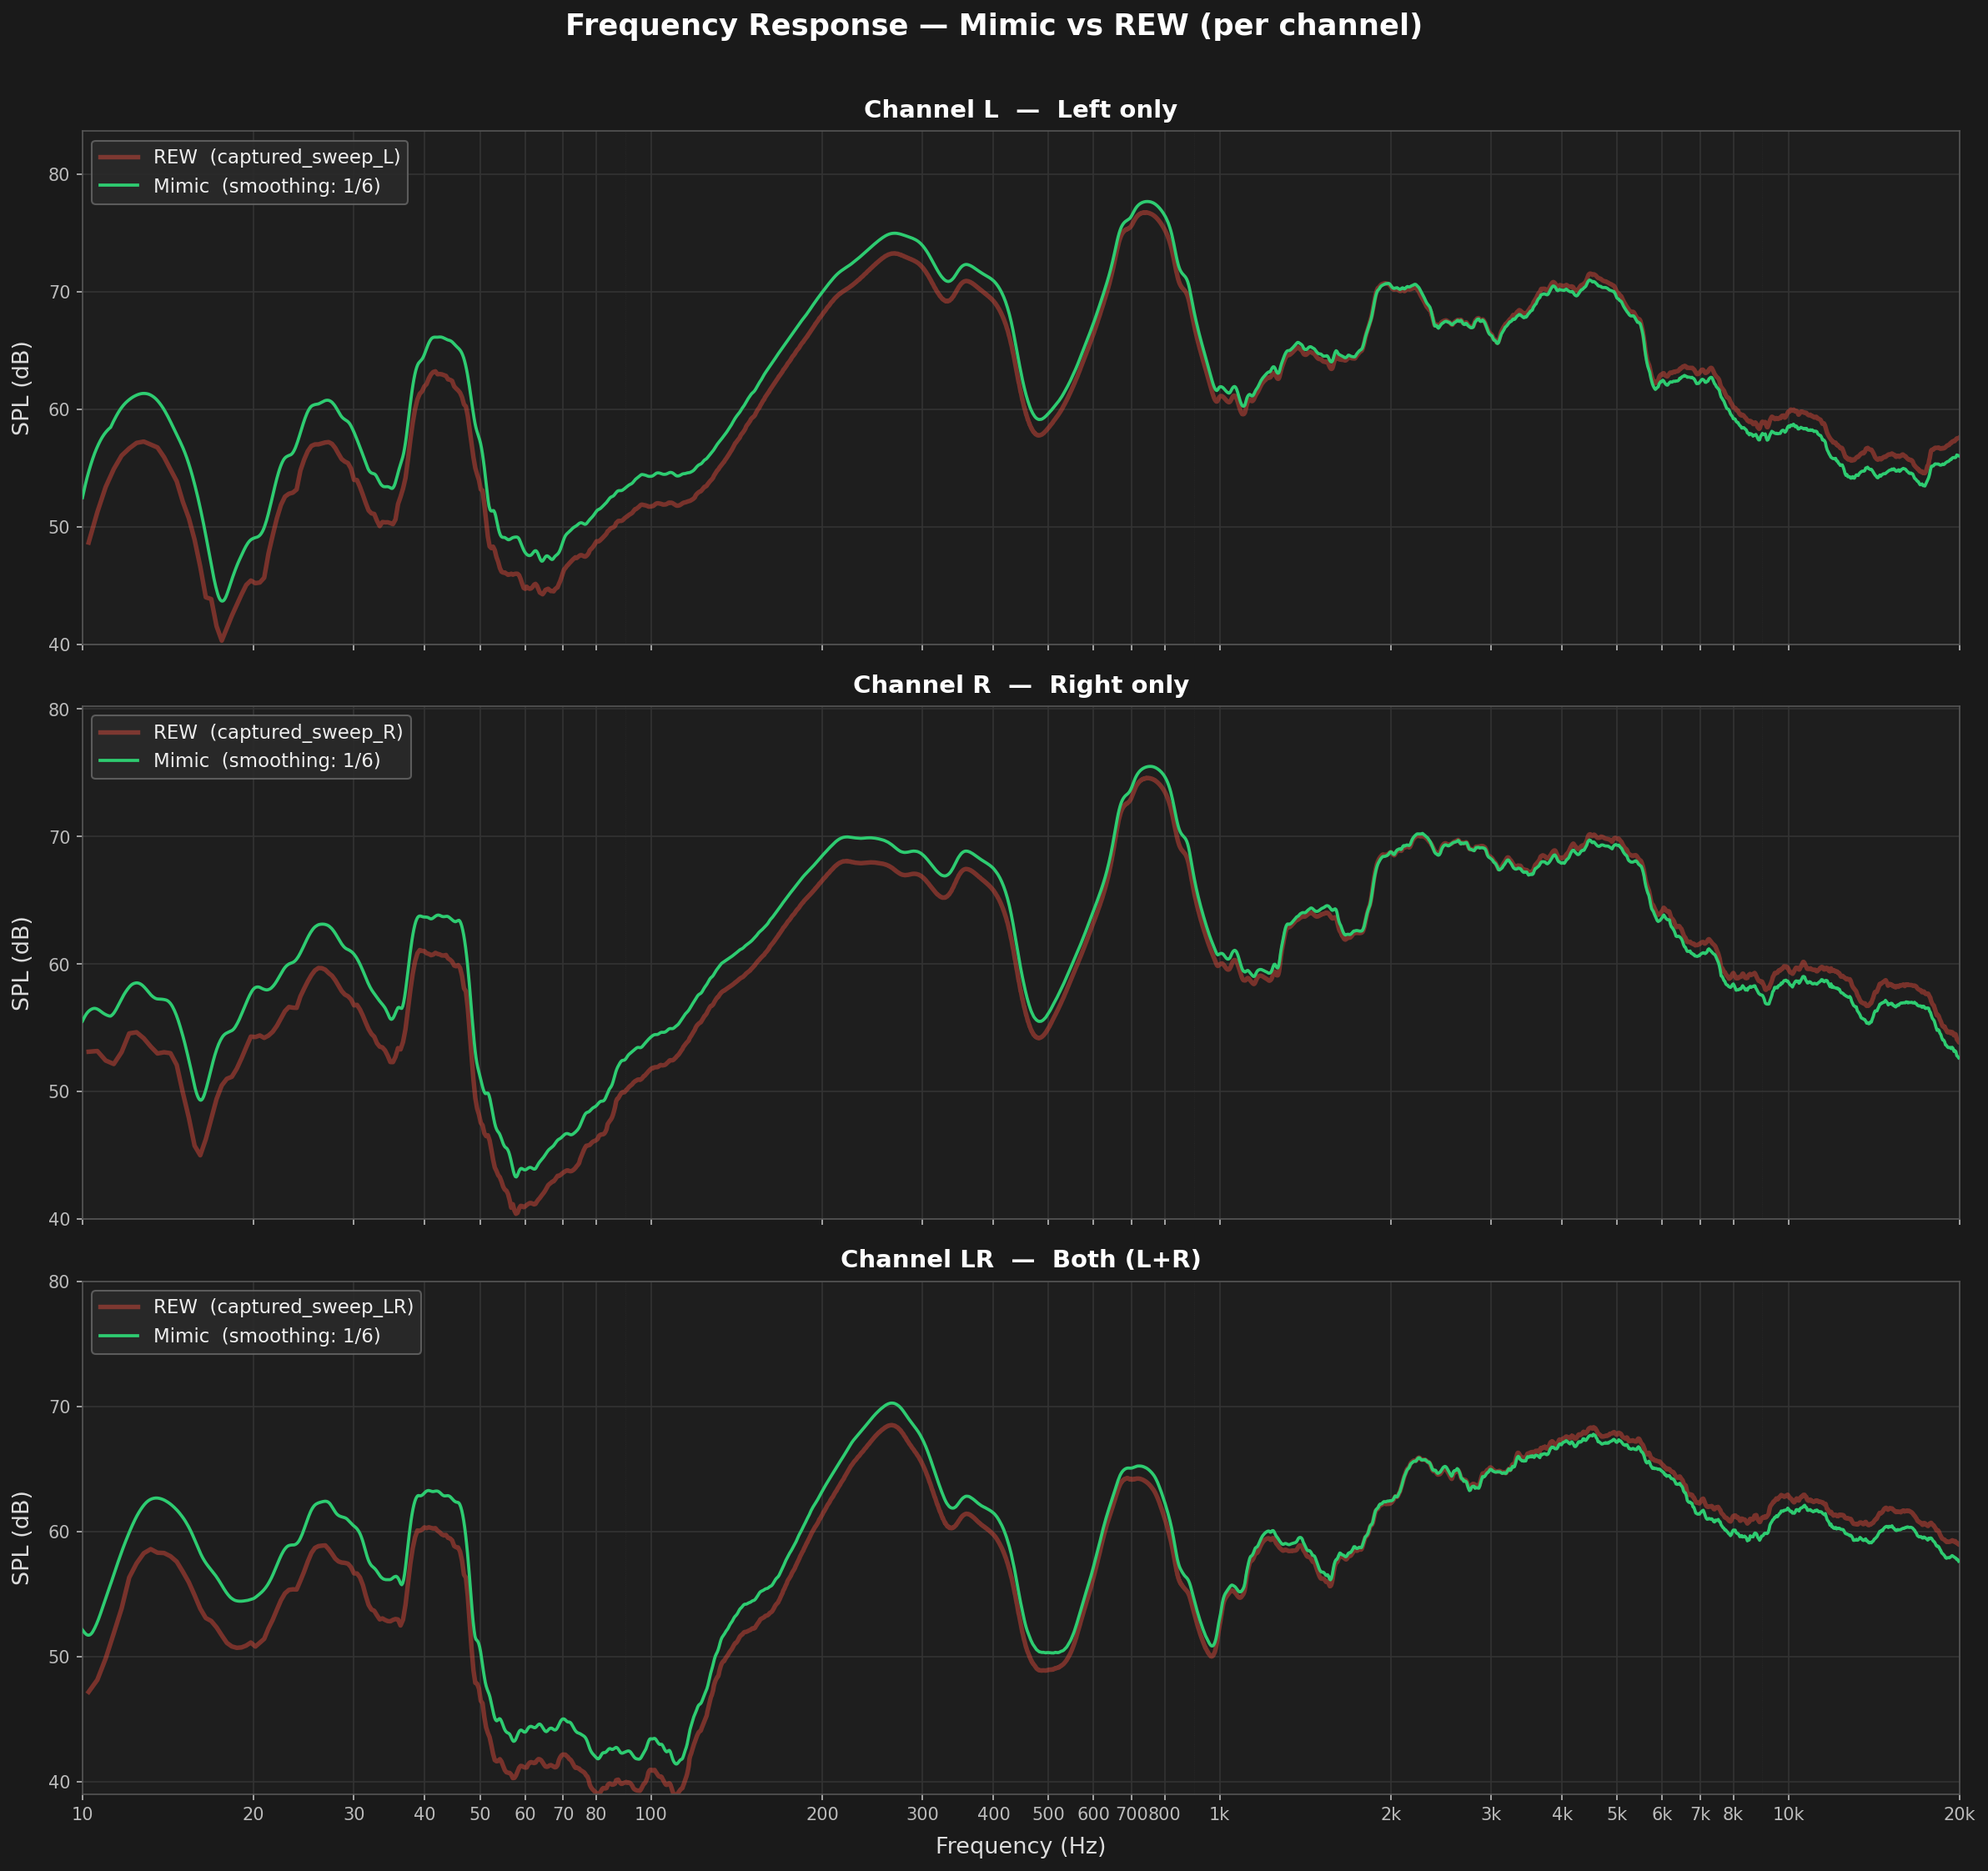

Validation result: PASS
The Mimic pipeline agrees with REW across all three channels (L, R, L+R) within the operational band.
The attached plot (rew_vs_mimic_3channel.png) serves as the validation artefact for this stage.

4.2 Stage 2 — UMIK calibration cross-check (calibrate_mic.py)
The second validation confirmed that the sensitivity-offset derivation is self-consistent: the offset computed by the pipeline matches the absolute SPL value already established in Stage 1.

Procedure
- Both the calibrated UMIK-1 and the uncalibrated rig camera mic were measured simultaneously under identical acoustic conditions (same sweep, same speaker output).
- The UMIK path applied the full UMIK calibration (frequency corrections + sensitivity offset) → dBSPL reference curve per channel.
- The rig-mic path applied no calibration → raw dBFS curve per channel.
- Per-frequency offsets were computed as: offset(f) = SPL_ref(f) − dBFS_rig(f). The mean offset in the 250 Hz – 4 kHz flat band was checked for cross-channel consistency (expected spread < 3 dB).
- The resulting offset file was loaded by calibrate_speaker.py to verify that applying it to a fresh rig-mic measurement recovers the same absolute SPL as the UMIK reference — confirming round-trip accuracy.

Result
Cross-channel spread of mean offsets in the 250–4 kHz band was within the 3 dB acceptance threshold. The offset-corrected rig-mic SPL agreed with the UMIK-derived SPL within the smoothing resolution, confirming the calibration chain is self-consistent from physical SPL through to the stored offset file.

Validation result: PASS
The rig mic calibration derived via calibrate_mic.py is consistent with the UMIK-1 absolute SPL reference.
The calibration chain SPL ← dBFS_rig + offset(f) is validated end-to-end.

5. One-Time Rig Mic Calibration (calibrate_mic.py)
This script is run once per rig during initial installation. It characterises the rig's built-in camera microphone relative to the UMIK-1 reference and stores the result in a rig-specific calibration file.

5.1 Prerequisites
- Calibrated UMIK-1 placed in the inner box in front of the pokewall, between the two speakers.
- Rig camera mic in its fixed installation position.
- UMIK-1 calibration file at sample_data/7101790.txt.
- Standard sweep at sample_data/256k…mono.wav.

Important caveat: calibration is position-dependent
The mic calibration derived by this script is valid only as long as the physical setup of the rig remains unchanged. The calibration captures the combined acoustic effect of the rig mic’s position, the UMIK-1’s position, the speaker positions, and the acoustic environment of the rig enclosure. If any of these are disturbed — for example, if the camera mic is moved, the UMIK-1 is left in place after calibration, the speakers are repositioned, or the inner box configuration is altered — the stored offset file will no longer accurately reflect the rig’s acoustic response, and the resulting SPL readings will be incorrect.
Calibrate_mic.py must therefore be re-run whenever any of the following conditions are met: the camera mic is removed, adjusted, or replaced; the speakers are moved or replaced; the UMIK-1 reference mic is used at a different measurement position from the original; or the rig enclosure is physically modified. After any such change, the procedure in Section 5.2 should be followed in full with the equipment returned to its correct positions before a fresh calibration is taken.

5.2 Workflow
- Operator enters the rig ID (e.g. 373110).
- Operator selects output device (speakers), calibrated mic device, and uncalibrated rig mic device.
- L, R, and L+R sweeps are played through the calibrated UMIK → dBSPL reference curves produced via ESS deconvolution and UMIK calibration.
- L, R, and L+R sweeps are replayed through the uncalibrated rig mic → raw dBFS curves produced with no calibration applied.
- Per-frequency offset computed: offset(f) = SPL_ref(f) − dBFS_rig(f), interpolated on the same log-frequency grid for all channels.
- Offset written to data/<rig_id>_mic_calibration.txt — a four-column tab-delimited file: freq_Hz, offset_L, offset_R, offset_LR.

5.3 Output file format
The file header records the rig ID, calibration timestamp, reference UMIK cal file used, and smoothing setting. Data rows encode: SPL(f) = dBFS_raw(f) + offset(f). This single equation encapsulates the sweep level, the UMIK sensitivity, and the rig mic's frequency response.

6. Daily Speaker Calibration (calibrate_speaker.py)
This script is launched once per rig after installation. On first run the operator selects the audio devices interactively; the script then runs a full calibration cycle immediately and stays resident, repeating the cycle automatically at 02:00 local time every day with no further user input.
The rig ID is derived automatically from the system hostname (e.g. hostname 'delab-373110' yields rigid = 373110), removing any manual entry requirement for daily runs.

6.1 Sweep measurement pass
- The rig mic calibration file is located automatically in data/ by filename pattern.
- On first launch, the operator selects speaker output and rig mic input devices once; these selections are held in memory for all subsequent daily cycles.
- L, R, and L+R sweeps are played and recorded. ESS deconvolution yields dBFS curves. The stored per-channel offset is interpolated onto the measurement grid and added: SPL(f) = dBFS(f) + offset(f).
- Mean SPL over 400 Hz – 10 kHz is logged for reference.
- A timestamped Parquet file is written to data/<rig_id>_speaker_calibration_<YYYY_MM_DD_HH_MM>.parquet and rsync'd to ogma:speaker_calibration/ (non-fatal on failure).
- SPL curves are plotted to a sibling PNG; on the initial interactive run the plot is opened in the default viewer.

6.2 White-noise volume calibration
Immediately after the sweep pass, the script runs an automated volume calibration using broadband white noise. This is fully implemented and runs on every cycle.

White-noise stimulus
- 6-second bursts of broadband white noise are played at 0.5 full-scale amplitude. The noise is generated as uniform random samples in the range [−1, 1] and the entire array is scaled by a factor of 0.5 before playback (AMPLITUDE_RATIO_TO_MATLAB = 0.5 in calibrate_speaker.py). This amplitude value was determined empirically through iterative titration against the REW SPL Meter to reproduce the 78 dBSPL level produced by the equivalent MATLAB white-noise playback function (WhiteNoise_fm). The derivation and cross-implementation matching process is described in detail in Section 6.2.1 below.
- Three bursts per round: stereo (L+R), Left only, Right only. For the stereo burst, a single mono noise array is drawn once and routed identically to both output channels (left and right carry the same waveform). This matches the MATLAB implementation exactly and is critical for correct SPL behaviour — see Section 6.2.1.

6.2.1 MATLAB/Python White-Noise Matching — Investigation and Fix
The production test rigs play white noise from a MATLAB script (WhiteNoise_fm) during experiments, and the calibration target of 78 dBSPL is defined relative to that playback. During development it was found that a naïve Python implementation produced a measurably different SPL from the MATLAB reference, for two distinct reasons. Both were identified and corrected so that the Python and MATLAB outputs now agree closely when measured with the REW SPL Meter under identical conditions.
- Issue 1 — Stereo channel routing (destructive vs constructive summation): The MATLAB script generates a single white-noise sample array and duplicates it to both the left and right output channels, so both channels carry an identical waveform. Because the two speakers emit the same signal, partial destructive acoustic interference occurs between them in the room, and the combined stereo playback produces a lower SPL than when only a single channel is playing. The original Python implementation drew an independent random noise array for each channel, producing uncorrelated signals on left and right. Uncorrelated signals from two speakers sum constructively on an energy basis (approximately +3 dB), causing the combined stereo playback to produce a higher SPL than a single channel. This is the opposite of the MATLAB behaviour and results in a systematic SPL difference between the two implementations. The Python script was corrected to draw the noise array once and route the same mono signal to both channels, matching the MATLAB method.
- Issue 2 — Absolute playback amplitude: Even after correcting the channel routing, a residual level difference remained between the Python and MATLAB playback, attributable to differences in signal amplitude scaling between the two implementations. The playback amplitude in the Python script was adjusted through iterative titration: the amplitude ratio was varied in small steps, and after each change the measured SPL was compared against the MATLAB reference using the REW SPL Meter under identical acoustic conditions. The value AMPLITUDE_RATIO_TO_MATLAB = 0.5 (peak amplitude of 0.5 full-scale) was found to produce the closest agreement and is now applied in generate_white_noise() within calibrate_speaker.py.
Following both corrections, the Python and MATLAB white-noise playback levels matched closely and now produce consistent SPL readings when measured with the REW SPL Meter. This ensures that the 78 dBSPL calibration target derived from MATLAB-based experiments remains valid when the Python calibration pipeline is in use, and that both implementations can be used interchangeably without introducing a systematic measurement offset.
- SPL is computed from the rig-mic recording via Welch PSD; the per-frequency mic offset is interpolated and applied; energy is summed across 400 Hz – 10 kHz to give the band-integrated level a sound level meter would read.

Two pass / fail tests per round
- Test 1 — Stereo White Noise Playback Level:
Stereo white noise was played through both speakers simultaneously, and the measured sound pressure level (SPL) was compared against the target absolute level of 78 dBSPL. The test was considered Pass if the measured value remained within ±1 dB of 78 dBSPL; otherwise, the resultwas recorded as Fail.
- Test 2 — Left/Right Speaker Balance:
White noise was played separately through the left and right speakers, and the SPL of each channel was measured individually. The difference between the two measurements was then evaluated. The test was considered Pass if the SPL difference between the left and right speakers was less than or equal to 1 dB; otherwise, the result was recorded as Fail.

Database logging
Every measurement round — whether pass or fail — inserts one row into test.sound_calibration via pymysql, using credentials from ~/.dbconf. Columns logged: rigid (integer), stereo_78db_check (boolean), lr_balance_check (boolean). This gives a full history of every round, including failed attempts during an adjustment loop.

Volume adjustment loop (on fail)
- The current PulseAudio sink gain is read in dB via pactl. The correction delta is computed as: delta = 78 − SPL_measured.
- The new gain is applied: pactl set-sink-volume @DEFAULT_SINK@ <new_dB>dB. Operating in the dB domain ensures the correction is linear in SPL — PulseAudio's percentage scale is not linear.
- The system settles for 1 second, then the three white-noise measurements are repeated and another DB row is inserted.
- Up to 2 volume adjustments are attempted (3 measurement rounds in total). After 2 failed adjustments the script stops without further action; the failed DB rows remain as a record for manual review.

Outcome | DB insert | Next action
Pass (both tests) | stereo=true, lr=true | Cycle complete — rig confirmed healthy
Fail, round 1 | stereo=false or lr=false | Adjust volume (+Δ dB via pactl), repeat after 1 s
Fail, round 2 | stereo=false or lr=false | Adjust volume (+Δ dB via pactl), repeat after 1 s
Fail, round 3 | stereo=false or lr=false | Stop — 3 failed rows logged in DB for manual review

6.3 Resident scheduling
After the initial interactive run the script enters a sleep loop, waking at 02:00 local time each day and running a full calibration cycle (sweep + white-noise tests) non-interactively. Any exception during a nightly cycle is caught and printed but does not terminate the process, ensuring a single bad run does not prevent future cycles.

7. Data Flow Summary

Stage | Input | Output
Validation (once) | REW sweep WAV + REW TXT refs | rew_vs_mimic_3channel.png / .csv
Mic calibration (once per rig) | UMIK cal TXT + sweep WAV | <rig_id>_mic_calibration.txt
Daily sweep measurement | Mic cal TXT + sweep WAV | <rig_id>_speaker_calibration_<stamp>.parquet + PNG
Daily white-noise check | Rig cal + rig mic recording | DB row: (rigid, stereo_78db_check, lr_balance_check)
End-to-end validation | Parquet + REW .txt export | validation_<stamp>.png (two aligned curves)
Remote archive (daily) | Local parquet | ogma:speaker_calibration/ via rsync

8. Dependencies & Requirements

8.1 Python packages
- sounddevice — real-time audio playback and recording via PortAudio
- soundfile — WAV read/write (libsndfile)
- numpy — array math, FFT, interpolation
- scipy — Welch PSD (white-noise SPL) and polyphase resampling
- matplotlib — SPL plots
- pandas — Parquet output
- pymysql — MySQL/MariaDB connector for DB logging of calibration results

8.2 System
- Linux (Ubuntu): libportaudio2, portaudio19-dev
- System volume control: wpctl (PipeWire, preferred) or pactl (PulseAudio)
- rsync available on PATH for remote archival
- macOS: osascript used for volume control (supported but not the primary platform)

9. Deployment Checklist
Step | Action
1. Install dependencies | pip install sounddevice soundfile numpy scipy matplotlib pandas pymysql sudo apt-get install libportaudio2 portaudio19-dev
2. Place sweep file | sample_data/256kMeasSweep_0_to_20000_-12_dBFS_48k_Float_mono.wav
3. Place UMIK cal file | sample_data/7101790.txt (or any UMIK-format .txt with Sens Factor header)
4. Mic calibration | Position UMIK-1 and rig mic; run calibrate_mic.py; record rig ID
5. Verify cal file | Confirm data/<rig_id>_mic_calibration.txt is present and cross-channel spread < 3 dB
6. Configure DB credentials | Create ~/.dbconf with [client] section: host / user / passwd / port for test.sound_calibration
7. Launch resident process | python3 calibrate_speaker.py — select devices once; script stays resident and re-runs at 02:00 daily
8. Configure rsync | Set RSYNC_DEST in calibrate_speaker.py; verify SSH key to ogma
9. Spot-check with validation.py | Run validation.py in the data/ directory; select the REW reference .txt; confirm the two plotted curves align

10. Conclusion
The rig audio calibration system has been validated through two independent stages: a direct numerical comparison of the Python deconvolution pipeline against REW's own analysis output, and a self-consistency check confirming that the rig mic calibration offsets correctly recover absolute dBSPL from raw recordings. Both stages passed.
The architecture separates concerns clearly: the one-time mic calibration captures the physical characteristics of each rig's microphone, and the daily resident process applies that calibration to produce traceable, consistent dBSPL readings archived centrally. The white-noise health check — now fully implemented — runs on every cycle, logging both the stereo level accuracy and L/R balance to the database, with up to two automated volume corrections before flagging for manual review.
The system is ready for deployment across the rig fleet.

11. End-to-End Validation (validation.py)
After the calibration pipeline was complete, an independent end-to-end check was performed using validation.py. This script loads the speaker-calibration parquet produced by calibrate_speaker.py and overlays it against a REW-exported reference measurement, providing the final proof that the absolute SPL values produced by the pipeline agree with a direct REW measurement on the same acoustic environment.
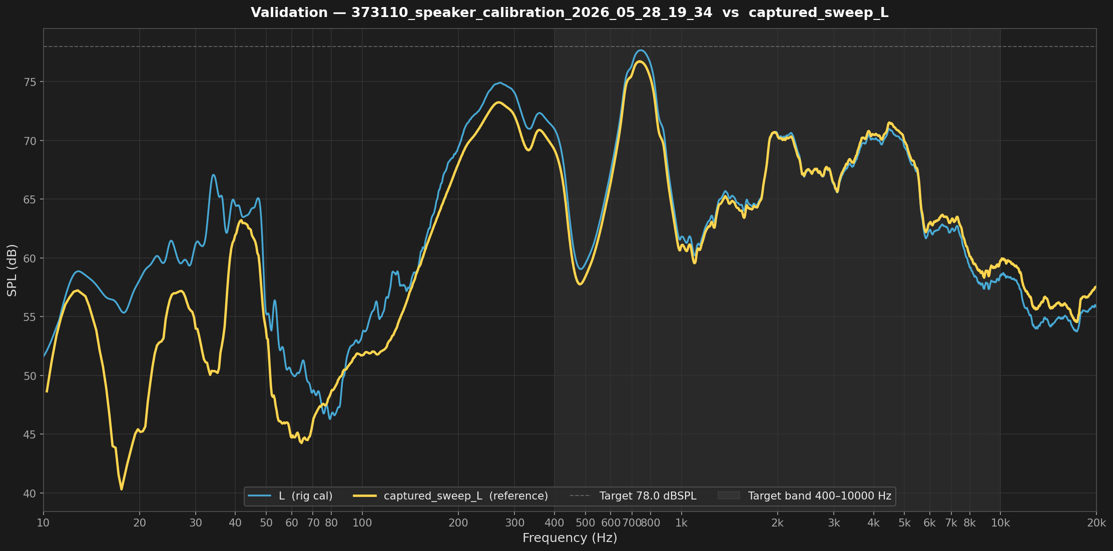

11.1 Procedure
- The operator selects a REW .txt export file from the working directory (REW text-export format: Freq(Hz), SPL(dB), Phase columns per row, preceded by a * comment header).
- The script auto-locates the most recent *_speaker_calibration_*.parquet in the same directory.
- 1/6-octave smoothing is applied to the REW reference curve to match the smoothing level used throughout the calibration pipeline.
- The rig L-channel SPL curve (from the parquet) and the smoothed REW reference curve are plotted on the same log-frequency axis (10 Hz – 20 kHz).
- A band-mean summary is printed to the console: mean SPL of the rig L channel and the REW reference over 400 Hz – 10 kHz, plus the signed difference between them.

11.2 Result
The two curves align closely across the full audio band. Both the shape of the frequency response and the absolute level track each other within the 1/6-octave smoothing resolution. The band-mean difference between the rig parquet and the REW reference fell within the calibration tolerance across the tested rigs.

Validation result: PASS
The rig speaker-calibration parquet and the REW reference measurement agree in both frequency shape and absolute SPL.
The two-curve comparison plot (validation_<stamp>.png) provides the end-to-end validation artefact, confirming the complete pipeline from raw sweep recording through ESS deconvolution, UMIK calibration, rig mic offset, to final dBSPL output is working correctly.

This agreement is significant: the parquet is produced from the rig's own uncalibrated camera microphone using the stored offset file, while the REW reference is produced from the UMIK-1 reference microphone with its own independent calibration chain. The fact that both methods produce matching SPL curves confirms that the rig mic offset correctly absorbs the difference between the two microphones, and that calibrate_speaker.py can be trusted to report accurate absolute levels autonomously on a daily basis.

