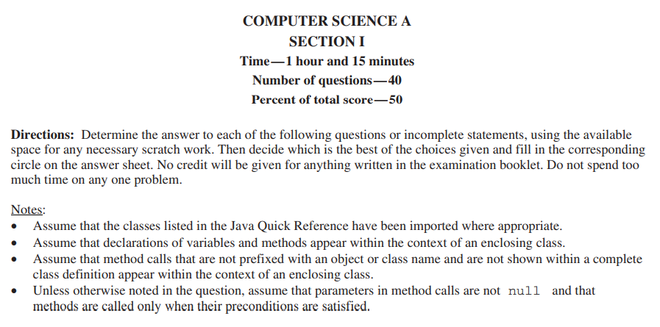

|  |  |  |
| --- | --- | --- |
| 1. |  | |
| (A) | |  |
| (B) | |  |
| (C) | |  |
| (D) | |  |
| (E) | |  |

|  |  |  |
| --- | --- | --- |
| 2. |  | |
| (A) | | The code results in a runtime error |
| (B) | | A |
| (C) | | B |
| (D) | | AB |
| (E) | | BA |

|  |  |  |
| --- | --- | --- |
| 3. |  | |
| (A) | |  |
| (B) | |  |
| (C) | |  |
| (D) | |  |
| (E) | |  |

|  |  |  |
| --- | --- | --- |
| 4. |  | |
| (A) | |  |
| (B) | |  |
| (C) | |  |
| (D) | |  |
| (E) | |  |

|  |  |  |
| --- | --- | --- |
| 5. |  | |
| (A) | | x && y |
| (B) | | y |
| (C) | | x |
| (D) | | x || y |
| (E) | | x && y |

|  |  |  |
| --- | --- | --- |
| 6. |  | |
| (A) | |  |
| (B) | |  |
| (C) | |  |
| (D) | |  |
| (E) | |  |

|  |  |  |
| --- | --- | --- |
| 7. |  | |
| (A) | | containsArt("start", "article", "Bart") |
| (B) | | containsArt("harm", "chortle", "crowbar") |
| (C) | | containsArt("darkroom", "cartoon", "articulate") |
| (D) | | containsArt("rattrap", "similar", "today") |
| (E) | | containsArt("matriculate", "carat", "arbitrary") |

|  |  |  |
| --- | --- | --- |
| 8. |  | |
| (A) | | 2 * (int) (Math.random() * 6) |
| (B) | | 2 * (int) (Math.random() * 7) |
| (C) | | (int) (Math.random() * 13) |
| (D) | | 2 + (int) (Math.random() * 6) + (int) (Math.random() * 6) |
| (E) | | (int) (Math.random() * 6) + (int) (Math.random() * 6) |

|  |  |  |
| --- | --- | --- |
| 9. |  | |
| (A) | | Athlete c = new TennisPlayer(); |
| (B) | | Student a = new TennisPlayer(); |
| (C) | | TennisPlayer b = new TennisPlayer(); |
| (D) | | Athlete e = new Athlete(); |
| (E) | | Student d = new Athlete(); |

|  |  |  |
| --- | --- | --- |
| 10. |  | |
| (A) | | {17, 20, 23, 26, 29, 32, 35, 38, 41} |
| (B) | | {17, 37, 21, 42, 18, 69, 48, 28, 39} |
| (C) | | {20, 23, 21, 42, 45, 69, 51, 54, 39} |
| (D) | | {20, 34, 21, 45, 15, 69, 51, 25, 39} |
| (E) | | {17, 20, 21, 42, 45, 69, 48, 51, 39} |

|  |  |  |
| --- | --- | --- |
| 11. |  | |
| (A) | | 0 1 2 3 4 5 6 7 8 9 |
| (B) | | 0 1 2 3 4 5 6 7 8 9 |
| (C) | | 0 1 2 3 4 5 6 7 8 9 10 |
| (D) | | 11 |
| (E) | | 10 |

|  |  |  |
| --- | --- | --- |
| 12. |  | |
| (A) | | The smallest value in the two-dimensional array |
| (B) | | The row index of an element with the smallest value in the two-dimensional array |
| (C) | | The column index of an element with the largest value in the two-dimensional array |
| (D) | | The largest value in the two-dimensional array |
| (E) | | The row index of an element with the largest value in the two-dimensional array |

|  |  |  |
| --- | --- | --- |
| 13. |  | |
| (A) | | The sum of all integers between 1 and num, inclusive |
| (B) | | The sum of all even integers between 1 and num, inclusive |
| (C) | | The sum of all odd integers between 1 and num, inclusive |
| (D) | | No value is returned because of an infinite loop. |
| (E) | | num |

|  |  |  |
| --- | --- | --- |
| 14. |  | |
| (A) | | The sum of all integers between 1 and num, inclusive |
| (B) | | The sum of all even integers between 1 and num, inclusive |
| (C) | | The sum of all odd integers between 1 and num, inclusive |
| (D) | | No value is returned because of an infinite loop. |
| (E) | | num |

|  |  |  |
| --- | --- | --- |
| 15. |  | |
| (A) | | I, II, and III |
| (B) | | I and II only |
| (C) | | I and III only |
| (D) | | II only |
| (E) | | I only |

|  |  |  |
| --- | --- | --- |
| 16. |  | |
| (A) | | I, II, and III |
| (B) | | I and II only |
| (C) | | I and III only |
| (D) | | II only |
| (E) | | I only |

|  |  |  |
| --- | --- | --- |
| 17. |  | |
| (A) | | An index of the maximum value that occurs in nums |
| (B) | | A value that occurs most often in nums |
| (C) | | An index of a value that occurs most often in nums |
| (D) | | The number of times that the maximum value occurs in nums |
| (E) | | The maximum value that occurs in nums |

|  |  |  |
| --- | --- | --- |
| 18. |  | |
| (A) | | An index of the maximum value that occurs in nums |
| (B) | | A value that occurs most often in nums |
| (C) | | An index of a value that occurs most often in nums |
| (D) | | The number of times that the maximum value occurs in nums |
| (E) | | The maximum value that occurs in nums |

|  |  |  |
| --- | --- | --- |
| 19. |  | |
| (A) | |  |
| (B) | |  |
| (C) | |  |
| (D) | |  |
| (E) | |  |

|  |  |  |
| --- | --- | --- |
| 20. |  | |
| (A) | |  |
| (B) | |  |
| (C) | |  |
| (D) | |  |
| (E) | |  |

|  |  |  |
| --- | --- | --- |
| 21. |  | |
| (A) | | I, II, and III |
| (B) | | II and III |
| (C) | | I and II only |
| (D) | | I and III only |
| (E) | | I only |

|  |  |  |
| --- | --- | --- |
| 22. |  | |
| (A) | | 0 0 0 0 0 6 blackboard |
| (B) | | 1 2 3 4 5 6 black |
| (C) | | 0 0 0 0 0 0 black |
| (D) | | 1 2 3 4 5 6 blackboard |
| (E) | | 1 2 3 4 5 0 black |

|  |  |  |
| --- | --- | --- |
| 23. |  | |
| (A) | | The sum of the digits in the decimal representation of val is returned. |
| (B) | | Nothing is returned. A run-time error occurs because of infinite recursion. |
| (C) | | The value val/10 is returned. |
| (D) | | The number of digits in the decimal representation of val is returned. |
| (E) | | The value 1 is returned. |

|  |  |  |
| --- | --- | --- |
| 24. |  | |
|  |  | |
| (A) | | II and III |
| (B) | | I and II |
| (C) | | I only |
| (D) | | II only |
| (E) | | III only |

|  |  |  |
| --- | --- | --- |
| 25. | Which of the following represents board after this code segment is executed? | |
| (A) | |  |
| (B) | |  |
| (C) | |  |
| (D) | |  |
| (E) | |  |

|  |  |  |
| --- | --- | --- |
| 26. | Consider the problem of finding the maximum value in an array of integers. The following code segments are proposed solutions to the problem. Assume that the variable arr has been defined as an array of int values and has been initialized with one or more values. | |
|  |  | |
| (A) | | I, II, and III |
| (B) | | II and III only |
| (C) | | III only |
| (D) | | II only |
| (E) | | I only |

|  |  |  |
| --- | --- | --- |
| 27. | Consider the problem of finding the maximum value in an array of integers. The following code segments are proposed solutions to the problem. Assume that the variable arr has been defined as an array of int values and has been initialized with one or more values. | |
|  |  | |
| (A) | | I, II, and III |
| (B) | | II and III only |
| (C) | | III only |
| (D) | | II only |
| (E) | | I only |

|  |  |  |
| --- | --- | --- |
| 28. |  | |
| (A) | |  |
| (B) | |  |
| (C) | |  |
| (D) | |  |
| (E) | |  |

|  |  |  |
| --- | --- | --- |
| 29. |  | |
| (A) | | 5 |
| (B) | | -1 |
| (C) | | 3 |
| (D) | | 8 |
| (E) | | 6 |

|  |  |  |
| --- | --- | --- |
| 30. |  | |
| (A) | | II and III |
| (B) | | I and II |
| (C) | | III |
| (D) | | II |
| (E) | | I |