|  |  |  |  |
| --- | --- | --- | --- |
|  |  | **Command Line Basics** |  |

|  |
| --- |
| **Your Tasks (Mark these off as you go)** |
| * Open the command line * List the contents of a directory * Navigate between directories * Create directories * Create files * Have Ms. Pluska check off the above tasks before you continue * Remove a filename * Rename a file * Delete a directory * Receive credit for the group portion of this lab |

* **Open the command line**

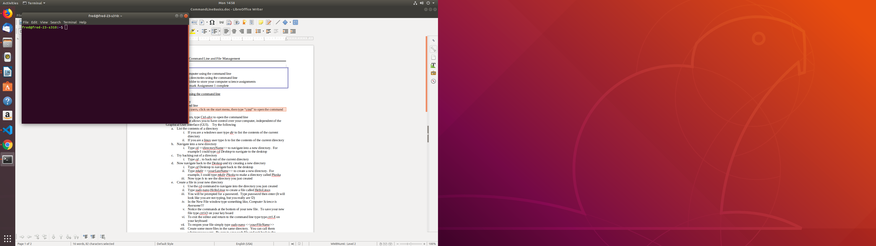The command line, also referred to as the terminal, provides you a means of interacting with your computer. All the programs you write in this class can be ran (and compiled) using the command line. If you want to be a serious programmer, or even half serious, you must learn the command line.

Although the command line may seem intimidating at first, over the course of the year, you will come to appreciate its utility and power.

To locate the command line on Linux type ctrl-alt-t

Windows users, click on the start menu, then type “cmd” to open the command line

If all goes well, you should see screen similar to the one shown to the right.

* **List the contents of a directory**

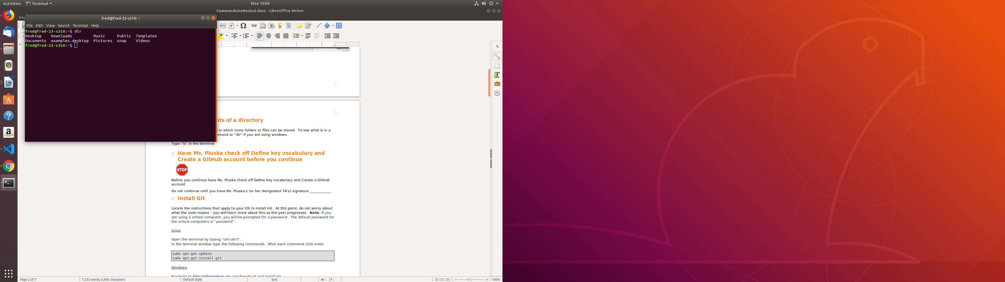

Directories are just folders in which more folders or files can be stored. To see what is in a directory, use the “ls” command or “dir” if you are using windows.

* Type “ls” in the terminal to display the contents of your home directory.
* Indicate the names of the folders and files you see below. If you see more than 5, just list the first 5.

|  |
| --- |
|  |

* **Navigate between directories**

To navigate to a different directory use the “cd” command. For example, if I want to navigate to the Desktop directory, I would type “cd Desktop”.

What if you want to back out of a directory? To do this, use the “cd ..” command.

* Try navigating into the different directories from your home directory using the “cd” command, then once inside the new directory try listing the contents using the “ls” command. Remeber to use the “cd ..” command to return to the home directory each time.

If you computer is new, or you are using a school computer, you probably didn’t see much. But there is a ton of stuff stored on your computer – lets go find it!

* From the home directory, type “cd ..”. This command will move us one level higher than the home directory where we started. Once there type “ls”
* Now type “cd ..” again to go up yet another directory. Once there type “ls” again.
* Write the names of the first five directories you see below,

|  |
| --- |
|  |

* Continue to explore directories. If you ever get lost the following command will take you back to your home directory,

cd ~

* **Create directories**
* Now navigate back to the Deskop. The mkdir command below can be used to create a new directory.

mkdir myDirectory

* Create three new directories on your desktop. Call these “projects”, “labs”, “tutorials”

**NOTE**: Directory names cannot contain spaces

* **Create files**

Linux has several built in editors. We will be using gedit for the majority of the work in this class. The following command can be used to open gedit from the command line,

gedit

To create a file call file1 type,

gedit file1

* In each of the directories you just created. Create a new file using the gedit command. You can call these whatwever you like.

**NOTE**: Filenames cannot contain spaces

* **Have Ms. Pluska check off the above tasks before you continue**



Before you continue have Ms. Pluska check off the above tasks before you contine

Do not continue until you have Ms. Pluska’s (or her designated TA’s) signature ____________

* **Remove a file**

The following command can be used to remove a file,

rm <filename>

To rm the file created previously,

rm file1

* Remove one of the files you just created
* **Rename a file**

Files can be renamed using the following command,

mv <originalFileName> <newFileName>

To rename file1 to file2,

mv file1 file2

Rename the remaining files in the directories you created

* **Remove a directory**

Directories can be removed using the following command,

rmdir <directoryName>

* Try removing all of the directories you created.

Did you get an error? Yes! Because not all of your directories are empty. To remove an empty directory use

rm -rf <directoryName>

**NOTE:**  Be careful removing directories from the command line. The do not go in the trash bin, they are removed from the system permanently

* Try removing all of the directories you created.
* **Receive Credit for the group portion of this lab**

Make sure you and your parter have the following file system set up on your Desktop:

APCompSciA

Labs Projects ExamReviews Resources