|  |  |  |  |
| --- | --- | --- | --- |
|  |  | **GitHub Workshop Part 2** |  |

|  |
| --- |
| **Your Tasks (Mark these off as you go)** |
| * Create a class repository * Create a new repository on GitHub * Initialize your local repository * Create a file in your local repository and push it to your remote GitHub repository * Receive credit for the group portion of this lab |

* **Create a class repository**

In part 1 of this workshop you learned how to clone an existing repository to your computer, edit it, then push it back up to to GitHub. In this lesson you are going to create a respository on your computer where you can store all of your code for the class. You will then create a remote repository on GitHub to store your work.

Before we do anything on GitHub, we need to create a folder structure to organize your work for this class. Remember that to make a directory (folder) on the command line, you use the following commands:

The following commands will be useful as you create your folder structure.

|  |  |
| --- | --- |
| Make a directory | mkdir <directory name> |
| Change or move into a directory | cd <directory name> |
| Back out of a directory | cd .. |
| Return to your home directory | cd ~ |

* Create a directory on your desktop called “APCompSciARepo”
* Inside this directory create the following directories. You can add additional directories later if you like.
  + Lab
  + Projects
  + ExamReviews
  + Resources
* **Create a new repository on GitHub**
* Once you've created your directory structure, go to your GitHub account "Repositories" page and create a new repository! This repository will have the same name as the one you just created on your computer (APCompSciARepo).
  + If you have the student developer pack, mark this repository as private
  + Un-check the box that says "initialize this repository with a README"

Some images to guide you through this process are included below:

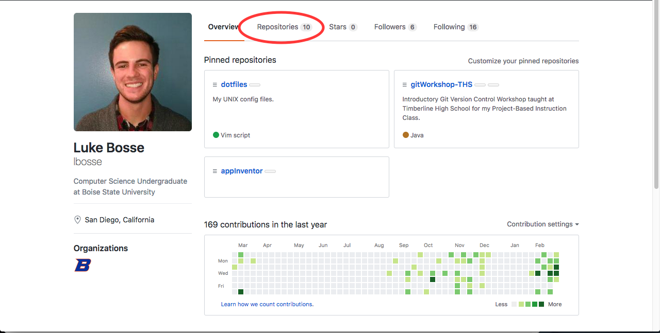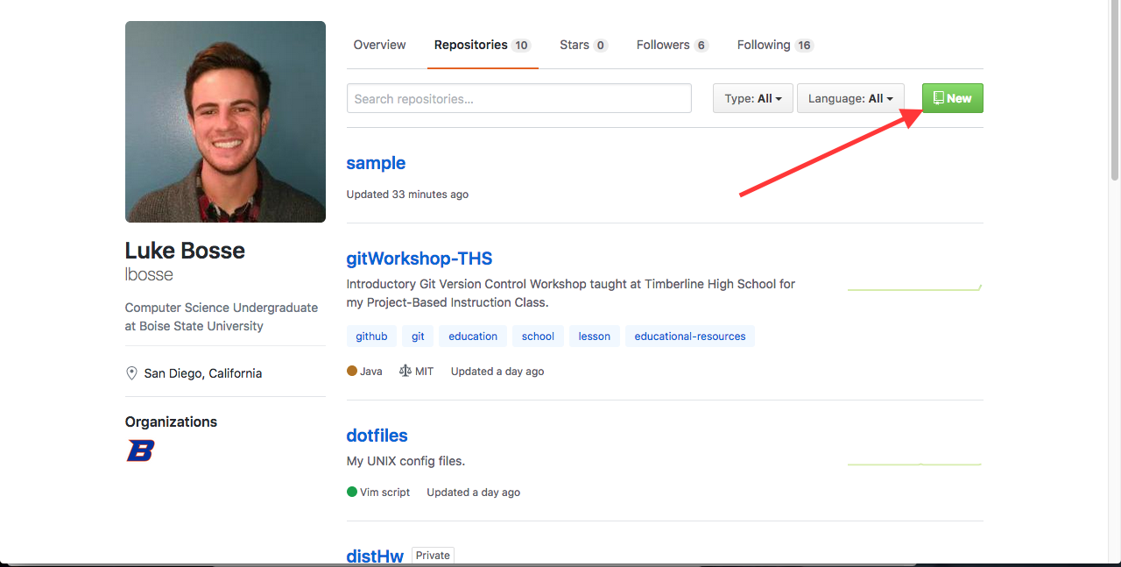

* **Intialize your local repository**

Once you create a repository, GitHub will show you the commands you need to run in your local repository to link it to the remote repository you just created. Really just two are needed however.

* Navigate to the APCompSciARepo folder you created on your desktop, copy each of the commands (ctrl-c) and paste them into the command line (ctrl-shift-v).

git init

git remote add origin <link to your repository>

* **Create a file in your local repository and push it to your remote GitHub repository**
* Use the command below to create a new file inside your APCompSciARepo directory you just created on your desktop.

gedit helloGitHub

* Inside this file type a message to yourself... “Hello GitHub!”, “Coding is Awesome!”, or whatever you like. Save thie file and close it.
* Now push your changes to your remote GitHub repository,

git add .

git commit -m “Type your commit message here”

git push origin master

* **Receive Credit for the group portion of this lab**

Switch roles, and repeat this workshop with your partner.



Before you submit your lab have Ms. Pluska check that both you and your partner have linked local and remote repositories.

Do not continue until you have Ms. Pluska’s (or her designated TA’s) signature ____________