|  |  |  |  |
| --- | --- | --- | --- |
|  |  | **GitHub Workshop Lab Guide** |  |

|  |
| --- |
| **Your Tasks (Mark these off as you go)** |
| * Define key vocabulary * Create a GitHub account * Fork a repository * Add the Gitpod extension to Chrome * Make changes to a repository with GitPod * Push changes to a repository * Receive credit for this portion of the lab |

* **Define key vocabulary**
* Open up your browser and search for definitions to the following terms as they relate to “Git”. For example you could type “Git vocabulary”.
* Work with your partner to write definitions for the following terms.

|  |  |
| --- | --- |
| **Git** |  |

|  |  |
| --- | --- |
| **GitHub** |  |

|  |  |
| --- | --- |
| **repository** |  |

|  |  |
| --- | --- |
| **local** |  |

|  |  |
| --- | --- |
| **remote** |  |

|  |  |
| --- | --- |
| **stage** |  |

|  |  |
| --- | --- |
| **commit** |  |

|  |  |
| --- | --- |
| **push** |  |

|  |  |
| --- | --- |
| **clone** |  |

|  |  |
| --- | --- |
| **fork** |  |

|  |  |
| --- | --- |
| **pull** |  |

|  |  |
| --- | --- |
| **origin/master** |  |

|  |  |
| --- | --- |
| **Gitpod** |  |

* **Create a GitHub account**

Navigate to the following address,

<https://education.github.com/students>

Locate the “Get Benefits for Students” button and click on it.

Locate the “Create an account” link and click on it.

Create your account when prompted

* **Fork a repository**

Navigate to <https://github.com/TimberlineCS/GitWorkshop>

Click the "Fork" button in the upper right hand corner of the screen. This will create your own personal copy of the repository in your account, where you can modify it freely without changing the code in my repository. This is often used when using someone else's code as a starting point for your own project or for proposing changes to their project.

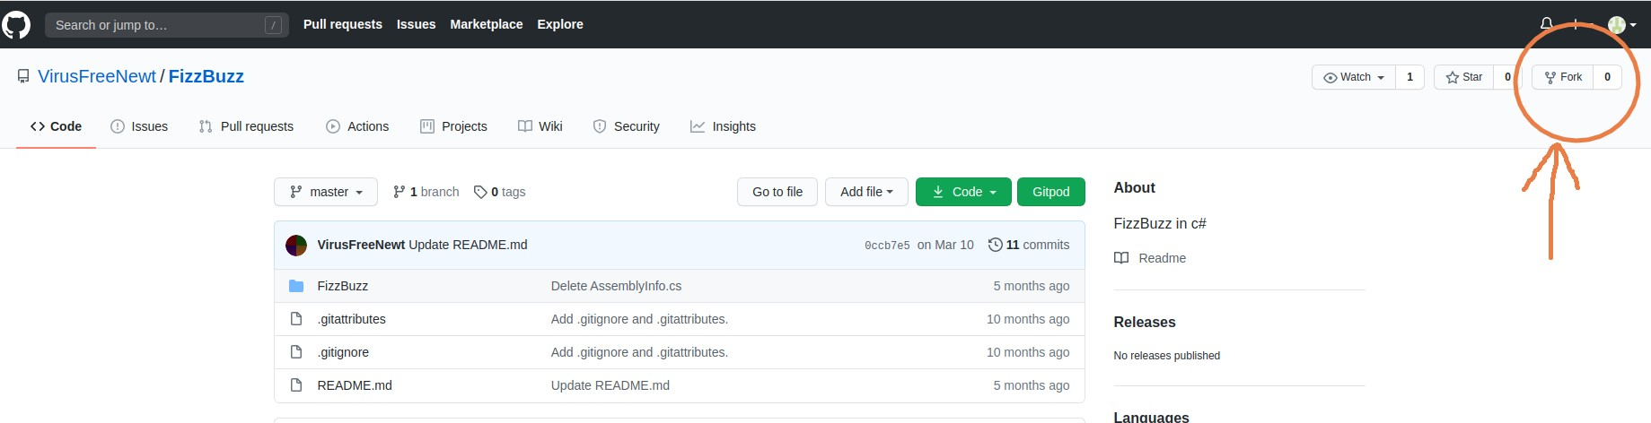You should now see your own copy of this repository on your Github profile page! Click on the repository name to go to it's page.

Click on the "Settings" tab right underneath the "Fork" button to go to the settings page. Then click the "Collaborators" button on the menu on the left side of the settings page. Use the search box to search for my username (**hpluska**) to add me as a collaborator on your repository. This will allow me to see your code and assess whether or not I did a good job teaching this lesson :)

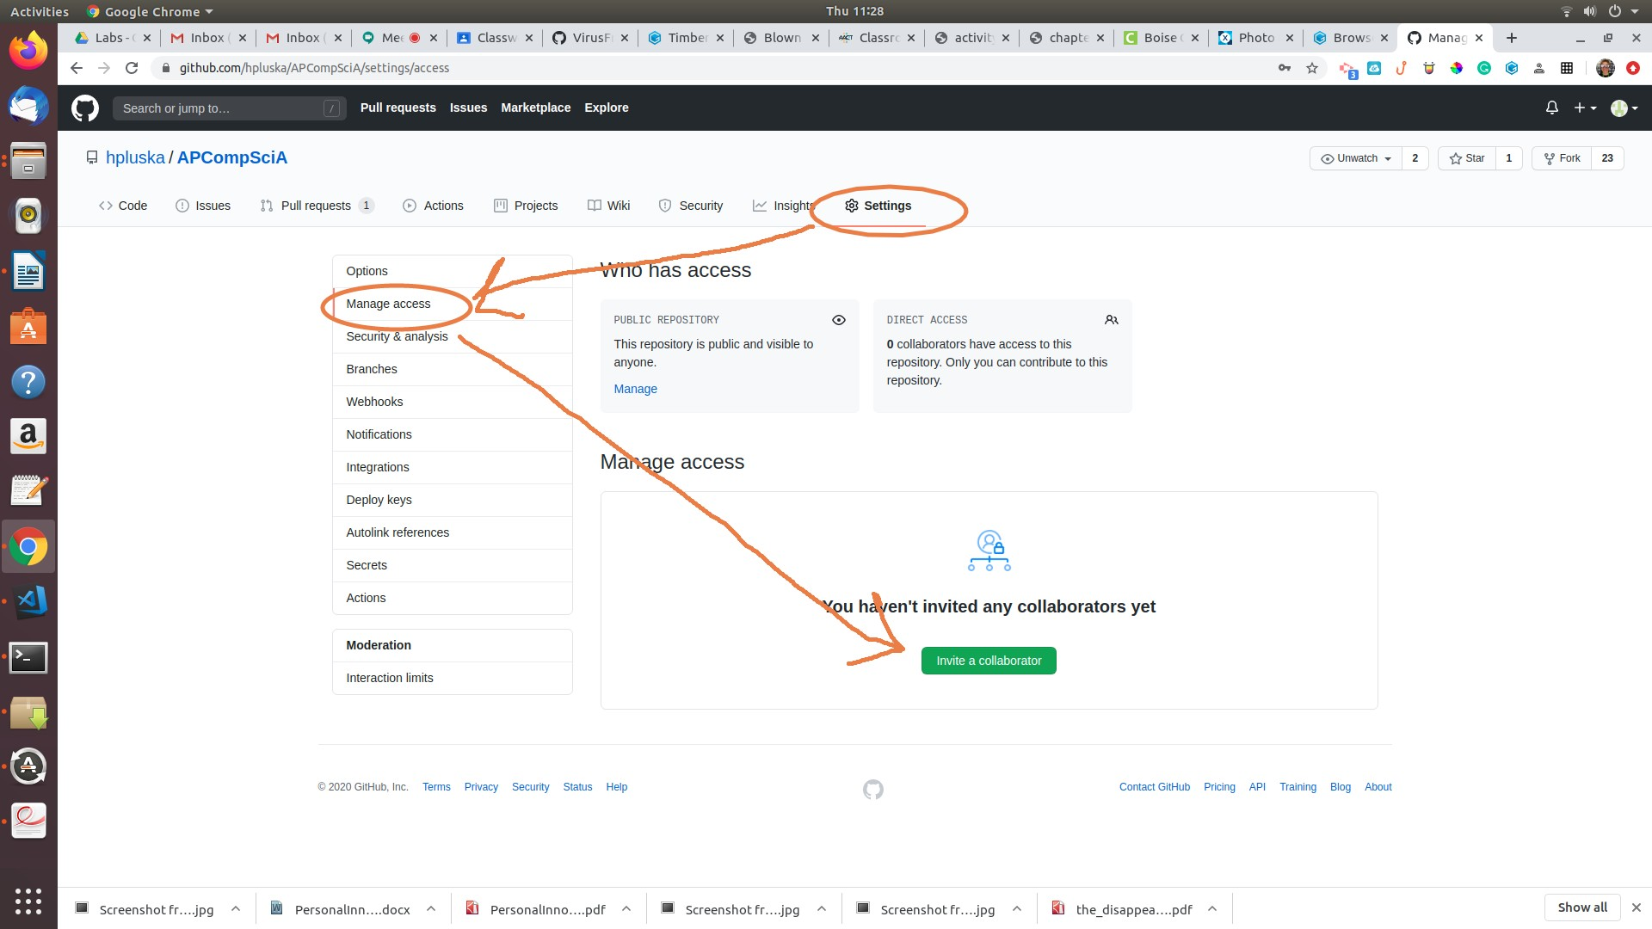

Click on the "Code" tab on the right side of the screen to go back to your files.

* **Add the GitPod Extension to Chrome**

Click on the link below and add the Gitpod extension to Chrome

<https://www.gitpod.io/docs/browser-extension/>

* **Make changes to a repository with GitPod**

Now that you have added the GitPod extension, you can make changes to your repository using Gitpod.

Return to the GitWorkshop repository you forked previously. Refresh the page and you should now see a button Gitpod button. Click on the Gitpod button to open the repository in the Gitpod editor.

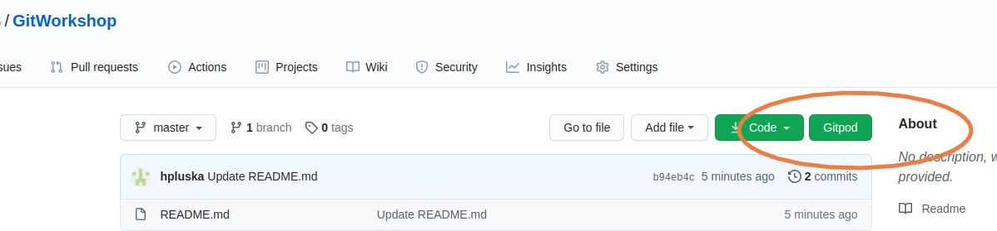

The editor will take a few minutes to load. Once it is loaded, you screen should look like the screenshot below,

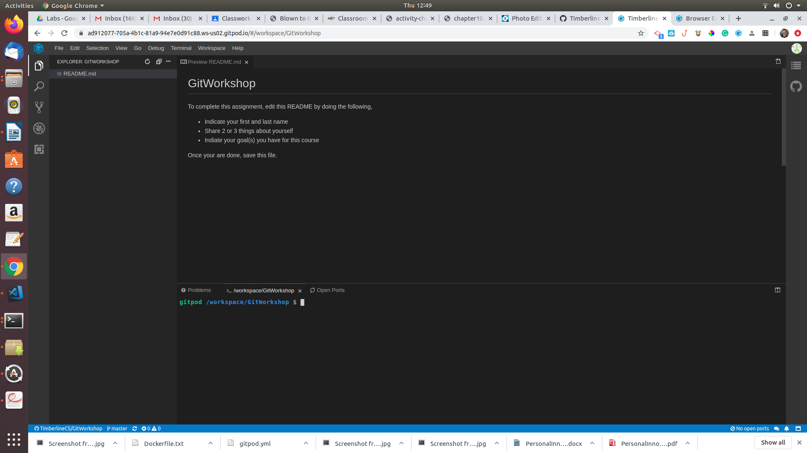

The Gitpod editor is divided into three sections. The left section is a list of files in the repository. The big window to the right, is the editing window. The window at the bottom is the terminal. As we progress through the course, you will become very familiar with each of these.

To edit the README.md file for this assignment, double click on this file in the left menu. The file will open in the editing window. Once it is open, respond to each of the prompts,

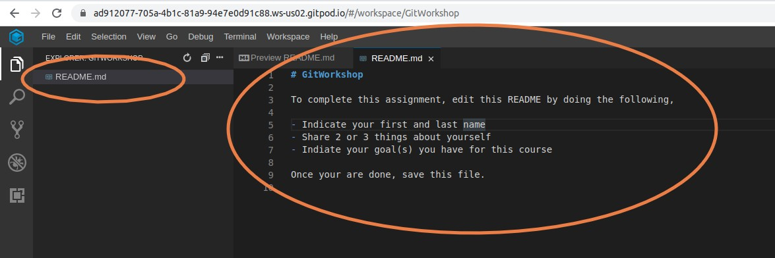

Once you are done, save your changes by typing Ctrl-s.

* **Push changes to a repository**

Everytime you make changes to a repository, you need to update your repository on GitHub. To do this you will need to *stage*, *commit* and *push* your changes. To do this,

* Click on the source control icon located on the far left menu. A list of changes and a text box will appear
* Type a message in the box to indicate what you did. This should be very brief
* To *stage* your changes click on the plus sign to the right of the file that was modified
* To *commit* your changes click on the check mark located above the text box

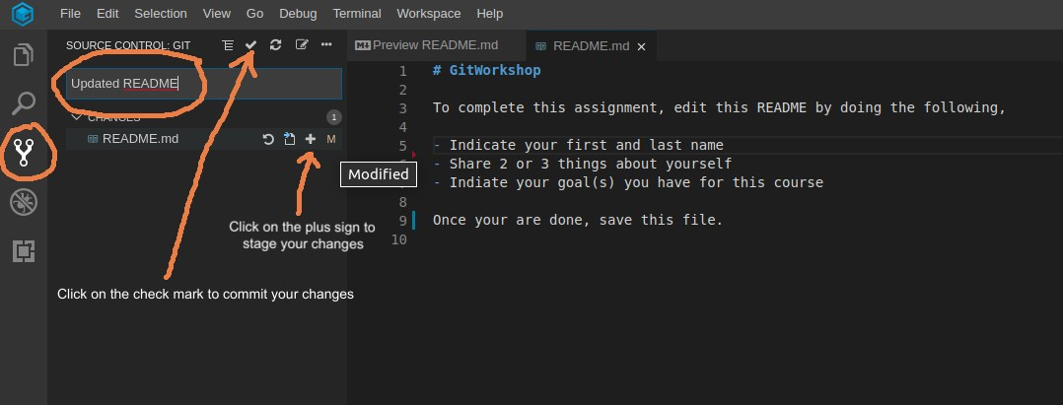

* To push your changes, click on the 3 small dots located above the text box. From the Source Control menu, select push.

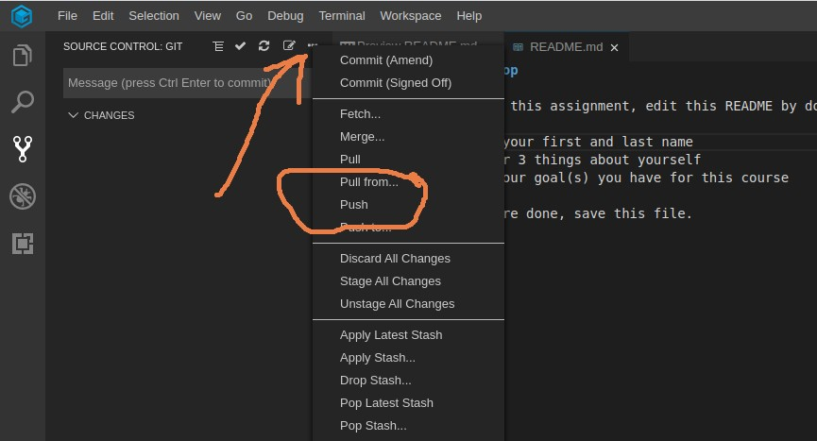

Now return to your GitWorkshop repository and you should see your completed assignment!

* **Receive Credit for this portion of this lab**

Submit this portion of the lab to Pluska to receive credit for the lab guide. Once received, your completed README will also be graded and will count towards your final lab grade.