|  |  |  |  |
| --- | --- | --- | --- |
|  |  | **GitHub Workshop Lab Guide** |  |

|  |
| --- |
| **Your Tasks (Mark these off as you go)** |
| * Define key vocabulary * Create a GitHub account * Fork a repository * Create a Repl.it account * Make changes to a GitHub repository * Push changes to a repository with Repl.it * Check out your changes on GitHub * Receive credit for this portion of the lab |

* **Define key vocabulary**

Open up your browser and search for definitions to the following terms as they relate to “Git”. For example you could type “Git vocabulary”.

|  |  |
| --- | --- |
| **Git** |  |

|  |  |
| --- | --- |
| **GitHub** |  |

|  |  |
| --- | --- |
| **repository** |  |

|  |  |
| --- | --- |
| **local** |  |

|  |  |
| --- | --- |
| **remote** |  |

|  |  |
| --- | --- |
| **stage** |  |

|  |  |
| --- | --- |
| **commit** |  |

|  |  |
| --- | --- |
| **push** |  |

|  |  |
| --- | --- |
| **clone** |  |

|  |  |
| --- | --- |
| **fork** |  |

|  |  |
| --- | --- |
| **pull** |  |

|  |  |
| --- | --- |
| **origin/master** |  |

|  |  |
| --- | --- |
| **Gitpod** |  |

* **Create a GitHub account**

Navigate to the following address,

<https://education.github.com/students>

Locate the “Get Benefits for Students” button and click on it.

Locate the “Create an account” link and click on it.

Create your account when prompted

* **Fork a repository**

Navigate to <https://github.com/TimberlineCS/GitWorkshop>

Click the "Fork" button in the upper right hand corner of the screen. This will create your own personal copy of the repository in your account, where you can modify it freely without changing the code in my repository. This is often used when using someone else's code as a starting point for your own project or for proposing changes to their project.

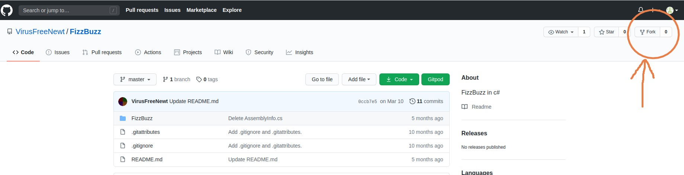You should now see your own copy of this repository on your Github profile page! Click on the repository name to go to it's page.

Click on the "Settings" tab right underneath the "Fork" button to go to the settings page. Then click the "Collaborators" button on the menu on the left side of the settings page. Use the search box to search for my username (**hpluska**) to add me as a collaborator on your repository. This will allow me to see your code and assess whether or not I did a good job teaching this lesson :)

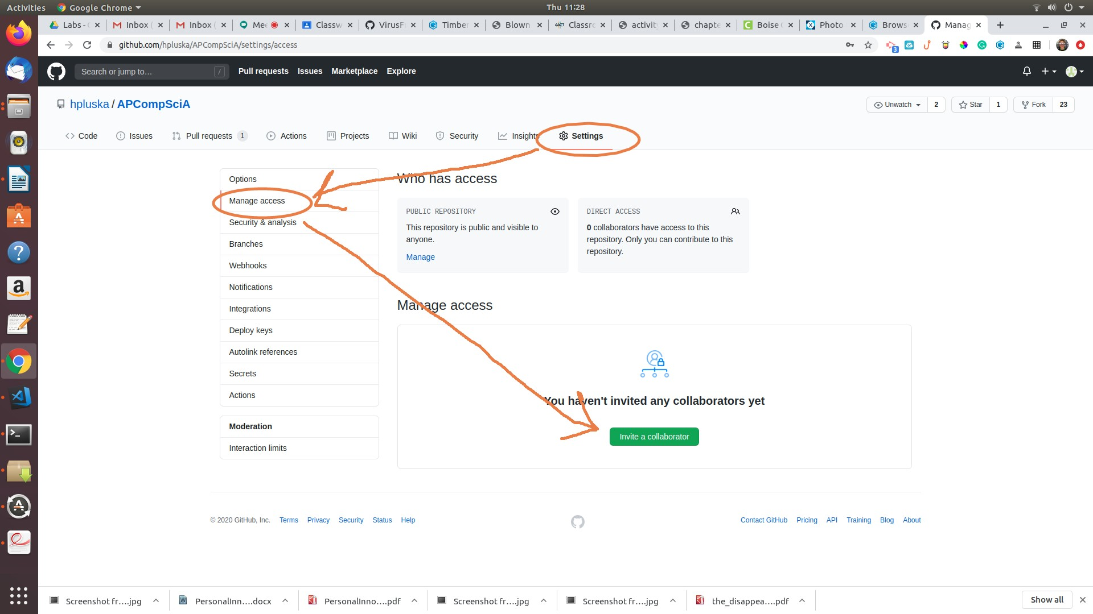

Click on the "Code" tab on the right side of the screen to go back to your files.

* **Create a Repl.it account**

Click on the link below to navigate to Repl.it sign up page,

<https://repl.it/signup>

Select the GitHub option to login with Repl with your newly created GitHub account

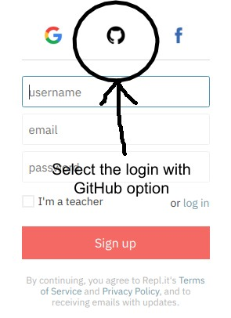

Provide your GitHub login credentials

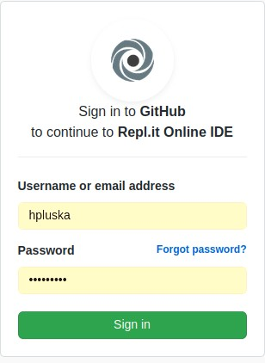

* **Make changes to a repository with Repl**

Now that you have associated your Repl.it account with your GitHub account, you can make changes to your repository using Repl.it.

To begin, log in to Repl.it and locate the plus icon in the upper right corner,

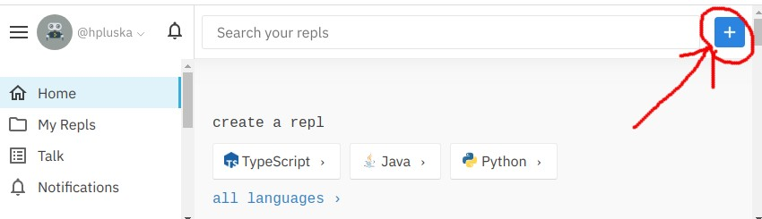

Select the *Import From GitHub* option. Locate the GitWorkshop you forked and select it.

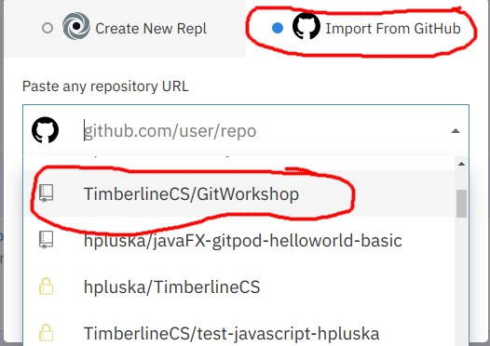

When prompted, click the *Import from GitHub* button

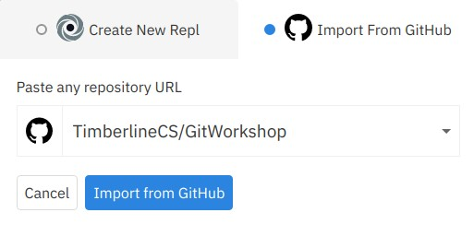

The Repl.it editor is divided into four sections. For now, do not worry about what everything means, our only goal for not is to learn how to make changes to a GitHub repository from Repl.it.

To edit the README.md file for this assignment, click the *Edit* button. Once you have answered

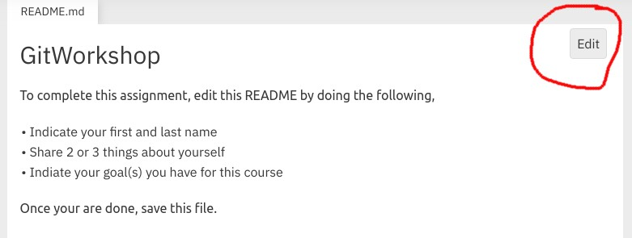

Once you have clicked the *Edit* button, you can answer the questions. Don’t go crazy! The point of this lesson is to learn the workflow for the class.

Once you have answered the questions, you are ready to push your changes back to GitHub.

* **Push changes to a GitHub repository with Repl.it**

Everytime you make changes to a repository, you need to update your repository on GitHub. To do this you will need to *stage*, *commit* and *push* your changes. Repl.it makes this process very easy!

* Click on the source control icon located on the far left menu.

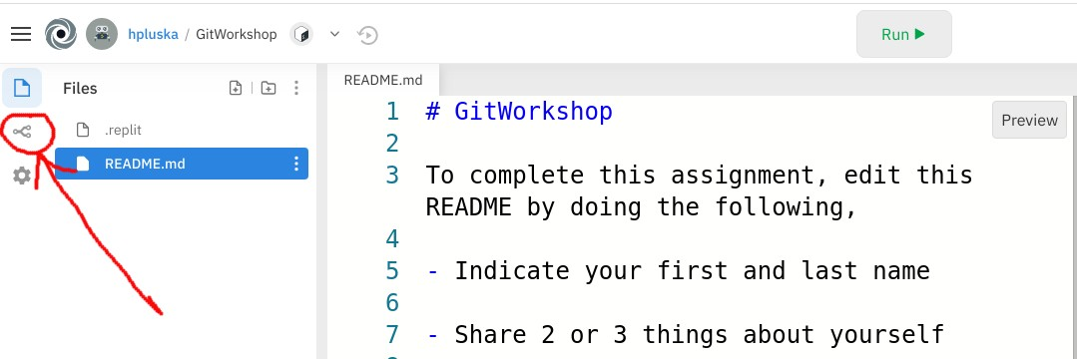

* 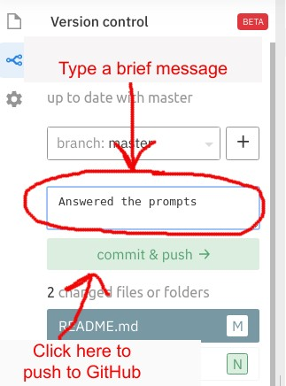Repl.it automatically saves and stages your changes. To commit and push your changes simply type a message (this should be very brief) in the text box to indicate what you did then click the commit and push button.
* **Check our your changes on GitHub**

Now return to your GitHub account and check out your changes!

Welcome to GitHub!!! GitHub is an amazing community of developers from around the world. As you develop your skills as a programmer, you too someday will be a contributer to this community!

* **Receive Credit for this portion of this lab**

Submit this portion of the lab to Pluska to receive credit for the lab guide. Once received, your completed README will also be graded and will count towards your final lab grade.