|  |  |  |  |
| --- | --- | --- | --- |
|  |  | **Mine Hunter Path** |  |

|  |
| --- |
| **Your Tasks (Mark these off as you go)** |
| * Create the MineHunterPath and MineHunterGrid classes * Initialize an ArrayList of Points * Write the showPath method * Have Ms. Pluska check off your showPath method * Write the MineHunterPath constructor * Have Ms. Pluska check off your mineHunterPath constructor * Complete challenges 1 thru 5 * Have Ms. Pluska check off your challenges 1 thru 5 before you continue * Receive credit for the group portion of this lab * Receive credit for the individual portion of this lab |

* **Create the MineHunterPath and MineHunterGrid classes**

At the top of the first piece of paper create the MineHunterGrid class

MineHunterGrid{}

At the top of the second piece of paper create the MineHunterPath class

MineHunterPath{}

* **Initialize an Array List of Points**

In this lab you will build upon the Mine Hunter program you wrote previously. The goal of this lab is to write a class that when implemented will find a path through the mines on the grid like the picture shown below.

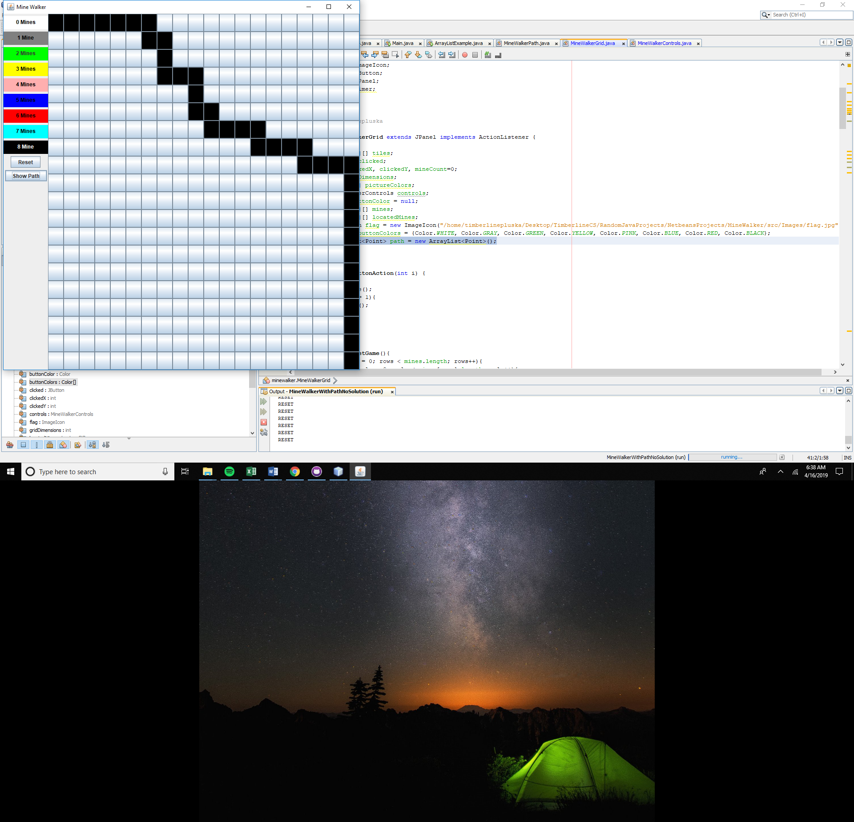

To create the path, you can assume that the path begins at coordinates x = 0 and y = 0 and ends at x = gridDimensions -1 and y = gridDimensions – 1. The path your program creates will be random that is, you will generate a random number and depending on the number the path will proceed forward or down. But, the path can NEVER hit a mine. Because we do not know how long the path will be we will store the coordinates of the path in an ArrayList. The ArrayList you create will hold Point values. Point values are convenient because we can use the points to represent x, y coordinates on the grid.

Locate the MineHunterGrid class and at the top declare an ArrayList

private ArrayList<Point> path = new ArrayList<Point>();

* **Write the showPath method**

Locate the MineHunterGrid class. Here you will write the showPath method. The show path method is a void type method and does not accept any parameters. The job of showPath is to show the random path through the mines when the “show mines” button is clicked.

The showPath method will create a new instance of MineHunterPath. To create the path, the MineHunterPath needs two pieces of information (1) the gridDimensions and (2) the mines. You will pass this information to the MineHunterPath constructor as parameters.

In the showPath method add the following,

MineHunterPath newPath = new MineHunterPath(gridDimensions, mines);

Once MineHunterPath has done its job of creating the path, we need to get the path back and assign it to the path ArrayList we created previously,

this.path = newPath.getPath();

Recall that the path stores the point values of the path. To access these we need to iterate over the path we retrieved and access the x and y values for each point. You can color the path any color you choose, but in my example, I chose black.

for(Point p : path){

tiles[p.x][p.y].setBackground(Color.BLACK);

}

* **Have Ms. Pluska check off your showPath method**



Before you continue have Ms. Pluska check off your showPath method

Do not continue until you have Ms. Pluska’s (or her designated TA’s) signature ____________

* **Declare the necessary global variables in the MineHunterPath class**

To create our path we need some information. Before we get started on the MineHunterPath class we need to declare the following global variables. Feel free to add or modify these as you go along.

private int gridDimensions;

private Point start;

private Point end;

private Point current;

private ArrayList<Point> path = new ArrayList<Point>();

private boolean done;

private boolean[][] mines;

private int x, y;

* **Write the MineHunterPath constructor**

Locate the MineHunterPath class. The constructor in this class must accept two parameters, (1) the gridDimensions and (2) the mines. In the constructor we also need to initialize the global variables we declared above.

An important feature in the MineHunterPath constructor is that we create two Point objects – one for the starting point and one for the ending point. These points represent tiles on the grid. The example below illustrates how to access the x and y values of any point on the grid,

|  |
| --- |
| **Access x and y values of a Point object** |
| Point start = new Point(0,0);  int starting x = start.x;  int starting y = start.y; |

Another important feature is that we add the starting point to our ArrayList that we declared above.

public MineHunterPath(int gridDimensions, boolean[][] mines){

this.mines = mines;

this.gridDimensions = gridDimensions;

this.start = new Point(0,0);

this.end = new Point(gridDimensions-1, gridDimensions-1);

this.current = start;

this.done = false;

path.add(start);

}

* **Receive Credit for the group portion of this lab**



Before you submit your lab have Ms. Pluska check off the above tasks

Do not continue until you have Ms. Pluska’s (or her designated TA’s) signature ____________