**well_Name井**

**固井水泥胶结测井评价报告**

**（套管尺寸:** **casing_Goal mm 测量井段:** **first_Pro_Interval m）**

|  |  |
| --- | --- |
| 编写人: |  |
| 审核人: |  |



**中国石油集团测井有限公司西南分公司解释评价中心**

**year年month月**

# 一 测井及固井施工简况

|  |  |  |  |  |  |  |  |  |  |  |  |  |  |
| --- | --- | --- | --- | --- | --- | --- | --- | --- | --- | --- | --- | --- | --- |
| **基 本 井 况** | | | | | | | | | | | | | |
| 井 名 | | | 地 区 | | 构 造 | | | 完钻井深  （m） | | | 人工井底  （m） | | 最大井斜  （°/m） |
| well_Name井 | | | geo_Position | | stru_Position | | | deepest_bit | | | arti_Bottom | | dev_Depth_Ratio |
| 套管程序 | | | | | 钻头尺寸 | | | | | |  | 井液（泥浆） | |
| 次序 | 外径（mm） | | 下深井段（m） | | 尺寸（mm） | | | 钻达井深（m） | | | 性质 | flu_Property |
| 1 | casing1_Dia | | casing1_interval | | bit1_Diameter | | | bit1_Depth | | |
| 2 | casing2_Dia | | casing2_interval | | bit2_Diameter | | | bit2_Depth | | | 密度  (g/cm3) | flu_Density |
| 3 | casing3_Dia | | casing3_interval | | bit3_Diameter | | | bit3_Depth | | |
| 4 | casing4_Dia | | casing4_interval | | bit4_Diameter | | | bit4_Depth | | | 粘度  (s) | flu_Viscosity |
| 5 | casing5_Dia | | casing5_interval | | bit5_Diameter | | | bit5_Depth | | |
| **固 井 施 工** | | | | | | | | | | | | | |
| 水泥性质 | | 水泥浆密度  (g/cm3) | | 注入水泥量  (t) | | | 水泥设计返高  (m) | | | | | 固井日期 | |
| 嘉华G级 | | cement_Density | | cement_Quantity | | | design_Depth | | | | | cement_End_Time | |
| 特 殊  施 工 | |  | | | | | | | | | | | |
| **测 井 项 目** | | | | | | | | | | | | | |
| 测井项目 | | 测井井段(m) | | | 深度比例 | | 测井日期 | | | 曲线条数 | | | 质量评定 |
| 声幅 | | first_Pro_Interval | | | 1:500 | | log_End_Time | | | 1 | | | 合格 |
| 变密度 | | first_Pro_Interval | | | 1:500 | | log_End_Time | | | 1 | | | 合格 |
|  | |  | | |  | |  | | |  | | |  |
|  | |  | | |  | |  | | |  | | |  |
| **测 井 施 工** | | | | | | | | | | | | | |
| 测井单位 | | | 测井小队 | | | 测井队长 | | | 仪器型号 | | | | 备 注 |
| 测井西南分公司 | | | logging_Group | | | logging_Leader | | | logging_Equipment | | | |  |

# 二 固井质量测井评价

**1．固井质量评价标准**

**固井质量评价指标：**参照中华人民共和国石油天然气行业标准中的《固井质量评价方法》（标准号：SY/T 6592-2016）及川庆钻探工程有限公司工程技术处指导意见，一界面采用相对声幅(CBL)评价指标定量评价固井质量；二界面根据计算的第二界面胶结指数（BR2）、结合对变密度的定性分析，进行综合解释评价。

一界面固井水泥胶结质量相对声幅评价指标（川庆工程技术处）

|  |  |
| --- | --- |
| CBL | 评价结论 |
| CBL≤20% | 好 |
| 20%＜CBL≤40% | 中等（合格） |
| CBL＞40% | 差（不合格） |

二界面固井水泥胶结质量胶结指数评价指标

|  |  |
| --- | --- |
| BR2 | 评价结论 |
| BR2≥0.8 | 好 |
| 0.6≤BR2＜0.8 | 中等（合格） |
| BR2＜0.6 | 差（不合格） |

**固井质量合格率标准**：参照川庆钻探工程有限公司企业标准Q/SYCQZ 001-2015钻井技术操作规程（全井段固井水泥胶结合格率≥60%为合格）。

**2．固井质量测井评价**

well_Name本次测量井段measure_Intervalm，测井时液面位于fluid_Heightm，故本次固井质量测井在0-fluid_Heightm未能取到可靠数据，不做解释。本次测井处理评价井段first_Pro_Intervalm。[待检查]

evaluation_Start-second_Startm为双层及多层套管，受双层套管及外层介质干扰波影响，该固井段套管二界面水泥胶结质量不进行好、中、差评定。[待检查]

水泥设计返高为design_Depthm，水泥实际返高为actual_Depthm以上。

**一界面**（first_Pro_Intervalm）固井质量总体情况是：水泥胶结好井段占first_GRatio%，水泥胶结中等井段占first_MRatio%，水泥胶结差井段占first_BRatio%。

**一界面**（first_Pro_Intervalm）固井水泥胶结合格率为first_Pass_Percent%，测井评价为固井质量**first_Eval_Result**。

**二界面**（second_Start-evaluation_Bottomm）固井质量总体情况是：水泥胶结好井段为second_GRatio%，水泥胶结中等井段为second_MRatio%，水泥胶结差井段为second_BRatio%。

**二界面**（second_Start-evaluation_Bottomm）固井水泥胶结合格率为second_Pass_Percent%，测井评价为固井质量**second_Eval_Result**。

（1）套管顶、底部及油气层上部井段固井质量评价和裸眼储层解释表（见表1、表2）。

套管顶、底部及油气层上部井段固井质量评价表 表1

|  |  |
| --- | --- |
| 套管顶、底部井段  （套管头处100米内连续25米以上） | 油气层上部井段  （连续25米以上好） |
| 套管顶（井口）：casing_head | oil_gas_upper_interval |
| 套管底（套管鞋）：casing_bottom |
| 说明：instructions | |

well_Name井储层测井解释表 表2

| 序号 | 层位 | 井段  (m) | 厚度  (m) | 解释结论 |
| --- | --- | --- | --- | --- |
| 1 | 嘉二1 | 2915.6--2927.1 | 11.5 | 含气水层 |
| 2 | 长兴组 | 3602.7--3607.1 | 4.4 | 差气层 |
| 3 | 长兴组 | 3611.3--3626.8 | 15.5 | 差气层 |
| 4 | 茅三 | 3835.7--3840.7 | 5.0 | 差气层 |
| 5 | 茅三 | 3843.6--3850.2 | 6.6 | 差气层 |
| 6 | 栖二 | 4044.4--4053.6 | 9.2 | 差气层 |
| 7 | 龙王庙组 | 4870.9--4891.7 | 20.8 | 含气水层 |
| 8 | 龙王庙组 | 4893.5--4906.4 | 12.9 | 水层 |
| 9 | 龙王庙组 | 4939.6--4964.5 | 24.9 | 水层 |

（2）固井质量统计及单层固井质量评价（见表3、表4、表5、表6）。

well_Name井**一界面**（first_Pro_Intervalm）固井质量统计表 表3

| 序 号 | 标 准  (%) | 厚 度  (m) | 比 例  (%) | 结 论 |
| --- | --- | --- | --- | --- |
| 1 | 0.00--20.0 | first_GLength | first_GRatio | 好 |
| 2 | 20.0--40.0 | first_MLength | first_MRatio | 中 |
| 3 | 40.0--100.0 | first_BLength | first_BRatio | 差 |

well_Name井**二界面**（second_Start-evaluation_Bottomm）固井质量统计表 表4

| 序 号 | BR标准 | 厚 度  (m) | 比 例  (%) | 结 论 |
| --- | --- | --- | --- | --- |
| 1 | 0.80-1.00 | second_GLength | second_GRatio | 好 |
| 2 | 0.60-0.80 | second_MLength | second_MRatio | 中 |
| 3 | 0.00-0.60 | second_BLength | second_BRatio | 差 |

well_Name井**一界面**单层固井质量评价表 表5

| 序号 | 井段(m) | 厚度(m) | 最大声幅(%) | 最小声幅(%) | 平均声幅(%) | 结论 |
| --- | --- | --- | --- | --- | --- | --- |
|  |  |  |  |  |  |  |
|  |  |  |  |  |  |  |
|  |  |  |  |  |  |  |
|  |  |  |  |  |  |  |
|  |  |  |  |  |  |  |
|  |  |  |  |  |  |  |
|  |  |  |  |  |  |  |
|  |  |  |  |  |  |  |
|  |  |  |  |  |  |  |
|  |  |  |  |  |  |  |
|  |  |  |  |  |  |  |
|  |  |  |  |  |  |  |
|  |  |  |  |  |  |  |
|  |  |  |  |  |  |  |
|  |  |  |  |  |  |  |
|  |  |  |  |  |  |  |
|  |  |  |  |  |  |  |
|  |  |  |  |  |  |  |
|  |  |  |  |  |  |  |
|  |  |  |  |  |  |  |
|  |  |  |  |  |  |  |
|  |  |  |  |  |  |  |
|  |  |  |  |  |  |  |
|  |  |  |  |  |  |  |
|  |  |  |  |  |  |  |
|  |  |  |  |  |  |  |
|  |  |  |  |  |  |  |
|  |  |  |  |  |  |  |
|  |  |  |  |  |  |  |
|  |  |  |  |  |  |  |
|  |  |  |  |  |  |  |
|  |  |  |  |  |  |  |
|  |  |  |  |  |  |  |
|  |  |  |  |  |  |  |
|  |  |  |  |  |  |  |
|  |  |  |  |  |  |  |
|  |  |  |  |  |  |  |
|  |  |  |  |  |  |  |
|  |  |  |  |  |  |  |
|  |  |  |  |  |  |  |
|  |  |  |  |  |  |  |
|  |  |  |  |  |  |  |
|  |  |  |  |  |  |  |
|  |  |  |  |  |  |  |
|  |  |  |  |  |  |  |
|  |  |  |  |  |  |  |
|  |  |  |  |  |  |  |
|  |  |  |  |  |  |  |
|  |  |  |  |  |  |  |
|  |  |  |  |  |  |  |
|  |  |  |  |  |  |  |
|  |  |  |  |  |  |  |
|  |  |  |  |  |  |  |
|  |  |  |  |  |  |  |
|  |  |  |  |  |  |  |
|  |  |  |  |  |  |  |
|  |  |  |  |  |  |  |
|  |  |  |  |  |  |  |
|  |  |  |  |  |  |  |
|  |  |  |  |  |  |  |
|  |  |  |  |  |  |  |
|  |  |  |  |  |  |  |
|  |  |  |  |  |  |  |
|  |  |  |  |  |  |  |
|  |  |  |  |  |  |  |
|  |  |  |  |  |  |  |
|  |  |  |  |  |  |  |
|  |  |  |  |  |  |  |
|  |  |  |  |  |  |  |
|  |  |  |  |  |  |  |
|  |  |  |  |  |  |  |
|  |  |  |  |  |  |  |
|  |  |  |  |  |  |  |
|  |  |  |  |  |  |  |
|  |  |  |  |  |  |  |
|  |  |  |  |  |  |  |
|  |  |  |  |  |  |  |
|  |  |  |  |  |  |  |
|  |  |  |  |  |  |  |
|  |  |  |  |  |  |  |
|  |  |  |  |  |  |  |
|  |  |  |  |  |  |  |
|  |  |  |  |  |  |  |
|  |  |  |  |  |  |  |
|  |  |  |  |  |  |  |
|  |  |  |  |  |  |  |
|  |  |  |  |  |  |  |
|  |  |  |  |  |  |  |
|  |  |  |  |  |  |  |
|  |  |  |  |  |  |  |
|  |  |  |  |  |  |  |
|  |  |  |  |  |  |  |
|  |  |  |  |  |  |  |
|  |  |  |  |  |  |  |
|  |  |  |  |  |  |  |
|  |  |  |  |  |  |  |
|  |  |  |  |  |  |  |
|  |  |  |  |  |  |  |
|  |  |  |  |  |  |  |
|  |  |  |  |  |  |  |
|  |  |  |  |  |  |  |
|  |  |  |  |  |  |  |
|  |  |  |  |  |  |  |
|  |  |  |  |  |  |  |
|  |  |  |  |  |  |  |
|  |  |  |  |  |  |  |
|  |  |  |  |  |  |  |
|  |  |  |  |  |  |  |
|  |  |  |  |  |  |  |
|  |  |  |  |  |  |  |
|  |  |  |  |  |  |  |
|  |  |  |  |  |  |  |
|  |  |  |  |  |  |  |
|  |  |  |  |  |  |  |
|  |  |  |  |  |  |  |
|  |  |  |  |  |  |  |
|  |  |  |  |  |  |  |
|  |  |  |  |  |  |  |
|  |  |  |  |  |  |  |
|  |  |  |  |  |  |  |
|  |  |  |  |  |  |  |
|  |  |  |  |  |  |  |
|  |  |  |  |  |  |  |
|  |  |  |  |  |  |  |
|  |  |  |  |  |  |  |
|  |  |  |  |  |  |  |
|  |  |  |  |  |  |  |
|  |  |  |  |  |  |  |
|  |  |  |  |  |  |  |
|  |  |  |  |  |  |  |
|  |  |  |  |  |  |  |
|  |  |  |  |  |  |  |
|  |  |  |  |  |  |  |
|  |  |  |  |  |  |  |
|  |  |  |  |  |  |  |
|  |  |  |  |  |  |  |
|  |  |  |  |  |  |  |
|  |  |  |  |  |  |  |
|  |  |  |  |  |  |  |
|  |  |  |  |  |  |  |
|  |  |  |  |  |  |  |
|  |  |  |  |  |  |  |
|  |  |  |  |  |  |  |
|  |  |  |  |  |  |  |
|  |  |  |  |  |  |  |
|  |  |  |  |  |  |  |
|  |  |  |  |  |  |  |
|  |  |  |  |  |  |  |
|  |  |  |  |  |  |  |
|  |  |  |  |  |  |  |
|  |  |  |  |  |  |  |
|  |  |  |  |  |  |  |
|  |  |  |  |  |  |  |
|  |  |  |  |  |  |  |
|  |  |  |  |  |  |  |
|  |  |  |  |  |  |  |
|  |  |  |  |  |  |  |
|  |  |  |  |  |  |  |
|  |  |  |  |  |  |  |
|  |  |  |  |  |  |  |
|  |  |  |  |  |  |  |
|  |  |  |  |  |  |  |
|  |  |  |  |  |  |  |
|  |  |  |  |  |  |  |
|  |  |  |  |  |  |  |
|  |  |  |  |  |  |  |
|  |  |  |  |  |  |  |
|  |  |  |  |  |  |  |
|  |  |  |  |  |  |  |
|  |  |  |  |  |  |  |
|  |  |  |  |  |  |  |
|  |  |  |  |  |  |  |
|  |  |  |  |  |  |  |
|  |  |  |  |  |  |  |
|  |  |  |  |  |  |  |
|  |  |  |  |  |  |  |
|  |  |  |  |  |  |  |
|  |  |  |  |  |  |  |
|  |  |  |  |  |  |  |
|  |  |  |  |  |  |  |
|  |  |  |  |  |  |  |
|  |  |  |  |  |  |  |
|  |  |  |  |  |  |  |
|  |  |  |  |  |  |  |
|  |  |  |  |  |  |  |
|  |  |  |  |  |  |  |
|  |  |  |  |  |  |  |
|  |  |  |  |  |  |  |
|  |  |  |  |  |  |  |
|  |  |  |  |  |  |  |
|  |  |  |  |  |  |  |

well_Name井**二界面**单层固井质量评价表 表6

| 序号 | 井段(m) | 厚度(m) | 最大指数 | 最小指数 | 平均指数 | 结论 |
| --- | --- | --- | --- | --- | --- | --- |
|  |  |  |  |  |  |  |
|  |  |  |  |  |  |  |
|  |  |  |  |  |  |  |
|  |  |  |  |  |  |  |
|  |  |  |  |  |  |  |
|  |  |  |  |  |  |  |
|  |  |  |  |  |  |  |
|  |  |  |  |  |  |  |
|  |  |  |  |  |  |  |
|  |  |  |  |  |  |  |
|  |  |  |  |  |  |  |
|  |  |  |  |  |  |  |
|  |  |  |  |  |  |  |
|  |  |  |  |  |  |  |
|  |  |  |  |  |  |  |
|  |  |  |  |  |  |  |
|  |  |  |  |  |  |  |
|  |  |  |  |  |  |  |
|  |  |  |  |  |  |  |
|  |  |  |  |  |  |  |
|  |  |  |  |  |  |  |
|  |  |  |  |  |  |  |
|  |  |  |  |  |  |  |
|  |  |  |  |  |  |  |
|  |  |  |  |  |  |  |
|  |  |  |  |  |  |  |
|  |  |  |  |  |  |  |
|  |  |  |  |  |  |  |
|  |  |  |  |  |  |  |
|  |  |  |  |  |  |  |
|  |  |  |  |  |  |  |
|  |  |  |  |  |  |  |
|  |  |  |  |  |  |  |
|  |  |  |  |  |  |  |
|  |  |  |  |  |  |  |
|  |  |  |  |  |  |  |
|  |  |  |  |  |  |  |
|  |  |  |  |  |  |  |
|  |  |  |  |  |  |  |
|  |  |  |  |  |  |  |
|  |  |  |  |  |  |  |
|  |  |  |  |  |  |  |
|  |  |  |  |  |  |  |
|  |  |  |  |  |  |  |
|  |  |  |  |  |  |  |
|  |  |  |  |  |  |  |
|  |  |  |  |  |  |  |
|  |  |  |  |  |  |  |
|  |  |  |  |  |  |  |
|  |  |  |  |  |  |  |
|  |  |  |  |  |  |  |
|  |  |  |  |  |  |  |
|  |  |  |  |  |  |  |
|  |  |  |  |  |  |  |
|  |  |  |  |  |  |  |
|  |  |  |  |  |  |  |
|  |  |  |  |  |  |  |
|  |  |  |  |  |  |  |
|  |  |  |  |  |  |  |
|  |  |  |  |  |  |  |
|  |  |  |  |  |  |  |
|  |  |  |  |  |  |  |
|  |  |  |  |  |  |  |
|  |  |  |  |  |  |  |
|  |  |  |  |  |  |  |

**3．储层段固井质量分析**

该次测井井段有9个解释储层。

（1）2890-2940m该封固井段上部声幅值中到高，一界面水泥胶结中到差，以差为主；变密度曲线反映内层套管波能量较强到强，以强为主，地层波能量强到较强到弱，二界面水泥胶结好到中到差。

1#储层声幅高，一界面水泥胶结差；变密度曲线反映套管波能量强、地层波能量较强，二界面水泥胶结中。（见图1）

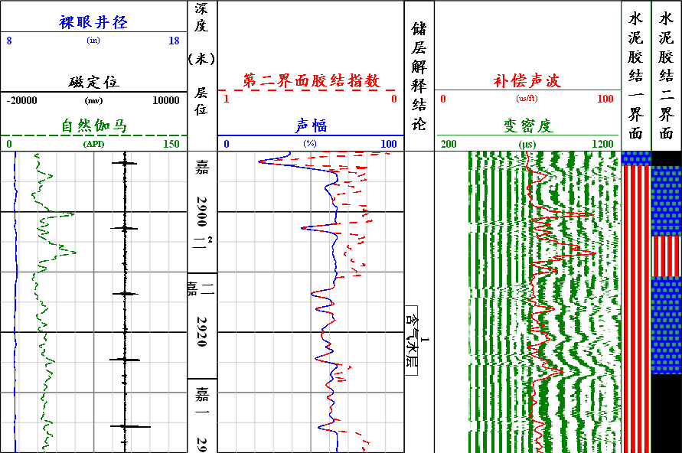

图1 高石130井（2890-2940m）固井处理成果图

（2）3570-3630m该封固井段上部声幅值高，一界面水泥胶结差；变密度曲线反映内层套管波能量强，地层波能量较强到强，以较强为主，二界面水泥胶结中到好，以中等为主。

2#储层声幅高，一界面水泥胶结差；变密度曲线反映套管波能量强、地层波能量强，二界面水泥胶结好。3#储层声幅中到高，一界面水泥胶结中到差，以差为主；变密度曲线反映套管波能量较强到强，以强为主、地层波能量强，二界面水泥胶结好。（见图2）

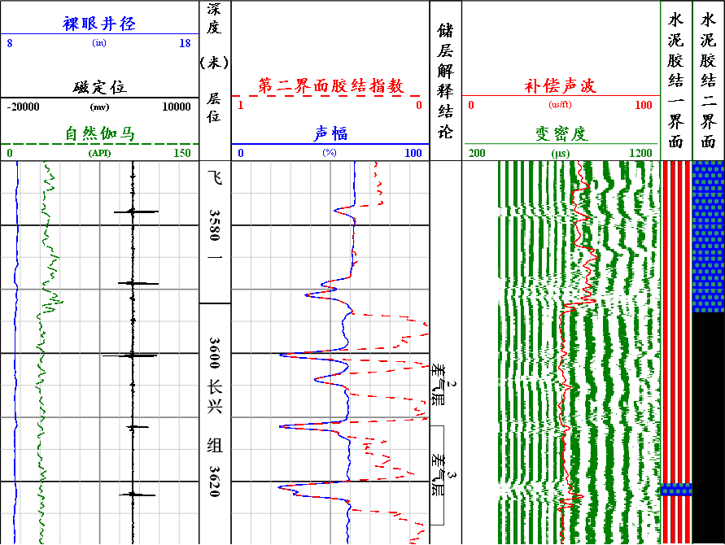

图2 高石130井（3570-3630m）固井处理成果图

（3）3810-3860m该封固井段上部声幅值高，一界面水泥胶结差；变密度曲线反映内层套管波能量强，地层波能量较强到弱，以弱为主，二界面水泥胶结中到差，以差为主。

4#储层声幅高，一界面水泥胶结差；变密度曲线反映套管波能量强、地层波能量较强，二界面水泥胶结中。5#储层声幅高，一界面水泥胶结差；变密度曲线反映套管波能量强、地层波能量较强，二界面水泥胶结中。（见图3）

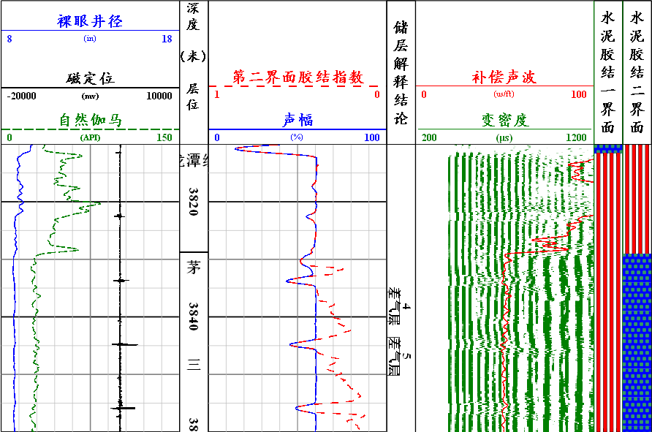

图3 高石130井（3810-3860m）固井处理成果图

（4）4010-4060m该封固井段上部声幅值低到高，一界面水泥胶结好到中到差；变密度曲线反映内层套管波能量强到较强到弱，地层波能量较强到强，以强为主，二界面水泥胶结中到好，以好为主。

6#储层声幅高，一界面水泥胶结差；变密度曲线反映套管波能量强、地层波能量强，二界面水泥胶结好。（见图4）

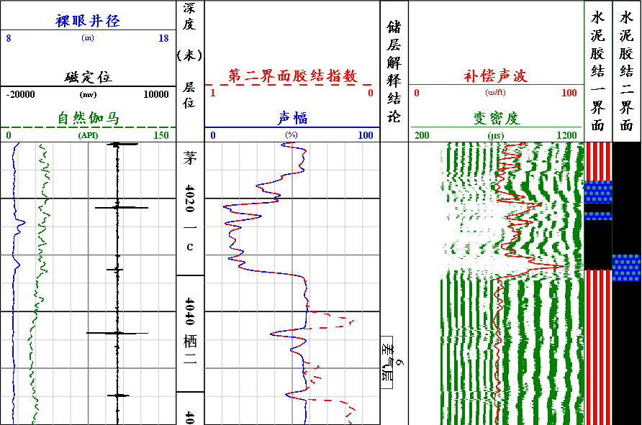

图4 高石130井（4010-4060m）固井处理成果图

（5）4840-4910m该封固井段上部声幅值低到高，一界面水泥胶结好到中到差；变密度曲线反映内层套管波能量强到较强到弱，地层波能量强，二界面水泥胶结好。

7#储层声幅中到低，一界面水泥胶结中到好，以中等为主；变密度曲线反映套管波能量较强到弱，以较强为主、地层波能量强，二界面水泥胶结好。（见图5）

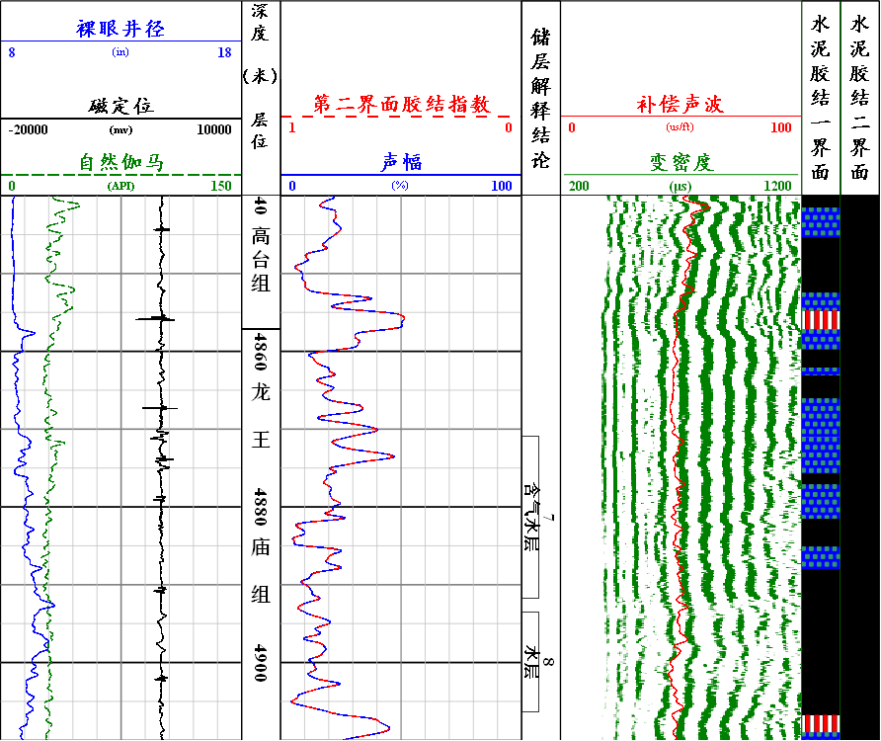

图5 高石130井（4840-4910m）固井处理成果图

（6）4910-4975m该封固井段上部声幅值中，一界面水泥胶结中；变密度曲线反映内层套管波能量较强，地层波能量强，二界面水泥胶结好。

8#储层声幅低，一界面水泥胶结好；变密度曲线反映套管波能量弱、地层波能量强，二界面水泥胶结好。（见图6）

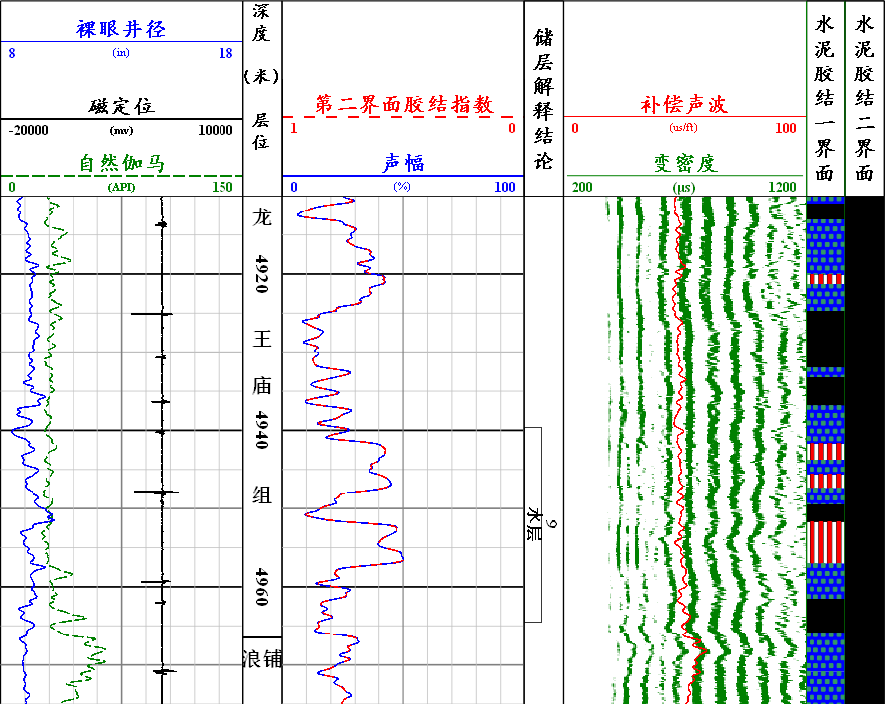

图6 高石130井（4910-4975m）固井处理成果图

**三 建议及其它**

2428-2873m、2893-3150m、3169-3666m、3767-3952m、4033-4207m、4220-4716m井段声幅值较高，部分套管接箍信号明显，建议采取相应措施（见图7-12）。

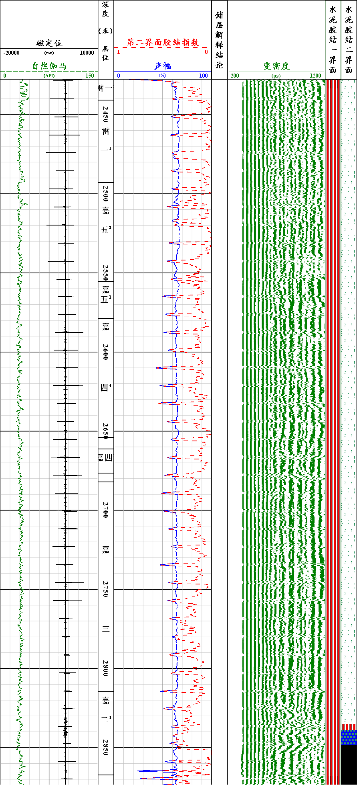

图7 高石130井（2428-2873m）固井处理成果图

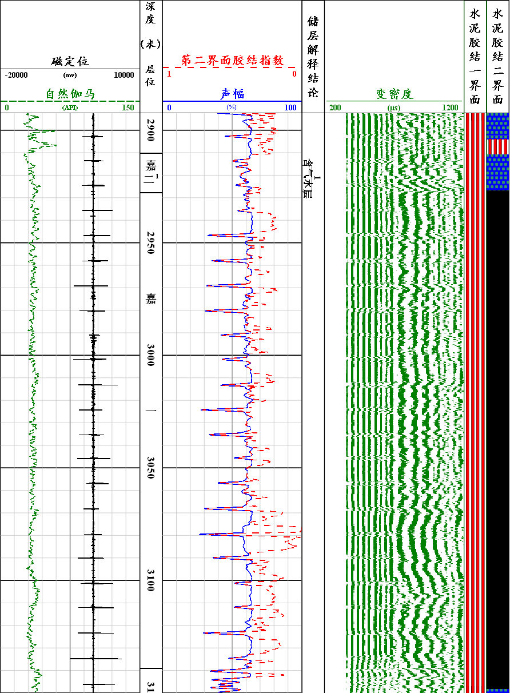

图8 高石130井（2893-3150m）固井处理成果图

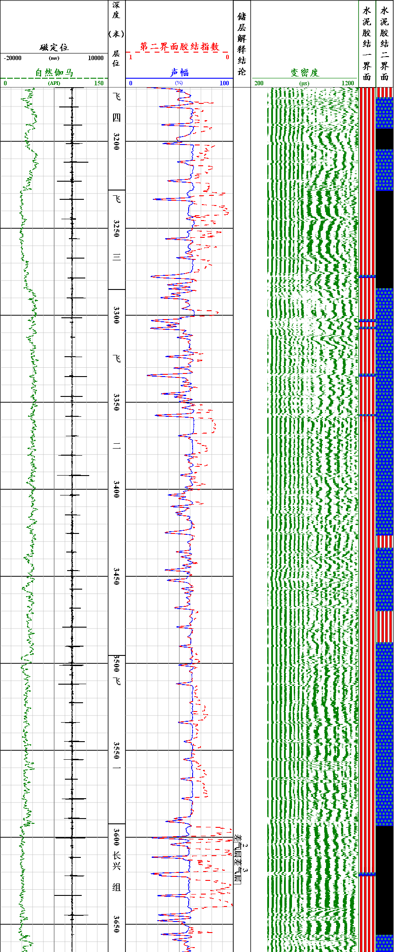

图9 高石130井（3169-3666m）固井处理成果图

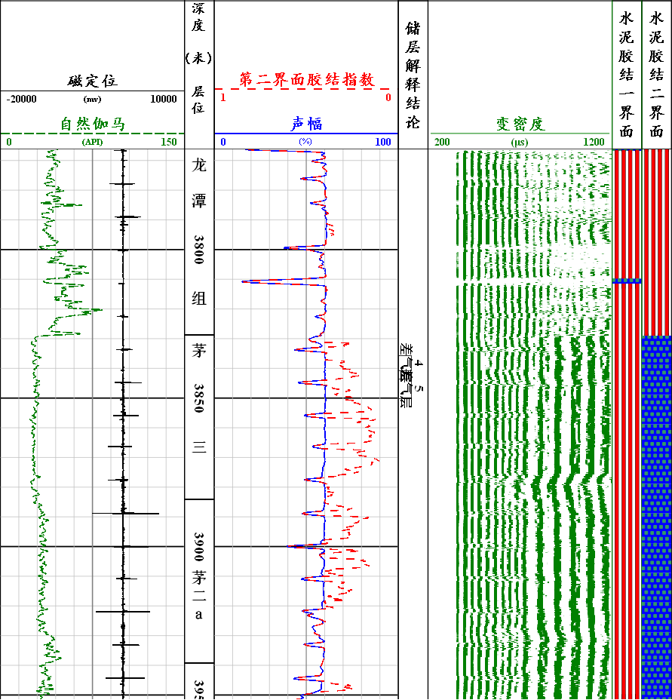

图10 高石130井（3767-3952m）固井处理成果图

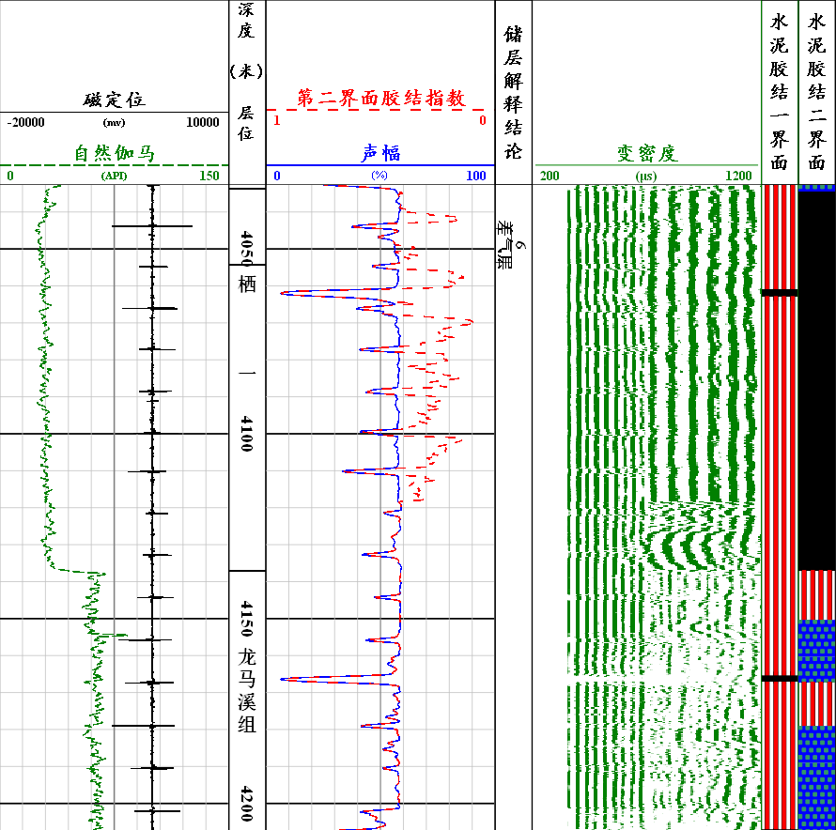

图11 高石130井（4033-4207m）固井处理成果图

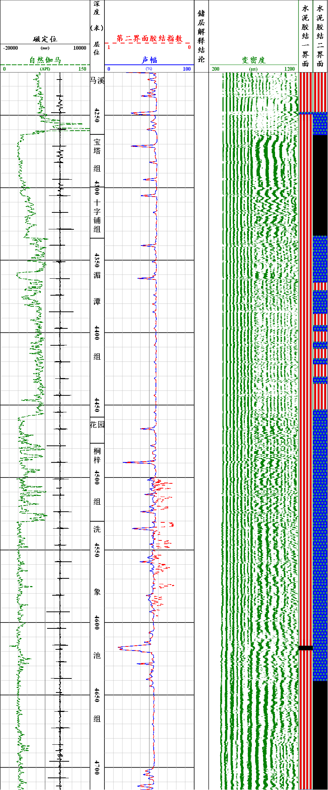

图12 高石130井（4220-4716m）固井处理成果图