Feature Doc: Player Powers

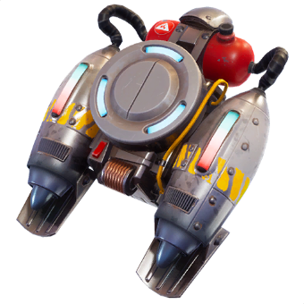
Jetpack
Figure 1 Jetpack from Fortnite (first picture from google)

Executive Summary
The Jetpack each player should allow the player to have an easier time traversing the map and should lessen the chance of accidental deaths

Goals
- Easier traversal through the map
- Making missing a jump more forgiving

Feature Breakdown
- When the Jump button is pressed while on ground the player jumps.
- When the Jump button is held while in the air, the player gets boosted upwards.
  - When pressed while falling, it will stop the falling quickly, not instantly.
  - The effectiveness of the Jetpack is increased out in space, with less gravity.

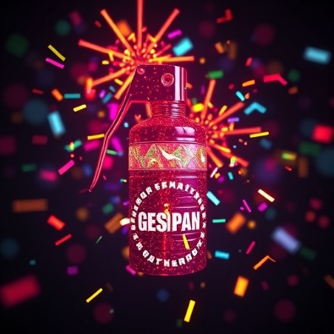
Confetti bomb
Figure 2 Confetti Grenade made by deepai.org

Executive Summary
This Confetti bomb allows the player to be able reposition when getting caught by another player in a disadvantaged position.

Feature Breakdown
- When a specified button is pressed, the player throws a bomb.
- When thrown, the bomb explodes after a time or when hitting something solid like a floor, wall or ceiling.
- When exploding, confetti particles will appear that obstruct line of sight (NOT line of movement or action).
- The confetti particles will fall slowly to the ground and disappear.
- The cooldown is long (maybe 30 seconds) and resets on player respawn.

