Feature Doc: Weapons

Mid-Range Machine Gun

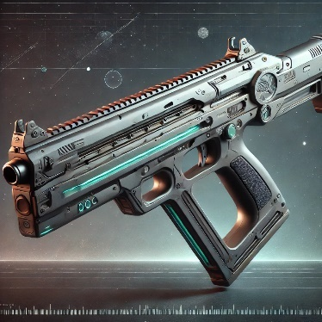
Executive Summary
Figure 1 Made with ChatGPT
This is the weapon each player will always have which does consistent damage but as a default weapon, it’s slightly weaker than Pickup-Weapons.

Goals
- The Machine gun should be a decently accurate weapon that works best mid-range distances.
- As the default weapon, it should require skill to consistency kill other players

Feature Breakdown
- When the game starts and each player has spawned, every player should already have the machine gun equipped
- The weapon has a slight spread, also slightly increasing based on the time the trigger is held.
- The weapon has damage fall-off, decreasing the damage done the further away the target is away.
  - After 15m, the damage falls off linearly from 100%-80% until 20m.
  - After 20m, the damage falls off linearly from 80% - 30% until 30m.
  - After 30m, the damage done is 30%.
- 7 rounds per second, 5 Damage per bullet,
  - TTK 2.8 seconds

Grenade Launcher

Executive Summary
This weapon adds flexibility for the player as the grenade that gets shot will be affected by gravity. Inside the dome, it falls in a stronger curve than outside in space.

Goals
- This weapon should be quite strong and attract players toward the center of the map (center of the dome).
- This weapon should reward the player with easier kills, but for limited ammunition.

Feature Breakdown
- When the game starts and then after a set amount of time, the weapon will spawn as a Pickup in the center of the dome.
- After the weapon has been collected, the weapon will respawn again after a set amount of time.
- When the trigger is pressed, a grenade will be shot out and will be affected by gravity.
  - The grenade will fall faster inside of the dome.
  - The grenade will “fly” in a straighter line when in space.
  - The grenade does 60 damages on direct hit.
  - The explosion does 40 damages to nearby enemies in a 1-meter radius, then linearly falling off to from 1 to 3 meters of distance. Enemies that took a direct hit will also receive the full explosion damage
- The weapon comes with 3 ammunitions, reloaded between each shot with a reload time of 3.3 seconds.

Laser Weapon

Executive Summary
The laser weapon is just slightly stronger in terms of power that also lowers the time they get killed from the default weapon by healing some damage when dealing damage.

Goals
- This weapon is a good alternative to the grenade launcher since it gives the user an advantage over the default weapon.
- This weapon increases the likely hood of survival by healing the user.

Feature Breakdown
- When the game starts and then after a set amount of time, the weapon will spawn as a Pickup on some of the outer, elevated platforms.
- After the weapon has been collected, the weapon will respawn again after a set amount of time.
- While the trigger is pressed, the weapon shoots out a continuous beam that deals damage (slightly more than the default weapon) and heals a bit from the damage done.
  - The beam does 40 damage per second.
  - The beam heals the user for 40% of damage dealt.
- The weapon can shoot for 12 seconds in total

