

***AIN SHAMS UNIVERSITY FACULTY OF ENGINEERING***

***ECE413 Project 2 – MIPS16 PnR***

|  |  |
| --- | --- |
| ***2100467*** | ***Moustafa Ahmed hashem*** |
| ***2001967*** | ***Aya Faried Hussain*** |
| ***2100913*** | ***Kreem ehab Ibrahim*** |
| ***2100709*** | ***Michael George Naem*** |

**• Perform placement and routing for MIPS16 RTL (inside VM).**

**• Objective: Optimize both area and frequency as much as possible.**

**• Constraints: Floorplan not square, Pins not on M3 & M2 in one line of TCL**

**Command, Do not use compile ultra.**

**• Deliverables: Edits done to any scripts highlighted in the flow, Area, Frequency,**

**Timing Report (Setup & Hold), DRC Report in ICC.**

**Hold report**

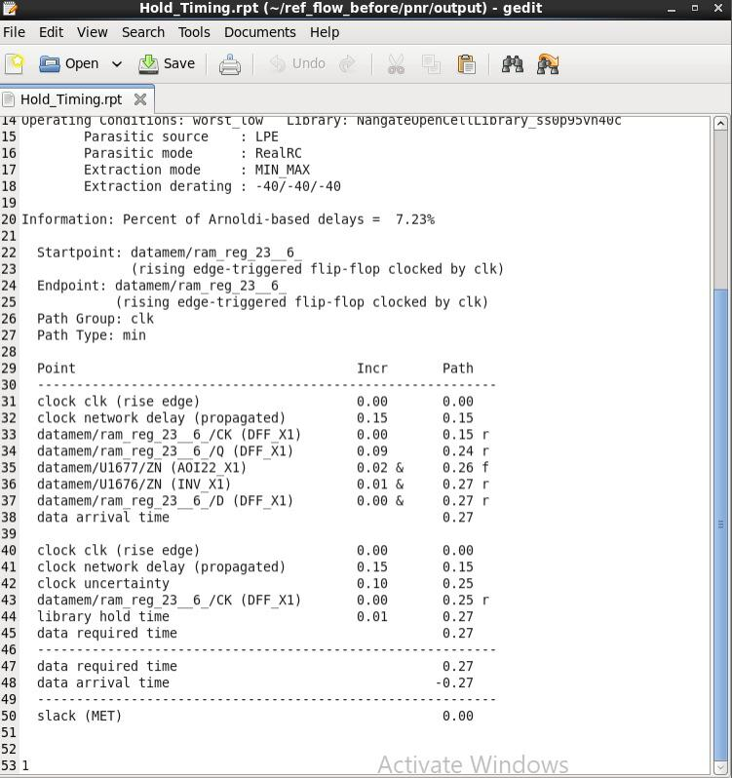

**Setup report**

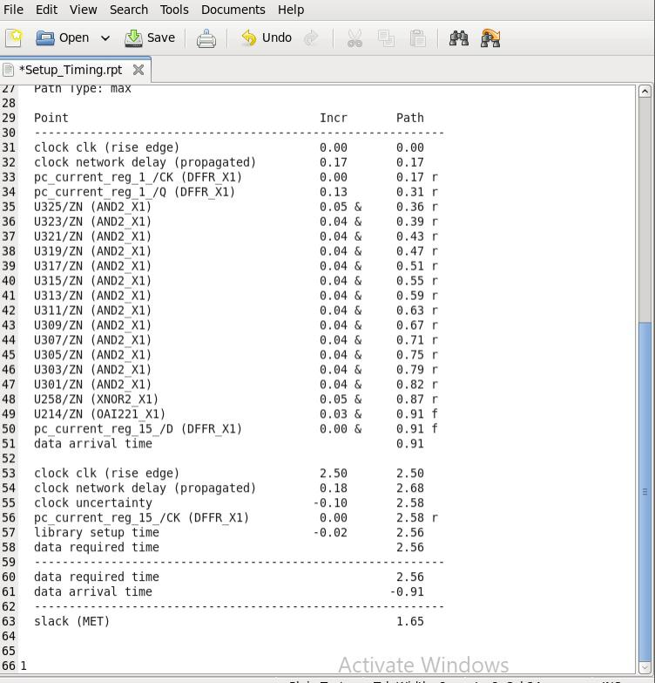

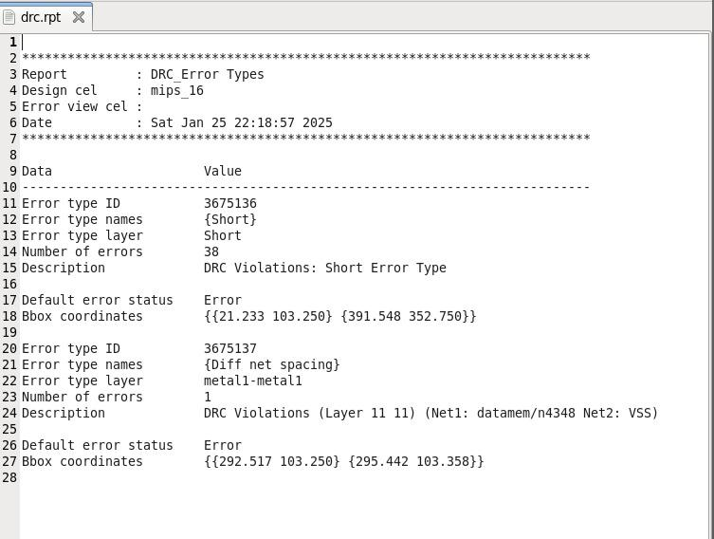**DRC**

**No DRC**

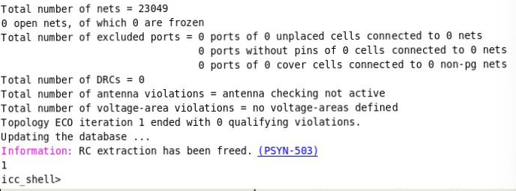

**Area report**

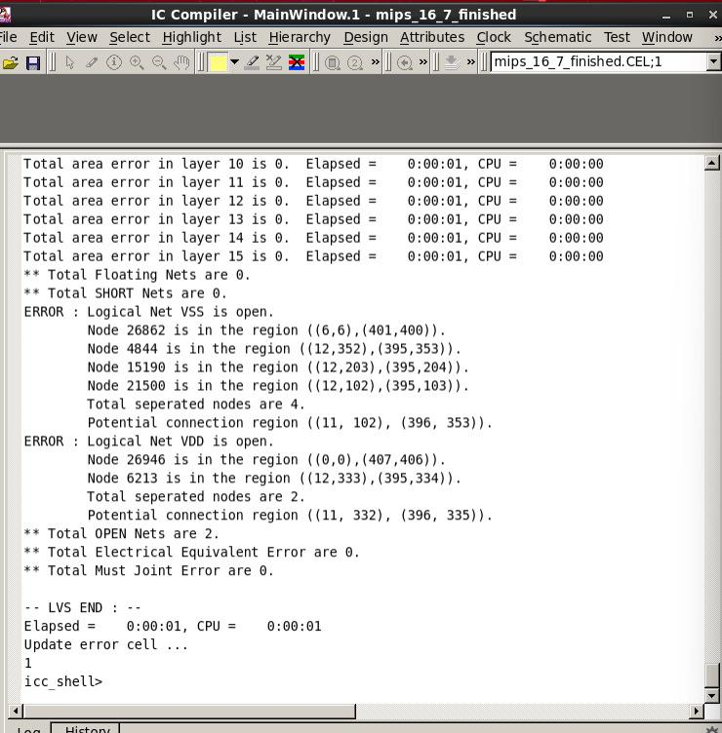

**Final layout**

