Introduction 2
What is our app? 3
High level requirements. 3
High level design 4
High level implementation of the main components 7
AI feature 7
End-to-end encryption 9
Real-time chatting 11
Login and authentication 11
Search users 11
“Available” user overview 11
Architecture 11
General overview 11
AI functionality 12
End-to-end encryption 13
Chat functionality 15
Login functionality 15
Challenges we have faced 15
AI feature 15
Who has done what 16
Conclusion 16

Introduction
Nowadays the term AI is discussed in nearly every corner of this world. The Term AI refers to artificial intelligence. But what that actually means is hard to tell, as we humans do not have a decisive definition of the term intelligence. Mainly because our own intellect is still a mystery to us. The term artificial seems a lot more straightforward, as it refers to something that is man-made and not naturally produced. (Although as every component in every machine is made out of particles, you cannot definitely prove that there is not a planet in the universe where this particular machine was made by nature). To still derive a general definition artificial intelligence refers to a man-made machine which exhibits cognitive skills similar to that of a human. In recent years AI has made further progress and was able to sophisticate itself in everyday life, that is to escape from the purely scientific world and acquiring general relevance in the world of all human beings. ChatGPT made a significant contribution to this change, as it allowed every human being to come into contact with the scientific and mathematical world of AI, without having to understand any of the complex structure behind it. For most of us ChatGPT has become an irreplaceable companion that helps us in our everyday tasks. Especially for university students this technology became a brand-new way of learning and understanding complex concepts in every branch of research. But as popular as AI is, it is also a highly controversial topic. Many fear the rise of AI, as it has the potential to become a lot smarter than us. Although, there a valid reasons for this fear, a bigger problem right now stems from the fact that most people discussing this topic do not actually understand how AIs like ChatGPT work. ChatGPT does not actually understand us, what it does instead is predict the most likely next word for an input. It then concatenates the input and the predicted word as a new input and repeats this process. This is resumed until there is a response. In this project we want to leverage this “skill” ChatGPT has, we take user profiles as an input and try to produce an output for that. We call the desired output “Icebreakers” and as the name implies, we want this system to generate good first messages for a given user profile. All of this is part of a real-time chat application. How we realised this task and what problems and obstacles we faced will be discussed in this report. Furthermore, this report serves as a first dive into the strange and scientific world of AI, that we as team began diving into since the start of this semester (October 2024).

What is our app?
Our application is a real-time chatting website. Here users have accounts and can see all other users of this application. Each user has a profile with a description. When a new user: Laura logs in, she can select another user: Bilal. Then our AI analyses the description that Bilal wrote about himself and suggests Laura a few potential first messages she can send to Bilal. For instance: Bilal wrote about himself that he likes boxing, so a potential first message may be: “Boxing is so nerve-wrecking. Who is your favourite Boxer?” Laura selects this Icebreaker and sends it as a first message. A new chat now exists between Laura and Bilal. Here they can spend as much time texting each other as they want and best of all, only they know the content of their conversation. Because we value user privacy, we want this chatting feature to be end-to-end encrypted, this means only Laura and Bilal have the means to decrypt the exchanged messages.

High level requirements.
The most important requirements this app must fulfill are the following:
- The generated Icebreakers reflect the user’s description
- The chat feature is real time, meaning instantaneous messaging and sending messages without waiting for the recipient to “acknowledge” them
- The user’s keys and passwords are securely stored
- The UI design is intuitive and easily accessible
- A secure login system
- All chat messages are stored
- A user can adjust his profile to his/her liking
- The website can handle multiple users using the website at once
- Chat messages are stored in an encrypted form
- Chat messages are encrypted while in transit
- A user can search for specific users
- A user sees only the users in the overview component, whom he does not have a chat with
- Automatically logout inactive users
- Encryption is robust enough to prevent brute force attacks
- Only authenticated users can use the website
- Make something to distract users while icebreakers are loading
- Find a balance between security and accessibility
- Users can mark themselves as “inactive” so to not be disturbed
- Each message is accompanied by a timestamp
- Users can logout manually
- There shall be a minimum character number for passwords

High level design
When accessing the website users first meets a login screen, here they can choose to create a new account or sign in with an existing one. Users can also choose which language the prefer: German or English.
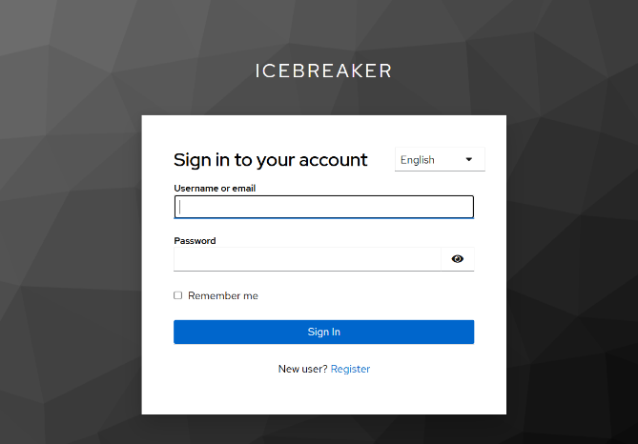

When the login was successful new users have to create a passphrase and a magic number, “old” users will only have to confirm their passphrase.
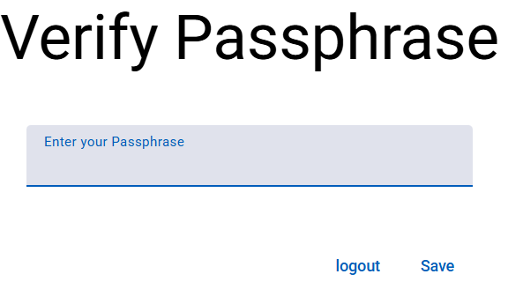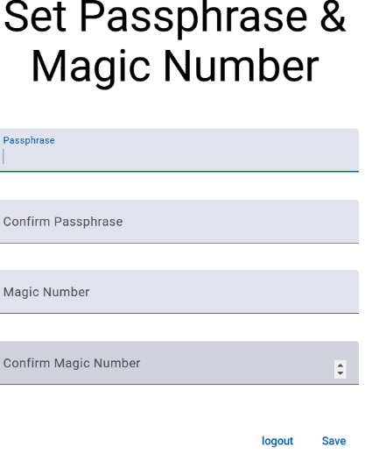

After this a user will be prompted to “complete” his profile.
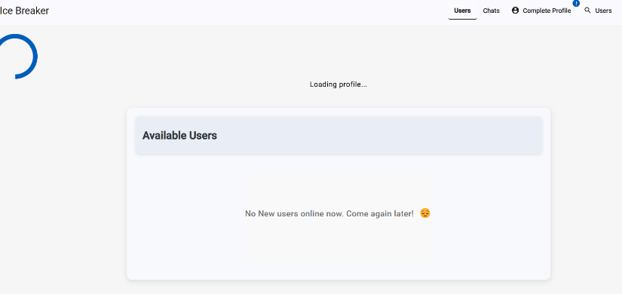
When the user then clicks on complete profile, he will need to write a description about him/herself disclose their age and their gender, additionally, users can choose to use a profile photo.
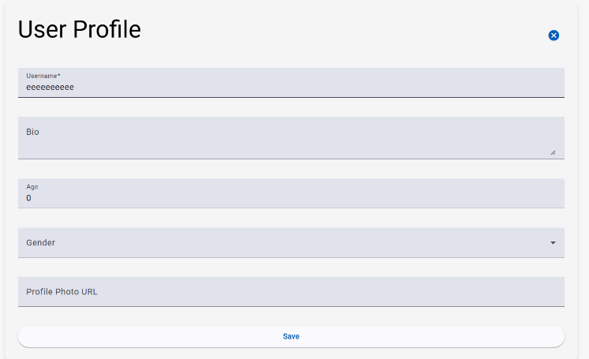

After that the user is greeted with following screen
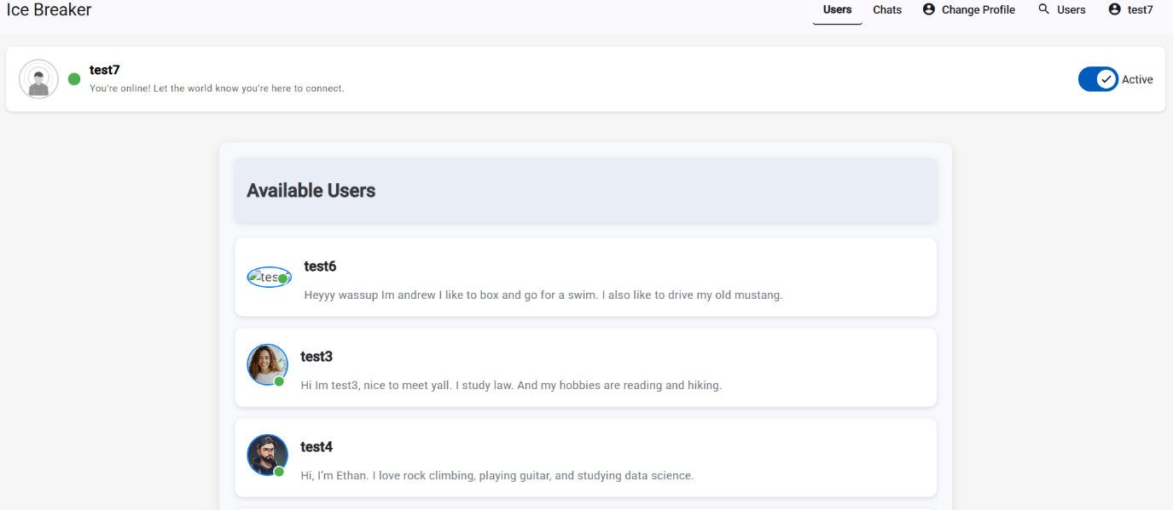

Here the user can see all other “available” users. The term “available” in this context means active users, whom this user does not yet have a chat with. The user can see the description, username and picture (if provided) of every “available” user. Furthermore, a user can set himself as inactive, can change his profile and search for users.
When clicking on a user profile the user can send a first message to this person, there the icebreakers are also generated, this takes some time, so in the mean time the user sees various messages as to distract him/her from the passing time.
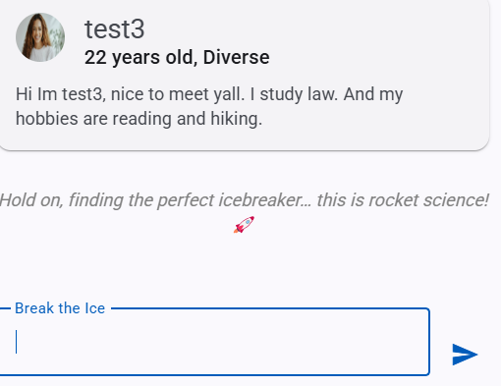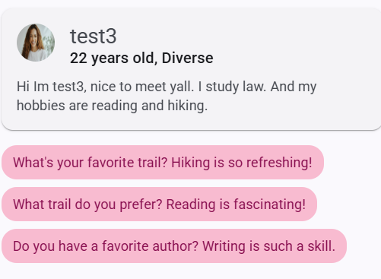
One particular “waiting Generated Icebreakers for time slogan” this profile

When a user sends a first message a chat is created this chat can be views, when the user clicks on chat overview.
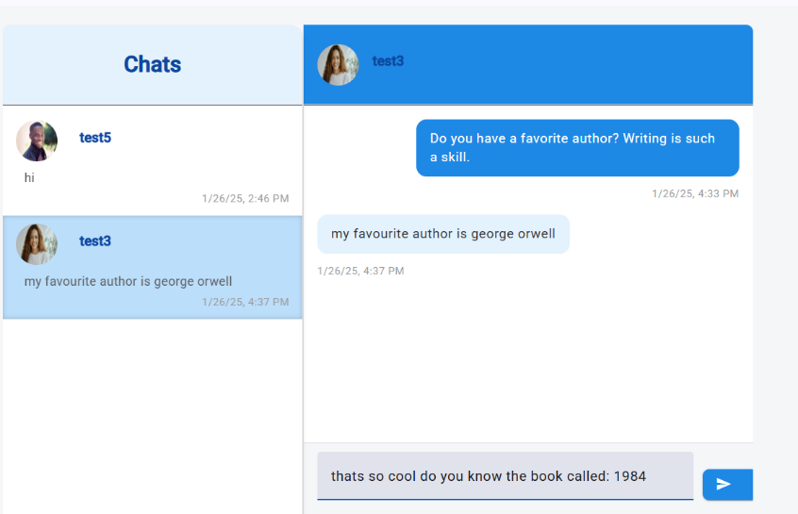
This is what the user sees afterwards, here all of his chats are displayed. When he selects a particular chat (like here with test3) he can see all exchanged messages along with timestamps for each message. The messages on the right hand side are the ones the user wrote him/herself the messages on the left hand side are the messages of the other participant.

High level implementation of the main components

AI feature
The feature is a fine-tuned version of the pretrained gpt2-medium model. In the following it will be described step-by-step how generative AIs work and how we can leverage that for our own purposes.
Machine learning and neural networks Most of the modern AI technology revolves around so called “neural networks”. The idea is that the initial input is split into much smaller features. For example, a picture may be split into pixels. These features are then multiplied by so called “weights”, at first the values for these weights are random, this process can also be described as a matrix multiplication. Because many inputs (for example multiple pictures each with 1000 pixels for instance) are multiplied by a variety of weights. (The height of the input matrix may be the number of pictures and the width the number of pixels). Each output from the matrix multiplication (weights × inputs) is called a pre-activation. A bias term is added to each pre-activation, acting as a learnable offset that adjusts the neuron’s sensitivity. The result is then passed through a non-linear activation function (e.g., ReLU), which returns 0 for negative inputs and the input itself for positive values. This final output is called the neuron’s activation, loosely inspired by biological neurons that ‘fire’ when their input crosses a threshold. This described process is then repeated x times. At last, there is an output, also called a “prediction”, (for example there may be 10 outputs representing the numbers 0-9, the neuron with the highest number at the end represents the predicted number by the neural network). As expected at first this expected output will not make any sense but that is why we need to train the AI. In the training process we know the desired output for each input. We then compare each predicted output with the actual output. We can use functions like mean squared error, to estimate how bad the prediction actually is and then build an estimate of all predictions. But since the prediction depends on the weights which can be changed, the weights can be seen as variables and the average, the so called “loss” is the outcome of a function with these variables. Since now the whole system can be described as multi-dimensional function, we can also find a minimum for it (could also be a local minimum). But in this context a minimum would correspond to a system which makes the (mostly) correct prediction, this is our desired outcome. But how do we find this minimum, in calculus we learned that functions have derivatives which describe the slope of the function, and a multi-dimensional function has a gradient, the derivatives with respect to all variables, this gradient points into the direction of the steepest slope, if we were to go into the opposite direction of said gradient we can find a minimum. This is what backpropagation is all about. We calculate the derivatives for all the weights and subtract that from the current weights. This is the basis for basically all modern AI models.
Generative AI Models New models took this idea and refined it for their needs, as computational power rose, the models could also become more complex and nuanced, the so-called transformer model used by ChatGPT was born. How does that work? ChatGPT takes an input of words, it then maps these words or tokens (tokens do not necessarily have to be words) into vectors. These vectors go through many layers of layers of multiplications and at last these vectors are used to predict a subsequent vector; this is the quintessence of generative AI models like ChatGPT. This new sentence will then form the next input to then predict the yet next vector, this is repeated until a response is formed. Especially notable is the “Attention” model, used in between mapping the tokens into vectors and then using the vectors to predict the next. To put it simply each of the sentence’s token’s embeddings (the vectors) is mapped into query, key and value vectors using matrices. Then the dot product of all key and query vectors is computed and then divided by the square root of the dimension size of the vectors (for scaling), this is put into softmax (a function scaling all values between 0 and 1) to find out the probability distribution of the results. (a high probability means a strong relevance between tokens). This in turn is multiplied by the value vectors; by learning how closely each of the embedding vectors are, the AI can learn the structure of the sentences. If the AI models is fed with a lot of sentences and information, it could thus, learn its structure and reproduce it. This is the magic behind how ChatGPT is able to predict the next word for an input. (A few important aspects to mention are generative AI models often use Gelu instead of Relu and a cross-entropy loss instead of the mean squared error; masked self-attention is also important so that no “future” tokens are used when predicting the next token during training. Lastly, the model uses positional embeddings so that vectors have their initial position in the sentence encoded).
Our fine-tuned model With this knowledge our use of the gpt2-medium model can be explained. We wanted the model to learn the structure of user profiles and corresponding “icebreakers”, thus, we had to create 200-300 of these examples. (For professional purposes a lot more a needed). These are then fed into the gpt2-medium model to learn the relationship between the profiles and the icebreakers. We used a pretrained model, because, without a pretrained model, gpt2-medium would have no knowledge of grammar or sentence structure and a lot more than 200-300 examples would have been needed to train the model. Now that we understood how the model works it also makes sense why feeding the model the following structure for learning would not bring any result: “Profile A- Icebreaker 1; Profile A- Icebreaker 2...”. For someone not understanding how the attention mechanism works this may seem like a way of teaching gpt2-medium the different possibilities for icebreakers for a given user profile. But now we know that this will no work as the model will learn contradicting relationships between the tokens and would not be able to produce valid output. Thus, a better structure would be “Profile A- Icebreaker 1- Icebreaker 2.... Profile B- Icebreaker 1....”. With this structure the model will learn all icebreakers corresponding to one user profile. This learned knowledge is then captured in its updated weights, these are used to then predict several icebreakers for new profiles written by users of our app. This works pretty well; the limitations of our fine-tuned model are discussed in the section “Challenges we have faced”.

End-to-end encryption
During the discussion, as to how this app shall look like, we derived that it is extremely important that each chat is end-to-end encrypted. The first reason is, that users may not want the server or the provider of the app to know the contents of their conversations and secondly the messages are saved on servers, if they are stored as plaintext, an attacker hijacking the servers may find out all contents of each conversation. Therefore, we needed a way to prevent this. Upon creating an account, the user creates a passphrase and a magic number. The passphrase alongside the magic number is put into a hash function and only the hash value alongside the magic number (also called salt) is saved on the server. A hash function is used so that hash(p,m) = x is easy but the reverse is computationally infeasible. Then in the frontend a new public/private key pair is generated. The private key is encrypted with passphrase to the power of magic number modulo 10^12+33. (A modulo value large enough, so that brute force attacks are infeasible). The keypair is then uploaded to the server. When starting a new chat, the frontend retrieves the public key of the recipient (which is not encrypted) and generates a symmetric key, then it encrypts the first message with the symmetric key and then in turn encrypts the symmetric key twice. Once with his public key and once with the public key of the recipient. These encrypted symmetric keys are uploaded to the server. When the recipient logs into the website he/she has to type in the passphrase, the output hash is compared to the one stored on the server if they match, he/she is permitted to enter. His/her encrypted private key is fetched from the server, in the frontend the passphrase is used to decrypt it. Now he/she can go to the new chat. For this, the symmetric key (encrypted with this user’s public key) is fetched, the decrypted private key is used to decrypt the symmetric key, then the symmetric key is used to decrypt the new message. This lengthy process is only needed in the beginning, from the moment the user fetched the symmetric key for this chat, the key is saved in the local cache and used for encrypting/decrypting all messages during the session. (Referring to the period where the user uses our website; a session terminates, if a user is inactive or logs out).

Real-time chatting

Login and authentication

Search users

“Available” user overview

Architecture

General overview
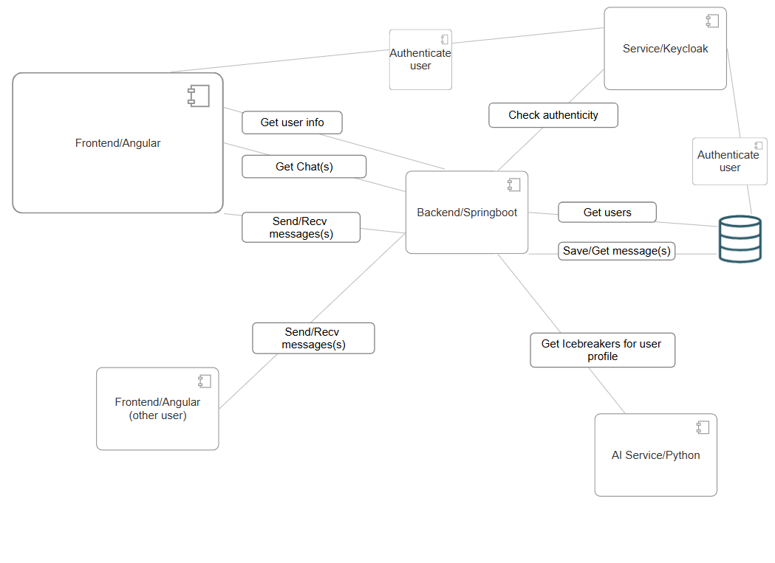This a general overview of our project, here the general ideas with the core components are illustrated. (Most of the shown steps are an over-simplification of the actual processes). Furthermore, the diagram illustrates a main user (Frontend/Angular) using our systems and all components and connections relevant for the general use cases, the other user is “only there” to illustrate the chat functionality between different end users.

AI functionality
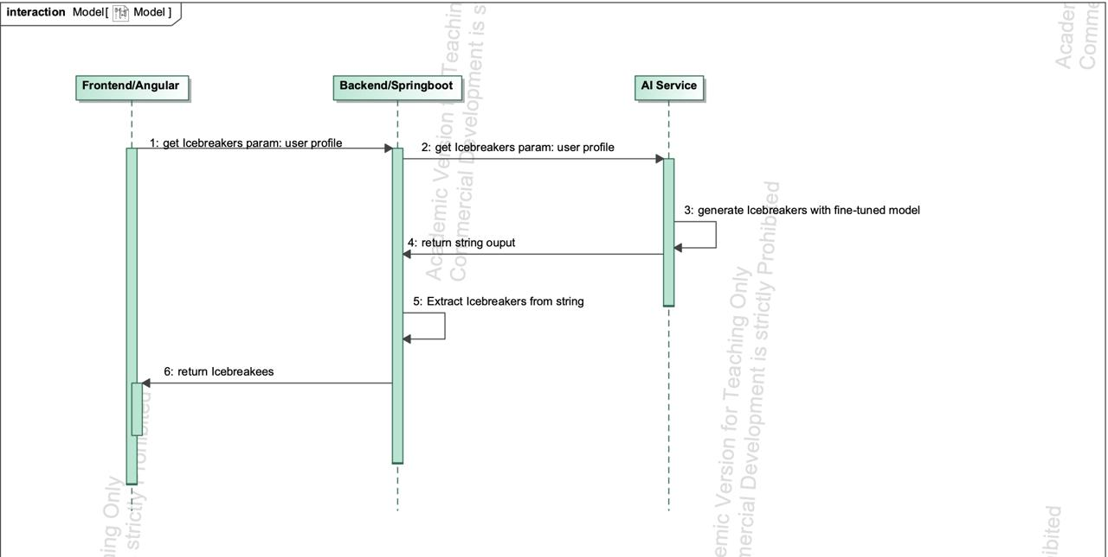

This sequence diagram illustrates how the different components interact when new Icebreakers for a profile shall be generated.

End-to-end encryption
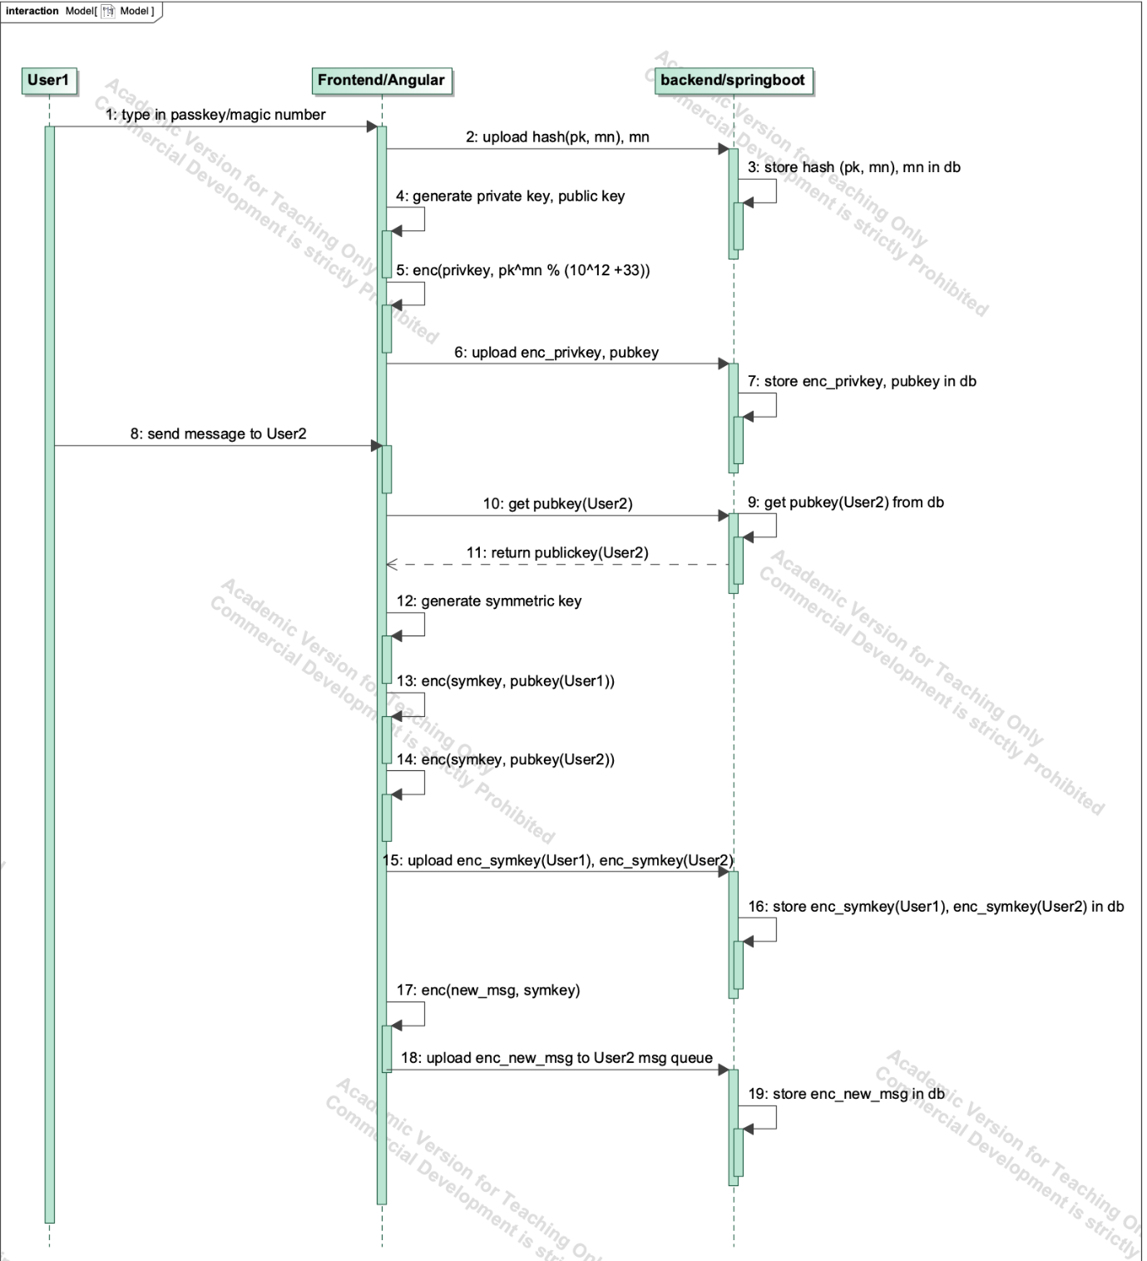
This sequence diagram illustrates how end-to-end encryption is realized, through illustrating the flow when a new user registers and sends a new message to another (existing) user. Important abbreviations: hash – hashing algorithm, pk – passkey, mn – magic number, enc – encryption algorithm, enc_variable - encrypted variable, pubkey – public key, privkey – private key, symkey – symmetric key, msg – message, db - database.
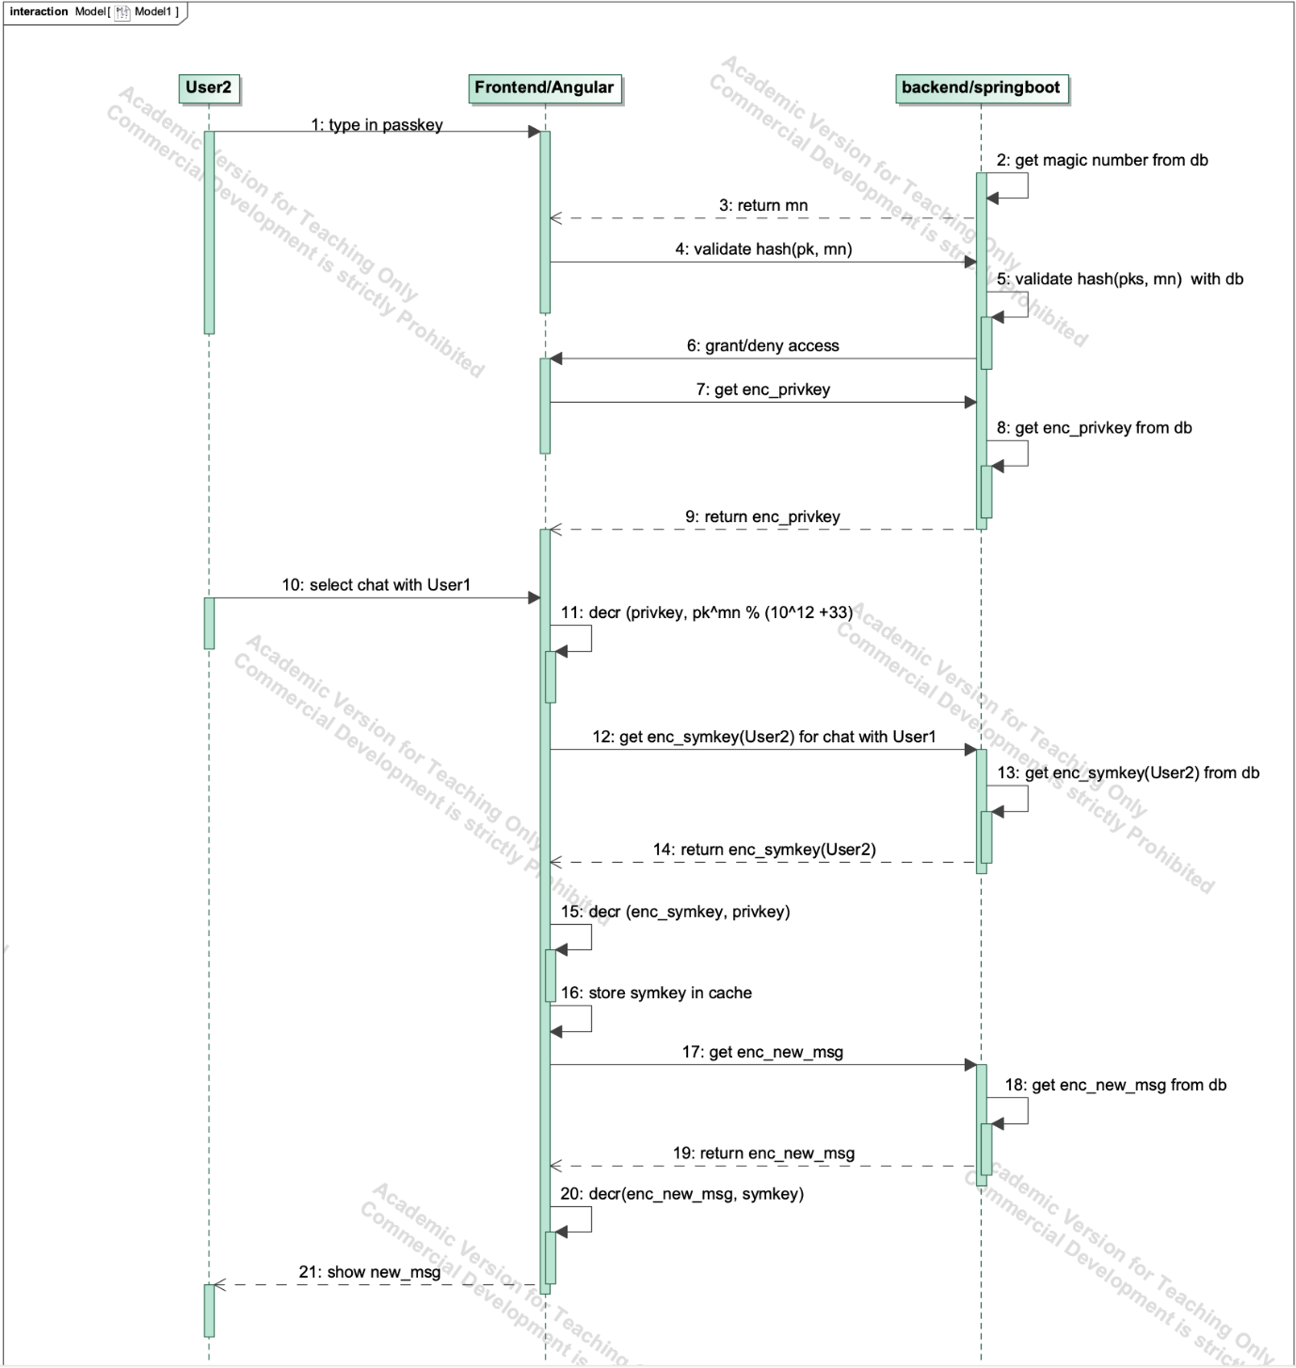
This sequence diagram illustrates how the other user logs in and receives the new message from the new user. Important abbreviations: hash – hashing algorithm, pk – passkey, mn – magic number, decr – decryption algorithm, enc_variable - encrypted variable, pubkey – public key, privkey – private key, symkey – symmetric key, msg – message, db - database.

Chat functionality

Login functionality

Challenges we have faced

AI feature
Data gathering Initially we wanted to write 20 Profiles + Icebreakers ourselves and let ChatGPT generate 5000 more, but we soon noticed that ChatGPT was not able to do this at all (the quality of the generated examples was extremely bad, ChatGPT essentially wrote an algorithm to generate them, meaning each profile and Icebreaker was nearly the same). We then created 50 Profiles + Icebreaker ourselves and through countless tries were able to let ChatGPT create 150-200 more sufficient ones. This meant that we had an extremely much smaller dataset to work with, furthermore, the provided examples were extremely similar in how their structure was. An example, profile: “Hey, I’m Maya, I like singing, learning, languages, and eating sweets. I’m currently studying computer science.” Each profile starts with a hello and the name, then hobbies and often the current occupation(s) is/are listed. An Icebreaker for this profile would be: “Singing is really nice. What kind of songs do you really like singing the most?” Each Icebreaker has two sentences, one sentence reaffirming the interest of the person and the other asking a question about it. We believe such a structure makes the most sense for first messages but also due to limitation in the number of datasets that we have, all Icebreakers follow this structure. Thus, the generated Icebreakers do the same, the real problem comes from when the structure of the profile is deviated from. We first trained the gpt2-small model, here minor changes in the profile structure often meant illogical Icebreakers. With the gpt2-medium model this is a little better, even if the provided profile is significantly different from the learnt structure, the model is still able to generate mostly “good” Icebreakers. But the lack of datasets and the fact that all datasets follow a similar structure for the profiles still means, that when giving the model a profile that completely deviates from the learned structure the generated Icebreakers can not be considered “good”. Here we want to demonstrate an example for a generates Icebreaker with the fine-tuned gpt2-medium model. Profile:” Hey, I’m Lucas. I love playing guitar, coding games, and studying astrophysics.” One of the generated Icebreakers: “Astrophysics is mind-blowing! Do you have a favorite celestial phenomenon?”
Training the model Another issue that we faced was that none of our GPUs had enough VRAM to train the small (117 million parameters) or the medium (345 million parameters) model. Thus, we used Google Collab and bought 100 computational units, with these we could select a GPU which had approximately 40 GB of VRAM. With this we could train the model, after assessing that we had sufficient results we could download the weights and use them in our application.

Who has done what
Utkarsh Fulara was responsible for the login and authentication, for the chat overview component and for the real time chatting feature. Bilal Alali was responsible for the search feature, the profile overview component and for creating data for our AI feature. Andrej Sum-Shik was responsible for conceptualising the AI, training the AI and integrating the AI into the Website. Furthermore, he was also responsible for the end-to-end encryption of the messages. All members worked on creating architectures for the application. Especially conceptualising the database where login and chat data is stored.

Conclusion
This was our favourite project of our young career so far, mainly because we were given the freedom to create what we want and the fact that we could work on one of the most important topics in computer science of this day. Through this project we were able to understand neural networks which are the basis for all modern AI. Furthermore, we were able to work with and understand the complex models of todays age which extend the classic neural networks, namely generative AI models like ChatGPT. We had a lot of fun understanding how AIs like ChatGPT work and how we can fine-tune these models to our demands. Furthermore, we were able to sophisticate and enlarge our knowledge of creating complex websites, which incorporate a java driven backend (in our case springboot), a javascript driven frontend (in our case angular) and database structure (in our case PostgreSQL). Especially conceptualizing and implementing the chat functionality demanded a lot of our knowledge acquired in courses like: Distributed Systems or Computer Networks. Thus, we could bring a lot of the learned concepts into practice. The same can be said for the end-to-end encryption. Here the knowledge acquired in the IT Security lectures was of vital importance to realize our ideas. As the mentioned courses were among some of our favourites in our journey in this university, we were able to sophisticate our interests and get a first idea of what to do after acquiring our bachelor’s degree. (If all goes well all of us are finishing this year or at the beginning of next year). In conclusion on behalf of the entire team: Utkarsh Fulara, Bilal Alali and Andrej Sum-Shik we would like to thank Prof. Dr. Ing. Markus Miettinen for giving us this wonderful opportunity. We are very satisfied with this course and are looking forward to the presentation where we can present our work to all the other students.

Vuong, Q., La, V., Nguyen, M., Jin, R., La, M. & Le, T. (2023b). How AI’s Self-Prolongation Influences People’s Perceptions of Its Autonomous Mind: The Case of U.S. Residents. Behavioral Sciences, 13(6), 470. https://doi.org/10.3390/bs13060470
Vaswani, A., Shazeer, N., Parmar, N., Uszkoreit, J., Jones, L., Gomez, A. N., Kaiser, L. & Polosukhin, I. (2017). Attention is All you Need. arXiv (Cornell University), 30, 5998–6008. https://arxiv.org/pdf/1706.03762v5

