Object Oriented Programming in Java

Project Milestones

Table of Contents

1. Introduction 2

1.1. Learning Goals 2

2. Group Members 3

3. Milestones 3

3.1. Things that have been achieved so far 3

3.2. Things we are planning to achieve until the next submission 4

3.3. Problems that arose during the last milestone phase 4

4. Figures 5

# Introduction

In the history of mankind, there have been countless inventions that fundamentally changed the way we as humans have lived. One such invention, the airplane invented in 1903, allowed us, for the first time ever, to take to the skies.  
Over a century later, we can now travel thousands of miles or fly hundreds of tons of cargo from one end of the world to the other within a day.

As part of our **Java-OOP project** we are delighted to get to know a little bit more about drones and build an application which fetches data from a Django based web server and visually displays it.  
Our aim is to create a working app using the fundamentals of object-oriented programming in Java. The app should allow for user interaction with said data, using buttons and multiple windows which ensure that the app does not look cluttered.   
The Java Framework known as “Swing” is used for front end development.

Interestingly, the rendered data also contains dynamic data which changes in regular intervals. This makes the application standout in terms of data-rendering. The written code should deal with the server’s restrictions and access the server’s data using a basic authentication header with an access token.  
Additionally, we made sure that our application does not send too many requests at once, which could lead to the application or worse the server temporarily not working.

## Learning Goals

After successfully completing this project, our team will have learnt…

1. How to coordinate in a team
2. How to fairly and efficiently divide tasks among a group
3. How to solve problems together ensuring smooth development
4. How to come up with and implement a feature or in case we lack the knowledge research a solution as a group

# Group Members

|  |  |
| --- | --- |
| **Responsibilities** | **Name** |
| Frontend Team | Mohit, Bilal, Utkarsh |
| Backend Team | Andrej, Yun See |
| Designing Team | Whole Group |
| GitHub Management | Andrej und Utkarsh |

**Besides each member’s individual work on the project, we also held group meetings at least once per week in which we discussed the project and shared our opinions on the code and how to improve it. These discussions were not limited to our “own section” of the code despite the group’s designation of responsibilities. **

# 3. Milestones

## Milestone 1

## Things that have been achieved so far

1. Visual representation (wireframe) of the App using Balsamiq  
   (Discussed collectively in 2 meetings)
2. UML diagram of the back end  
   (Andrej and Yun See)
3. Back end:
   1. Data can be successfully fetched from the API and formatted according to our needs  
      (Andrej and Yun See)
4. Front-end:
   1. Basic windows with graphics and images which outline the application’s general structure
   2. Basic buttons with basic functionality such as opening a new sub window
   3. Team decided to learn tools of swing first

(Mohit, Bilal, Utkarsh)

**Apart from that, a version control of the application has been initialized using a private repository of GitHub and access to the repository is confined to group members only. Various branches are used to develop individual features and then merged to the master branch of the repository **

## Things we are planning to achieve until the next submission

1. Front end:
   1. Successfully connecting front end with back end and achieving 70% of the designs of the wire-frame.
   2. Creating return buttons for all windows except the first window upon opening the app
2. Back end:
   1. Reviewing the code and cleaning it up  
      Solving unwanted exceptions and bringing the back end product to 90% of the desired product.

## Problems that arose during the last milestone phase

1. We encountered difficulties in gathering data across various web pages, primarily due to our limited knowledge of the correct format for writing query parameters in URLs. Our code consistently succeeded in accessing information from the first page but failed to retrieve data from subsequent pages. This challenge was ultimately overcome by relying on intuition and a deeper examination of the rules governing endpoints, as well as a more comprehensive understanding of the conventions for query parameters and variables within URLs.
2. We had programmed buttons in our graphical user interface (GUIs) to facilitate the transition between different windows. However, despite our efforts, the buttons did not function as intended. Although the code was written in accordance with our existing knowledge and seemed correct, the buttons remained unresponsive. This problem was solved by setting the requested window as “visible”, when the button is pressed.
3. We had conflicts in merging Files that was solved manually. Furthermore, we had to grow accustomed to GitHub itself, as most of us had little to no experience with it. Consequently a lot of problems arised when using GitHub’s various commands and features.

## Milestone 2

## Things that have been achieved since the last submission

1. Back end:
   1. All the drone data can now be fetched including the drone dynamics.
   2. The drone dynamics are stored as individual objects in a list and sorted by recency. This is realized by implementing a time class which splits the time string into separate strings which are saved as ‘years, ‘months’, ‘days’, etc.
2. Front-end:
   1. Successful connection of Front-end and Back-end
   2. Implemented a loading screen.
   3. Implemented a first window with a greeting and buttons.
   4. Implemented a following window in which the user can choose between viewing slow, medium, or fast drones by pressing the respective button.
   5. Implemented a window that tabularly displays drones of the same speed class (sorted by their maximum speed) and their basic attributes. Additional information about a drone can be found in a new window which the user can open by pressing an ‘Info’-button.
3. General:
   1. By including the use of threads in the ‘test’-class in which we run the program,  
      new data is being fetched from the server every 5 minutes while running the program.

## Things we are planning to achieve until the final submission

1. Front end:
   1. Fixing a bug which causes the window in which you choose the speed class to reopen twice when pressing the info or back button.
   2. Fixing a bug which causes the first window to be blank unless maximized.
   3. Implement a ‘history’-function which allows the user to search through older drone dynamics data with a search bar or table.
   4. Refresh button to update the data in the ‘speed class’ windows and ‘Additional info’ windows.
2. Back end:
   1. Reviewing the code and cleaning it up
   2. Potentially rewriting some parts to improve runtime and efficiency.

## Problems that arose during the last milestone phase

1. We encountered a bug which causes the window in which you choose the speed classes to be reopened twice when pressing the ‘Back’-button or the ‘Info’-button.
2. If the user were to quickly click through all the windows to view a drone speed class, the program would not be able to fetch the drone data quickly enough. This leads to a blank window until refreshed.   
   🡪 Solution: Loading screen on startup which closes when the program finished fetching the data.

**Below are all the referenced diagrams used for development**

# Figures

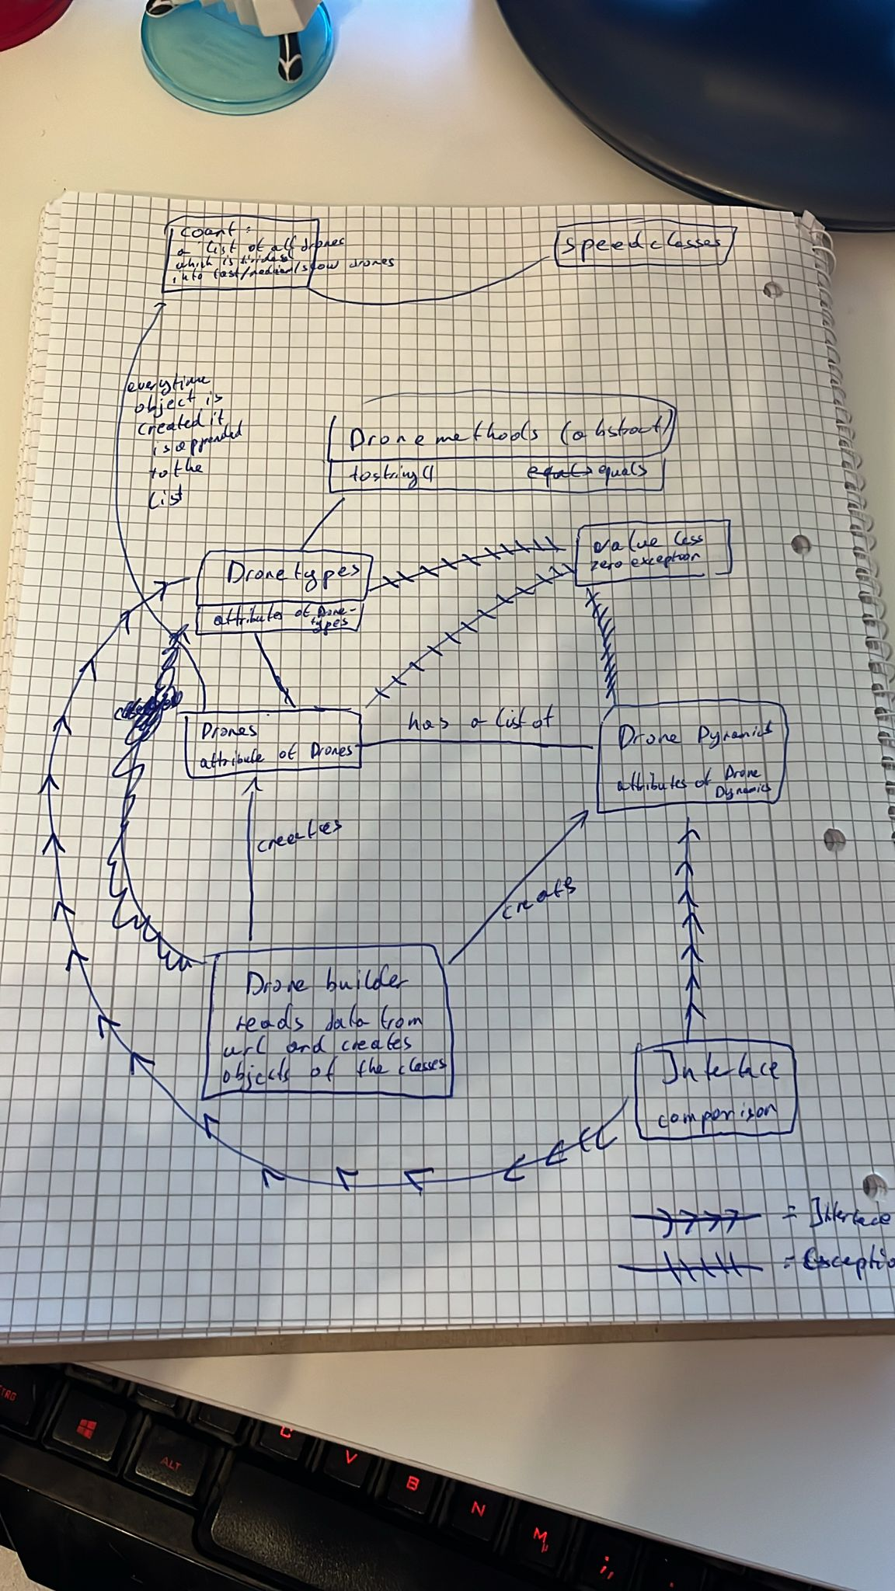

Figure 1 Initial sketch for back end

Figure Initial sketch of class diagrams

|  |  |
| --- | --- |
|  | |
| Ein Bild, das Text, Screenshot, Schrift, Reihe enthält.  Automatisch generierte Beschreibung |  |

