# User

### /user/login/

POST

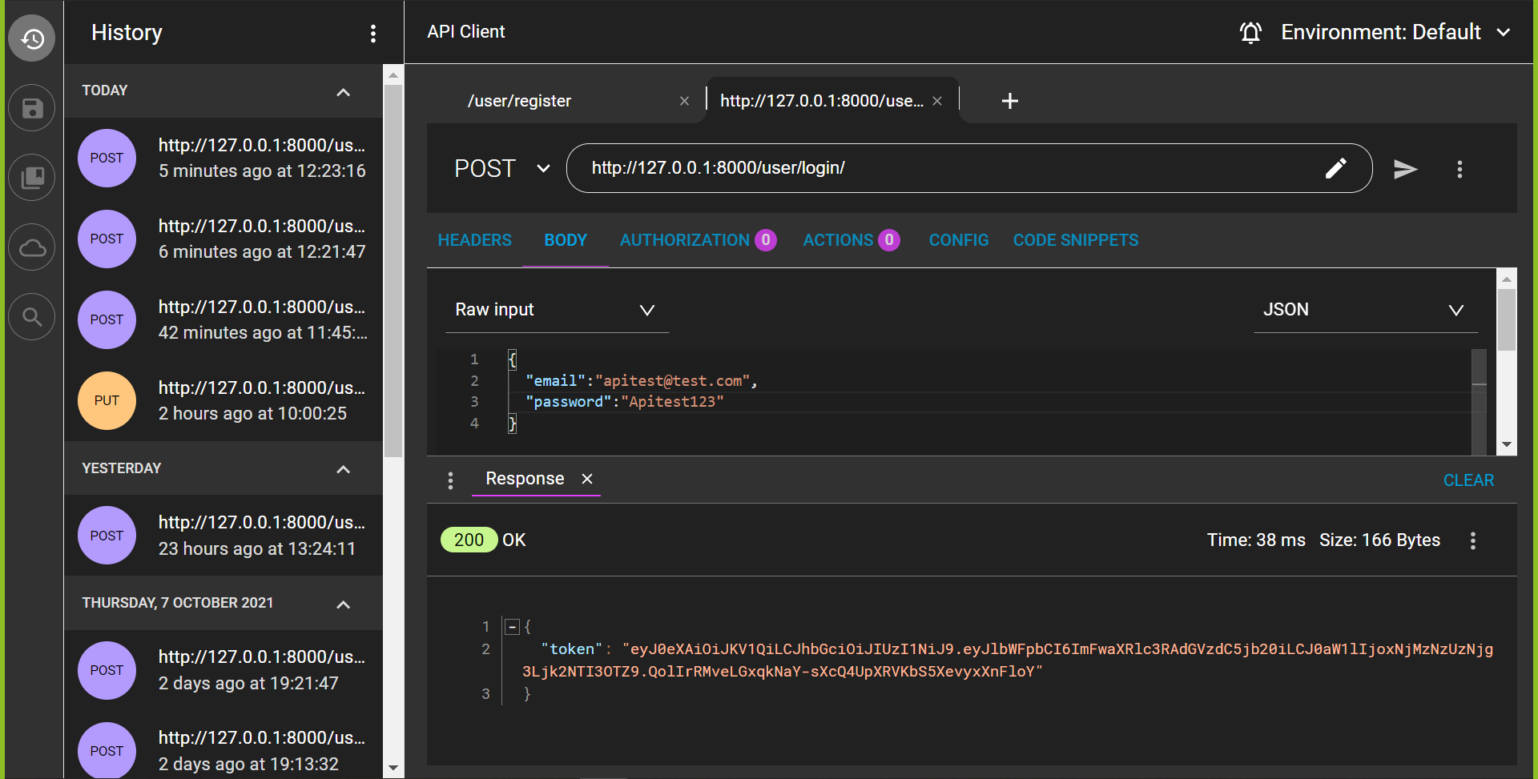

### /user/register

POST

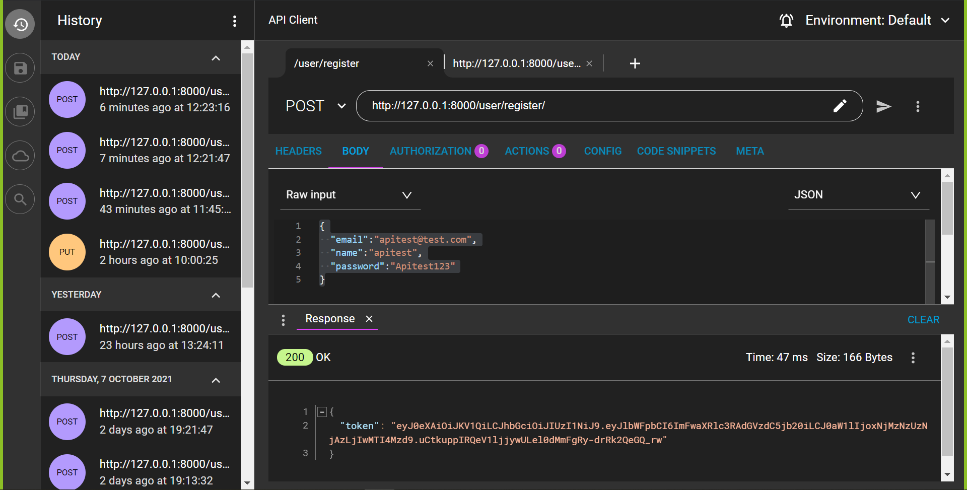

### /user/logout/

POST

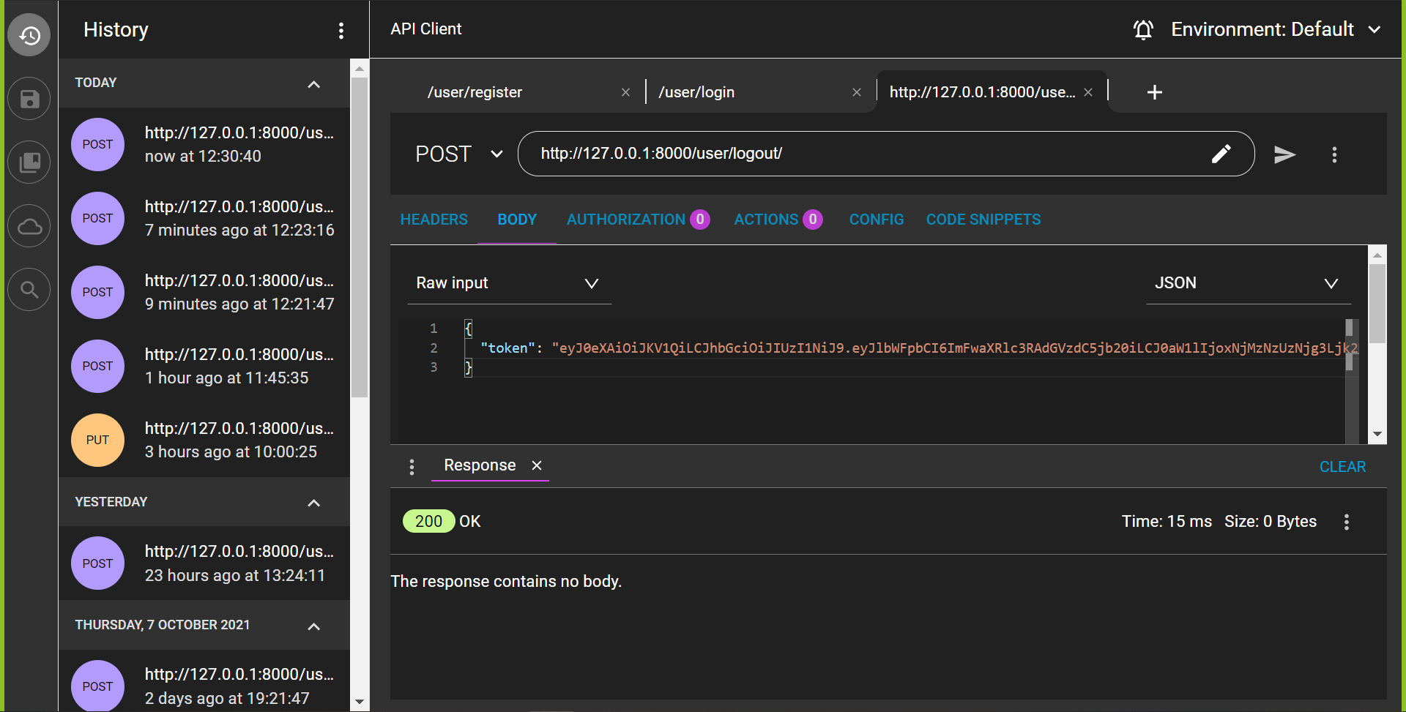

### /user/change_password/

POST

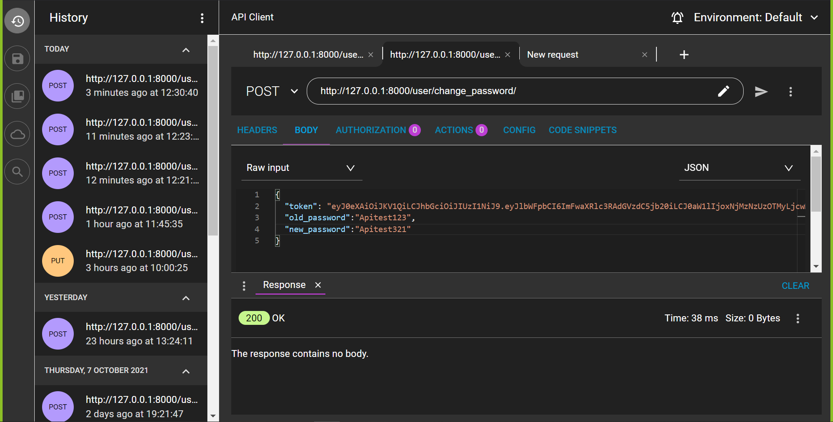

### /user/reset_password/

POST

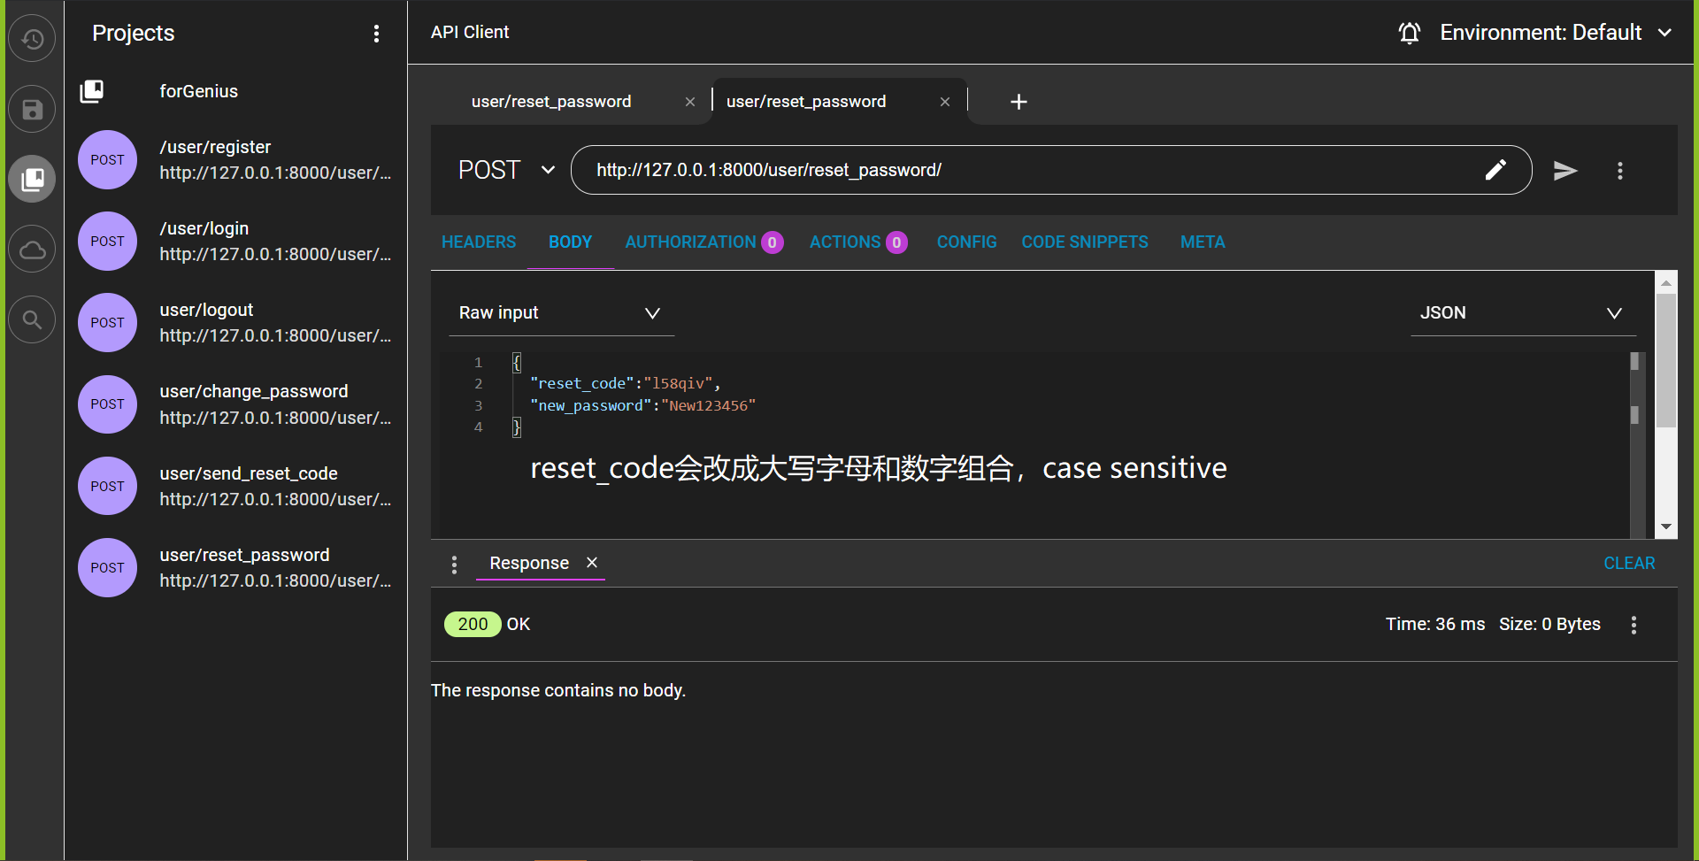

### /user/address/view/

POST

Input with token

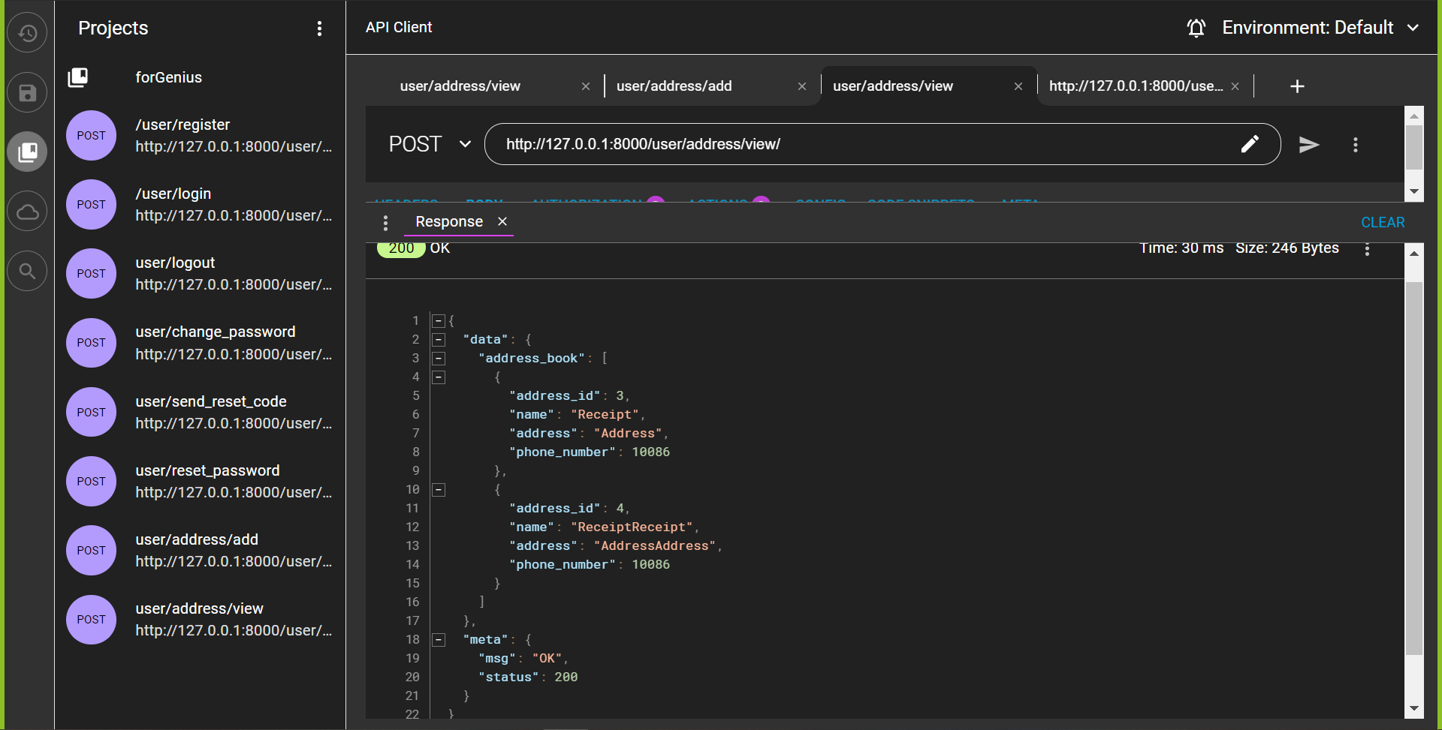

### /user/address/delete/

DELETE

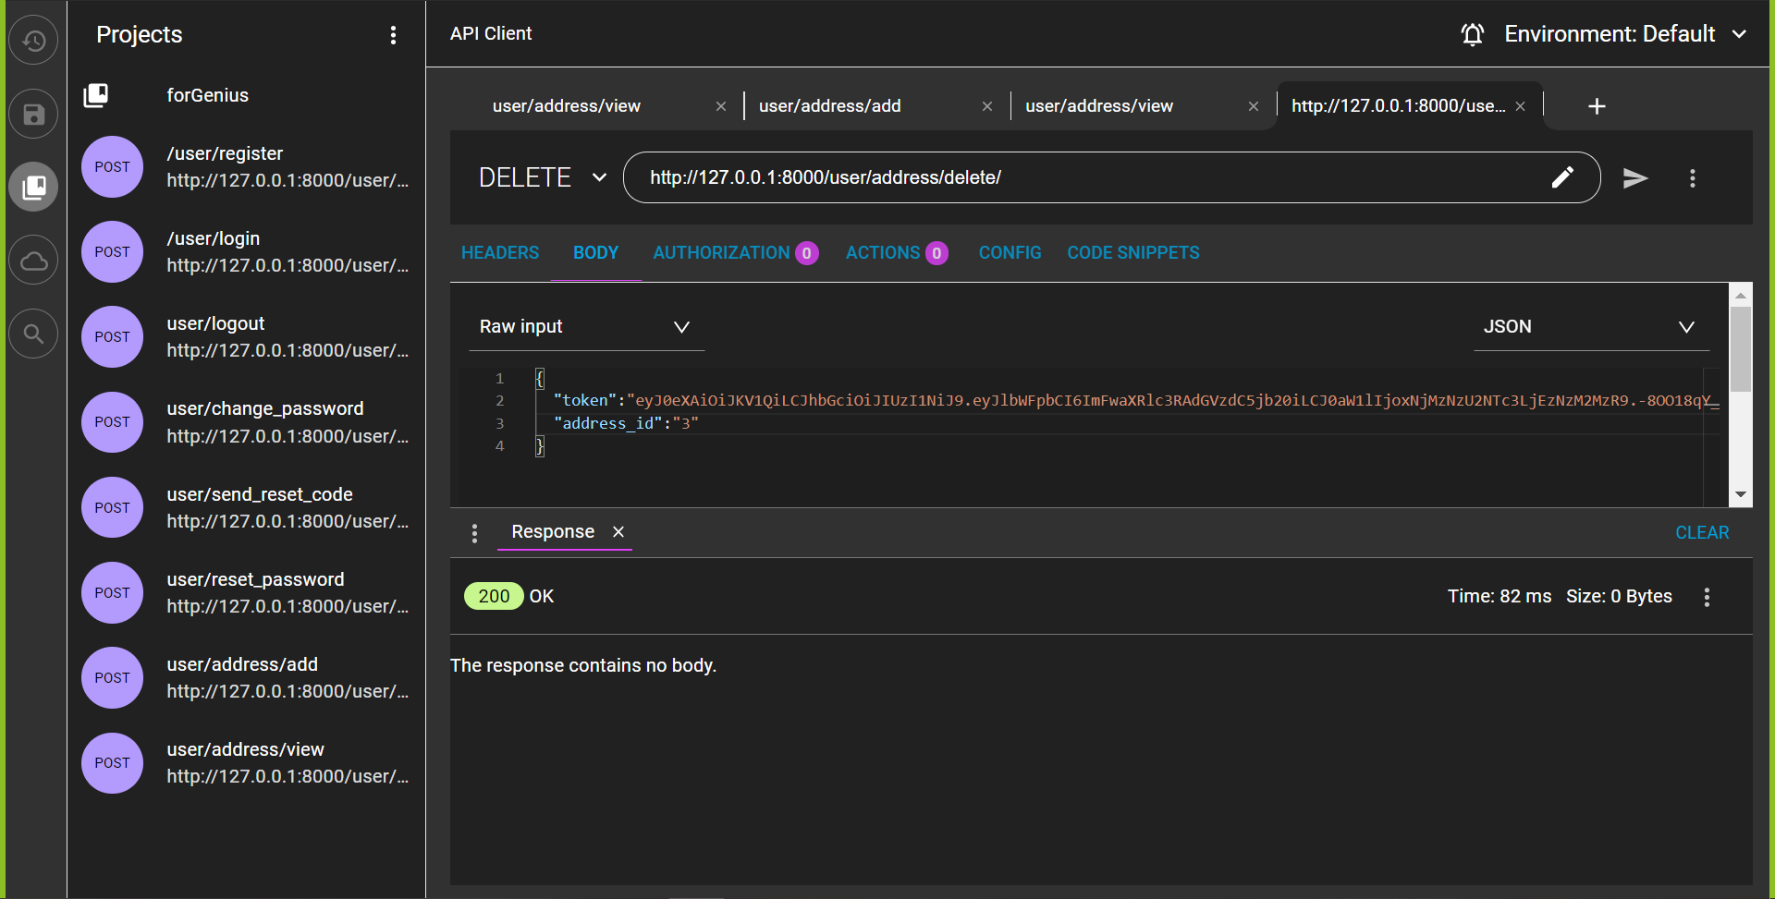

### /user/address/edit/

POST

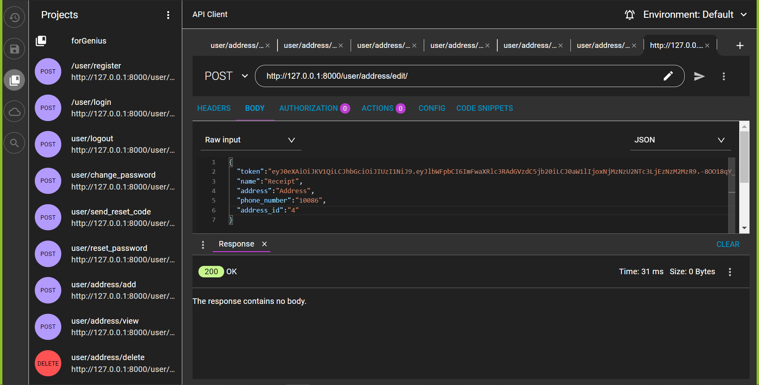

### /user/login/

POST

Admin example

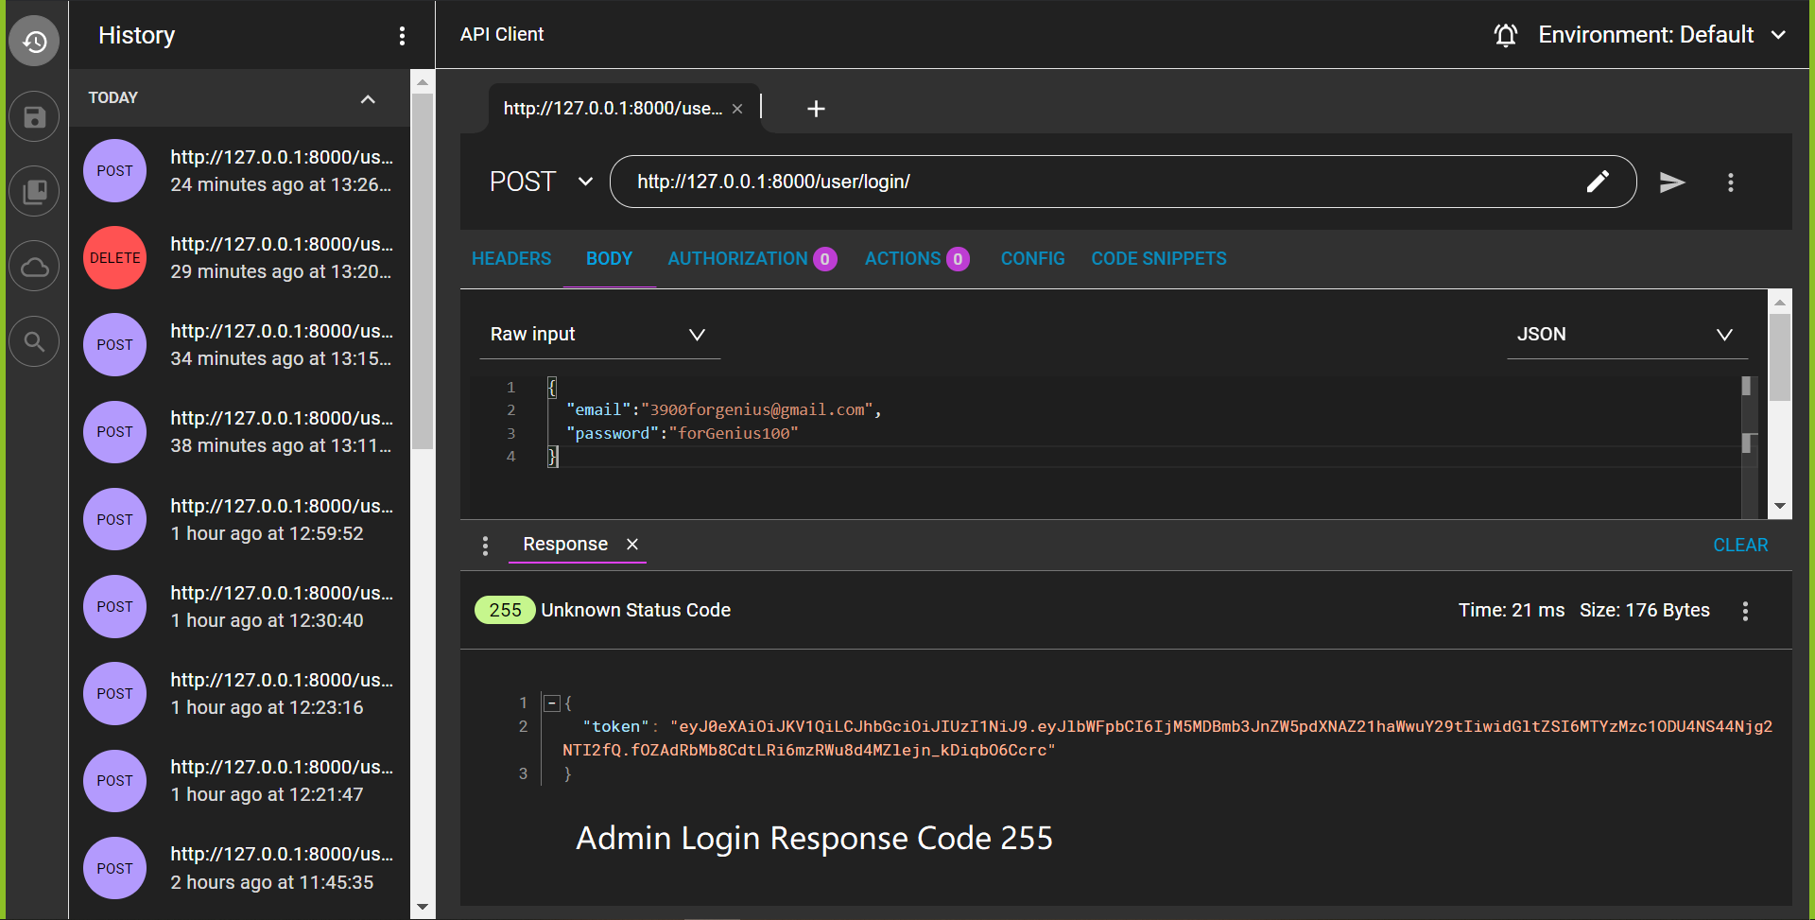

### /user/interests/add/

POST

# Order & Cart

### /order/cart/add/

POST

# Product

### /product/user/view/

Get

