Abstract
This internship project, titled “Radiation Calibration Curve and GUI Development for Radiochromic Film Dosimetry,” focused on developing a practical and automated approach for estimating radiation dose using radiochromic film (Gafchromic EBT3 Film). Radiochromic films undergo a radiation-induced colour change, allowing absorbed dose to be measured with high spatial resolution without conventional chemical processing. Their dose response was quantified through optical or High-quality professional flatbed scanner measurements and related to absorbed dose using a calibration curve.

During the internship, irradiated film samples corresponding to different known doses were scanned and digitally analysed. The mean red-channel pixel values from selected regions of interest were extracted from the TIFF images and used as the film response. A dose–response calibration curve was then developed by relating the measured pixel response to the corresponding radiation dose. The calibration approach was based on the established nonlinear response characteristics of radiochromic film, for which suitable fitting functions can be used to represent the dose–response relationship.

To improve usability and reduce manual processing, a GUI-based Film Dosimetry Calculator was developed using Python and Tkinter. The application enables film images to be processed and dose values to be estimated using the developed calibration model. The project therefore combined concepts from medical physics, digital image processing, calibration modeling, and software development to create a simple workflow for radiochromic film dosimetry.

The internship provided practical exposure to radiation dosimetry, film calibration, image-based measurement, data analysis, and development of a user-oriented computational tool. The work also highlighted important sources of uncertainty in film dosimetry, including scanner variability, film uniformity, environmental conditions, and measurement procedures. These factors are recognized as important considerations in achieving reliable radiochromic film measurements.

1. Introduction
1.1 Radiochromic Films
Radiochromic films are self-developing dosimetric films that undergo a permanent colour change when exposed to ionizing radiation. Unlike conventional radiographic films, they do not require chemical processing and are relatively insensitive to visible light. The degree of color change is proportional to the absorbed radiation dose, allowing them to serve as reliable tools for radiation dose measurement.
1.2 Used of Radiation Therapy
Radiochromic films are widely used in radiation therapy because they provide high spatial resolution and near tissue-equivalent response. They enable accurate measurement of two-dimensional dose distributions, making them valuable for treatment plan verification, beam profile analysis, and quality assurance (QA) procedures. Their ability to capture detailed dose variations makes them particularly useful in advanced radiotherapy techniques where precise dose delivery is critical.
1.3 Importance of Calibration
When a radiochromic film is exposed to radiation, the resulting colour change is recorded as pixel intensity values after scanning. However, these pixel values do not directly represent radiation dose. Calibration is therefore required to establish a mathematical relationship between known radiation doses and the corresponding film responses. This calibration curve enables accurate conversion of pixel values into absorbed dose estimates, ensuring reliable and clinically meaningful dosimetric measurements.

2. Objectives
- Establish a calibration curve relating mean red-channel pixel value to absorbed dose (cGy) using films irradiated to known reference doses.
- Develop a desktop application capable of batch-processing scanned TIFF film images and automatically converting pixel readings to dose values.
- Provide a user-friendly interface requiring no programming knowledge: folder selection, automated processing, tabular results display, and CSV export.
- Embed the calibration parameters directly into the application source code, removing the need to distribute a separate calibration file.
- Package the finished application as a standalone Windows executable (.exe) that runs independently of any Python installation.

3. Literature Review / Theoretical Background

3.1 Radiochromic Film Principles
Radiochromic films are radiation-sensitive detectors that undergo a permanent color change when exposed to ionizing radiation. Unlike conventional radiographic films, radiochromic films produce a visible color change directly through radiation-induced chemical reactions and do not require conventional wet chemical processing. The AAPM Task Group 55 report describes radiochromic films as high-spatial-resolution dosimeters whose coloration results from chemical changes initiated by absorbed radiation energy.
For Gafchromic-type films, irradiation produces strong absorption in the red spectral region, making the red channel particularly useful for quantitative image-based dosimetry. As the absorbed dose increases, the film becomes darker and its measured red-channel pixel value decreases.

3.2 Dose–Response Relationship
The fundamental physical quantity used to describe film darkening is optical density (OD). It is defined as
$$OD=\log_{10}{(\frac{I_0}{I})}$$
where (I_0) is the intensity of light transmitted through the unexposed film and (I) is the intensity transmitted through the exposed film. This relationship is described in standard film dosimetry theory.
Thus, greater radiation exposure produces greater film darkening, reducing transmitted light and increasing optical density. The basic film-dosimetry relationship can therefore be represented as
$$OD∝D$$
over an appropriate working region, where (D) is the absorbed radiation dose. However, radiochromic film response is generally nonlinear over a wide dose range. The response gradually approaches a limiting value at high doses, producing a saturation or asymptotic behaviour.
In the developed project, the scanned TIFF image was analysed using its red-channel pixel intensity. The mean red-channel pixel value was calculated over the selected region of interest (ROI) to obtain a representative response value:
$$P=\frac{1}{N}\sum_{i=1}^{n}{P_i}$$
where (P_i) represents the red-channel pixel value of an individual pixel and (N) is the total number of pixels in the ROI.
This averaging reduces the influence of local pixel-level variations and provides a stable film-response value for calibration.

3.3 Calibration Curve Concepts
A calibration curve establishes the mathematical relationship between known radiation doses and the corresponding measured film response. Calibration films are irradiated with predetermined doses, scanned under consistent conditions, and their mean red-channel pixel values are extracted.
The resulting calibration dataset can be represented as (D_i,P_i)
where (D_i) is the known calibration dose and (P_i) is the corresponding mean red-channel pixel response.
The calibration relationship is then expressed mathematically as
D = f(P)
so that the dose of an unknown film can be estimated from its measured pixel response.
In this project, the calibration model was represented by a logarithmic-polynomial relationship:
D = a * ln(P) + b * P + c
where (D) is the estimated radiation dose, (P) is the mean red-channel pixel value, and (a), (b), and (c) are calibration coefficients obtained by curve fitting. The logarithmic and linear terms allow the model to represent the nonlinear dose-response behaviour of the film.
The use of a mathematical calibration function is consistent with published radiochromic-film dosimetry studies, where nonlinear dose-response data are fitted using mathematical functions rather than assuming a simple linear relationship. Lewis et al. demonstrated the use of rational functions to model the inherently nonlinear response of radiochromic films.
The quality of the calibration can be assessed by comparing the fitted values with the measured calibration points. A higher coefficient of determination, (R^2), indicates better agreement between the fitted model and the experimental data.

3.4 Existing Dosimetry Software and Workflows
Conventional radiochromic film dosimetry involves irradiation, scanning, image processing, calibration, and dose analysis. Scanner characteristics, film orientation, temperature, post-exposure time, and other environmental factors can affect the measured response. AAPM recommendations therefore emphasize controlled scanning and calibration procedures.
Modern workflows may use specialized commercial software such as FilmQA Pro and multichannel dosimetry techniques. Lewis et al. reported that multichannel scanning can improve dosimetric accuracy by separating dose-related information from image disturbances such as film thickness variations, scratches, fingerprints, and dust.
The workflow developed in this project follows a simpler single-channel approach based on the red-channel response. Known-dose calibration films are scanned, their mean red-channel pixel values are extracted, and the resulting dose-response data are fitted to the calibration equation. The fitted model is then incorporated into a GUI-based Film Dosimetry Calculator for estimating the dose of unknown film samples.

4. Film Calibration

4.1 Methodology
A set of ten radiochromic films was irradiated to known reference doses ranging from 0 to 2000 cGy: 0, 50, 100, 200, 300, 500, 800, 1000, 1500, and 2000 cGy. Each film was scanned and saved as a TIFF image.
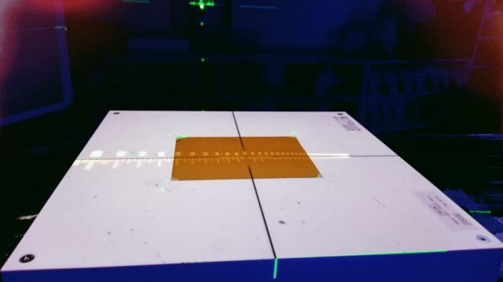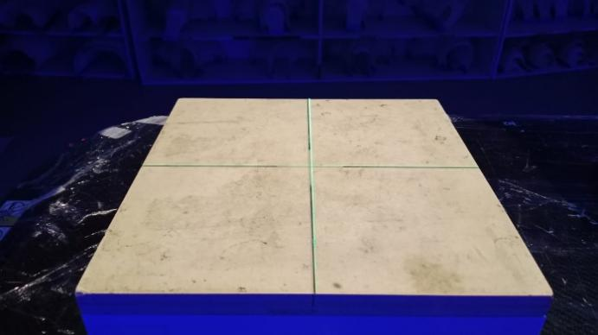
For each image, a central region of interest (ROI) was extracted and the mean pixel value of the red colour channel was computed, since the red channel exhibits the greatest sensitivity to dose-dependent darkening in radiochromic film.
The relationship between dose and pixel value follows a well-established rational (inverse) model for radiochromic film response:
Pixel = a + b / (Dose + c)
where a, b, and c are fitted calibration constants. This model was fitted to the nine measured (dose, pixel) data pairs using non-linear least-squares regression (scipy.optimize.curve_fit) in Python.

4.2 Calibration Data
Dose (cGy) | Mean Red Pixel Value
0 | 127.64
50 | 97.19
100 | 78.04
200 | 62.34
300 | 51.41
500 | 39.54
800 | 32.82
1000 | 31.28
1500 | 28.37
2000 | 26.89

4.3 Fitted Calibration Equation
The curve fit produced the following calibration constants:
Constant | Symbol | Fitted Value
Pixel offset | a | 19.633692558565524
Scale coefficient | b | 13278.683615150143
Dose offset | c | 122.75319518785591

Resulting calibration equation:
Pixel = 19.6337 + 13278.6836 / (Dose + 122.7532)
For dose prediction, this equation is algebraically inverted to solve for Dose given a measured pixel value:
Dose = b / (Pixel − a) − c
A calibration plot (measured data points overlaid with the fitted curve) was generated using matplotlib to visually confirm the quality of fit. The inverse relationship correctly captures the expected film behaviour: pixel value decreases sharply at low doses and asymptotically levels off at higher doses, consistent with radiochromic film saturation effects described in the literature.
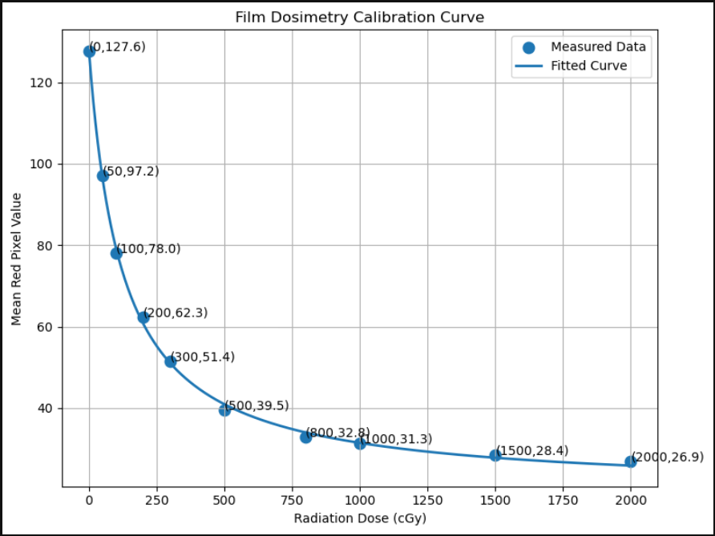

4.4 Calibrated Doses
Dose (cGy) | Calibrated Dose (cGy)
0 | 0.19
50 | 48.47
100 | 104.59
200 | 188.18
300 | 295.13
500 | 544.43
800 | 883.89
1000 | 1017.73
1500 | 1396.97
2000 | 1707.13

4.5 Calibration Curve Visualization
4.5.1 Calibration Plot
Figure X shows the calibration curve generated using the measured mean red pixel values obtained from radiochromic films irradiated with known doses ranging from 0 cGy to 2000 cGy. The measured data points are represented by markers, while the continuous line represents the fitted calibration model used for dose estimation. The curve establishes the relationship between radiation dose and film response and serves as the basis for converting pixel values from unknown films into absorbed dose values.
4.5.2 Interpretation of Curve Shape
The calibration curve exhibits a clear inverse nonlinear relationship between radiation dose and mean red pixel value. As the delivered dose increases, the mean red pixel value decreases because the film darkens progressively with increasing radiation exposure. The response changes rapidly at lower dose levels, where small dose increments produce significant variations in pixel value. At higher doses, the curve gradually flattens, indicating reduced sensitivity as the film response approaches saturation. This behavior is consistent with the known dose-response characteristics of radiochromic films and justifies the use of a nonlinear fitting function rather than a simple linear model.
4.5.3 Goodness of Fit
The fitted curve closely follows all measured calibration points across the entire dose range, indicating that the selected mathematical model accurately captures the film's dose-response behavior. The small deviations between the measured data points and the fitted curve suggest a good agreement between experimental observations and the calibration model. This close fit ensures reliable interpolation of dose values for unknown film samples and improves the accuracy of subsequent dose estimation performed by the GUI application.
4.5.4 Observation
The curve demonstrates high sensitivity in the low-dose region (0–300 cGy) and gradually transitions to a lower sensitivity region at higher doses (>1000 cGy), which is characteristic of radiochromic film dosimetry systems.
4.6 Sources of Error
4.6.1 Scanner Variability
Differences in scanner performance, scanning conditions, or repeated scans can cause slight variations in recorded pixel values, affecting dose calculations.
4.6.2 Film Uniformity
Small manufacturing variations in the film's active layer may lead to non-uniform responses, causing different regions of the film to produce slightly different pixel values for the same dose.
4.6.3 Ambient Lighting
Although radiochromic films are relatively insensitive to visible light, excessive exposure during handling and scanning may introduce minor changes in film response.
4.6.4 ROI Selection
The calculated mean red pixel value depends on the selected Region of Interest (ROI). Poor ROI placement or inclusion of artifacts, dust, or non-uniform areas can affect calibration accuracy and dose estimation.

5. GUI Application Development
The desktop application was developed using Python's built-in Tkinter library, chosen for its simplicity, zero external dependency footprint, and native compatibility with PyInstaller packaging. The GUI was built incrementally, with functionality added in stages and tested at each step.

5.1 Development Stages
- Stage 1 — Base window: A root Tkinter window was created with the title "Film Dosimetry Calculator" and a fixed size of 900 × 650 pixels. This served as the main application interface.
- Stage 2 — Calibration Integration: The fitted calibration constants obtained from the calibration procedure were embedded directly into the application source code. A calibration status label was added to the GUI to display the loaded calibration parameters to the user.
- Stage 3 — Folder Selection: A "Select Images Folder" button was implemented using filedialog.askdirectory(). The selected directory path is displayed within the interface to confirm the chosen dataset location.
- Stage 4 — Dose Calculation Engine: A process_folder() function was developed to:
    - Scan the selected directory for TIFF images (*.tif and *.tiff)
    - Load each image using Pillow
    - Extract a central 200 × 200 pixel Region of Interest (ROI)
    - Calculate the mean red-channel pixel value
    - Convert the measured pixel value into absorbed dose using the inverted calibration equation
- Stage 5 — Tabular Results Display: A ttk.Treeview widget was added to display results in tabular form. For each processed image, the following information is displayed:
    - File Name
    - Mean Pixel Value
    - Predicted Dose (cGy)
This allows multiple films to be analyzed and reviewed simultaneously.
- Stage 6 — CSV Export Functionality: An "Export CSV Results" button was implemented. The displayed results are converted into a Pandas DataFrame and saved as a user-selected CSV file through a Save-As dialog. Appropriate warning and confirmation dialogs are provided to improve usability.

5.2 Core Processing Logic
For each TIFF file in the selected folder, the application performs the following operations:
- Load the image using PIL.Image.open() and convert it into a NumPy array.
- Determine the image centre coordinates.
- Extract a 200 × 200 pixel Region of Interest (ROI):
  - Horizontal range: w/2±100w/2 \pm 100w/2±100
  - Vertical range: h/2±100h/2 \pm 100h/2±100
- Compute the mean value of the red colour channel (channel index 0) within the ROI.
- Calculate the absorbed dose using the inverted calibration equation:

Dose = b / ( Pixel – a ) – c

- Insert the file name, mean pixel value, and predicted dose into the results table.
If an image cannot be processed, the application records an error message in the corresponding table row rather than terminating execution.

5.3 Embedding the Calibration Constants
In the initial implementation, calibration constants (a, b, c) were loaded at runtime from an external calibration.json file. This created a dependency that would need to be distributed and correctly located alongside the executable. To simplify deployment, the calibration constants were embedded directly as constants within the application source code, removing the external file dependency entirely. Users of the final application only need to select a folder of TIFF files — no calibration file selection or management is required.

5.4 Final GUI Components
- Application title label ("Film Dosimetry Calculator")
- Calibration information label displaying the embedded calibration constants
- Select Image Folder button
- Selected folder path display
- Process Folder button (batch dose calculation)
- Results table (file name, mean pixel value, predicted dose)
- Export CSV button

5.5 GUI Workflow
A flowchart:
TIFF Image
↓
Extract Red Channel
↓
Calculate Mean Pixel Value
↓
Apply Calibration Equation
↓
Predict Dose
↓
Export CSV
A figure always improves reports.

6. Packaging as a Standalone Executable
To make the tool usable by staff without a Python environment, the application was compiled into a single Windows executable, film_dosimetry_gui.exe, using PyInstaller. This allows the calculator to be run by double-clicking the file, with no Python interpreter, Jupyter installation, or external calibration files required.

6.1 Environment Issues Encountered
During packaging, the development Anaconda environment became unstable after NumPy was inadvertently upgraded to a newer major version. This produced downstream binary incompatibilities with SciPy, scikit-learn, and matplotlib, and caused PyInstaller builds to fail with errors including:
- ImportError: numpy.core.multiarray failed to import
- ValueError: numpy.dtype size changed, may indicate binary incompatibility
- Qt binding conflicts between PyQt5 and PySide6 during the PyInstaller build
These issues were resolved by isolating the build in a clean virtual environment containing only the packages required by the final application (Tkinter, Pillow, NumPy, pandas, and PyInstaller), avoiding the broader, conflict-prone Anaconda base environment used during development and calibration analysis.

6.2 Outcome
The application was successfully built and tested as film_dosimetry_gui.exe. The packaged executable runs independently of Python, requires no calibration file to be distributed alongside it (constants are embedded in the code), and provides the complete workflow — folder selection, batch dose calculation, results review, and CSV export — in a single double-clickable file.

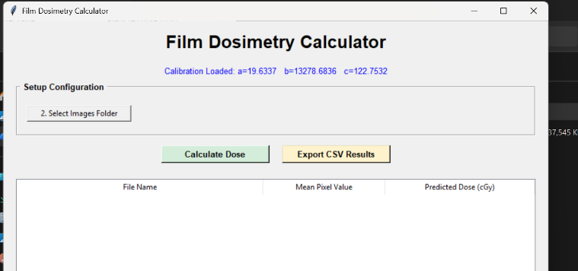

7. Results
The application was validated by processing a batch of scanned films through the packaged executable. Representative output, as exported by the CSV export function, is summarised below:
File Name | Mean Pixel | Predicted Dose (cGy)
1100.tif | 31.16 | 1029.77
1650.tif | 27.99 | 1465.45
250.tif | 53.99 | 263.79
550.tif | 37.31 | 628.53
600.tif | 36.92 | 645.54

8. Discussion

The project successfully developed a simple film dosimetry software that can calculate dose from scanned film images. The software combines calibration, image processing and dose calculation in one application. It can also process multiple TIFF images together, which can be useful for routine QA work. The red channel was used for the analysis because it showed good response to the change in the film after irradiation. A central ROI was used to calculate the average pixel value. This makes the analysis simple and easy to perform.

The calibration results show that the pixel value decreases as the dose increases. The calibration curve gives reasonable dose estimation, but some difference can be seen at higher doses. More calibration points and additional validation films can help to improve the accuracy of the software in the future. Overall, the project shows that film dosimetry can be made easier and faster by using a simple software-based approach.

9. Conclusion
This project successfully delivered an end-to-end film dosimetry workflow: a calibration curve was derived from reference-dose film scans using a non-linear regression fit; this calibration was embedded into a Tkinter-based desktop application capable of batch-processing TIFF film scans and exporting dose results to CSV; and the application was packaged into a standalone Windows executable, resolving environment-related build failures along the way by isolating the packaging process in a clean, minimal virtual environment. The result is a self-contained, easy-to-use tool that requires no programming knowledge, no Python installation, and no external configuration files to operate.

9.1 Future Work
- Dose-map visualization (2D heatmap of dose across the full film, not just the central ROI)
- Support for multiple/user-selectable ROI regions per film
- Built-in calibration manager for recalibrating without editing source code
- Dose profile plotting along a user-defined line
- Refined, professional UI styling, including a dark mode option

