POC

PowerBI Licenses

**Types**

1. **User based**
2. **Capacity based**

User Based

* Free
* Pro
* Premium per user

NOTE - Administration and licensing of the Power BI service is now integrated with Microsoft Fabric.

In How Many Ways We can share reports to different licenses in PowerBI services & Advantages & Limitations.

**Free** -

* With a Power BI Free license, you can share reports by publishing them to the Power BI Service and then sharing them with individual users by email. However, users with a Free license can only consume shared content; they cannot create or share their own reports.

Advantages

* It’s useful for who wants to learn PowerBI services.
* You can have the whole interface and go through several options of PBI services.

Limitations

* Whatever you create in PowerBI stays in that computer only.
* It’s not suitable in real world business situations.

**Pro**

Purchasing of PowerBI pro License you’ll charged for up to 10 USD Per month.

With a Power BI Pro license, you have more options for sharing reports:

* Sharing with individuals:

You can share reports with individual users by email, allowing them to view and interact with the report.

* Sharing with groups:

You can share reports with security groups or distribution lists within your organization. This allows you to share reports with multiple users at once.

* Publishing to web:

You can publish reports to the web, making them accessible to anyone with the link, even if they don't have a Power BI account. However, be cautious when using this option as it makes the report public.

* Embedding:

With a Pro license, you can embed reports into other applications or websites using Power BI Embedded or the Power BI REST API.

Advantages

* It’s cheap compared to premium.
* It can be helpful for learn PowerBI for real-time sharing scenarios.

Limitations

* Might be a burden to individual user to maintain.
* Has less data refreshes compared to premium.

**Premium per user**

* Power BI Premium offers dedicated capacity for your organization and includes features like larger data storage limits, advanced AI capabilities, and more. With Premium, you can share reports in all the ways mentioned above for Pro licenses, but you also have additional options:
* Apps:

You can package reports, dashboards, and datasets into an app and distribute it to users within your organization. Apps provide a centralized way to distribute and manage content.

* Paginated reports:

With Premium, you can also share paginated reports (traditional pixel-perfect reports) using Power BI Report Server or the Power BI service.

Advantages

* Unlike Pro license Premium has more capabilities like Paginated Reports, AI Doodles, Advanced AI & More. (Analysing Text Data, Image Recognition, Optical Character Recognition).
* Can use Data Flows and Data Marks.

Limitations

* Its charges double the Pro License up to 20 USD.
* Its likely useful to mid-size and large-scale industries only.

**Capacity**

**Premium Capacity**

* A capacity-based Premium license (often referred to as a Premium subscription) allows Pro or PPU users to create and save content in Premium capacity workspaces. They can then share that workspace with colleagues who have any license type. Only users with a Pro or PPU license can create and save content in Premium capacities, and only if their organization purchased Premium capacity.

Advantages

* Premium capacity allows for larger datasets to be stored and processed compared to the shared capacity available with Power BI Pro licenses.
* Premium unlocks various advanced features such as paginated reports, AI capabilities, dataflows, and advanced administration settings.

Limitations

* Premium capacity licenses are more expensive than Power BI Pro licenses, which can be a significant factor for smaller organizations.
* Organizations may end up over-provisioning capacity, paying for resources they don't fully utilize.
* Setting up and configuring Premium capacity may require more time and expertise compared to using Power BI Pro licenses.

**Report Sharing Scenarios Paid / Free**.

* The user who is going to view the report should also have the Pro License.
* The analyst can publish the report to the Power BI Service and share it with individual executives via email. However, executives with Free licenses will have limited interactivity and won't be able to edit or contribute to the report.
* To consume the reports with a free license the workspace which is sharing should be a premium capacity.

Table of Licenses with their features

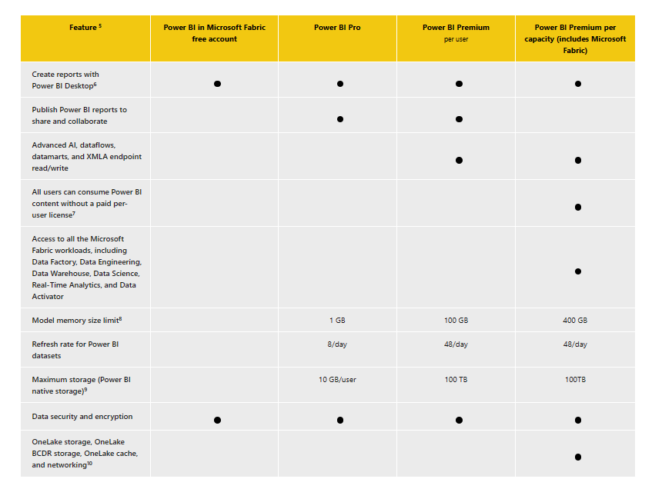

Report Sharing scenario with premium and non-premium workspace

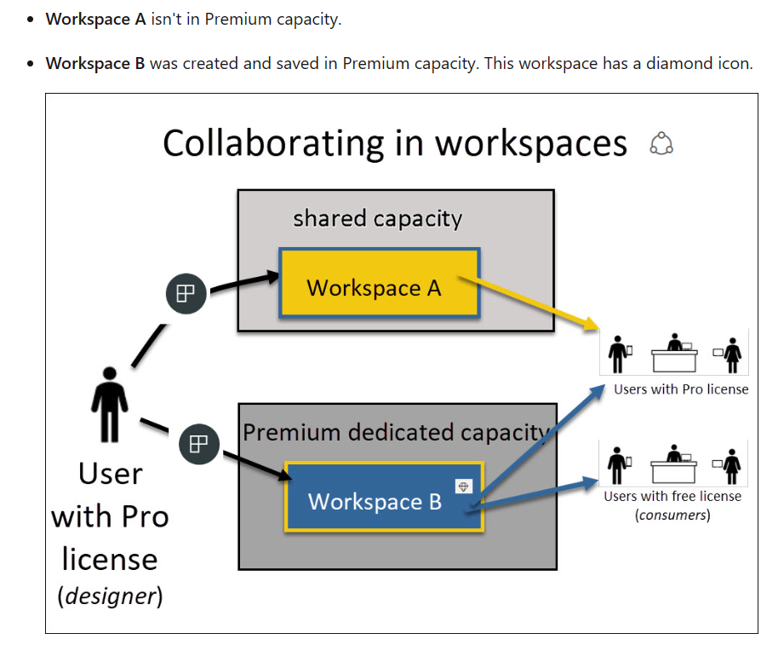

**Embedding a report**

While consuming the report shared, there a certain restrictions and limitations to the consumer. so, to overcome those scenarios, we can use the embed report option available in PowerBI services.

Embedding means sharing the report to end user through publishing in website so that the end user can consume the report with an ease.

Embedding a dashboard into the website can be done majorly in two types

* Iframe
* Java Script

There are different options are available for embedding a report on your website.

* **Public embedding**: This option allows anyone with the URL to access the dashboard. It does not require a Power BI account.
* **Internal embedding**: This option requires a Power BI account and allows you to embed a dashboard within your organization’s domain.
* **Embedding with authentication**: This option requires users to log in to access the dashboard. This is useful when you need to restrict access to sensitive data.

Another option for embedding a Power BI dashboard is through SharePoint Online. This allows you to embed the dashboard within a SharePoint page.

And also, when want to share only specific visualizations in PowerBI, we can embed only required visuals despite of sharing the whole dashboard.