“Performance Evaluation of Meta-Heuristics Techniques for the Generalized Assignment Problem: A Comparative Study”

Submitted To:
Dr. Dinesh Kumar
(Assistant professor CSE Dept.)
Submitted by:
Singh Siddhant AkhileshSingh (2025PGCSIS06)
Anish Kumar (2025PGCSIS07)
Pawan Pratap (2025PGCSIS13)
Branch: Information System Security Engineering

NATIONAL INSTITUTE OF TECHNOLOGY, JAMSHEDPUR

Abstract
- The Generalized Assignment Problem (GAP) is a complex NP-hard optimization problem involving the assignment of multiple tasks to agents while maximizing total cost and respecting capacity limits.
- To tackle this challenge, five metaheuristic algorithms were implemented and analysed:
  - Binary-Coded Genetic Algorithm (BCGA)
  - Real-Coded Genetic Algorithm (RCGA)
  - Particle Swarm Optimization (PSO)
  - Teaching–Learning-Based Optimization (TLBO)
  - Differential Evolution (DE)
- The performance of these algorithms was evaluated based on:
  - Solution quality accuracy and optimality of assignments.
  - Convergence behaviour speed and stability of reaching optimal solutions.
  - Computational efficiency time and resource usage.
- Penalty-based and repair-based constraint-handling methods were employed to ensure feasibility of solutions.
- Additionally, an infeasibility replacement strategy was used, where invalid individuals were substituted with newly generated feasible ones.
- Key findings:
  - Differential Evolution (DE) and Teacher Learning Based Optimization (TLBO) achieved faster convergence and produced more feasible, high-quality solutions.
  - Genetic Algorithm variants Binary code Genetic Algorithm (BCGA) and Real Coded Genetic Algorithm (RCGA) showed strong exploration capabilities, effectively searching a wide solution space.
  - Particle Swarm Optimization (PSO) delivered a balanced trade-off between exploration and exploitation, performing competitively on smaller instances.

1. Introduction
- Combinatorial optimization problems are common in engineering and management, focusing on optimizing discrete decision variables to maximize cost or maximize efficiency.
- The Generalized Assignment Problem (GAP) involves assigning tasks to agents to maximize total cost while respecting capacity constraints.
- GAP is NP-hard, making exact methods like branch-and-bound impractical for large instances.
- Metaheuristic algorithms offer near-optimal solutions in reasonable computation time, suitable for real-world applications.
- This study evaluates five metaheuristic techniques:
  - Binary-Coded Genetic Algorithm (BCGA)
  - Real-Coded Genetic Algorithm (RCGA)
  - Particle Swarm Optimization (PSO)
  - Teaching–Learning-Based Optimization (TLBO)
  - Differential Evolution (DE)
- Multiple constraint-handling schemes are applied to ensure solution feasibility. [1]

2. Background

2.1 Generalized Assignment Problem
- The GAP involves assigning n number of tasks to m number of agents.
- Each agent (i) has a limited capacity (b_{i}).
- Assigning task (j) to agent (i):
  - It gets the profit of the total (C_{ij}).
  - Total Resources that are used here allocated is (R_{ij}).
- Objective: Maximize total assignment cost while ensuring:
  - Every task must be atomically be assigned to the one of the machines, no two machines can have a single task here means mapping can be (one-one) or (one-two).
  - Also here make sure that during the allocation of the tasks to the machine here doesn’t exceed the total capacity of the machine individually.
Mathematical Formulation:
- Maximize: $\sum_{i}{\sum_{j}{c_{ij}x_{ij}}≤b_{i}}$ (Eq:01)
- Here we need to maximize the profit so the above (Eq:01) which is our objective function needs to maximized here.
- Subject to:
  - $\sum_{j}{r_{ij}x_{ij}}≤b_{i}$ for all agents $i.$ (Eq:02)
  - The above (Eq:02) here shows that every allocation is possible to the machine if and only if the total allocated task doesn’t exceed the limit of the machine.
  - $\sum_{i}{x_{ij}}=1$, for all tasks $j$ belongs to {0,1}. (Eq:03)
  - The above equation (Eq:03) here shows that the job or the task can only be assigned to the only machine only no two machines can bear the same task at any cost.
- Applications: Scheduling, production planning, logistics, and resource allocation.
- Challenge: GAP is NP-hard, motivating the use of metaheuristic methods for efficient near-optimal solutions. [2 - 3]

2.2 Metaheuristics Overview
Metaheuristics and Constraint Handling in GAP:
- Metaheuristics are iterative frameworks that guide search strategies using concepts inspired by natural and social phenomena. So, the search will be the guided search for the selection here it will be brute force technique but in the greedy version.
- Unlike exact algorithms, they prioritize computational efficiency over guaranteed optimality. So as the nature of the metaheuristics algorithms they don’t guarantee the optimal solution for the problem like the heuristics but they are robust and near optimal sometimes makes them good compared with the heuristics algorithm which are different every time the problem specification and nature changes.
- In the Generalized Assignment Problem (GAP), maintaining feasible task assignments is challenging due to interdependent constraints. To handle such cases the best remedy here is only the metaheuristics techniques.
- Effective constraint-handling strategies are essential to ensure feasibility while exploring solutions:
  - Static penalties: assign fixed penalties for constraint violations.
  - Adaptive penalties: adjust penalties dynamically based on search progress.
  - Repair mechanisms: modify infeasible solutions to make them feasible for those which values exceed the given limit.

3. Problem Definition
Let me denote the number of agents and n the number of tasks. Each agent i has capacity bᵢ, each assignment has a cost cᵢⱼ, and consumes rᵢⱼ resources. The goal is to maximize total cost: f(X) = $ΣᵢΣⱼ cᵢⱼ xᵢⱼ$ subject to $Σⱼ rᵢⱼ xᵢⱼ ≤ bᵢ$ and $Σᵢ xᵢⱼ = 1$. The variable $xᵢⱼ = 1$ if task j is assigned to agent i, otherwise 0.

4. Comparative Study of Metaheuristic Techniques
Metaheuristic Algorithms for GAP which are used for the solve the problem are as below:
- Binary-Coded Genetic Algorithm (BCGA):
  - Represents assignments as binary strings its encoding is simply where the tasks are represented in form of the bits of and the corresponding decimal value to the binary values represents the machine one which it is allocated.
  - Example: if the are 10 machines then every task will be represented as the for bit(0010) representation and the decimal value corresponding to it like in this case (2) will represent the machine which will perform it.
  - Uses selection, crossover, and mutation to evolve the population.
  - Suitable for discrete optimization, but may get trapped in local optima if mutation rate is low. [4]
- Real-Coded Genetic Algorithm (RCGA):
  - Uses real-valued vectors, enabling smooth crossover and mutation.
  - Offers better parameter exploration and faster convergence, especially in continuous or hybrid problems. [5]
- Particle Swarm Optimization (PSO):
  - Models’ social behaviour of particles moving through the search space.
  - Updates positions based on personal best and global best experiences.
  - Efficiently balances exploration and exploitation. [6]
- Teaching-Learning-Based Optimization (TLBO):
  - Inspired by the teaching-learning process.
  - Operates in two phases: teacher phase and learner phase.
  - Requires no algorithm-specific parameters, ensuring stable convergence and reduced tuning effort. [7]
- Differential Evolution (DE):
  - Perturbs candidate solutions using scaled differences between randomly selected individuals. [8]

5. Experimental Analysis

5.1 Parameter Settings
Experimental Setup for GAP
- Problem Instances: Multiple GAP instances tested.
- Population & Generations:
  - Population size = 50
  - Number of generations = 200
- Genetic Algorithms (BCGA & RCGA):
  - Crossover rate = 0.8
  - Mutation rate = 0.1
- Differential Evolution (DE):
  - Scaling factor (F = 0.5)
  - Crossover probability (CR = 0.9)
- Particle Swarm Optimization (PSO):
  - Inertia weight = 0.7
  - Acceleration coefficients (c1 = c2 = 1.5)
- Teaching–Learning-Based Optimization (TLBO):
  - Followed standard two-phase learning process
- Constraint Handling:
  - Static and dynamic penalties
  - Additional variant: infeasible individuals replaced with feasible solutions.

5.2 Constraint Handling and Variation Strategy
Constraint handling was implemented using both penalty and repair strategies. Penalty-based approaches imposed extra cost on infeasible solutions, while repair-based methods redistributed tasks to satisfy capacity limits. Infeasible-to-feasible replacement increased population diversity and improved exploration across generations. [9]

5.3 Results
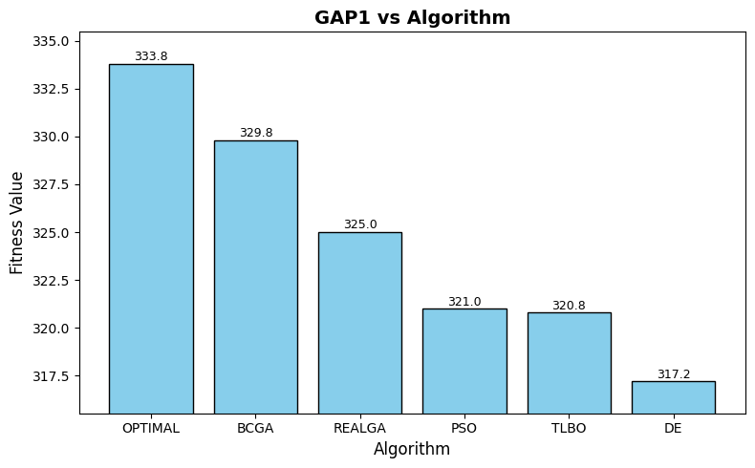
Fig 01: Gap1 fitness comparison
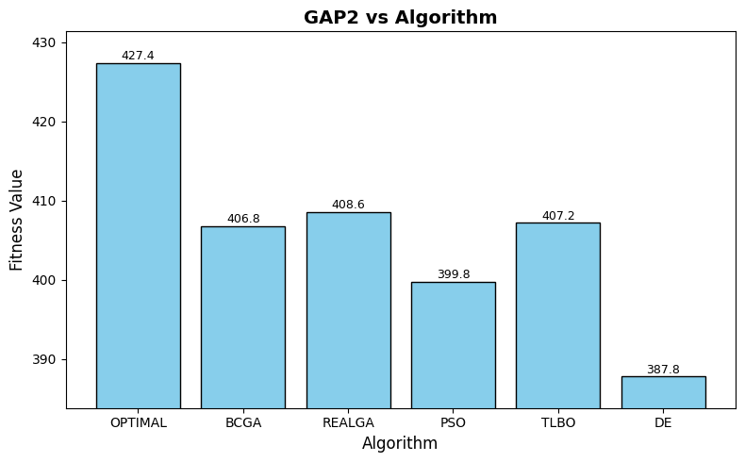
Fig 02: Gap2 fitness comparison

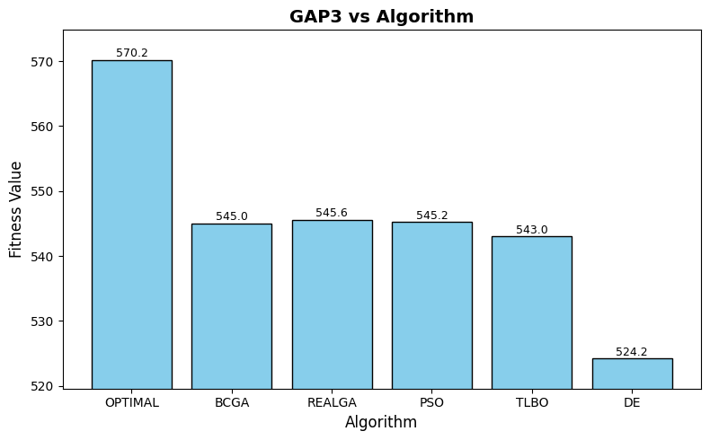
Fig 03: Gap3 fitness comparison
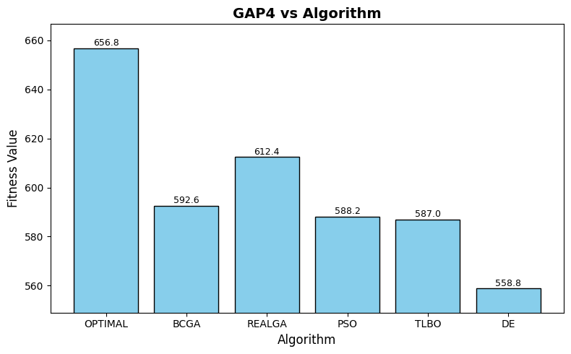
Fig 04: Gap4 fitness comparison
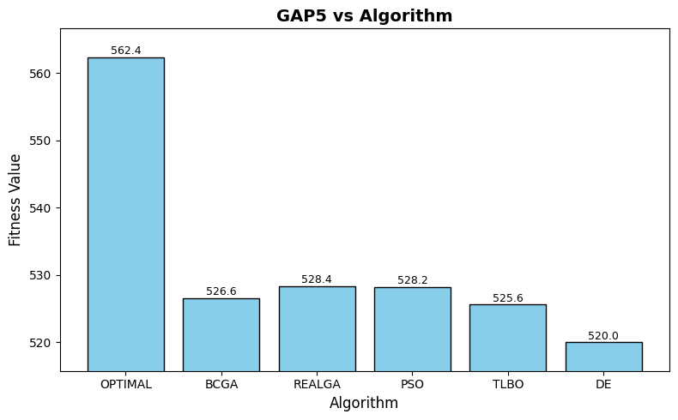
Fig 05: Gap5 fitness comparison
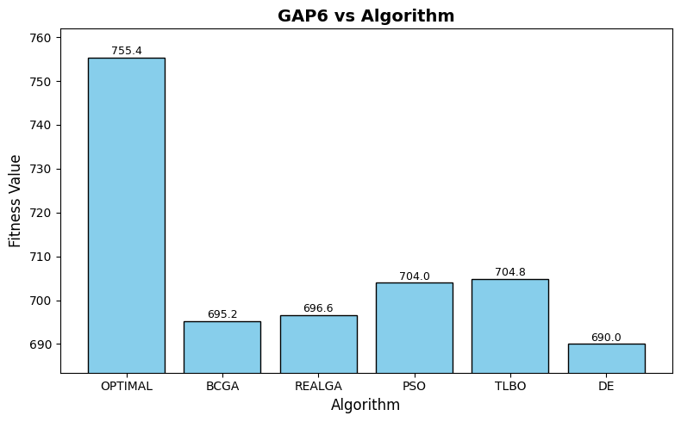
Fig 06: Gap6 fitness comparison
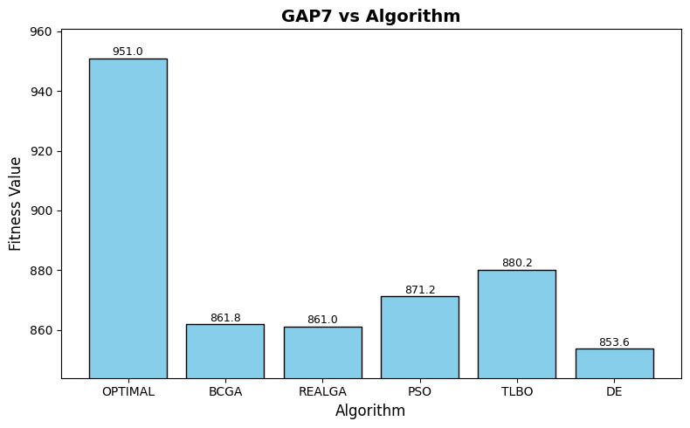
Fig 07: Gap7 fitness comparison
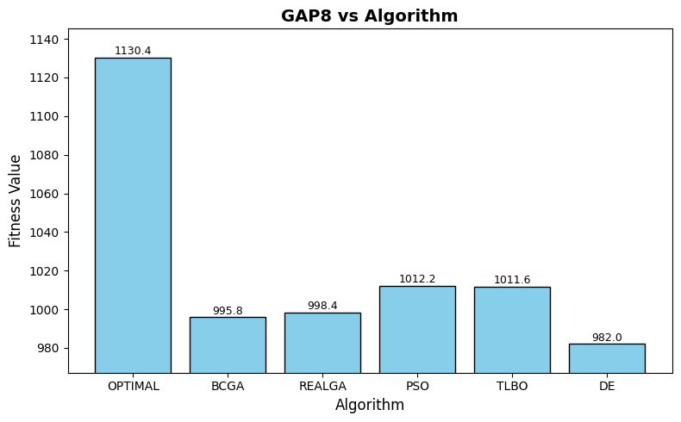
Fig 08: Gap8 fitness comparison
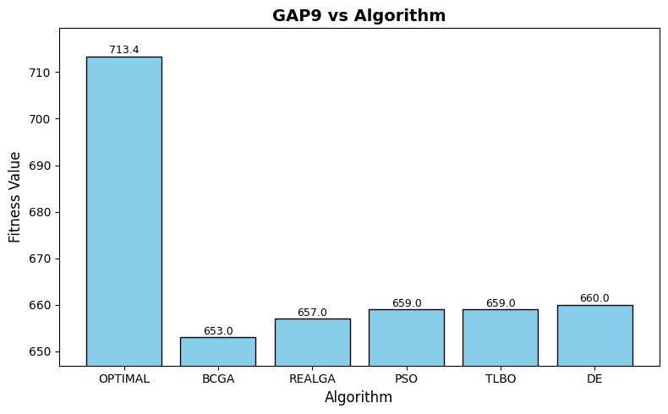
Fig 09: Gap9 fitness comparison
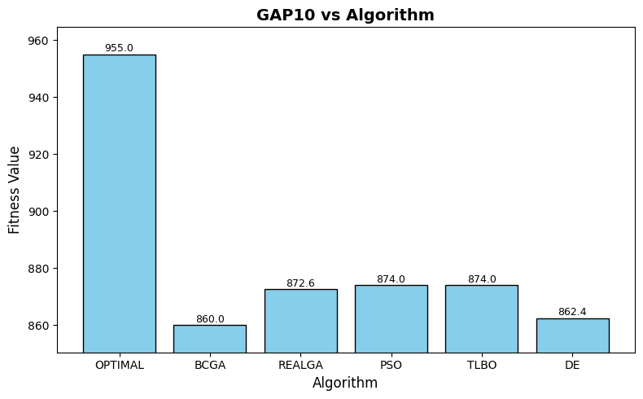
Fig 10: Gap10 fitness comparison
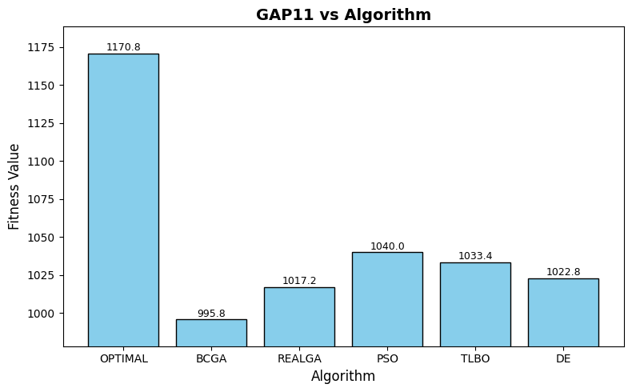
Fig 11: Gap11 fitness comparison
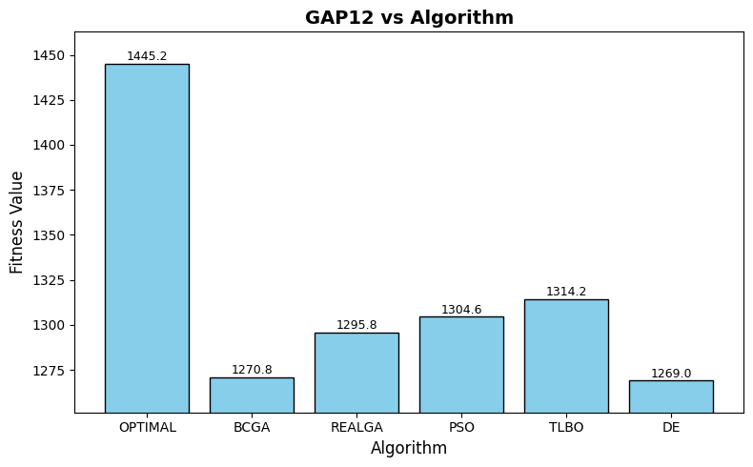
Fig 12: Gap12 fitness comparison
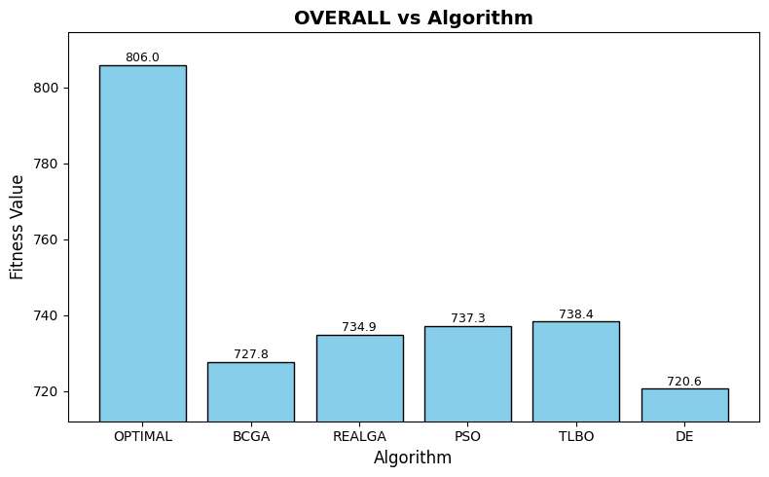
Fig 13: Gap overall fitness comparison

Table 01: comparison of different algorithm
GAP Instance | OPTIMAL | BCGA | REALGA | PSO | TLBO | DE
GAP1 | 333.8 | 329.8 | 325 | 321 | 320.8 | 317.2
GAP2 | 427.4 | 406.8 | 408.6 | 399.8 | 407.2 | 387.8
GAP3 | 570.2 | 545 | 545.6 | 545.2 | 543 | 524.2
GAP4 | 656.8 | 592.6 | 612.4 | 588.2 | 587 | 558.8
GAP5 | 562.4 | 526.6 | 528.4 | 528.2 | 525.6 | 520
GAP6 | 755.4 | 695.2 | 696.6 | 704 | 704.8 | 690
GAP7 | 951 | 861.8 | 861 | 871.2 | 880.2 | 853.6
GAP8 | 1130.4 | 995.8 | 998.4 | 1012.2 | 1011.6 | 982
GAP9 | 713.4 | 653 | 657 | 659 | 659 | 660
GAP10 | 955 | 860 | 872.6 | 874 | 874 | 862.4
GAP11 | 1170.8 | 995.8 | 1017.2 | 1040 | 1033.4 | 1022.8
GAP12 | 1445.2 | 1270.8 | 1295.8 | 1304.6 | 1314.2 | 1269
OVERALL | 805.98 | 727.77 | 734.88 | 737.28 | 738.4 | 720.65

5.4 Discussion
The Comparative analysis shows that Differential Evolution achieved the highest overall cost, followed by TLBO and RCGA. BCGA and PSO performed slightly lower due to slower convergence and encoding limitations. Overall, DE and TLBO demonstrated superior convergence speed and robustness. TLBO’s parameter-free nature made it more efficient, while DE effectively balanced exploration and exploitation. RCGA and PSO worked well for moderate problem sizes but required fine-tuning. BCGA remained dependable for discrete tasks but converged slower.

6. Conclusion
This comparative study analyzed five metaheuristic algorithms BCGA, RCGA, PSO, TLBO, and DE for solving the Generalized Assignment Problem. Results indicate that Differential Evolution provides the best balance between solution quality and convergence rate, while TLBO performs effectively without the need for algorithm-specific tuning. Genetic algorithms show strong exploration capability but require careful parameter management. PSO offers stable results with moderate effort. Future research can explore hybrid metaheuristics and adaptive learning mechanisms to further improve optimization performance on larger and more complex GAP instances.

7: References
- M. Fischetti and D. Vigo, "The generalized assignment problem: A survey," European Journal of Operational Research, 2003.
- P. C. Chu and J. E. Beasley, “A genetic algorithm for the generalised assignment problem,” Computers and Operations Research, vol. 24, no. 1, pp. 17–23, 1997, doi:10.1016/S0305-0548(96)00032-9.
- R. Cohen, L. Katzir, and D. Raz, “An efficient approximation for the Generalized Assignment Problem,” Information Processing Letters, vol. 100, no. 4, pp. 162–166, 2006, doi:10.1016/j.ipl.2006.06.003.
- D. E. Goldberg, "Genetic Algorithms in Search, Optimization and Machine Learning," Addison-Wesley, 1989.
- C. A. Coello Coello, "A review of evolutionary multiobjective optimization: Theoretical advances and applications," IEEE Transactions on Evolutionary Computation, 2006.
- J. Kennedy and R. Eberhart, "Particle swarm optimization," Proceedings of IEEE International Conference on Neural Networks, 1995, pp. 1942-1948.
- R. V. Rao, V. J. Savsani, and D. P. Vakharia, "Teaching–learning-based optimization: A novel method for constrained mechanical design optimization problems," Computer-Aided Design, vol. 43, no. 3, pp. 303-315, 2011.
- R. Storn and K. Price, "Differential evolution – A simple and efficient heuristic for global optimization over continuous spaces," Journal of Global Optimization, vol. 11, no. 4, pp. 341–359, 1997.
- E. Mezura-Montes and C. A. Coello Coello, "Constraint-handling in nature-inspired numerical optimization: Past, present and future," Swarm and Evolutionary Computation, vol. 1, no. 4, pp. 173-194, 2011.

