Lactobacillus iners is a memoryless marker of vaginal community mobility, not of directional decline: a machine-learning analysis of daily metagenomic dynamics
Consolidated project report — human vaginal microbiome predictive-modelling programme
Discovery cohort: PRJEB37731 (Danish daily shotgun cohort). Analyses: full public-data landscape survey, target/label feasibility, synthetic-data power analysis, leakage-safe CST-transition modelling, and three focused novelty analyses (competing-risks direction model, history-depth sweep, VALENCIA sub-type stratification). Compiled 2026-07-11. All results discovery-stage; single cohort; explicitly not externally validated.

Abstract
Background. The vaginal microbiome is a leading candidate biomarker for women's reproductive health, but publicly available data — especially shotgun metagenomics with per-sample outcome labels — are sparse, and the field's working model holds that Lactobacillus iners (community state type, CST III) is a transitional, less-protective state that acts as a stepping-stone toward diverse dysbiosis (CST IV).
Methods. We surveyed publicly deposited vaginal sequencing datasets (SRA/ENA/EBI) and mined linked publications, supplements and PubMed/Europe PMC to recover outcome labels. After finding intervention-response labels effectively unrecoverable from public data, we selected next-day CST transition as a well-powered, self-supervised proximal target and built a leakage-safe modelling dataset on PRJEB37731 (40 subjects, ~967 labelled consecutive day-pairs; VALENCIA CSTs on shotgun profiles), evaluated with subject-grouped cross-validation. We quantified the L. iners–instability relationship with subject-clustered GEE, formalised movement vs direction with a competing-risks model, tested how much prior daily history improves prediction, and stratified by VALENCIA iners sub-type. A synthetic-data simulation established detectable effect sizes at this sample size.
Results. Current community state predicts whether the community transitions the next day at AUROC ~0.66; microbiome taxa add nothing beyond current state, and onset of dysbiosis (CST IV) is near-unpredictable (AUROC ~0.49–0.55). Against this backdrop, baseline L. iners relative abundance is a strong, dose-graded marker of day-to-day instability (adjusted GEE OR ~5.0; movement OR 5.87, 95% CI 3.15–10.94, p=2.5e-8). However, three findings reframe its role: (i) at daily resolution CST III is not a preferential gateway to dysbiosis (next state near-independent of current, chi-square p=0.69); (ii) when iners-dominated communities move, they return to L. crispatus far more often than they descend to dysbiosis (escape 0.57 vs descend 0.24 daily risk), and no measured feature predicts which direction a mover takes (direction OR 0.40, p=0.36); (iii) adding up to five prior days of history does not improve prediction (AUROC flat ~0.65), so the process is effectively memoryless at this resolution. VALENCIA iners sub-types III-A and III-B do not differ in instability or direction.
Conclusions. L. iners behaves as a memoryless mobility biomarker: it reliably flags a high-turnover community, but the turnover is predominantly benign recovery rather than directional decline, and current composition does not forecast the minority descent to dysbiosis. This refines the textbook iners-as-gateway narrative. The single largest limitation is external validation, which available public data do not currently support without controlled-access data or de novo read reprocessing.

1. Introduction and project premise
This project set out to build a machine-learning classifier that predicts a clinically meaningful vaginal-microbiome state — ideally response to an intervention — from a baseline microbiome profile, using only publicly available data. A founding constraint, confirmed quantitatively in Phase 0, is that public vaginal metagenomic data are poor: shotgun data are scarce, metadata are inconsistent, and the most clinically informative cohorts sit behind controlled access. We therefore treated honest reporting of data limitations as a core deliverable, and let the available data — not an a priori target — determine the scientifically defensible prediction problem.

2. Public-data landscape survey and label mining
We enumerated publicly deposited human vaginal microbiome sequencing datasets from NCBI SRA, EBI ENA and Europe PMC, and — because outcome labels are frequently absent from deposited metadata — programmatically linked each BioProject to its primary publication and mined article text, supplementary tables and PubMed records to recover labels. Datasets were graded by how joinable an outcome label is to individual sequencing runs: G1 (read-joinable label in metadata) through G4 (label only in text or controlled access).
Across four candidate prediction targets, the count of read-joinable (G1) samples was decisive:
Candidate target | Read-joinable (G1) samples | SRA-usable | Verdict
#1 Probiotic / live-biotherapeutic response | 0 | 0 | Label-starved
#2 Antibiotic / ARV treatment response | 454 | 0 | Weak; labels mostly in text
#3 Preterm-birth risk | 4,365 | 6,227 | Possible but heterogeneous (mostly V3–V4 16S)
#4 CST transition / stability | 16,523 | 16,523 | Well-powered, self-supervised — SELECTED
The intervention-response targets the project originally envisioned proved essentially unlabelled in public data: probiotic/live-biotherapeutic response had zero read-joinable labels (treatment assignment held by trial sponsors, not deposited), and antibiotic/ARV response labels existed mainly as free-text Nugent scores or pre/post markers requiring manual curation. Preterm-birth cohorts were larger but dominated by V3–V4 16S amplicon data, which resolves L. iners from L. crispatus poorly — a critical failure for this organism. CST transition/stability was the only target with abundant, per-sample, self-supervised labels (the CST and its change are both computed from the reads), so we selected it as the scientifically defensible first target. PRJEB37731 — a Danish cohort with dense daily shotgun sampling — was chosen as the discovery cohort because it is the one turnkey, species-resolved daily dataset.

3. Modelling dataset and evaluation
Raw shotgun profiles were taxonomically resolved to species; VALENCIA (France et al. 2020) assigned a CST to every sample uniformly. For each subject we ordered samples by day and formed consecutive (t, t+1) day-pairs, labelling each baseline as stable (same coarse CST) or transitioned. The modelling dataset comprised ~967 day-pairs across 40 subjects and 184 modellable species (centred-log-ratio transformed), plus covariates (contraception, age, BMI, menstrual-cycle day). All predictive evaluation used subject-grouped (leave-one-subject-out) cross-validation so no subject appeared in both train and test; all inferential models used subject-clustered GEE or mixed-effects to respect repeated measures. Two targets were defined: any next-day CST transition, and onset of dysbiotic CST IV.

4. Predictive modelling: an honest, mixed result
Knowing the current community state and covariates predicts whether the community transitions the next day at AUROC 0.664 (AUPRC 0.762) — and this simple baseline was not beaten by elastic-net, random-forest or gradient-boosted models on the full taxonomic profile (AUROC 0.60–0.63). In other words, day-to-day transition is partly predictable, but the microbiome composition adds essentially nothing beyond the current CST label. Onset of dysbiotic CST IV was near-chance for every model (AUROC 0.49–0.55; AUPRC at or near the 0.277 base rate): next-day dysbiosis onset is not predictable from baseline composition in this cohort.
Model | Any transition AUROC | Any transition AUPRC | Onset CST IV AUROC
Current CST + covariates (baseline) | 0.664 | 0.762 | 0.543
Elastic-net (taxa) | 0.596 | 0.718 | 0.547
Random forest | 0.632 | 0.736 | 0.509
XGBoost | 0.623 | 0.726 | 0.507

5. Synthetic-data power analysis: what n=40 can and cannot detect
Because a null 'taxa add nothing' result is only interpretable alongside the study's statistical power, we ran a synthetic-data simulation. Holding the observed data structure fixed, we injected a known microbiome effect of a given odds ratio and asked how reliably a subject-grouped model recovers an AUROC improvement over baseline, as subject count varied from 20 to 640. Power to detect the added signal (ΔAUROC > 0, 60 replicates per cell) was:
Injected effect OR | n=20 | n=40 | n=80 | n=160 | n≥320
1.13 (small) | 0.03 | 0.00 | 0.02 | 0.00 | 0.00
1.3 (modest) | 0.05 | 0.00 | 0.02 | 0.02 | 0.02
1.6 (moderate) | 0.22 | 0.47 | 0.78 | 1.00 | 1.00
2.0 (large) | 0.73 | 0.95 | 1.00 | 1.00 | 1.00
At the cohort's actual size (n=40), only large per-taxon effects (OR ≥ 1.6, and reliably only OR ≈ 2) are detectable; realistic small microbiome effects (OR 1.1–1.3) are undetectable and would require roughly 80–160 subjects. This reframes the 'taxa add nothing' modelling result appropriately: it is strong evidence against a LARGE hidden compositional signal, but cannot exclude small effects. It also means the strongly significant L. iners instability effect (below) is exactly the kind of large effect this cohort is powered to see.

6. The novel finding: L. iners marks mobility, not directional decline

6.1 L. iners is a strong, dose-graded marker of day-to-day instability
Baseline L. iners relative abundance predicts a next-day CST transition with subject-clustered GEE OR ≈ 4.2 unadjusted (p=3.8e-11) and ≈ 5.0 adjusted for contraception, age, BMI and menstrual-cycle phase (p=2.8e-9), robust across GEE, GLMM and mixed-effects specifications. The effect is a monotone dose-response, not a threshold: the probability of next-day transition rises from ~0.58 at low iners to ~0.81 when iners dominates. This is the clearest positive signal in the project.

6.2 CST III is not a preferential gateway to dysbiosis
At 1-day resolution the next state is nearly independent of the current one (independence chi-square p=0.69), and the probability of moving into CST IV does not differ by current CST (p=0.56); CST III is not a stronger gateway to CST IV than CST I (Fisher OR 0.78). A boundary analysis showed that a substantial share of daily 'transitions' reflects CST scoring-boundary noise rather than true biological state change (flip-vs-stay margin p=0.004). Much of the apparent lability of the iners state is benign return toward L. crispatus dominance.

6.3 Competing-risks model: movement vs direction (Analysis S1)
We formalised the distinction between whether a community moves and where it goes. Each baseline day was assigned a next-day outcome — STAY, ESCAPE (to a more protective CST) or DESCEND (to a less protective CST) — using a literature-motivated protectiveness ordering (CST I/II > V > III > IV), and fitted with subject-clustered GEE adjusting for the same covariate set (contraception, age, BMI, menstrual-cycle B-spline df=3). Because a mover already in the most-protective state can only descend and one in the least-protective state can only escape, direction is only identifiable within CST III movers, where both moves are available; the direction analysis is restricted there (the full-cohort 'crispatus predicts descent' association is a structural floor/ceiling artifact, and is excluded).
Movement: L. iners drives whether the community moves — OR 5.87 (95% CI 3.15–10.94, p=2.5e-8), adjusted. As iners dose rises, the STAY probability falls from 0.41 to 0.17.
Direction: Among iners-dominated (CST III) movers, no measured feature predicts descend-vs-escape — L. iners OR 0.40 (95% CI 0.06–2.86, p=0.36), Gardnerella p=0.70, L. crispatus p=0.24, Shannon diversity p=0.15.
Absolute daily risk: from a CST III baseline, escape to L. crispatus 0.57 (95% CI 0.51–0.64) versus descent to dysbiosis 0.24 (0.18–0.31) — recovery is roughly 2.4× more likely than descent. This analysis was independently reproduced in a separate session, matching all estimates.

6.4 The process is memoryless: prior history adds nothing (Analysis S3)
We tested how much prior daily history improves next-day prediction by engineering history features of increasing depth (k = 0 to 5 prior days: lagged abundances and CST, running mean/variance of L. iners, recent-transition counts, cumulative time-in-CST-III) and comparing subject-grouped CV performance. Performance was flat across depth (AUROC 0.648 at k=0 versus 0.647 at k=5; all confidence intervals overlapping), gradient-boosted trees degraded with added history (overfitting), and usable day-pairs shrank 22% (967→750) as depth grew while subject count stayed at 40. The direction of CST III movement remained unpredictable at every depth (AUROC 0.42–0.51). A single baseline day therefore carries all the available predictive signal: the process is effectively Markovian at this resolution and sample size.

6.5 VALENCIA iners sub-types behave identically (Analysis S4)
Because recent literature argues 'not all L. iners is equal,' we stratified CST III baselines by VALENCIA sub-type (III-A, n=101; III-B, n=86; 40 subjects). Despite III-A carrying substantially more L. iners than III-B (mean 0.84 vs 0.54), the two sub-types were statistically indistinguishable in instability (subject-clustered GEE OR 0.78, p=0.53) and in direction of movement (OR 1.12, p=0.74; escape ~68–70%, descent ~30% in both). Importantly, VALENCIA III-A/III-B is an abundance/composition partition, not a strain-level (genotype) distinction; this null therefore does not test genuine L. iners strain heterogeneity, which would require read-level strain profiling (StrainPhlAn/inStrain) on the FASTQs.

7. Key figures
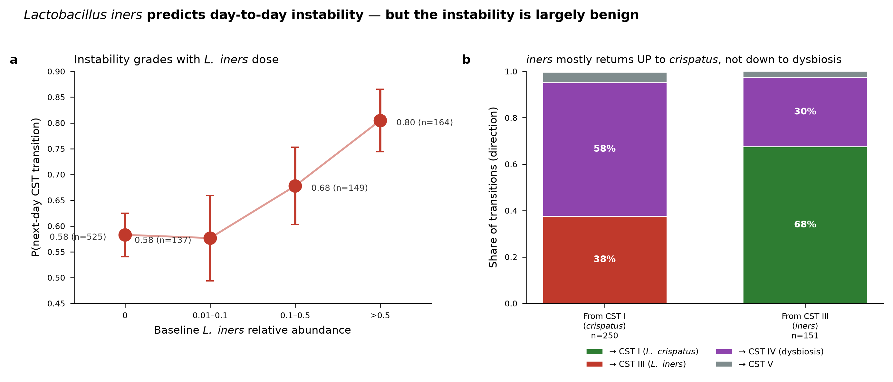
Figure 1. L. iners predicts day-to-day instability but the instability is largely benign. (a) Dose-response of next-day transition probability on baseline L. iners abundance. (b) Direction of transition: from CST III baselines, movement is predominantly recovery to L. crispatus (CST I), not descent to dysbiosis (CST IV).
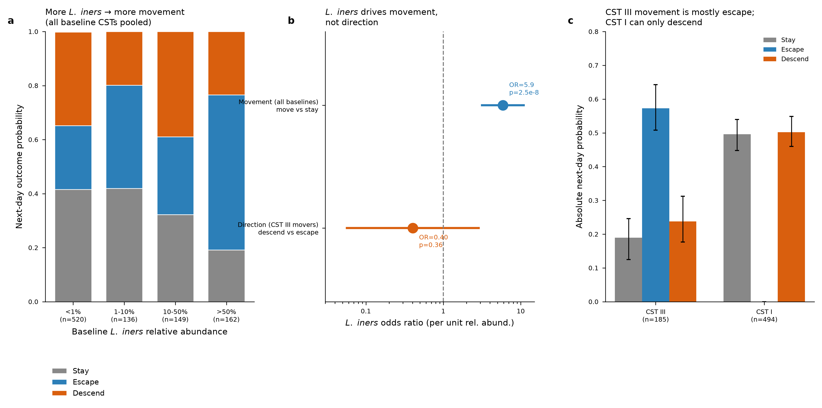
Figure 2. Competing-risks model (Analysis S1). (a) STAY shrinks and movement grows with iners dose. (b) L. iners drives movement (OR 5.9) but not direction among CST III movers (OR 0.40). (c) From an iners day, recovery (escape) exceeds descent ~2.4×.
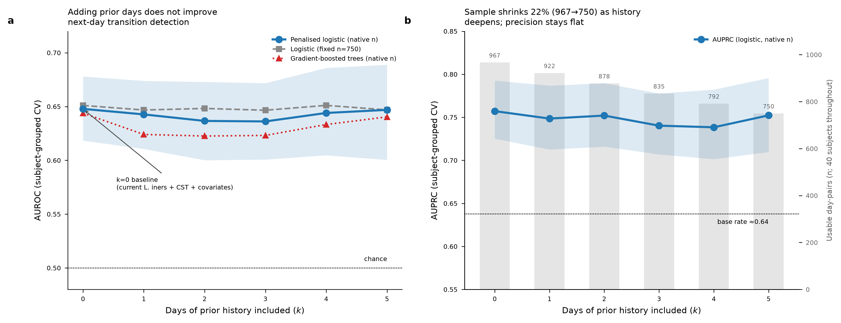
Figure 3. History-depth sweep (Analysis S3). Adding 1–5 prior days does not improve next-day transition detection (AUROC flat ~0.65); usable sample shrinks 22% as history deepens. The process is effectively memoryless.
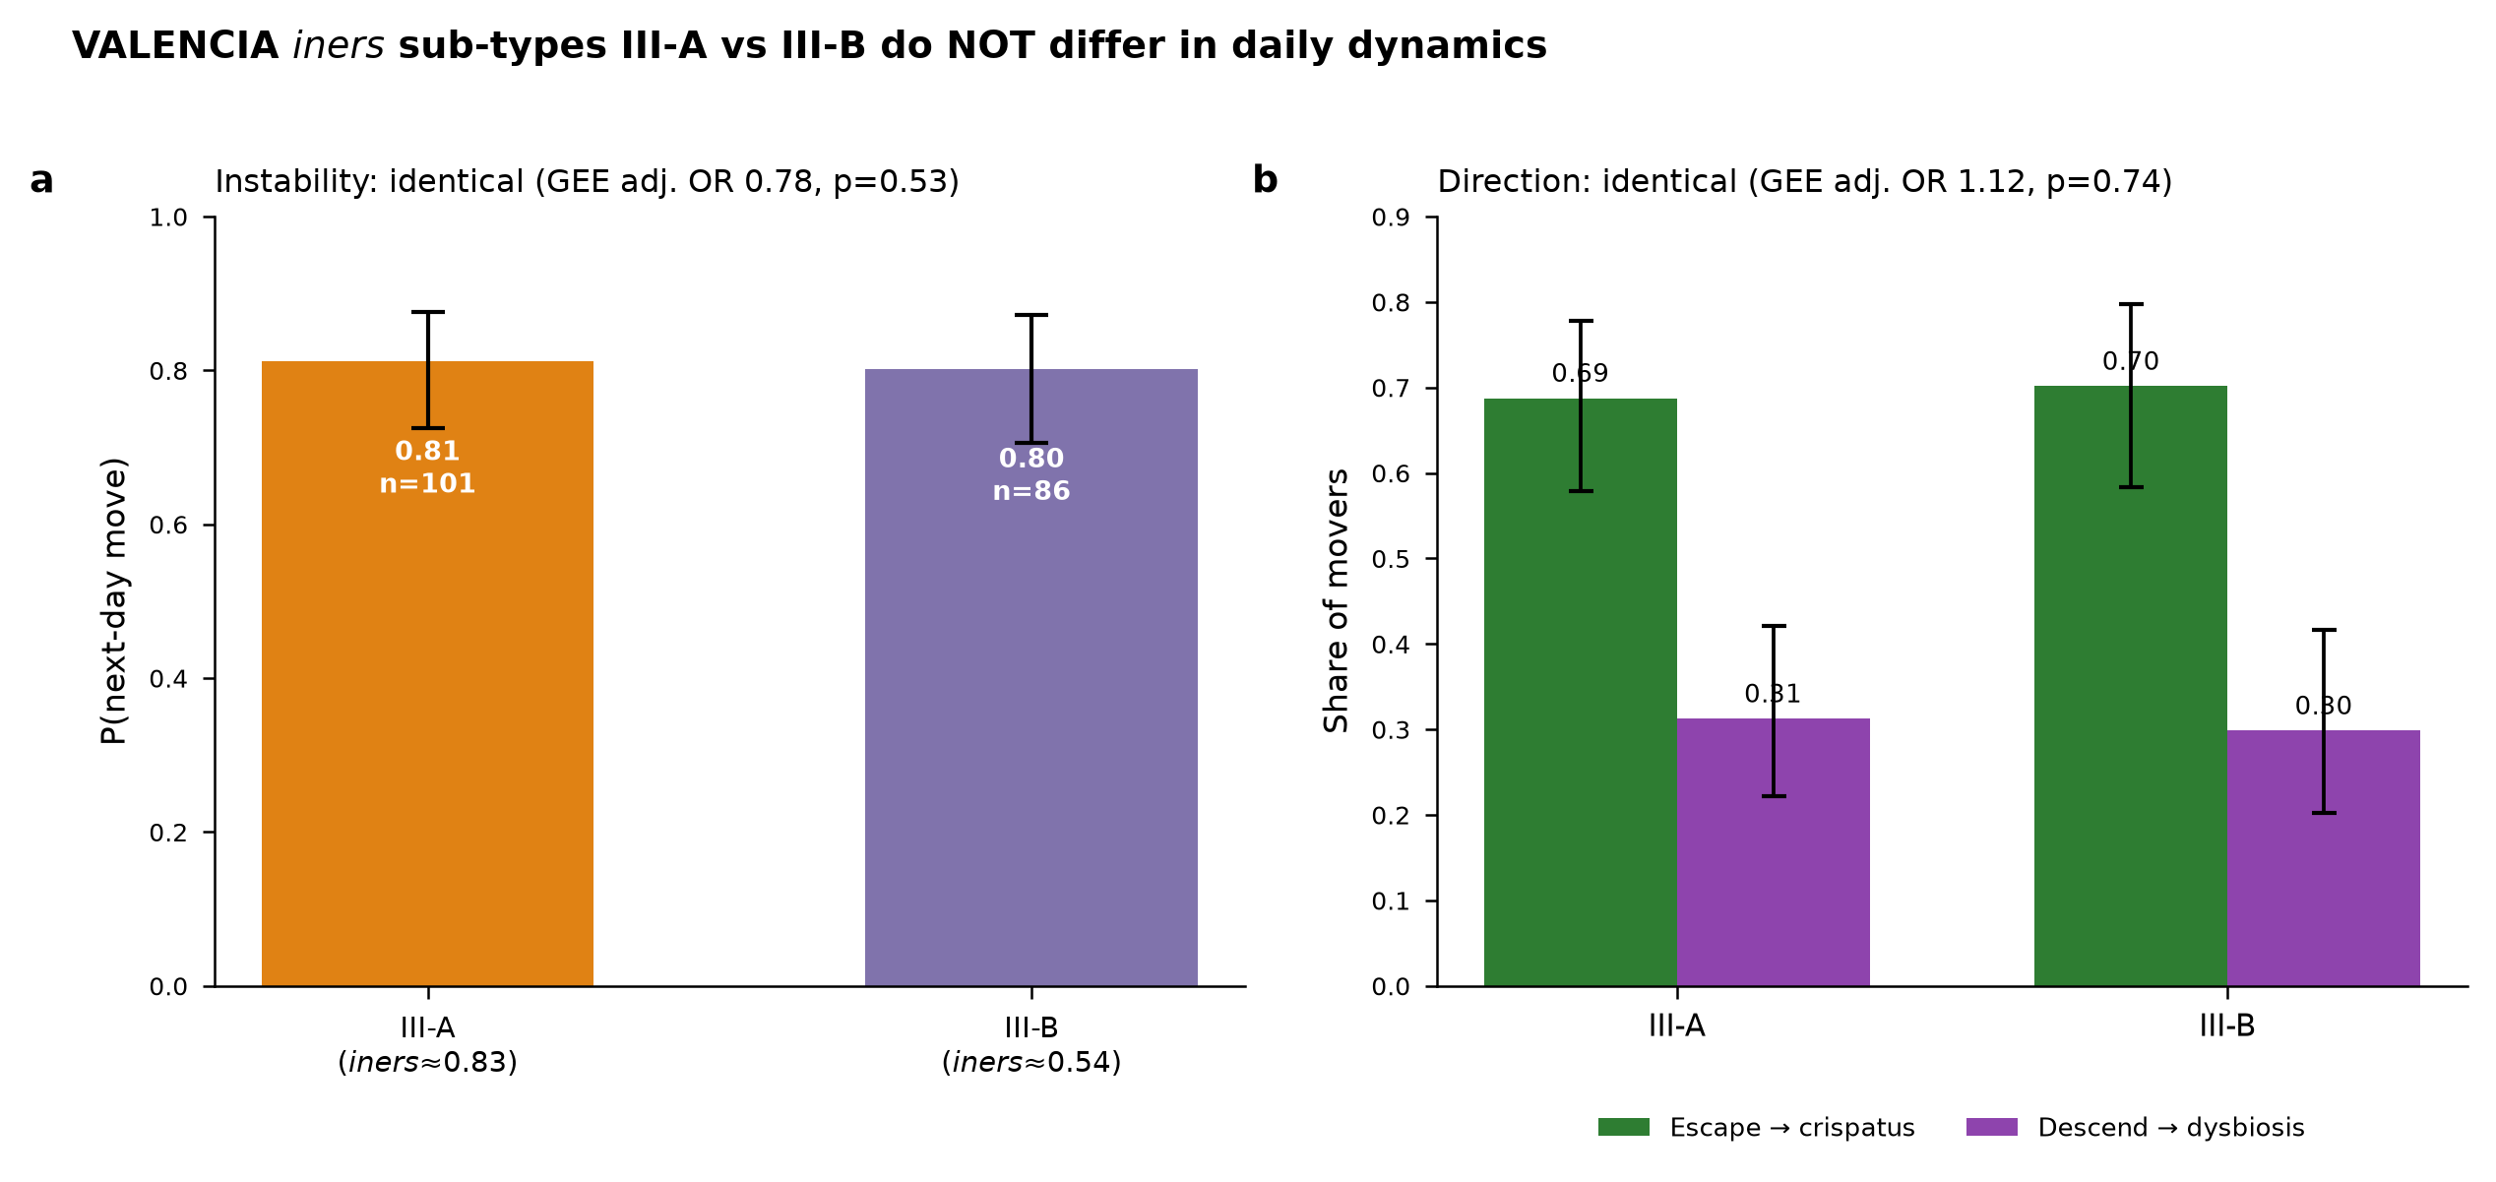
Figure 4. VALENCIA iners sub-type stratification (Analysis S4). III-A and III-B do not differ in instability (adj. OR 0.78) or in escape-vs-descent direction (adj. OR 1.12).

8. Discussion
The prevailing model treats L. iners as an ambivalent, less-protective Lactobacillus and CST III as a stepping-stone toward bacterial vaginosis. Our daily-resolution analysis supports the first half and qualifies the second. L. iners abundance is indeed a strong, dose-graded, covariate-robust marker that the community is in a high-turnover state (movement OR ~5–6). But that instability is predominantly reversible: iners-dominated communities return to L. crispatus about 2.4× more often than they descend to dysbiosis, the next state is near-independent of the current at 1-day resolution, and no measured baseline feature — including iners dose itself — forecasts which direction a mover will take. Prior history does not help, so the signal is memoryless. Together these reframe L. iners from 'pre-dysbiosis' to a memoryless mobility marker: informative about turnover, uninformative about trajectory.
The clinical reading is cautious but useful: a high-iners day flags a labile community worth monitoring, but on its own is a poor predictor of imminent dysbiosis, and single-timepoint composition should not be over-interpreted as a trajectory. The mechanistic driver of direction — why one iners day recovers and another declines — is not in the composition we measured and may lie in strain identity, host/immune factors, or behavioural exposures not captured here.

9. Limitations
- Single discovery cohort, n=40 subjects. Every result is discovery-stage and exploratory. The synthetic power analysis shows this cohort detects only large effects (OR ≥ 1.6); nulls (taxa add nothing; direction unpredictable; sub-types identical; history unhelpful) bound effects as undetectable here, not proven absent.
- No external validation. A dedicated assessment covered eight datasets; one is the discovery cohort itself (PRJEB37731, already in use), and of the seven candidate external datasets none was turnkey: each was FASTQ-only (needing reprocessing), controlled-access (dbGaP/EGA), or 16S V3–V4 (which resolves L. iners from L. crispatus poorly). A cheap summary-level replication was attempted and could not be completed — the required per-sample CST/abundance tables were paywalled or absent. No second-cohort result was fabricated.
- The original intervention-response goal remains out of reach with public data; CST transition is the defensible proxy the data support.
- A share of daily transitions reflects CST scoring-boundary noise rather than true state change (flip-vs-stay margin p=0.004), which likely caps achievable AUROC around 0.65.
- VALENCIA sub-type is not a genotype; strain-level heterogeneity of L. iners is untested and requires read-level profiling.
- cycle_day was joined from a secondary modelling table by value match in the competing-risks and sub-type analyses; a small number of pairs were unmatched and dropped from adjusted models.

10. Future directions
- External validation as the priority: obtain a turnkey second daily cohort — either Gajer 2012 Table S1 via journal access, or one de novo FASTQ reprocessing run (e.g. the Ravel/Gajer Baltimore daily cohort, PRJNA208535) — and reproduce the sign and magnitude of the dose-response and the recovery-vs-descent asymmetry.
- Strain-resolved iners analysis (StrainPhlAn/inStrain) to test whether L. iners strain identity — rather than VALENCIA sub-type — sets the direction of movement.
- Model the direction-setter directly in a larger cohort: with ~80–160 subjects, test host/immune, behavioural and menstrual-phase covariates as predictors of escape-vs-descent, which this cohort is underpowered to resolve.
- Time-resolution sensitivity: recompute the instability effect and recovery/descent ratio at 2-day, 3-day and per-visit gaps to reconcile the daily-resolution reframing with coarser-sampled literature that reported the gateway effect.

Appendix A. Analysis artifacts
All results are backed by saved artifacts in the project (figures, result tables, and per-analysis reports):
- Data landscape: vaginal_microbiome_data_report.docx; target_selection_decision_v2.docx; metagenomics_feasibility.csv; external_validation_dataset_assessment.csv.
- Power analysis: power_analysis_results.csv; power_analysis.png.
- Modelling: modeling_dataset.parquet; model_results.csv; baseline_results.csv; PRJEB37731_transition_model_report.docx.
- Novelty — instability & gateway: q2_results.csv; q2_adjusted_covariates.csv; gateway_test_results.csv; markov_transition_matrix.csv; boundary_analysis.csv; iners_dose_direction.csv; iners_instability_novelty.png.
- S1 competing-risks: S1_escape_descend_report.docx; S1_escape_vs_descend.png; S1_gee_coefficients.csv; S1_direction_within_cstIII.csv; S1_bootstrap_absolute_risk.csv.
- S3 history-depth & validation: S3_history_and_validation_report.docx; S3_history_depth_curve.png; S3_history_depth_results.csv; S3_direction_depth_results.csv.
- S4 sub-type stratification: S4_subCST_stratification_report.docx; S4_subCST_stratification.png; S4_subCST_gee.csv; S4_subCST_counts.csv.

