CSC 214 Final Project
Real-World 3-Tier Enterprise Network Design using RIPv2, OSPF, Subnetting, and ACLs

Student: Kizto Odinamkpa
Course/Instructor: CSC 214 / Professor George Effah
Date: 12/14/2025

Executive Summary
This project implements a small enterprise 3-tier network in Cisco Packet Tracer using a Core–Distribution–Access design. Five department LANs (Sales, HR, Inventory, IT, and Other/Core) were addressed and connected through four routers. OSPF was deployed across the core and distribution layer for scalable routing, while RIPv2 was used on the access layer to represent legacy segments. Route redistribution on the access router integrated the RIP domain with the OSPF domain. Security requirements were met using extended ACLs that enforce departmental isolation (HR and Sales), permit business-critical access from Inventory to the core database host, and deny unsafe protocols. Functional routing and ACL enforcement were validated using ping tests and IOS verification commands.
Note: Additional hardening (SSH-only management and disabling unused services) was identified as a recommended improvement, but it was intentionally not implemented as part of this submission.

Table of Contents
Executive Summary 2
Network Topology Diagram 4
Design Justification 5
Subnetting Plan 5
Routing Implementation 6
Access Control and Security 8
Testing and Verification 12
Security Audit 14
Lessons Learned and Recommendations 15
Appendices 16
If section page numbers change after edits, update this list to match your final export.

Network Topology Diagram
Figure 1 shows the Packet Tracer topology used for this project. The design is organized as:
- Core: Router16 (core backbone routing)
- Distribution: Router17 and Router19 (aggregation for departmental LANs)
- Access: Router18 (Inventory and IT LANs; RIP boundary and redistribution point)
- Core Database Host: PC0 on the Other/Core network

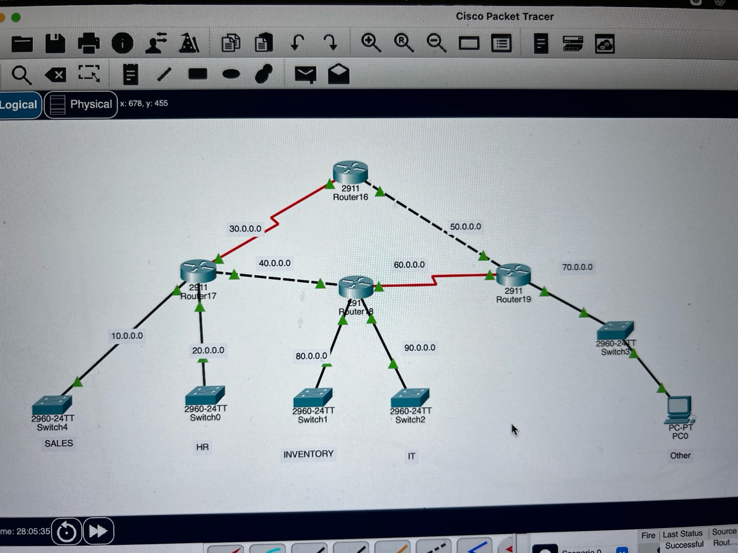
Figure 1. 3-tier enterprise topology (Core–Distribution–Access) with departmental LANs and core database host.

Design Justification
A 3-tier architecture was selected to reflect common enterprise design principles:
- Core layer provides fast, resilient routing between distribution devices and carries backbone traffic.
- Distribution layer aggregates departmental LANs and provides policy enforcement points.
- Access layer connects end hosts and legacy segments and provides a controlled boundary between routing domains.
OSPF was chosen for the core and distribution layers because it converges quickly and supports hierarchical design. RIPv2 was used on the access layer to represent legacy segments, with redistribution to exchange routes between domains.

Subnetting Plan
Each department was assigned a distinct IP network to provide logical separation and simplify policy enforcement. In the Packet Tracer implementation, the core database host (PC0) was configured with subnet mask 255.0.0.0; department LANs were treated as separate major networks to maintain isolation.
Department / Role | Network | Subnet Mask | Default Gateway | Example Host | Notes
Sales | 10.0.0.0 | 255.0.0.0 | 10.0.0.1 | 10.0.0.10 | User LAN on Router17
HR | 20.0.0.0 | 255.0.0.0 | 20.0.0.1 | 20.0.0.10 | User LAN on Router17
Inventory | 80.0.0.0 | 255.0.0.0 | 80.0.0.1 | 80.0.0.10 | User LAN on Router18 (RIP domain)
IT | 90.0.0.0 | 255.0.0.0 | 90.0.0.1 | 90.0.0.10 | User LAN on Router18 (RIP domain)
Other/Core | 70.0.0.0 | 255.0.0.0 | 70.0.0.1 | 70.0.0.10 (PC0) | Core database host placed here
Core Database Host: PC0 is used as the ‘core database’ for access-control testing and is configured as 70.0.0.10.

Routing Implementation

OSPF (Core and Distribution)
OSPF was enabled on Router16 (core) and on Router17/Router19 (distribution). Router18 participates in OSPF on its uplinks to integrate with the OSPF backbone. All OSPF interfaces were placed in Area 0 for this implementation.
Configured OSPF Router IDs (as implemented):
- Router16: 2.2.2.2
- Router17: 1.1.1.1
- Router18: 4.4.4.4
- Router19: 3.3.3.3
Note: OSPF process IDs are locally significant and do not need to match between routers. This report focuses on router IDs, areas, and interface participation, which determine adjacency and route exchange.

RIPv2 (Access Layer Legacy Segments)
RIPv2 was configured only on Router18 to advertise the Inventory (80.0.0.0) and IT (90.0.0.0) networks. RIP settings included version 2 and ‘no auto-summary’.

Route Redistribution (OSPF <-> RIP)
To exchange routes between the OSPF domain (core/distribution) and the RIP domain (Inventory/IT), bidirectional redistribution was configured on Router18. This makes Router18 the routing boundary and avoids multiple redistribution points.

Key Configuration Snippets (Sanitized)
Router18 – RIP configuration (example):
router rip
version 2
no auto-summary
network 80.0.0.0
network 90.0.0.0
Router18 – Redistribution (example):
router ospf <process-id>
redistribute rip subnets
router rip
redistribute ospf <process-id> metric 2
OSPF on core/distribution routers – participation in Area 0 (example interface method):
interface <uplink-or-lan-interface>
ip ospf <process-id> area 0
In the submitted Packet Tracer file, interface names and exact process IDs may vary; however, all OSPF-enabled links were placed in Area 0 and verified using neighbor and routing table checks.

Access Control and Security

ACL Strategy
Extended ACLs were used to enforce segmentation and reduce attack surface. ACLs were applied inbound on user-facing LAN interfaces to stop unwanted traffic as close to the source as possible. Each interface uses a single inbound ACL to avoid rule replacement.

ACL Requirements Implemented
- Department isolation: HR cannot reach Sales; Sales cannot reach HR.
- Business-critical access: Inventory is permitted to reach the Core Database host (PC0 = 70.0.0.10).
- Deny unsafe protocols/potential attack vectors: Telnet (TCP/23), FTP (TCP/21), and TFTP (UDP/69) are blocked from user LANs.

ACL Placement (Inbound Interfaces)
Router | LAN (Source) | Gateway IP | ACL Direction
Router17 | HR | 20.0.0.1 | Inbound on HR-facing interface
Router17 | Sales | 10.0.0.1 | Inbound on Sales-facing interface
Router18 | Inventory | 80.0.0.1 | Inbound on Inventory-facing interface
Router18 | IT | 90.0.0.1 | Inbound on IT-facing interface

ACL Rule Tables (Summary)

HR Inbound ACL (applied on Router17 HR interface)
Seq | Action | Match | Purpose
10 | deny | ip 20.0.0.0/8 -> 10.0.0.0/8 | Block HR from reaching Sales
20 | deny | tcp any any eq 23 | Block Telnet
30 | deny | tcp any any eq 21 | Block FTP
40 | deny | udp any any eq 69 | Block TFTP
50 | permit | ip 20.0.0.0/8 -> any | Allow all other HR traffic

Sales Inbound ACL (applied on Router17 Sales interface)
Seq | Action | Match | Purpose
10 | deny | ip 10.0.0.0/8 -> 20.0.0.0/8 | Block Sales from reaching HR
20 | deny | tcp any any eq 23 | Block Telnet
30 | deny | tcp any any eq 21 | Block FTP
40 | deny | udp any any eq 69 | Block TFTP
50 | permit | ip 10.0.0.0/8 -> any | Allow all other Sales traffic

Inventory Inbound ACL (applied on Router18 Inventory interface)
Seq | Action | Match | Purpose
10 | permit | tcp 80.0.0.0/8 -> host 70.0.0.10 eq 1433 | Allow Inventory to Core DB (SQL port)
15 | permit | icmp 80.0.0.0/8 -> host 70.0.0.10 | Allow ping for verification
20 | deny | ip 80.0.0.0/8 -> 10.0.0.0/8 | Block Inventory to Sales
30 | deny | ip 80.0.0.0/8 -> 20.0.0.0/8 | Block Inventory to HR
40 | deny | tcp any any eq 23 | Block Telnet
50 | deny | tcp any any eq 21 | Block FTP
60 | deny | udp any any eq 69 | Block TFTP
70 | permit | ip 80.0.0.0/8 -> any | Allow other Inventory traffic

IT Inbound ACL (applied on Router18 IT interface)
Seq | Action | Match | Purpose
10 | deny | ip 90.0.0.0/8 -> 10.0.0.0/8 | Block IT to Sales
20 | deny | ip 90.0.0.0/8 -> 20.0.0.0/8 | Block IT to HR
30 | deny | tcp any any eq 23 | Block Telnet
40 | deny | tcp any any eq 21 | Block FTP
50 | deny | udp any any eq 69 | Block TFTP
60 | permit | ip 90.0.0.0/8 -> any | Allow other IT traffic

Additional Hardening (Optional; Not Implemented)
The project requirements recommend secure device management practices such as SSH-only access and disabling unused services. These hardening steps were identified but not implemented in the final Packet Tracer configuration for this submission.
- Recommended hardening actions (for future improvement):
- Enable SSH on all routers and switches; disable Telnet on VTY lines (transport input ssh).
- Disable unused services (for example, no ip http server) and unnecessary discovery protocols where applicable.
- Restrict management access to IT subnet only using a standard ACL on VTY lines.
- Use strong local credentials and encrypted secrets; set exec-timeout and login-block policies.

Physical and Logical Segmentation
Physical segmentation: separate access switches were used per department LAN (Sales, HR, Inventory, IT, Other).
Logical segmentation: each department uses a separate IP network; ACLs enforce inter-department restrictions.

Testing and Verification

Routing Verification
The following IOS commands were used to confirm correct routing propagation across the network:
- show ip route
- show ip protocols
- show ip ospf neighbor
- show ip route ospf
- show ip route rip
Result: All routers learned the expected remote networks. Inter-domain reachability worked after redistribution on Router18.

ACL Verification
ACL enforcement was verified using ping tests and ACL counter checks:
- show access-lists
- show ip interface <interface-name>
Test Case | Source | Destination | Expected Result
HR -> Sales blocked | HR PC (20.0.0.x) | Sales PC (10.0.0.x) | Denied
Sales -> HR blocked | Sales PC (10.0.0.x) | HR PC (20.0.0.x) | Denied
Inventory -> HR blocked | Inventory PC (80.0.0.x) | HR PC (20.0.0.x) | Denied
Inventory -> Sales blocked | Inventory PC (80.0.0.x) | Sales PC (10.0.0.x) | Denied
Inventory -> Core DB allowed | Inventory PC (80.0.0.x) | PC0 (70.0.0.10) | Allowed
IT -> HR blocked | IT PC (90.0.0.x) | HR PC (20.0.0.x) | Denied
IT -> Sales blocked | IT PC (90.0.0.x) | Sales PC (10.0.0.x) | Denied
Core reachability | Router16 | Router18 | Allowed
Result: All listed tests were executed and matched expected behavior.

Verification Output (Screenshots/Logs)
Attach screenshots or logs showing the following verification outputs (recommended for grading):
- show ip route on Router16 and Router18 (showing OSPF and RIP-learned routes)
- show ip ospf neighbor on Router17/Router18/Router19 (adjacencies in FULL state)
- show ip protocols on Router18 (RIPv2 + redistribution visible)
- show access-lists on Router17 and Router18 (counters incrementing after denied/allowed tests)
- Ping test screenshots from HR, Sales, Inventory, IT, and to PC0 (core database)

Security Audit
Common attack scenarios considered and how the implemented controls reduce risk:
Unauthorized lateral movement: Department isolation ACLs prevent HR and Sales from directly accessing each other.
Data exfiltration or unauthorized access to sensitive resources: Inventory access to the core database host is explicitly permitted, while access to HR and Sales is denied.
Use of insecure legacy protocols: Telnet, FTP, and TFTP are blocked at the access layer to reduce credential leakage and unauthenticated file transfer risk.
Reconnaissance and protocol misuse: Inbound filtering on user LANs limits what traffic can enter the routed network from edge segments.
Limitation: device management hardening (SSH-only access, disabling unused services) was not implemented in this submission, but is recommended for production-like deployments.

Lessons Learned and Recommendations
Key challenges and how they were resolved:
- ACL attachment errors can silently weaken security. An early issue occurred when an ACL name applied to an interface did not match the ACL definition name; correcting the access-group name restored expected filtering.
- Only one ACL can be applied per interface per direction. When additional rules were needed, they were consolidated into a single inbound ACL per LAN interface to prevent rule replacement.
- Route redistribution is required when mixing routing protocols. Inter-domain reachability depends on Router18 advertising and learning routes in both OSPF and RIP.
Recommendations for improvement (optional enhancements):
- Implement SSH-only management on all routers/switches and restrict VTY access to the IT network.
- Use multiple OSPF areas (backbone + departmental areas) to better match enterprise hierarchy and reduce LSDB size as the network scales.
- Replace PC0 with a Server-PT device to demonstrate application-layer tests in addition to ICMP.

Appendices

Appendix A: Device Inventory
Device | Role | Notes
Router16 | Core Router | OSPF Area 0
Router17 | Distribution Router | OSPF Area 0; Sales + HR gateway
Router18 | Access / Boundary Router | RIPv2 for Inventory/IT; OSPF uplinks; redistribution
Router19 | Distribution Router | OSPF Area 0; Other/Core gateway
PC0 | Core Database Host (simulated) | 70.0.0.10

Appendix B: Configuration Evidence Placeholders
Paste or attach the following outputs for complete configuration evidence (recommended):
- Router16: show run | section router ospf

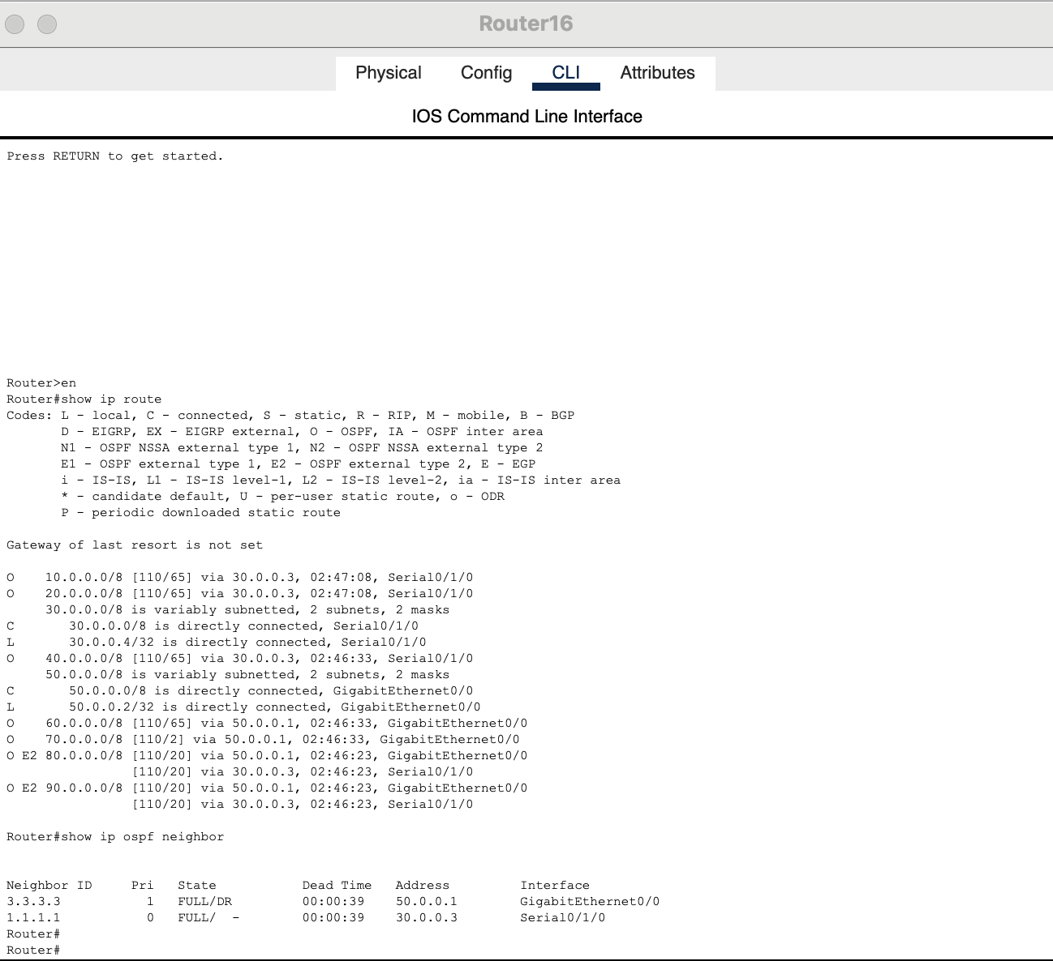

- Router17: show run | section router ospf ; show access-lists

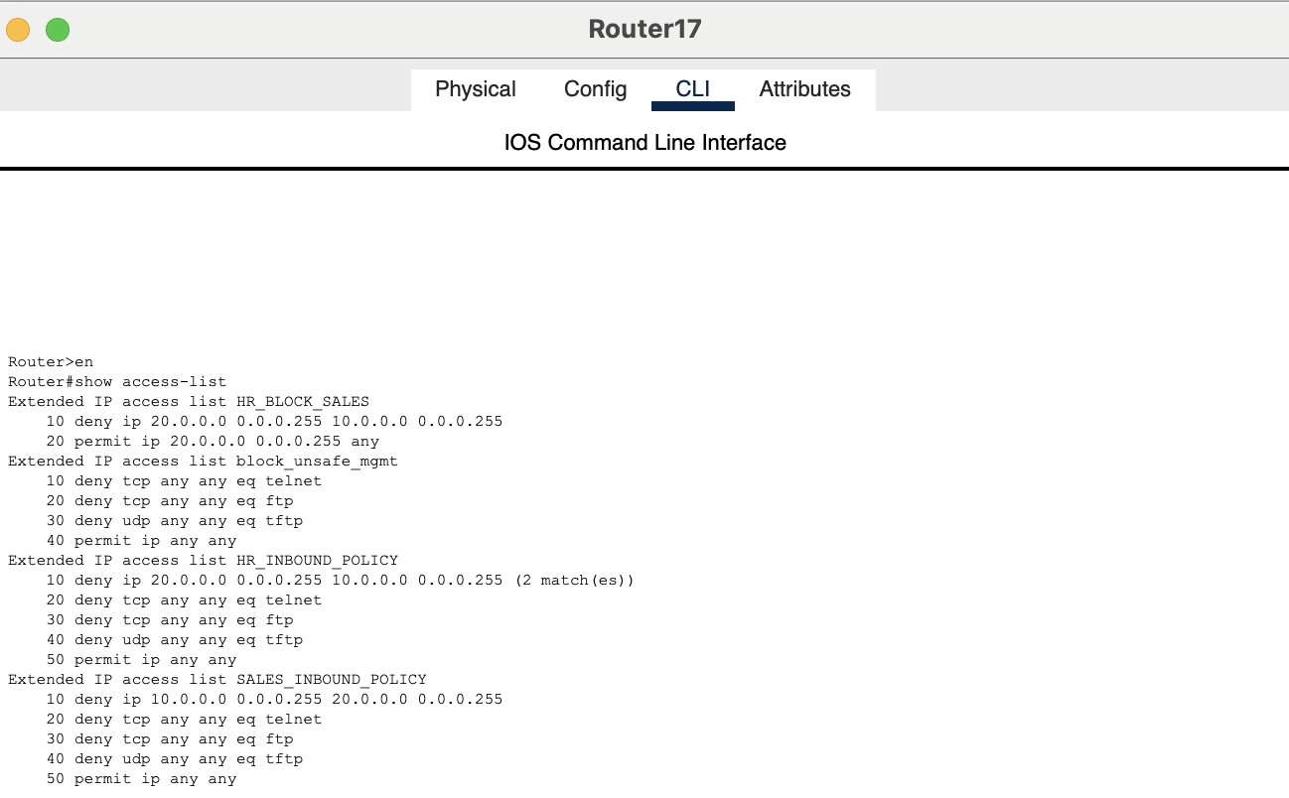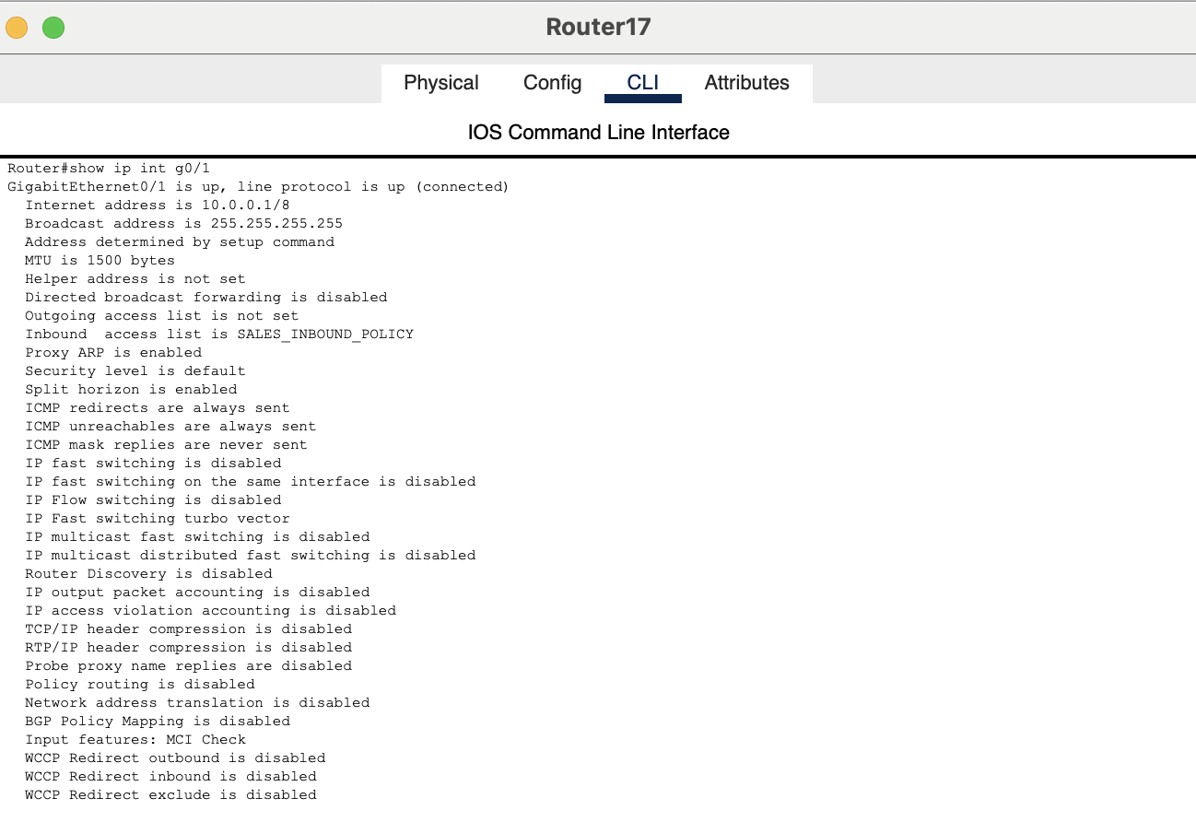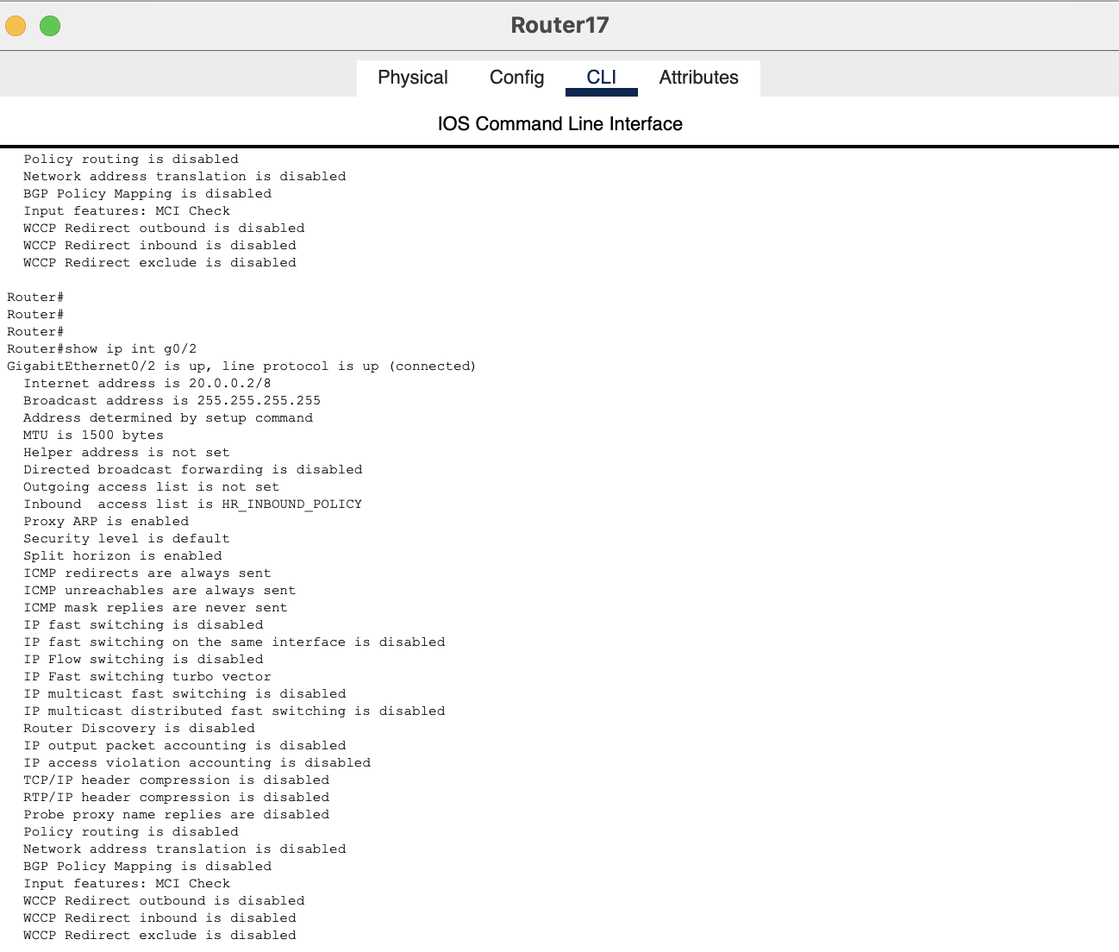

- Router18: show ip protocols ; show run | section router rip ; show run | section router ospf ; show access-lists

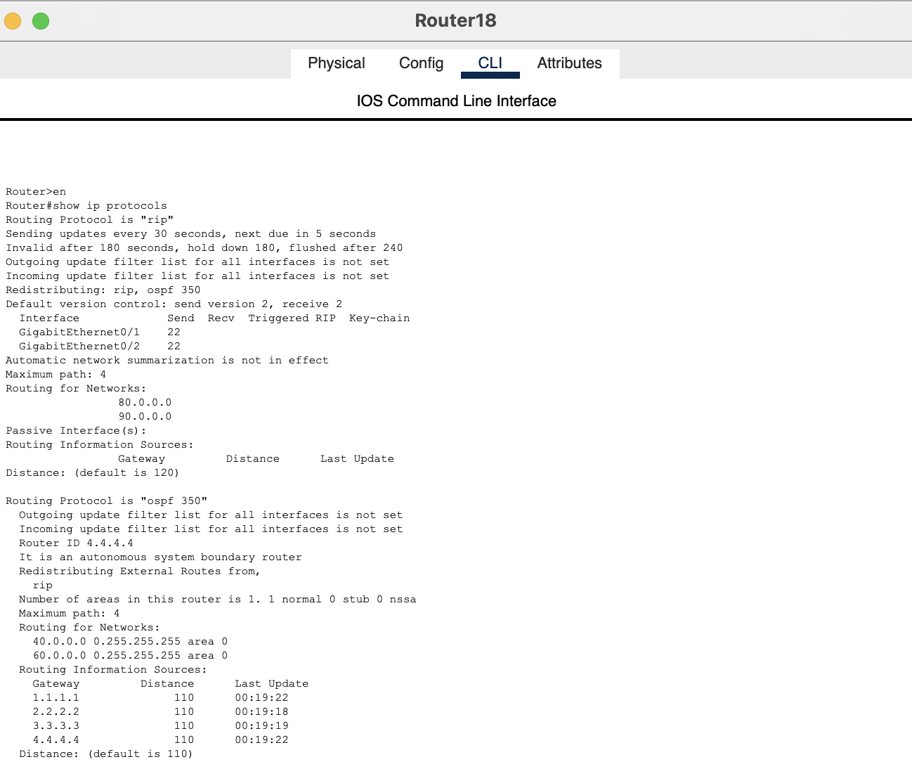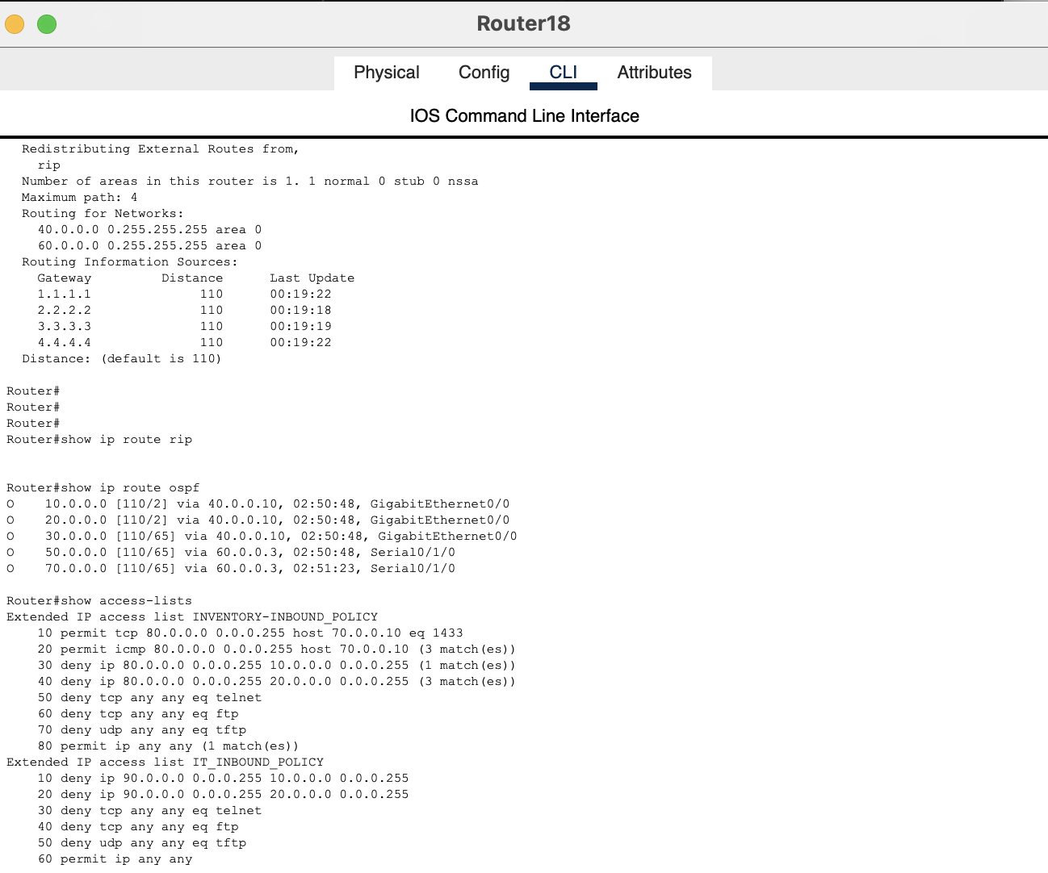

- Router19: show run | section router ospf

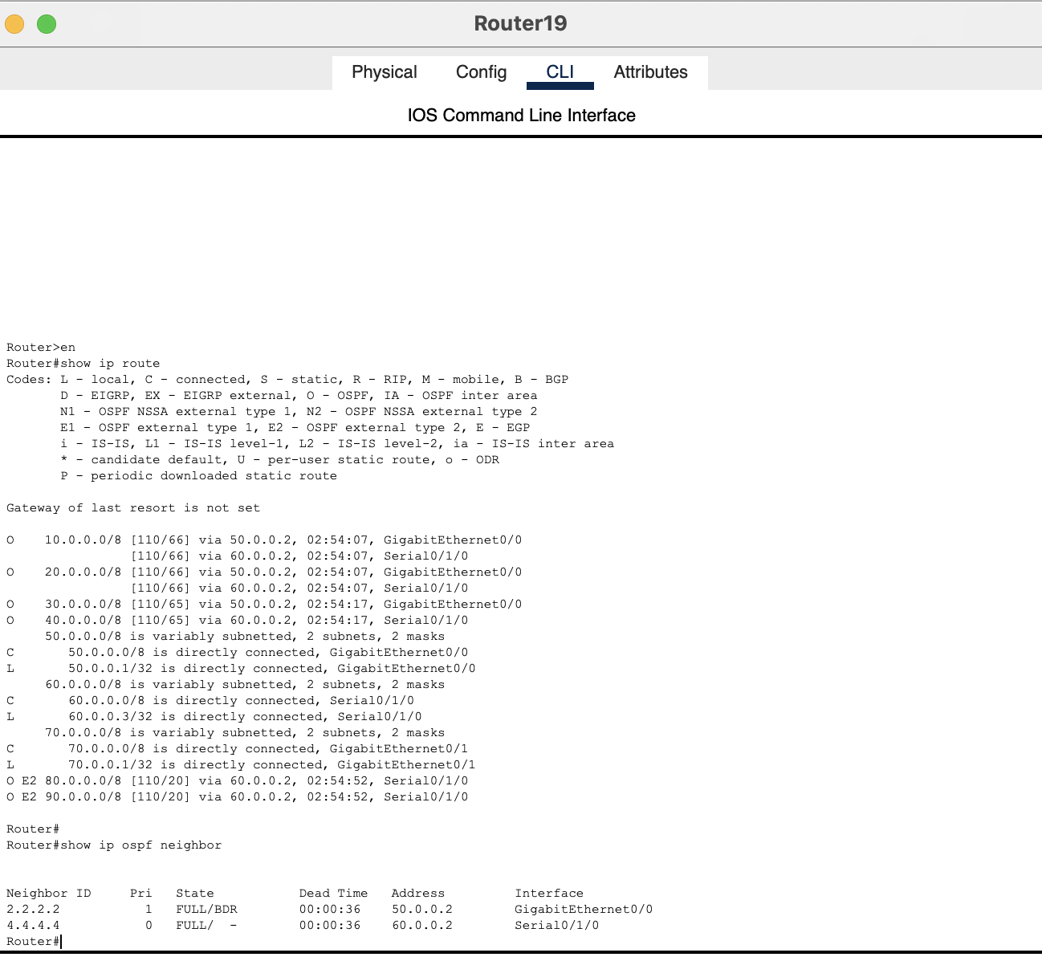

End of Report.

