

Course: Applied Statistical Modelling
Name: Kabir Kimtani
Student ID: GH1045344
Lecturer: William Baker Morrison
Date of submission: September 18th

Content Table:

- Core Business Problem And Research Questions
- Defining The Hypotheses
- Data Understanding
- Data Preparation And Descriptive Statistics
- Statistical Test Selection and Model Hypotheses
- Data Modeling
- Model evaluation
- Reference and Github link

1.Core Business Problem And Research Questions:

Enormous discoveries of new security flaws has created an overwhelming effect on business vulnerability management programs.Commonly, the main method for prioritizing these flaws was the Common Vulnerability Scoring System (CVSS).However, when vulnerabilities are weaponized out of the blue, the Cybersecurity and Infrastructure Security Agency (CISA) issues mandatory federal remediation deadlines (dueDate) through the Known Exploited Vulnerabilities catalog (KEV) under Binding Operational Directives.

A crucial operational misalignment occurs if an organization relies solely on static CVSS scores to dictate patching Service Level Agreements (SLAs). Then theoretically if severity fails to predict regulatory urgency, then weaponized flaws with moderate CVSS scores may remain unpatched long past their active exploitation window.

Core Business Questions:

1.Does the theoretical severity of a vulnerability predict the required remediation window (in days) mandates by CISA?

2.Do Standard businesses (SLA) severity tiers show significant differences in their average required remediation timelines?

2.Defining The Hypotheses:

To solve both these research questions, two different inferential statistical tests are used:

Test 1: Simple Linear Regression (for solving question 1):

We use linear regression in this case to test whether there is a gradual increases in the score predicting a tight patch window, as the raw CVSS Base Score is a continuous scale (0.0 to 10.0).

- Null Hypothesis (H0,1): β = 0, if the slope coefficient is 0. Hence, the continuous CVSS Base Score fails to predict the CISA remediation window.

- Alternative Hypothesis (HA,1): β ≠ 0, if slope coefficient is significantly different from 0. The continuous CVSS Base Score is a prediction of CISA’s remediation window.

Test 2: One-Way ANOVA (for solving question 2):

We use ANOVA to check the difference between the Business SLAs groups as they are made up of the four ordinal categories specified in the descriptive metrics (Low, Medium, High, Critical).

- Null Hypothesis (H0,2):μ_low = μ_medium = μ_high = μ_critical The average remediation window, measured in days, is not statistically different for the four standard CVSS severity levels.

- Alternative Hypothesis (HA,2):At least one μ_i ≠ μ_j for i ≠ j There exists at least one CVSS severity tier with a mean remediation window statistically significantly different from the other tiers.

3.Data Understanding:

The analysis is based on the synthesis of two separate frameworks of cybersecurity data.

- NVD JSON 2.0 Feeds (2024–2026) This dataset is the repository for theoretical technical severity. It contains deeply nested JSON objects describing the Common Vulnerabilities and Exposures (CVE) identifier and its corresponding CVSS v3.1 metrics (giving our independent variables).

- CISA KEV Catalog: The data set provides operational mandates that are actionable and threat-informed. This includes flat CSV records of CVEs that are actively weaponized, with dateAdded and federal compliance dueDate (giving our dependent variable).

Sampling Method: We use a purposive census sampling of all vulnerabilities that are both cataloged in the CISA KEV database with active exploitation dates between January 1, 2024 and August 31, 2026, and formally scored within the corresponding NVD JSON feeds (N ≈ 500-800 joint records).

4.Data Preparation And Descriptive Statistics :

4.1.Data cleansing:

Cleaning Steps | Target variable | Explanation
Data Parsing | dateAdded, dueDate | To turn sting dates into R Date object using lubridate to allow date arithmetic.
Feature creation | Remediation_Days | Creating a continuous numeric mandated patching window. (in dueDate − dateAdded)
Removing negative-values | Remediation_Days | Remove rows in which the Remediation_Days is less then zero as anomalies.
Removing missing-values | cvss_score, Remediation_Days | To achieve pair alignment we drop the missing cases.
Categorical binning | Severity | CVSS scores mapped by tiers (Low/Medium/High/Critical).

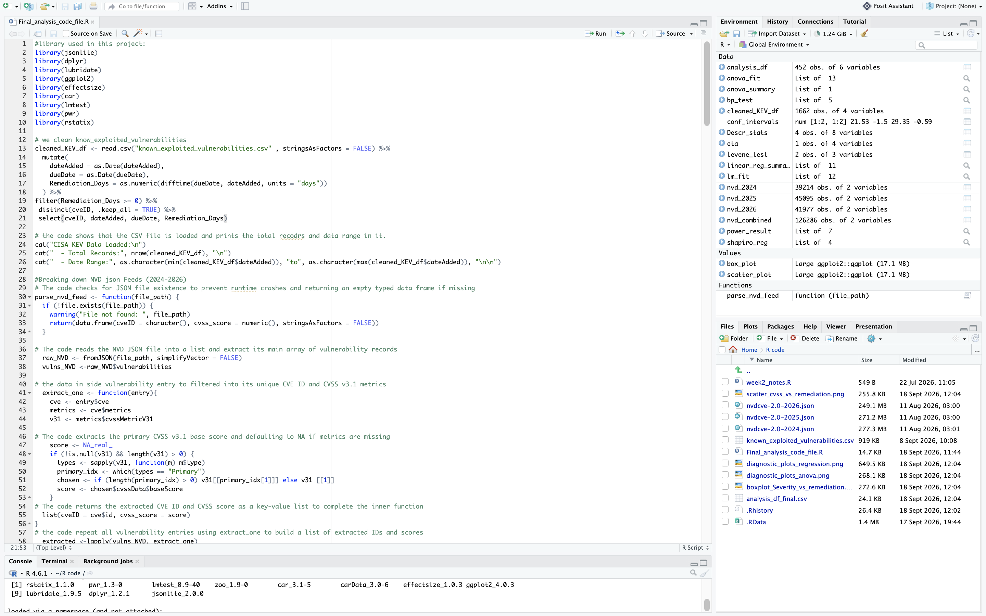

Fig 1.1. R code for importing and cleaning the CISA KEV catalog (read.csv, date parsing with lubridate, calculation of Remediation_Days, removal of negative values, and de-duplication by cveID) and the beginning of a custom function parse_nvd_feed() to extract CVSS v3.1 base scores from the NVD JSON records.

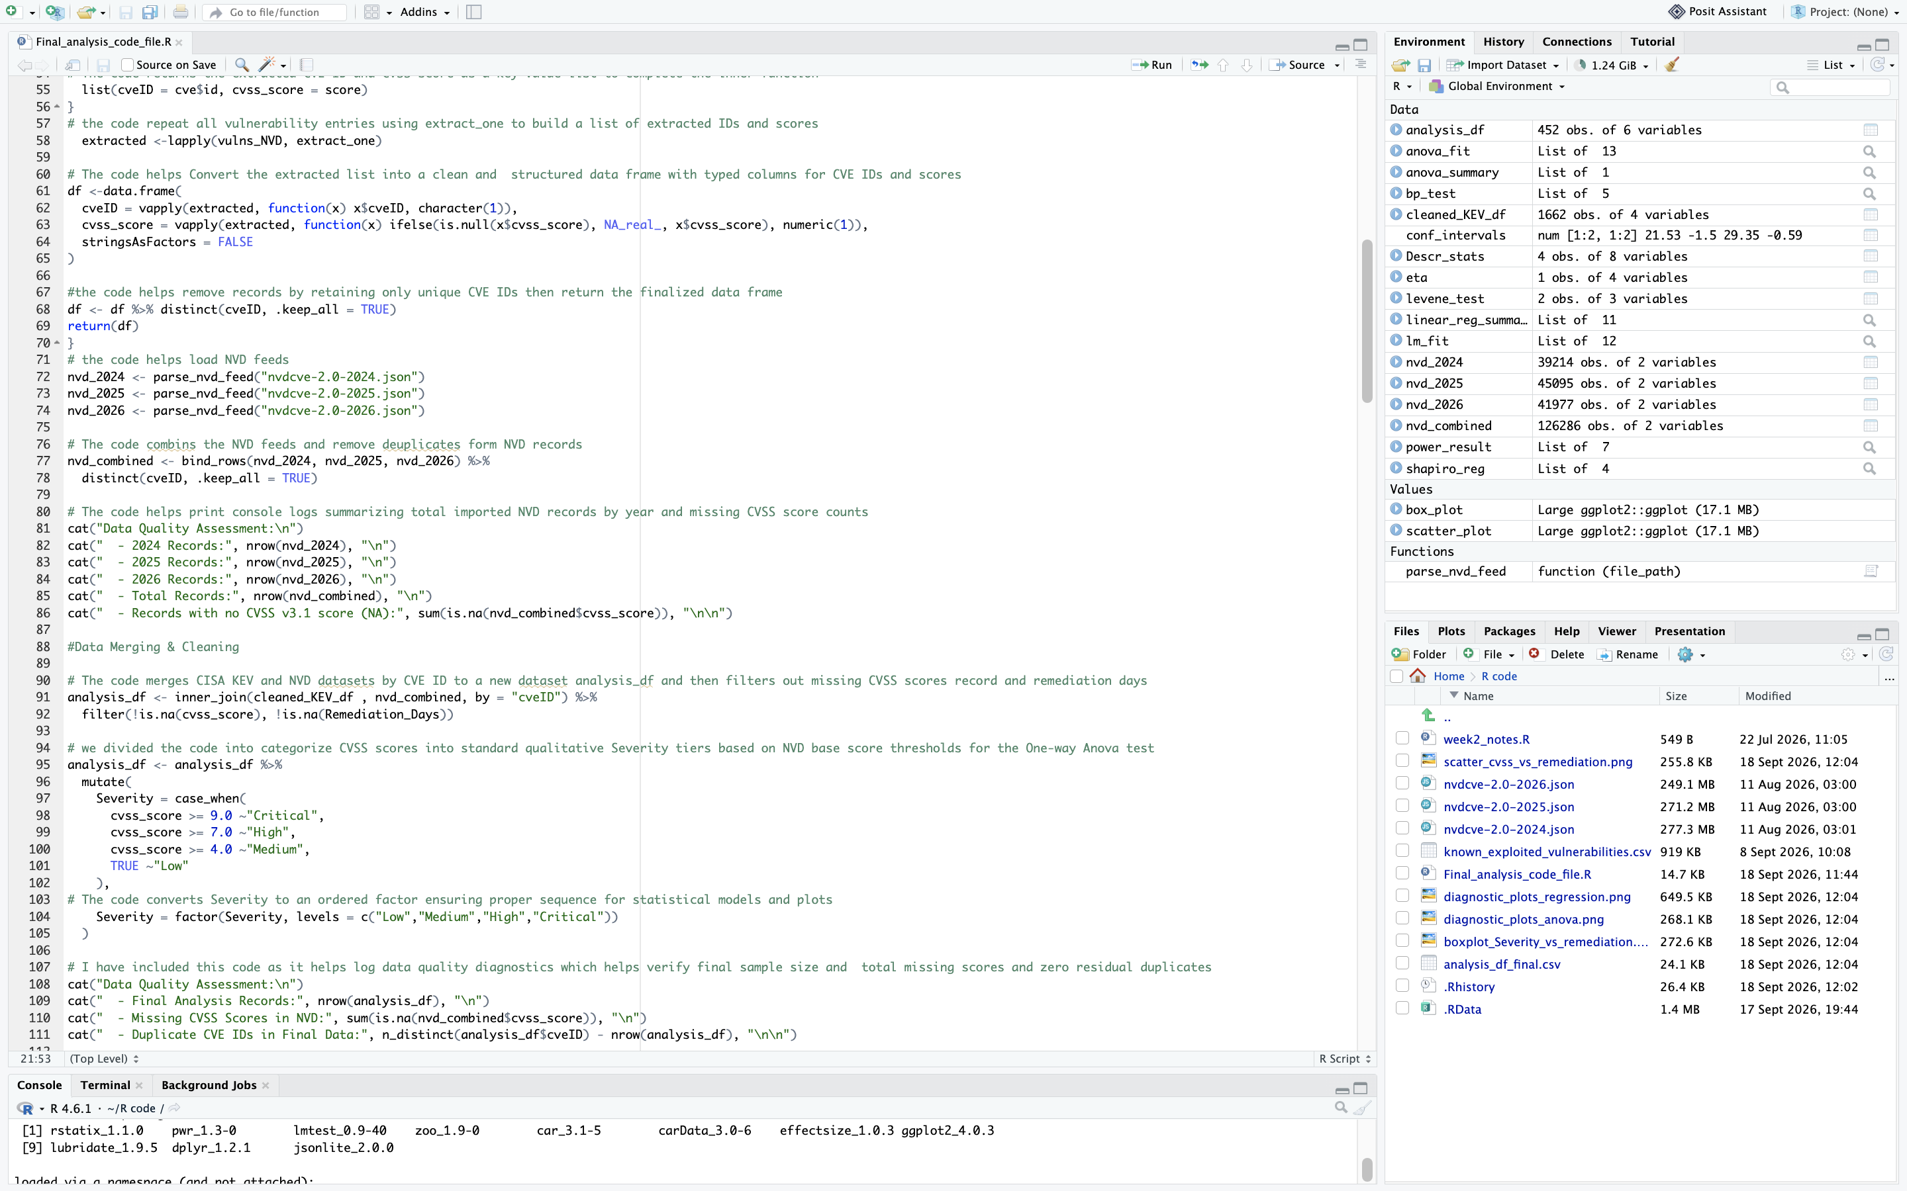

Fig 1.2. This picture is a continuation of the picture above which starts with NVD parsing pipeline converting the extracted CVE and CVSS list into a structured data frame, loading the 2024–2026 NVD feeds, merging them with the cleaned KEV data using inner_join(), and distibuting cvss_score into the four Severity tiers (Low/Medium/High/Critical) which is used in the ANOVA model.

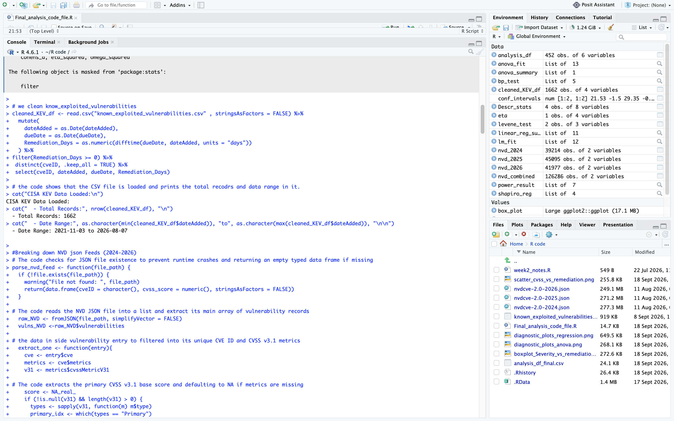

Fig 1.3. The screenshot above indicates the console output which verifies the CISA KEV data load: 1,662 total records over a date range of 2021-11-03 to 2026-08-07, before the inner join with the NVD feeds and missing-value filtering which resulted in the final N = 452 analysis sample.

4.2.Grouped Descriptive Metrics:

Severity Level | N | Mean Day | Median Day | SD | IQR
Low (0.1–3.9) | 1 | 21 | 21 | NA | 0
Medium (4.0–6.9) | 50 | 17.4 | 21 | 5.82 | 7
High (7.0–8.9) | 201 | 18.2 | 21 | 5.63 | 0
Critical (9.0–10.0) | 200 | 14.7 | 21 | 8.19 | 18

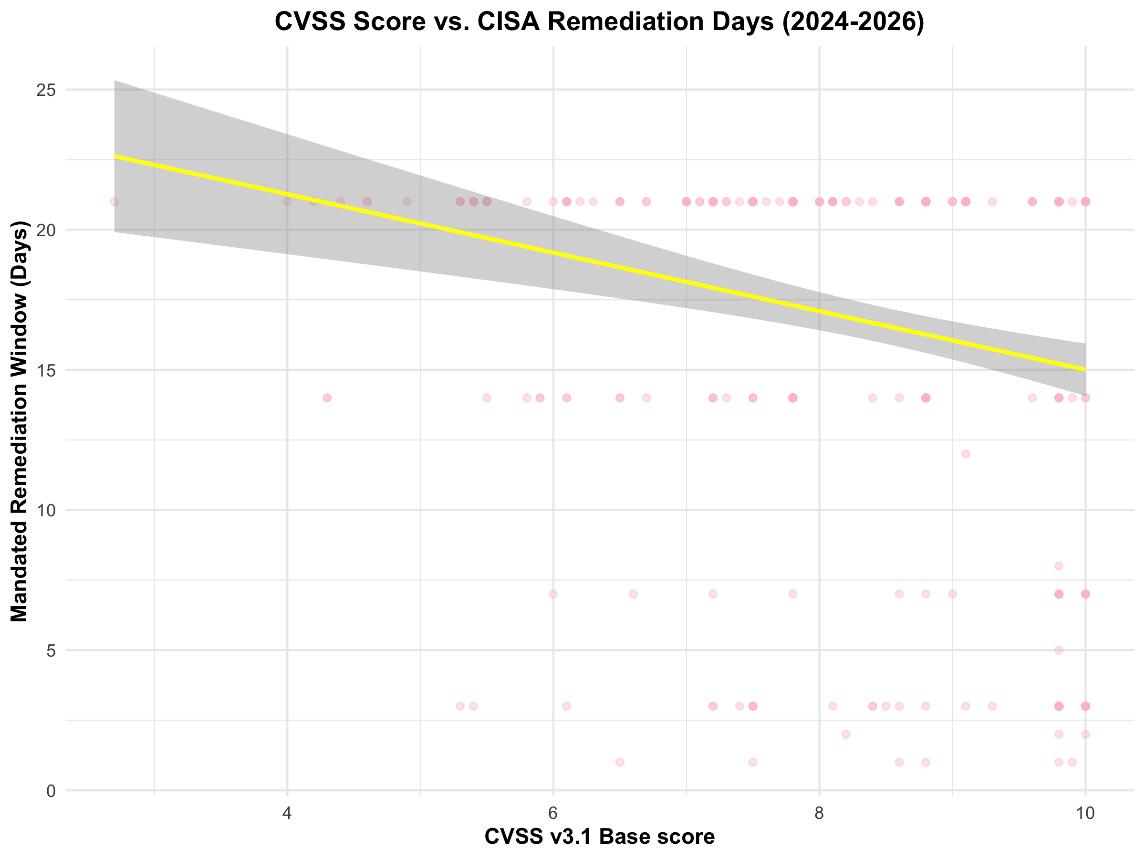

Fig 2.1. The figure above shows the scatterplot of CVSS v3.1 base score against the mandated CISA remediation window (days), with a fitted linear trend line and 95% confidence band. The negative slope visually reflects the β₁ = −1.04 coefficient discussed in Section 7, and the horizontal banding of points illustrates the deadline-clustering effect discussed in the Limitations.

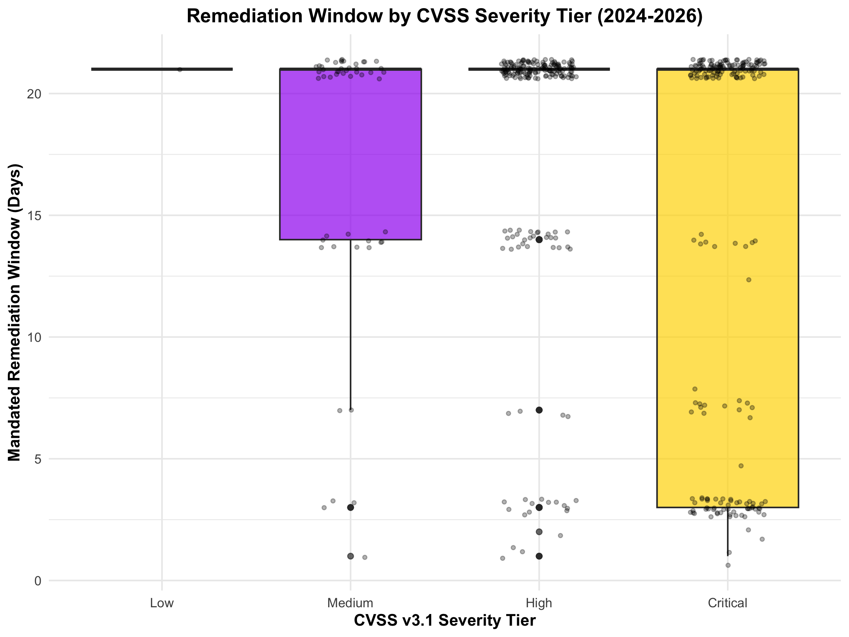

Fig 2.2. The figure above shows the boxplot of remediation window by CVSS severity tier, with individual observations shaken for visibility. The single Low-tier point N = 1 is visible as a flat line with no distribution, reinforcing the Limitations note that the Low tier cannot be meaningfully compared to the other three. Similarly, the High tier's interquartile range collapses to a single line because the vast majority of its vulnerabilities share the same administrative deadline

5.Statistical Test Selection and Model Hypotheses:

Normality of residuals we use Shapiro-Wilk : W = 0.7724, p = 1.4422e-24 N=452. Some non-normality is expected due to the discrete clustering of Remediation_Days around administrative boundaries (e.g. 14/21 day deadlines). F-tests are still pretty robust at this sample size (Central Limit Theorem).

Homoscedasticity = Breusch-Pagan for Simple linear regression: BP = 25.2989, p = 4.9099e-07.

Homogeneity of Variance = Levene's Test for One-way ANOVA: F = 9.2647, p = 5.899e-06.

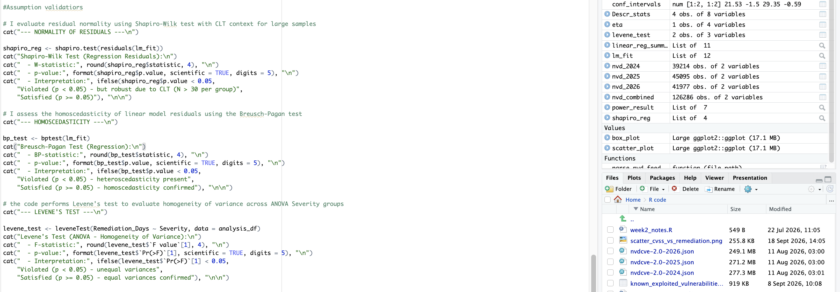

Fig 3.1. The snapshot above shows the r code using the three assumption checks selected for this analysis. Which are the Shapiro-Wilk test for normality of regression residuals, the Breusch-Pagan test for homoscedasticity, and Levene's test for homogeneity of variance across the ANOVA severity groups.

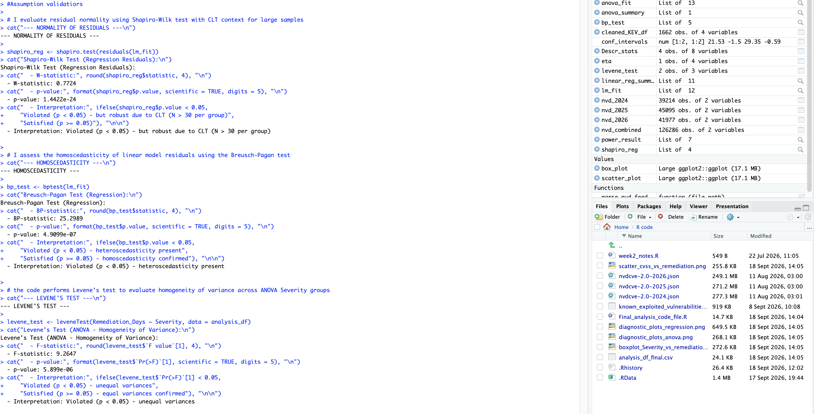

Fig 3.2. The above screen shot is the console output of the assumption diagnostics which the output report, in order of the output are: Shapiro-Wilk: W = 0.7724, p < 0.001 which means normality violated. Breusch-Pagan: BP = 25.30, p < 0.001 which means heteroscedasticity present.Levene's: F = 9.26, p < 0.001 which means unequal variances.

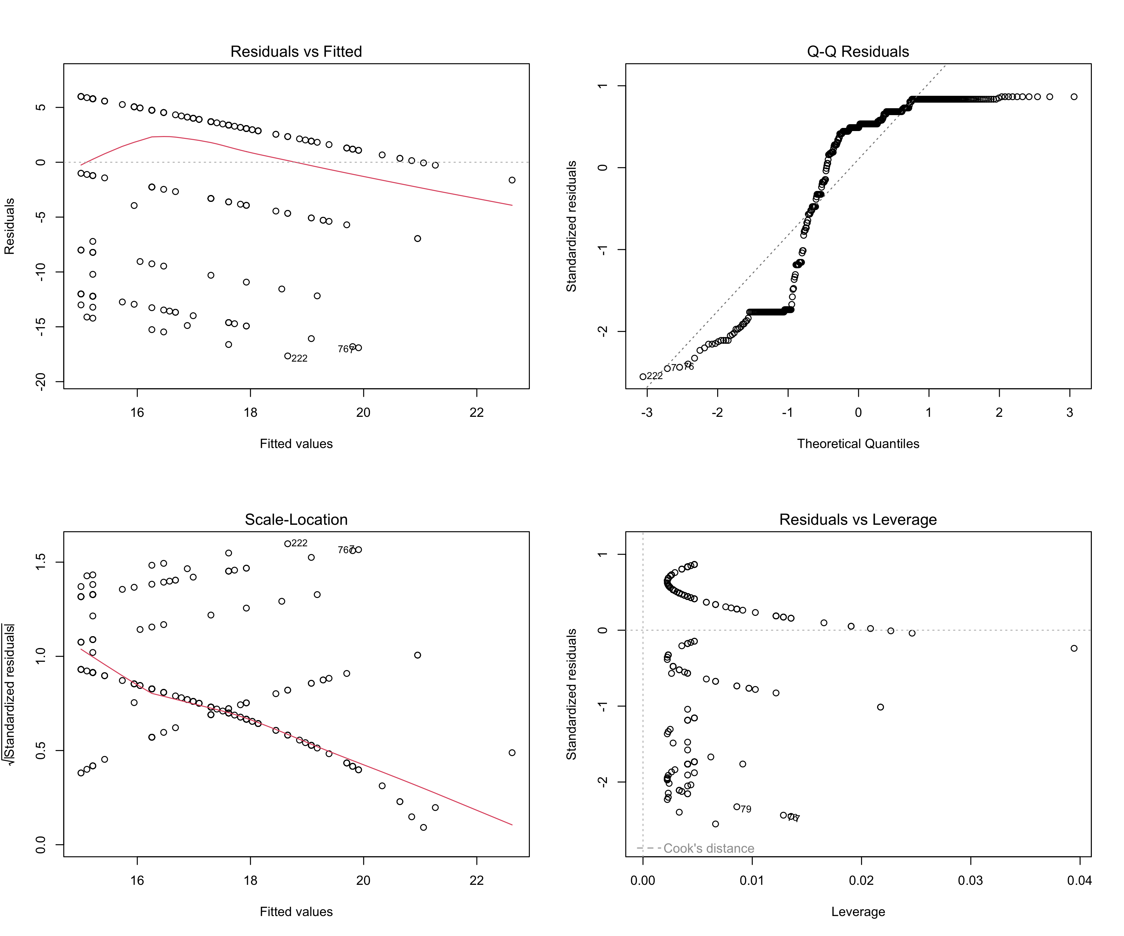

Fig 3.3. The figure above shows a diagnostic plots for the linear regression model Residuals vs. Fitted, Normal Q-Q, Scale-Location, and Residuals vs. Leverage.

6.Data Modeling:

6.1 Model 1: Simple Linear Regression

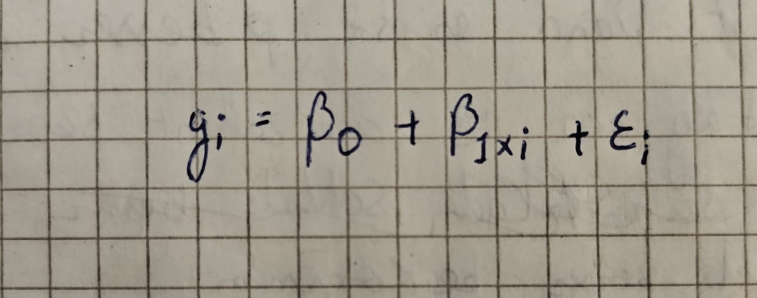
Fig 4.Shows the OSimple Linear Regression model equation where Yi stands for Remediation_Days, Xi stands for cvss_score, β0 stands for the intercept, β1 stands for the slope coefficient, and εi stands for the random error term.

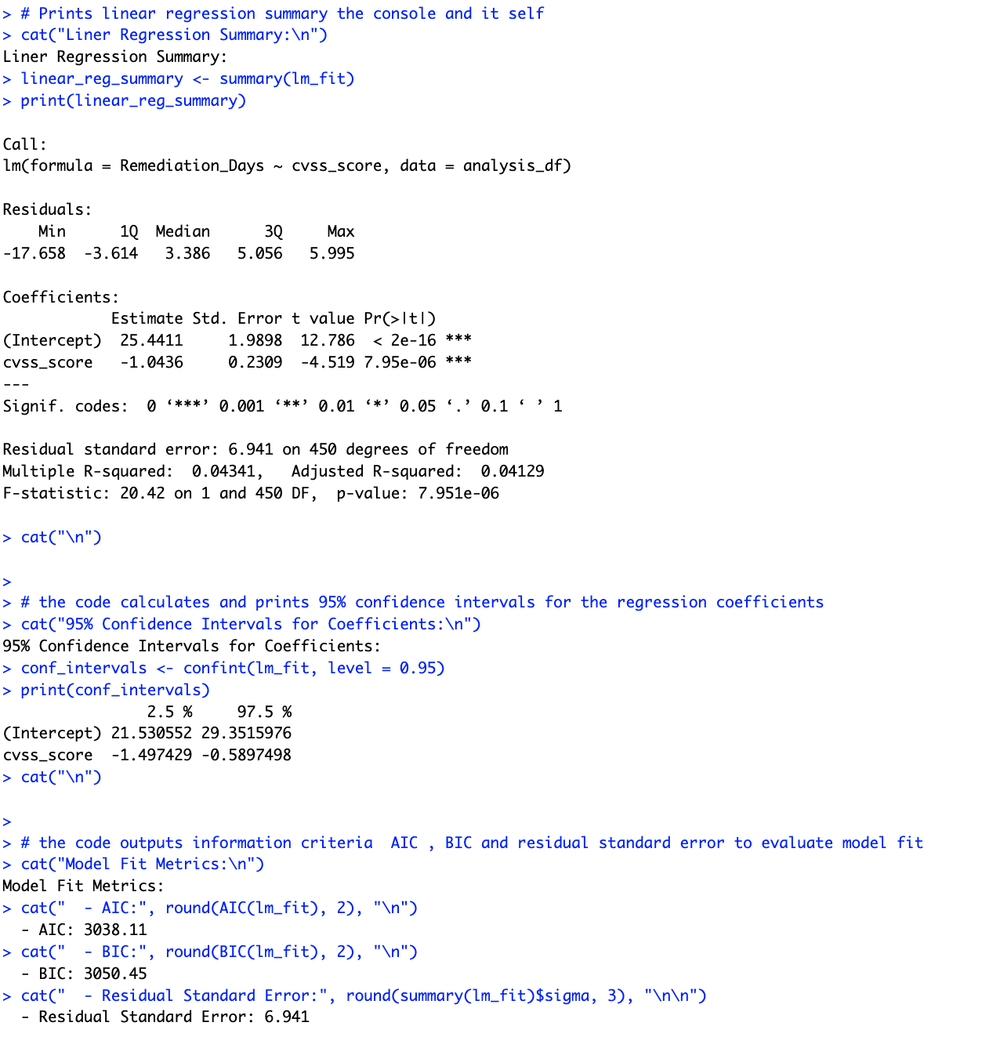
Fig 4.2. The snapshot fit the output of models fitted for regression, including: model coefficient (= 1.0436, p < 0.001), 95% confidence interval for the coefficient (R = 0.0434) and model fit statistics (AIC = 3038.11, BIC = 3050.45, residual SE = 6.941).

6.2 Model 2: One-Way ANOVA

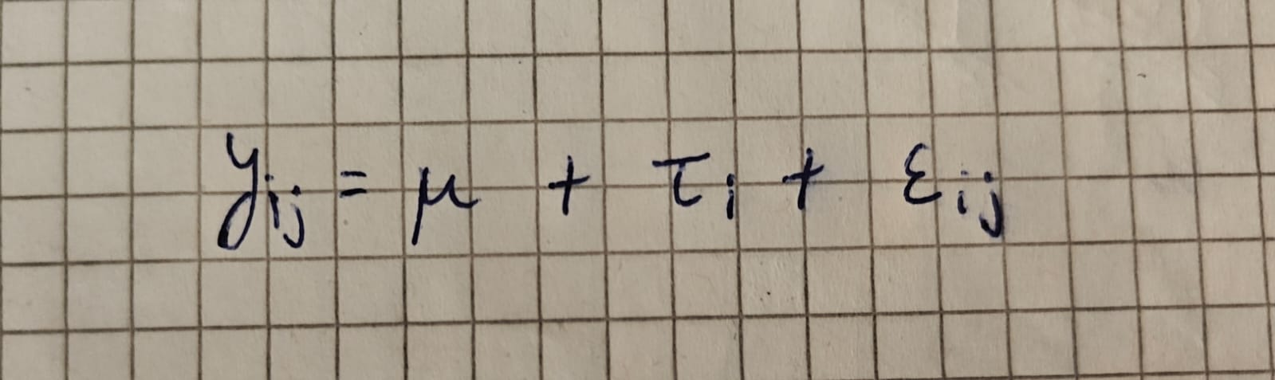
Fig 4.3: Shows the One-Way ANOVA modle equation Yij stands for the remediation window for the j-th vulnerability in the i-th severity tier, μ stands for the grand mean, τi stands for the tier's treatment effect, and εij stands for the random error.

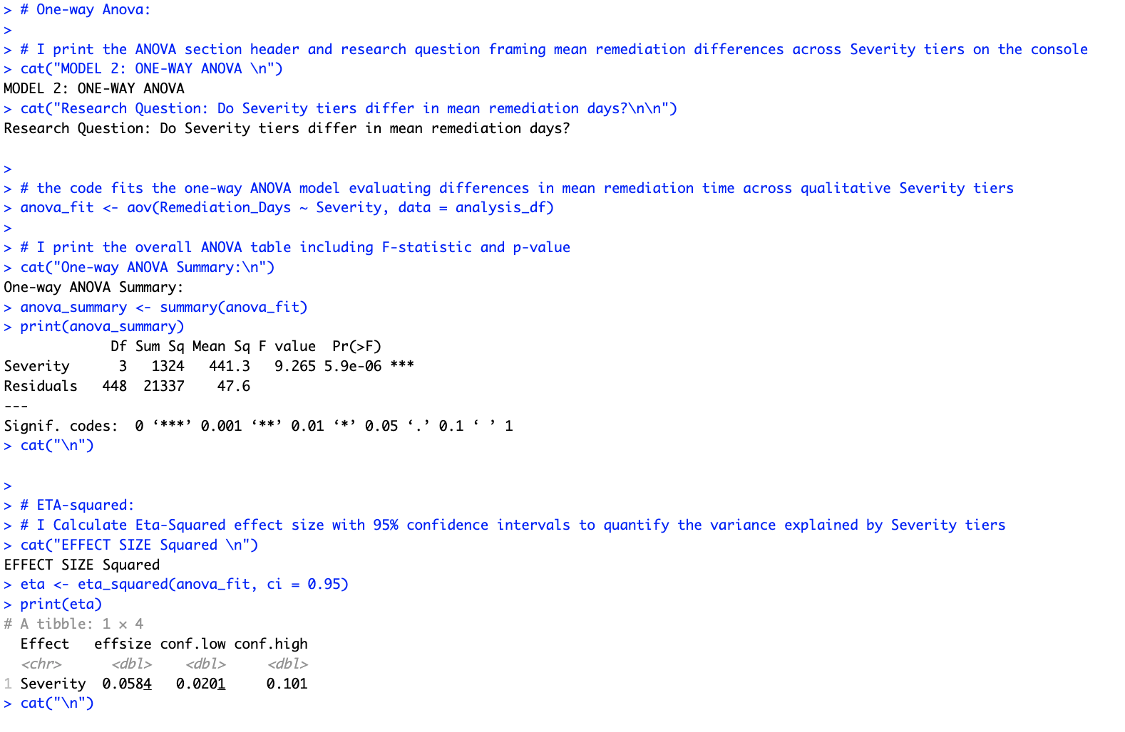

Fig 4.4. The picture above shows the console output of the one-way ANOVA which shows F(3, 448) = 9.265, p < 0.001, and the eta-squared effect size (η² = 0.0584, 95% CI [0.0201, 0.101]) quantifying the proportion of variance explained by severity tier.

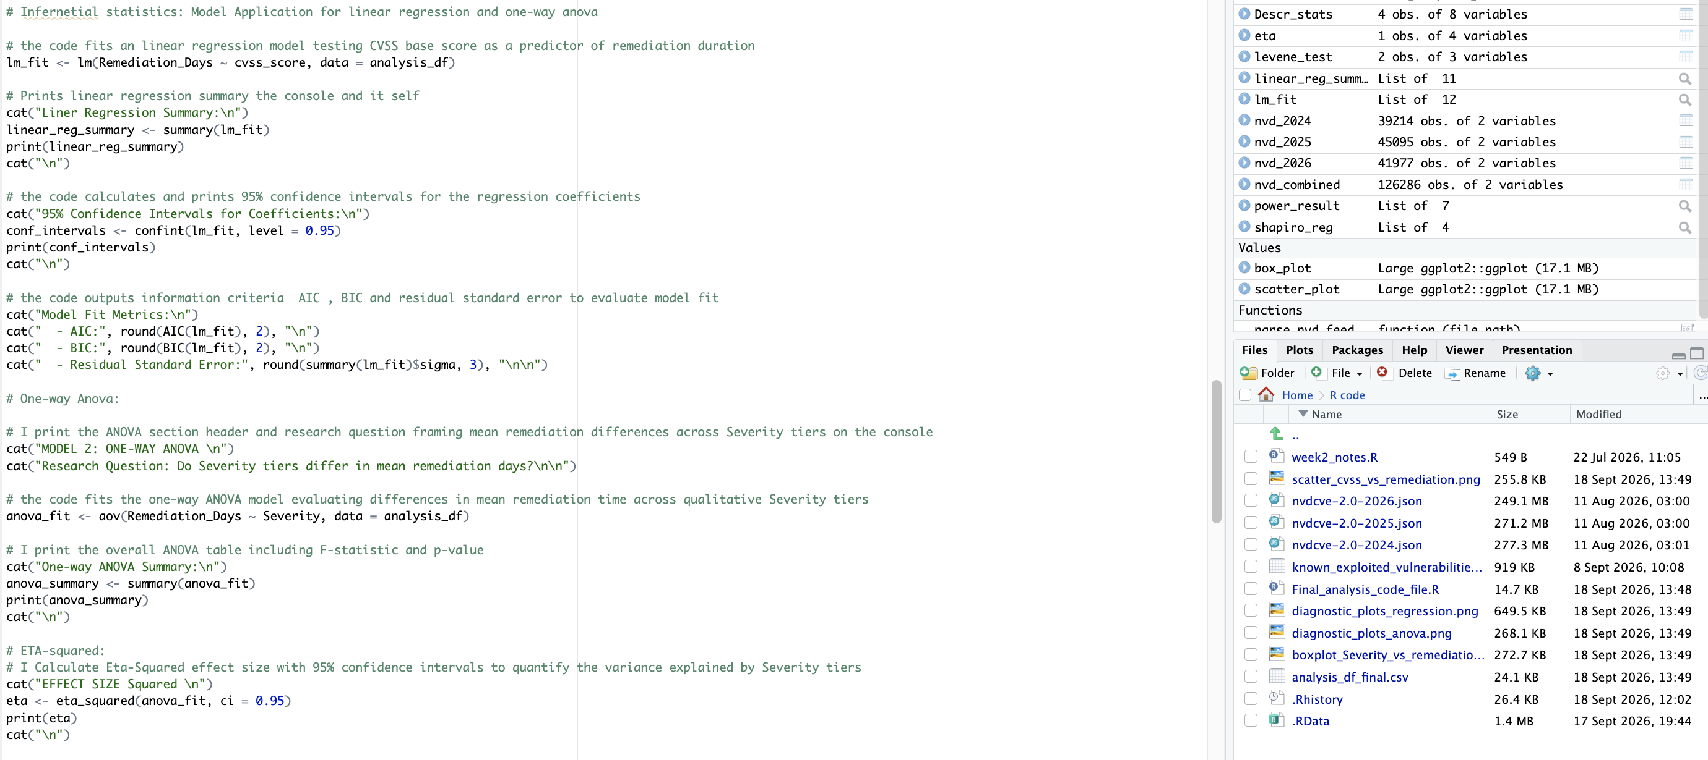

Fig 4.5. The R source code for fitted models linear model (lmfit) and the one-way ANOVA (anovafit) over all and per meta-models replicates, with the summary, confidence interval and effect-size analysis calls to produce the outputs in the picture above.

7.Model evaluation:

In conclusion for linear Regression analysis shows that there is a small but statistically detectable relationship. Which the coefficient of determination R^2 = 0.0434 and Adjusted R^2 = 0.0413 shows that CVSS score. Which explains roughly 4.3% of the variance in CISA remediation timelines. The omnibus F-test shows that F(1, 450) is 20.42 which is significant at p < 0.001 and the slope coefficient being β1 = −1.0436 of 95% CI [−1.4974, −0.5897] is significantly different from zero means we rejecting H0,1.

The ANOVA analysis shows the omnibus F-test displays F(3, 448) = 9.265, p < 0.001. Because p < 0.05, we reject H0,2 meaning that at least one severity tier's mean remediation window differs from the others. Which means the effect size (η² = 0.0584, 95% CI [0.0201, 0.101]) suggests severity-tier membership accounts for roughly 5.8% of the variance in remediation timelines a small to moderate effect by conventional benchmarks (Cohen), and consistent in magnitude with the regression R².

My personal interpretation point would be that with N = 452, even a small underlying effect reaches statistical significance he p-values here reflect that the relationship is real and unlikely to be due to chance, not that it is large. Both statistical significance and small effect size should be reported At the same time; reporting only the p-value would overstate CVSS's practical predictive power, and reporting only the small R²/η² without the significance test would understate that a real, non-zero relationship exists

7.1. Discussion & Data based Recommendations:

The statistical evaluation shows that CVSS severity does carry some predictive signal for CISA's federal patching mandates, but that signal is limited because it explains only a small share of why remediation deadlines vary. This nuances, rather than eliminates, the original concern: organizations cannot treat CVSS score as a strong proxy for regulatory urgency, but it is not entirely disconnected from it either.

- Treat KEV listing, not CVSS alone, as the primary SLA trigger: because CVSS explains only ~4–6% of the variance in mandated remediation windows, KEV listing status should remain the dominant signal for patch urgency, with CVSS used as a secondary input.

- Re-purpose CVSS metrics for technical triage: use CVSS to gauge potential technical impact (e.g., loss of confidentiality or system authority) and to prioritize compensating controls, rather than as the sole timer for patch SLAs.

- Automate KEV ingestion: Embed CISA KEV feed into ticketing tools (Jira, Service Now), enabling weaponization score (rather than just base score) to update score priority.

- Explore the minor yet statistically significant severity effect: As severity tier can explain a small share of variance in a remediation window, it might be interesting to see which sub-factors (e.g., attack vector, vendor, product category) contribute to that residual.

7.2.Limitations:
The dependent variable is plagued by policy deadline clustering, as CISA tends to assign a batch of 14- and 21- day deadline deadlines every few days. This categorization prevents any real changeability of the dependent variable for all CISA KEV entries, and is likely the reason for the Shapiro-Wilk normality violation. A snapshot of the NVD and KEV datasets as of August 2026 is used in this study.
As with any live database, any vulnerabilities that were added to the database after this date were not incorporated, and results may change.The dataset suffers from survivorship bias, as it only includes vulnerabilities that were both weaponized (KEV) and had a published v3.1 CVSS score. Some NVD entries do not even have a v3.1 score, and will not be included. And, finally, there was only one Low-severity entry in the dataset, so any comparison to other tiers is likely not statistically valid, regardless of what the omnibus ANOVA shows.
Future Work:
Subsequent analytical work should evaluate the Exploit Prediction Scoring System (EPSS) as a continuous covariate within an ANCOVA framework, to test whether probabilistic exploit-likelihood estimates explain more of the variance in regulatory remediation windows than CVSS base score alone.

8.Reference and Github link:
Github Link:
https://github.com/Kj07king/Statistical-Analysis-Report-

Cisa kev:
Cybersecurity and Infrastructure Security Agency (2026). Known Exploited Vulnerabilities Catalog. [Dataset]. U.S. Department of Homeland Security. Available at: https://www.cisa.gov/known-exploited-vulnerabilities-catalog [Downloaded 7 August 2026].

Nvd json:
National Institute of Standards and Technology (2026). National Vulnerability Database (NVD) JSON Feeds. [Dataset]. U.S. Department of Commerce. Available at: https://nvd.nist.gov/vuln/data-feeds [Downloaded 7 August 2026].

