Aufgabe 1.1
- Hive Verzeichnis zu finden : usr/lib/hive
- Hive einrichten :
Zuerste brauchen wir die Umgebungsvariablen zu setzen. Bearbeiten die ~/.bash_profile und editieren die Dokument :
HIVE_HOME=/usr/lib/hive
PATH=$PATH:/usr/local/hadoop/bin
PATH=$PATH:$HIVE_HOME/bin
- Bearbeiten die Konfiguration-Dokument
Wir brauchen hive-site.xml zu editieren.
- Hive benutzen
Hive Shell “beeline ” verbinden:beeline -u jdbc:hive2://

- Daten importieren
Unterschieden wird prinzipiell zwischen managed und external tables. Bei managed Tables wird der Datenbestand von Hive selbst im Warehouse verwaltet (undDROP TABLE foo; loescht die Daten). Bei external Tables koennen bereits existierende Dateien als Tabelle eingebunden werden. Die Daten bleiben erhalten auch wenn die Tabelle geloescht wird.

Ein word2vec-Datenbestand (Textdatei) als External Table einbinden
Falls noch nicht existent Ordner fuer Datenbestand anlegen und Daten kopieren:
hdfs dfs -mkdir /usr/local/hadoop/dbprak/group3/words`
hdfs dfs -cp /usr/local/hadoop/dbprak/public/example.txt /usr/local/hadoop/dbprak/group3/`
External Tabelle "words" anlegen, dabei wird das Format der Textdatei festgelegt:
DROP TABLE IF EXISTS words;
CREATE EXTERNAL TABLE words(word STRING, vector ARRAY<float>) ROW FORMAT DELIMITED
FIELDS TERMINATED BY ':'
COLLECTION ITEMS TERMINATED BY ','STORED AS TEXTFILELOCATION '/usr/local/hadoop/dbprak/group3/words';
Ab jetzt sind Queries auf die Tabelle moeglich. Eine typische Query um Aehnliche Woerter zu finden koennte so aussehen:
SELECT words.word, similarity(words.vector, words2.vector) as dist FROM words CROSS JOIN (SELECT * FROM words WHERE word='france') ORDER BY dist LIMIT 50;
Dazu muss aber zunaechst eine UDF similarity(array<FLOAT>, array<FLOAT>) implementiert werden.
Die Schluessel fuer die Table :word
Die Datentypen sind:
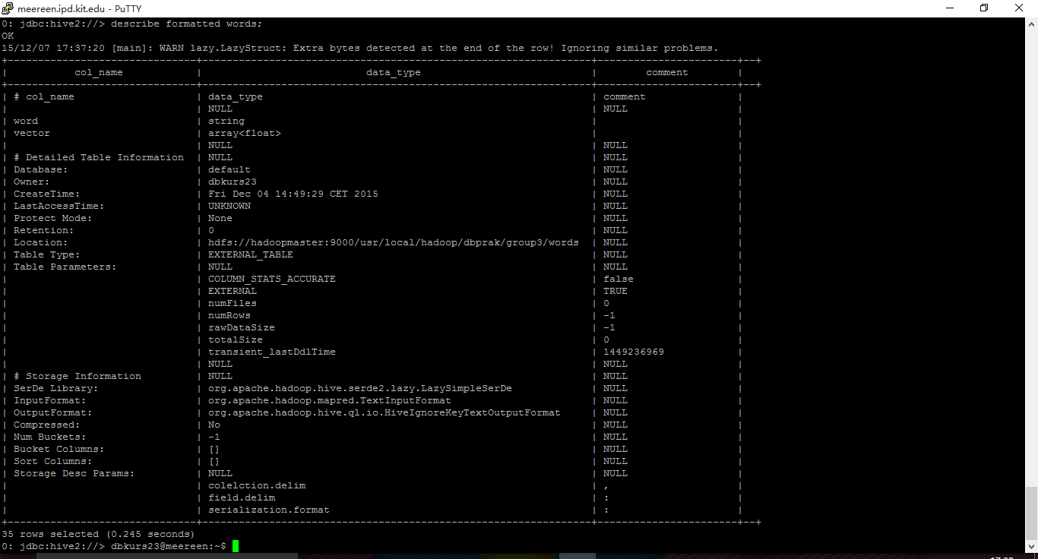
Aufgabe 1.2
Map-Funktion
//Mapper class
Mapper<LongWritable ,/*Input key Type */
Text, /*Input value Type*/
Text, /*Output key Type*/
IntWritable> /*Output value Type*/
//Map function
private final static IntWritable one = new IntWritable(1);
private Text word = new Text();
public void map(LongWritable key,Text value,Context context) throws IOException, InterruptedException {
word.set(value.toString());
context.write(word, one);

Aufgabe 1.2.1
Algorithm 1. map (key, value)
Input: Global variable centers, the offset key, the sample value
Output: <key’, value’> pair, where the key’ is the index of the closest center point and value’ is a string comprise of sample information
- Construct the sample instance from value;
- minDis = Double.MAX VALUE;
- index = -1;
- For i=0 to centers.length do dis= ComputeDist(instance, centers[i]); If dis < minDis { minDis = dis; index = i; }
- End For
- Take index as key’;
- Construct value’ as a string comprise of the values of different dimensions;
- output < key , value > pair;
- End;
Algorithm 2. combine (key, V )
**Input:** key is the index of the cluster, V is the list of the samples assigned to the same cluster **Output:** < key , value > pair, where the key’ is the index of the cluster, value’ is a string comprised of sum of the samples in the same cluster and the sample number
- Initialize one array to record the sum of value of each dimensions of the samples contained in the same cluster, i.e. the samples in the list V ;
- Initialize a counter num as 0 to record the sum of sample number in the same cluster;
- while(V.hasNext()){ Construct the sample instance from V.next(); Add the values of different dimensions of instance to the array num++;
- }
- Take key as key’;
- Construct value’ as a string comprised of the sum values of different dimensions and num;
- output < key , value > pair;
- End
Algorithm 3. reduce (key, V )
**Input: **key is the index of the cluster, V is the list of the partial sums from different host **Output:** < key , value > pair, where the key’ is the index of the cluster, value’ is a string repre- senting the new center
- Initialize one array record the sum of value of each dimensions of the samples contained in the same cluster, e.g. the samples in the list V ;
- Initialize a counter NUM as 0 to record the sum of sample number in the same cluster;
- while(V.hasNext()){ Construct the sample instance from V.next(); Add the values of different dimensions of instance to the array NUM += num;
- }
- Divide the entries of the array by NUM to get the new center’s coordinates; //
- Take key as key’;
- Construct value’ as a string comprise of the center ’s coordinates;
- output < key , value > pair;
- End
Aufgabe 1.2.2
Zufaellig
Aufgabe 1.2.3

