**ECONM0009**

**Summative Coursework**

**Student number: 2516562**

**Table of Content**

1. Introduction 3

2. Literature Review 4

3. Data 5

3.1 Data Description 5

3.2 Time series analysis 5

3.3 Unit root test 8

4. Methodology 9

4.1 Vector Autoregressive Model (VAR) 9

4.2 Impulse Response Function (IRF) 9

4.3 Generalized Autoregressive Conditional Heteroscedasticity (GARCH） 10

4.4 Vector Error Correction Model（VECM） 10

5. Results 11

5.1 Granger Causality Test Results 11

5.2 VAR model results 11

5.3 Impulse Response Function Results 12

5.4 GARCH Model Result 14

5.5 VECM Model Results 16

6. Conclusion 19

Reference 20

Appendix 21

1. Introduction

As one of the global financial centers, monetary system and stock market of Hong Kong have important impact on the global economy. The stability of the HKD/USD exchange rate can affect the confidence of the Hong Kong financial market directly, and as one of the most important stock indexes in Asia, the performance of Hang Seng Index (HSI) is related to the HKD/USD exchange rate. In addition, as an important indicator of global capital flows, the US Treasury Bill (T-bill) rate can also affect HSI through the capital flows and interest rate parity mechanism.

The purpose of this work is to investigate the impact of HKD/USD exchange rate on HSI, and it introduces US 3-month treasury bill rate to help analyzing dynamic relationship between them. For the context of increasing global economic uncertainty, understanding these relationships can help to better cope with market volatility and formulate effective economic policies.

1. Literature Review

Bahmani-Oskooee et al. (2018) proposed to use "flow-oriented model" and "stock-oriented model" to analyze the relationship between exchange rate and stock index, and pointed out that the fluctuation of exchange rate will affect the import and export cost of enterprises, and then affect the stock price [1]. Suriani et al. (2015) also mentioned the performance of the stock market will affect the exchange rate through capital flow [2]. This is closely related to the relationship between the HKD/USD exchange rate and the HSI analyzed in this report.

By studying the dynamic relationship between exchange rates and stock prices in G7 countries, Yuan et al. (2020) emphasized the impact of external shocks on market volatility [3], which related to the impact of trade frictions and the epidemic on market volatility mentioned in the report. In addition, the nonlinear ARDL model and Granger causality test mentioned in the document have similar analytical logic to the VAR, IRF and VECM models used in this report.

Nusair and Olson (2022) mentioned that exchange rate movements may affect the stock market through wealth effect and expectation effect [4], Kamal (2018) pointed that interest rates are negatively related to stock market returns, with high interest rates reducing stock values while low rates drive stock prices higher [5]. They echo the analysis in the report that US T-bill rate affects HKD/USD exchange rate and HSI through capital flow and interest rate parity mechanism.

The literature above can support the analytical framework presented in this report on the dynamic relationship between HKD/USD exchange rate, HSI and US T-bill rate.

1. Data

## 3.1 Data Description

The data sources used in the report are as follows:

Hang Seng Index (HSI): Taken from daily close prices of HSI.CSV from January 2010 to December 2020 which named "YFK" in this report.

HKD/USD exchange rate: Taken from ER_HongKongDollar_per_USDollar.csv daily close price for the same period.

U.S. 3-month treasury bill rate: Taken from US_3monthTBill.csv daily close prices for the same period.

After cleaning and merging the data, final sample contained 2,611 valid observations. The descriptive statistics of the data are shown in Table1:

|  |  |  |  |  |  |
| --- | --- | --- | --- | --- | --- |
| Variable | Obs | Mean | Std.dev. | Min | Max |
| YFK (HSI Close) | 2,611 | 23895.89 | 3117.577 | 16250.27 | 33154.12 |
| exchange_rate | 2,611 | 7.777608 | 0.0323056 | 7.7494 | 7.8512 |
| tbill_rate | 2,611 | 0.5331678 | 0.7564622 | -0.105 | 2.408 |

Table 1 Descriptive Statistics of HSI, Exchange Rate, and US Treasury Bill Rate

## 3.2 Time series analysis

The HSI time series in Figure 1 shows significant volatility between 2010 and 2020 with an overall upward trend, but experienced two sharp declines in 2015-2016 and 2018-2019, which may have been affected by the slowdown of the Chinese economy and the trade frictions between China and the US respectively [6]. The COVID-19 pandemic in 2020 further exacerbated the volatility of the HSI [7].

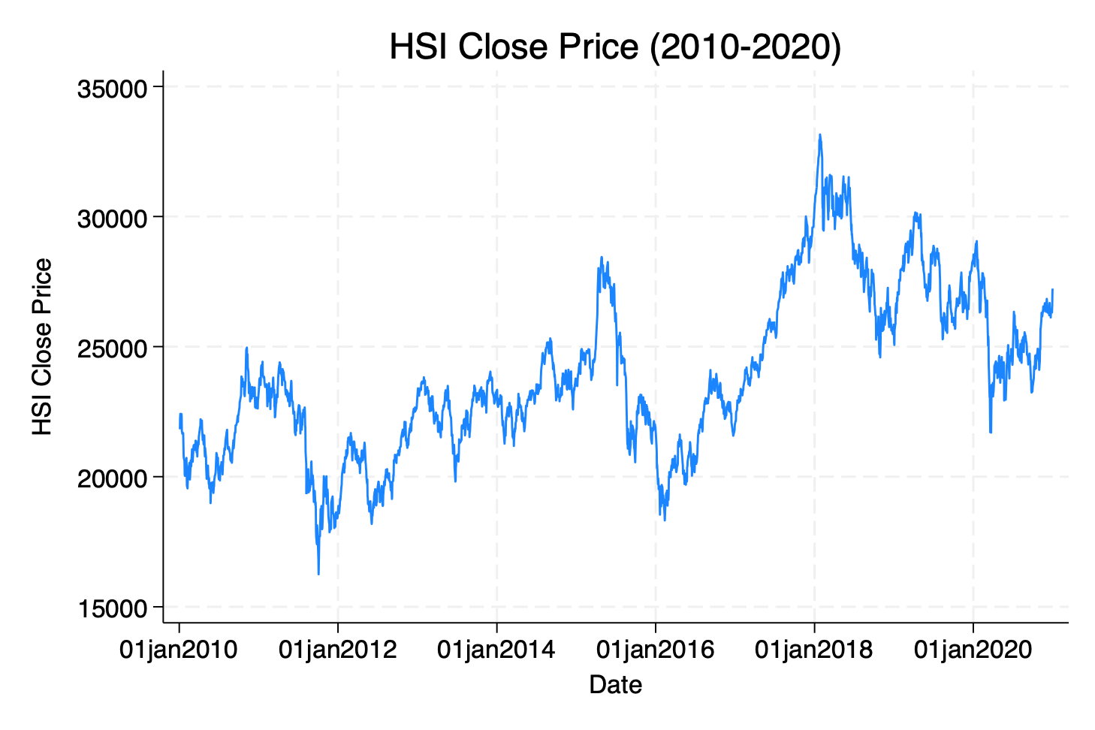

Figure 1 HSI Close Price Time Series (2010-2020)

HKD/USD exchange rate remained relatively stable during this period with a small range of fluctuations (7.75 to 7.85), but approached the upper limit of 7.85 in 2015-2016 and 2018-2019, reflecting capital outflow pressure.

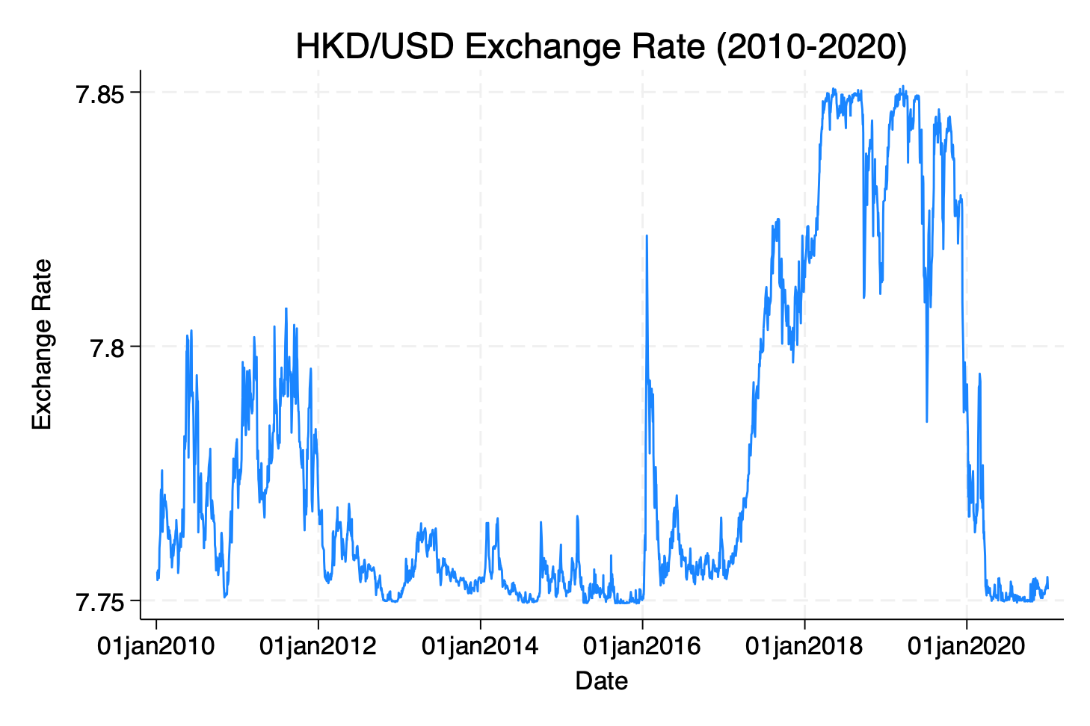

Figure 2 HKD/USD Exchange Rate Time Series (2010-2020)

The 3-month T-Bill Rate has trended down overall, from about 0.5% in 2010 to close to 0% in 2020, with a particularly sharp decline in 2019-2020.

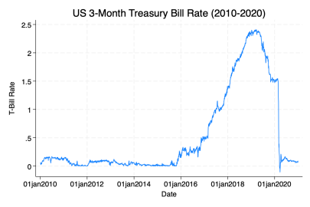

Figure 3 US 3-Month Treasury Bill Rate Time Series (2010-2020)

As can be roughly seen from the time series charts above, the stability of HKD/USD exchange rate provides confidence support for the HSI, especially in periods of high capital outflow pressure (such as 2018-19). Fluctuations in the HKD/USD exchange rate may also affect the performance of the HSI through capital flows. A fall in US T-bill rates (2019-20) may lead to flows into Hong Kong stocks, supporting the HSI performance (2015-2016), but a rise may trigger capital outflows and pressure the HSI [8].

.

## 3.3 Unit root test

Table 2 shows the unit root test results of HSI, HKD exchange rate and US 3-month T-bill rate and their stationarity conclusions.

|  |  |  |  |  |  |
| --- | --- | --- | --- | --- | --- |
| Variable | ADF Statistic | 1% Critical Value | 5% Critical Value | p-value | Conclusion |
| YFK(Level) | -2.302 | -3.430 | -2.860 | 0.1713 | Non-stationary |
| YFK(First difference) | -10.961 | -3.430 | -2.860 | 0.0000 | Stationary |
| exchange_rate(Level) | -2.624 | -3.430 | -2.860 | 0.0880 | Non-stationary |
| exchange_rate(First Difference) | -8.065 | -3.430 | -2.860 | 0.0000 | Stationary |
| tbill_rate(Level) | -4.921 | -3.430 | -2.860 | 0.0000 | Stationary |

Table 2 Descriptive Statistics of HSI, Exchange Rate, and US Treasury Bill Rate

The data show that the original series of HSI and HKD/USD exchange rates have a trend, but the first difference series is stationary, their daily changes are stationary and suitable for time series analysis. The original series of the US T-bill rate is stationary, its changes are mainly affected by short-term factors.

1. Methodology

## 4.1 Vector Autoregressive Model (VAR)

VAR model is a multivariate time series model, which is suitable for analyzing the dynamic interactions among multiple variables. In contrast to univariate models, VAR models are able to capture the interdependence among the variables without pre-assuming the direction of causality. The formula is as follows:

$$Y_{t​}=A_{1}​Y_{t-1}​+A_{2​}Y_{t-2}​+⋯+A_{p​}Y_{t-p​}+ϵ_{t​}$$

The VAR model in this report is used to analyze the dynamic relationship between HSI, HKD/USD exchange rate and US three-month T-bill rate. First, the unit root test is applied to the original data, and if the series is not stationary, the first difference processing is applied to make them become stationary series. Then we construct a VAR model with three variables, and select lags of order 1 to 2 (Lags (1/2)). The causal relationship between the variables was also analyzed by Granger causality test.

## 4.2 Impulse Response Function (IRF)

IRF is an important extension of VAR models to analyze the dynamic responses of other variables when one variable is hit by an external shock. This method is able to visually show the short-term dynamic relationship between variables and help understand the transmission mechanism of external shocks to the system.

This report uses the IRF to analyze the shock response of HKD exchange rate and US Treasury interest rate to HSI. The dynamic response of the HSI is observed by simulating a one-unit positive shock to the HKD exchange rate and the US Treasury interest rate. The results of IRF can intuitively understand the short-term impact of external shocks on HSI and provide an important reference for policy making and investment decisions.

## 4.3 Generalized Autoregressive Conditional Heteroscedasticity (GARCH）

GARCH models are used to analyze the volatility of time series and are particularly suitable for financial data, as financial markets usually exhibit volatility clustering effects. The formula is as follows:

$$σ_{t_{​}}^{2}=a_{0}+a_{1}ϵ_{t-1}^{2}+…+a_{p}ϵ_{t-p}^{2}$$

To analyze the volatility characteristics of the HSI, the report uses the GARCH model. First, process the original series of the HSI in first difference to make it a stationary series. Then estimate GARCH (1,1) model, which include the ARCH term of order 1 and the GARCH term of order 1, and generate the conditional variance plot.

## 4.4 Vector Error Correction Model（VECM）

The VECM is an extension of the VAR model and is specifically used to analyze the long-run equilibrium relationship between non-stationary variables. Unlike VAR models, VECM introduces an error correction term, which is able to capture both the short-run dynamic relationship and the long-run equilibrium relationship between variables. The formula is as follows:

$$ΔY_{t​}=ΠY_{t-1}​+Γ_{1}​ΔY_{t-1}+⋯+Γ_{p-1}​ΔY_{t-\left(p-1\right)}​+ϵ_{t}​$$

This report uses the VECM model to analyze the long-term equilibrium relationship between the HKD/USD exchange rate, HSI and US T-bill rate. Based on unit root test and difference processing, the co-integration relationship between variables was determined by Johansen co-integration test, and second-order lag (2) was selected to estimate the VECM model. In order to provide a complete data basis, interpolation, forward and backward filling are combined to deal with missing values.

1. Results

## 5.1 Granger Causality Test Results

Granger causality test results in Table 3 shows that exchange rate significantly affects HSI, and not vice versa; The HSI has a significant impact on the interest rate of government bonds, and not vice versa (p<0.05).

|  |  |  |  |
| --- | --- | --- | --- |
| Null Hypothesis | Chi2 Statistic | | p-value |
| Exchange Rate does not Granger-cause HSI | | 15.294 | 0.000 |
| T-Bill Rate does not Granger-cause HSI | | 0.443 | 0.801 |
| HSI does not Granger-cause Exchange Rate | | 1.180 | 0.554 |
| HSI does not Granger-cause T-Bill Rate | | 7.739 | 0.021 |

Table 3 Granger Causality Test Results

## 5.2 VAR model results

The results of the VAR model in Table 4 shows that the HKD/USD exchange rate has significant autocorrelation and reversal effect in the short term. L1 has a positive impact on the current exchange rate (0.1555, p=0.000), while L2 has a negative impact (−0.1530, p=0.000). The one-period-lagged HSI has a negative impact on the HKD/USD exchange rate (-1.29e-06, p=0.000), reflecting the effect of capital flow. The lagged HKD/USD exchange rate significantly affects the US T-bill interest rate (0.4139, p=0.042), indicating that there is a lagged effect of capital flow on the interest rate market.

|  |  |  |  |  |  |
| --- | --- | --- | --- | --- | --- |
| Equation | Variable | Coefficient | Std. Err. | z-value | p-value |
| D_exchange_rate | L1.exchange_rate | 0.1555 | 0.0369 | 4.21 | 0.000 |
| L2.exchange_rate | -0.1530 | 0.0366 | -4.18 | 0.000 |
| L1.YFK | -1.29e-06 | 3.47e-07 | -3.71 | 0.000 |
| D_YFK | L1.exchange_rate | -3623.615 | 3705.697 | -0.98 | 0.328 |
| L2.exchange_rate | 1613.280 | |  |  | | --- | --- | | 3676.688 |  | | 0.44 | 0.661 |
| D_tbill_rate | L1.exchange_rate | -0.3732 | 0.2053 | -1.82 | 0.069 |
| L2.exchange_rate | 0.4139 | 0.2037 | 2.03 | 0.042 |

Table 4 VAR Model Results

## 5.3 Impulse Response Function Results

As shown in the Figure 4, a positive shock to the HKD/USD exchange rate suppresses the HSI in the short term, which may be due to lower capital inflows or higher outflows. In the long run, the impact of HKD/USD exchange rate stability on HSI is weakened, indicating that the market reaction to exchange rate fluctuations is mainly short-term effect.

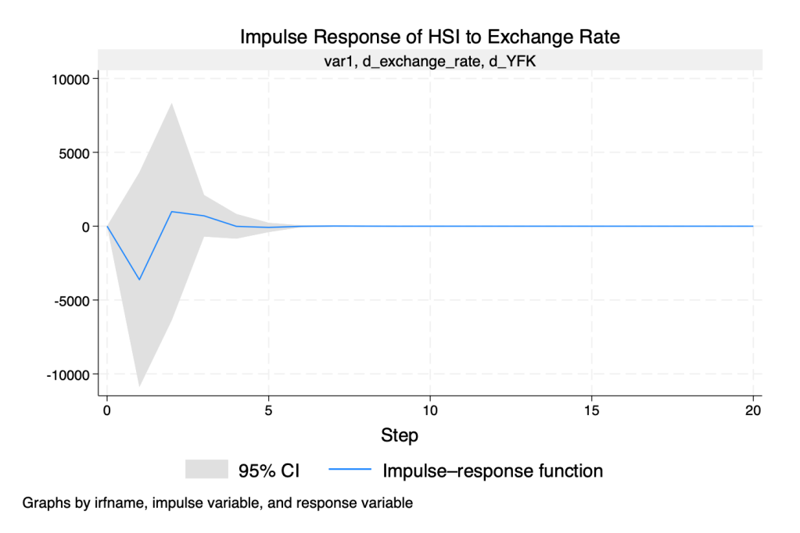

Figure 4 Impulse Response of HSI to Exchange Rate

As shown in Figure 5, the positive impact of the HSI on the HKD/USD exchange rate is weak and insignificant, and the impulse response function fluctuates within the 95% confidence interval, indicating that the HKD/USD exchange rate is not mainly affected by the stock market performance.

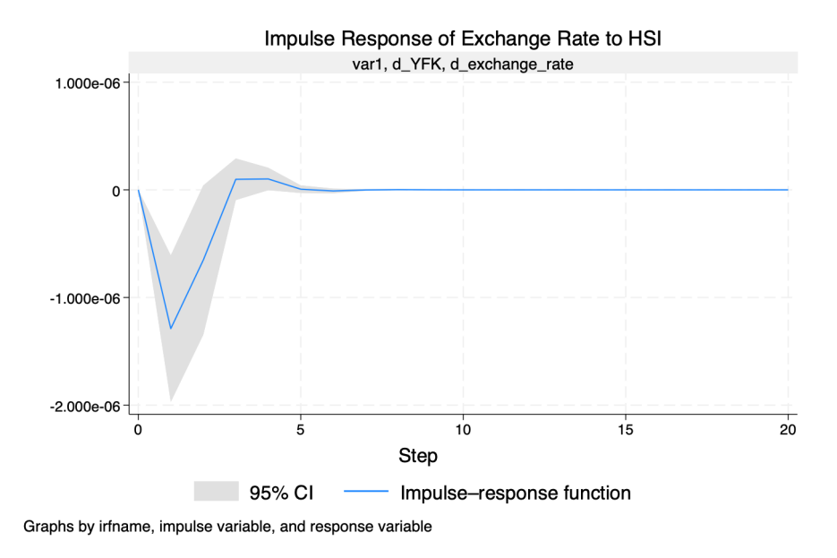

Figure 5 Impulse Response of Exchange Rate to HIS

As Figure 6 below, a positive shock to the US 3-monthT-bill rate has a short-term negative impact on the HSI, which is most significant in the first five periods and then weakens. Indicating that money may flow to the United States, the market responds quickly to interest rate changes.

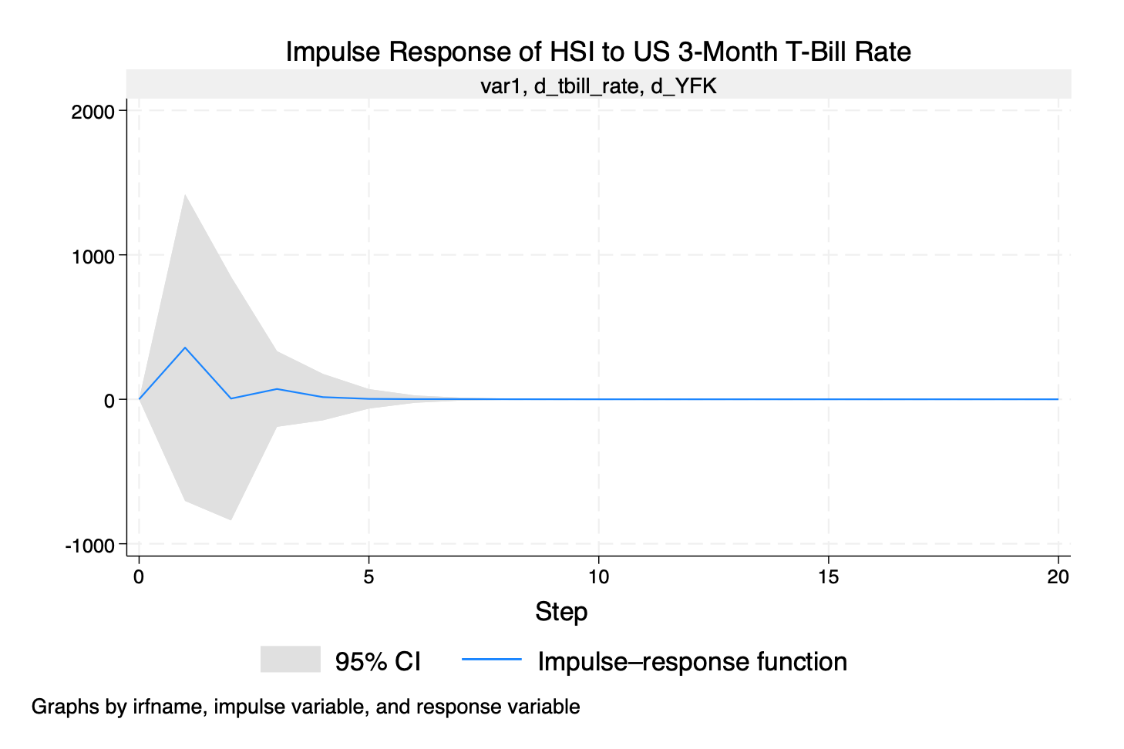

Figure 6 Impulse Response of HSI to US 3-Month Treasury Bill Rate

## 5.4 GARCH Model Result

From Table 5-7, the volatility of HSI is the most persistent, GARCH(L1) 1.5490 (p=0.000), indicating that the impact accumulates for a long time and the risk is large; The fluctuation of exchange rate is the most affected by short-term shocks, ARCH(L1) 0.8162 (p=0.000), but GARCH(L1) 0.4401, which means that the fluctuation decays quickly and the market is stable. US T-bill rate volatility is moderate, ARCH(L1) 0.5082, GARCH(L1) 0.5175, indicating moderate persistence but overall stability.

|  |  |  |  |  |
| --- | --- | --- | --- | --- |
| d_YFK | Coefficient | Std. Err. | z-value | p-value |
| ARCH(L1) | 0.0610 | 0.0196 | 3.11 | 0.002 |
| GARCH(L1) | 1.5490 | 0.3359 | 4.61 | 0.000 |
| Constant | -41633.63 | 21975.31 | -1.89 | 0.058 |

Table 5 GARCH Model Results for HSI

|  |  |  |  |  |
| --- | --- | --- | --- | --- |
| d_exchange_rate | Coefficient | Std. Err. | z-value | p-value |
| ARCH(L1) | 0.8162 | 0.0299 | 27.30 | 0.000 |
| GARCH(L1) | 0.4401 | 0.3359 | 22.81 | 0.000 |
| Constant | 2.10e-07 | 9.74e-8 | 2.15 | 0.031 |

Table 6 GARCH Model Results for Exchange Rate

|  |  |  |  |  |
| --- | --- | --- | --- | --- |
| d_tbill_rate | Coefficient | Std. Err. | z-value | p-value |
| ARCH(L1) | 0.5082 | 0.0160 | 31.74 | 0.000 |
| GARCH(L1) | 0.5175 | 0.1840 | 28.13 | 0.000 |
| Constant | -0.0000187 | 3.77e-06 | -4.97 | 0.000 |

Table 7 GARCH Model Results for US 3-Month Treasury Bill Rate

Through Figure 7, the GARCH model shows that the conditional variance of the HSI fluctuates significantly, especially in 2015-2016, 2018-2019 and 2020, showing an obvious clustering effect. External shocks can have persistent effects, and high volatility reflects increased market uncertainty and reduced investor risk appetite.

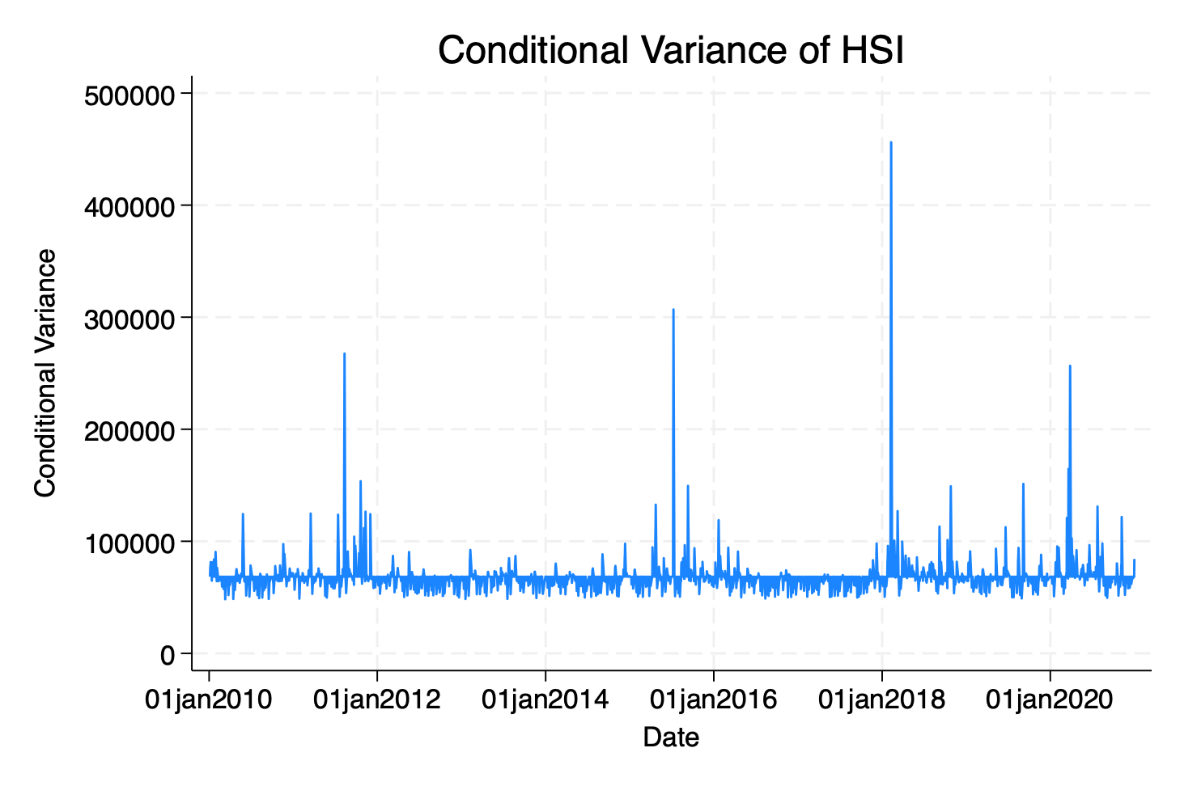

Figure 7 Conditional Variance of HSI

Figures 8 and Figure 9 show that the conditional variance of the HKD/USD exchange rate and the US 3-month T-bill rate are lower during off-peak periods, indicating market stability; In case of severe fluctuations, it is necessary to strengthen risk management and deal with potential risks.

|  |  |
| --- | --- |
| Figure Conditional Variance of HKD/USD Exchange Rate | Figure Conditional Variance of T-Bill Rate |

## 5.5 VECM Model Results

1) Johansen Cointegration Test results

Table 8 shows that when rank=1, the Trace statistic is less than the critical value, indicating that there is a cointegration relationship and long-run equilibrium between the exchange_rate and YFK. However, there is no cointegration relationship and long-run equilibrium between YFK and tbill_rate.

|  |  |  |  |  |
| --- | --- | --- | --- | --- |
| Variable Pair | Max Rank | Trace Statistic | Critical Value (5%) | Selected Cointegration Rank |
| exchange_rate & YFK | 1 | 2.6557 | 3.76 | 1 |
| YFK & tbill_rate | 0 | 9.3327 | 15.41 | 0 |

Table 8 Johansen Cointegration Test results

2) VECM estimation results

The coefficient of the error correction term _ce1 on D_exchange_rate is − 0.00404 (significant), indicating that the exchange rate will gradually adjust back to the long-run equilibrium in the short term. The coefficient of the error correction term _ce1 on D_YFK is 234.85 (significant), indicating that YFK is also affected by the cointegration relationship, and the regression speed is fast.

|  |  |  |  |  |  |
| --- | --- | --- | --- | --- | --- |
| Dependent Variable | Error Correction Term (_ce1) | Coefficient | Std. Err. | p-value | Short-run Dynamics |
| D_exchange_rate | L1. _ce1 | -0.00404 | 0.00108 | 0.000 | Significant |
| D_YFK | L1. _ce1 | 234.852 | 112.854 | 0.037 | Significant |

Table 9 VECM Results: Exchange Rate and HIS

Through Table 11, the error correction term _ce1 is significant on D_YFK (P=0.006), so YFK may adjust back to the long-run equilibrium, but adjustment speed is slow. The error correction term _ce1 is not significant in D_tbill_rate (P=0.329), indicating that the T-bill rate will not be affected by the long-run equilibrium relationship in the short run.

|  |  |  |  |  |  |
| --- | --- | --- | --- | --- | --- |
| Dependent Variable | Error Correction Term (_ce1) | Coefficient | Std. Err. | p-value | Short-run Dynamics |
| D_YFK | L1. _ce1 | -0.00396 | 0.00146 | 0.006 | Significant |
| D_tbill_rate | L1. _ce1 | 9.64e-08 | 9.86e-08 | 0.329 | Not Significant |

Table 10 VECM Results: HSI and US 3-Month Treasury Bill Rate

Table 11 shows the estimation results of VECM, there is a long-term equilibrium relationship between HKD/USD exchange rate and HSI (l.e1 coefficient -0.00404, p<0.01), and the short-term autocorrelation of HKD/USD exchange rate is significant (one-period lag coefficient 0.170, p<0.01). HSI has a negative impact on HKD/USD exchange rate (one-period lagged coefficient -8.59e-07, p<0.01).

|  |  |  |
| --- | --- | --- |
|  | (1) | (2) |
| VARIABLES | D_exchange_rate | D_YFK |
|  |  |  |
| L._ce1 | -0.00404*** | 234.9** |
|  | (0.00108) | (112.9) |
| LD.exchange_rate | 0.170*** | -1,614 |
|  | (0.0157) | (1,633) |
| LD.YFK | -8.59e-07*** | 0.0917*** |
|  | (1.53e-07) | (0.0159) |
| Constant | 1.95e-05 | 6.43e-09 |
|  | (3.02e-05) | (3.152) |
|  |  |  |
| Observations | 4,013 | 4,013 |

Table 11 Estimation results of VECM

Standard errors in parentheses

*** p<0.01, ** p<0.05, * p<0.1

The VECM model in Figure 10 shows that the cointegrating residuals of the HSI and the US 3-month T-bill rate fluctuate greatly, indicating that their long-run equilibrium relationship is weak and that external shocks may cause significant deviations.

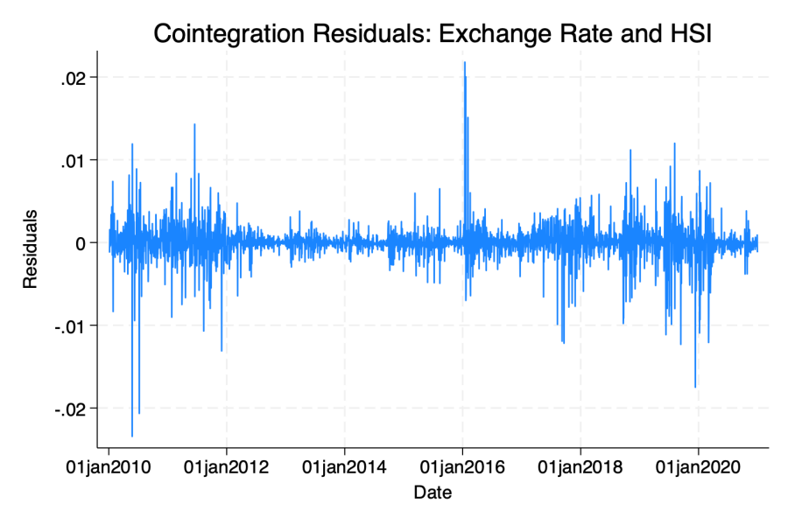

Figure 10 Cointegration Residuals: Exchange Rate and HSI

The cointegrating residuals plot between the HKD/USD exchange rate and the HSI in Figure 11 shows that the residual fluctuates around zero, indicating that there is a significant long-run equilibrium relationship between the two, but external shocks may cause short-term deviations.

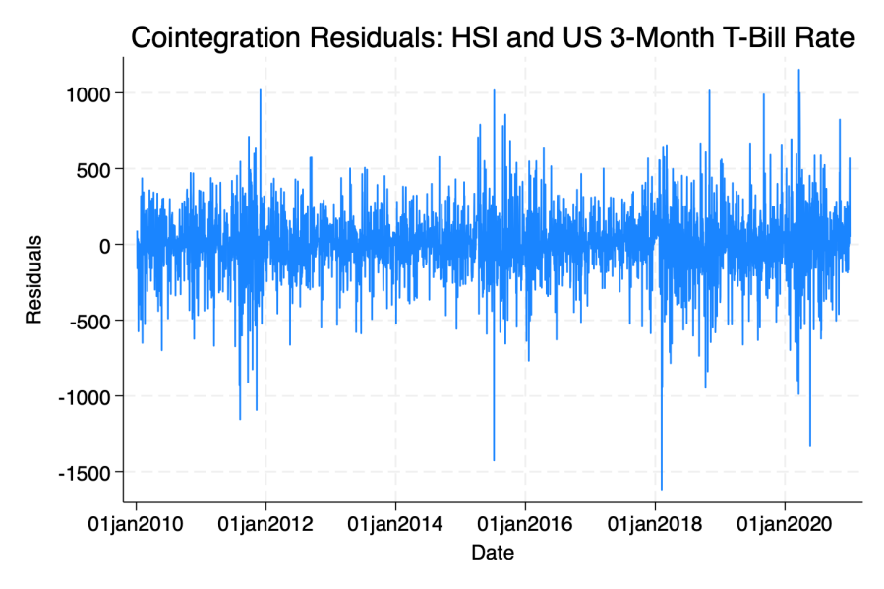

Figure 11 Cointegration Residuals: HSI and US 3-Month Treasury Bill Rate

1. Conclusion

This report analyzes the dynamic relationship between HKD/USD exchange rate, HSI and US 3-month T-bill rate through VAR, IRF, GARCH and VECM models. The results show that HKD/USD exchange rate has a significant short-term impact on HSI (one-period lagged coefficient -1.29e-06, p=0.000), while HSI has a weak impact on US T-bill rate. The GARCH model shows that HSI volatility has significant short-term clustering effect (ARCH coefficient 0.0610, p=0.002) and long-term persistence (GARCH coefficient 1.5490, p=0.000). The VECM model confirms the existence of a long-run equilibrium relationship between HKD exchange rate and HSI, while the long-run relationship between HSI and US Treasury interest rate is weaker. External shocks have significant impact on market volatility.

However, this report is limited to the HKD/USD exchange rate, HSI and US T-bill rate, it does not consider global economic policies, geopolitical risks and other factors, which may lead to incomplete results. Although the GARCH model captures volatility agglomeration effects and persistence, structural changes and asymmetric effects of volatility are not explored. In the future, the model can be extended to include more macroeconomic variables, DCC-GARCH can be used to study the linkage effect of market fluctuations, and the asymmetric impact of external shocks on the market and its transmission mechanism can be explored.

Reference

[1] Bahmani-Oskooee, M., Saha, S. On the relation between exchange rates and stock prices: a non-linear ARDL approach and asymmetry analysis. J Econ Finan 42, 112–137 (2018). <https://doi.org/10.1007/s12197-017-9388-8>

[2] Suriani, S., Kumar, M. D., Jamil, F., Muneer, S. (2015). Impact of Exchange Rate on Stock Market. International Journal of Economics and Financial Issues, 5(1), 385-388.

[3] Yuan, J., Li, X., Shi, Y., Chan, F., Ruan, J. & Zhu, Y. 2020, ‘Linkages between Chinese stock price index and exchange rates – An evidence from the Belt and Road Initiative’, *IEEE Access*, pp. 1-1. doi:10.1109/ACCESS.2020.2995941.

[4] Nusair, S.A. & Olson, D., 2022. Dynamic relationship between exchange rates and stock prices for the G7 countries: A nonlinear ARDL approach. Journal of International Financial Markets, Institutions and Money, 78, p.101541.

[5] Kamal, A.L.M., Lotfy, A. and Kamal, M., 2018. The impact of Treasury bill rate and interest rate on the stock market returns in Egypt. *International Journal of Development and Sustainability*, *7*(2), pp.604-619.

[6] Liu, L.-J., Creutzig, F., Yao, Y.-F., Wei, Y.-M., & Liang, Q.-M. 2020, ‘Environmental and economic impacts of trade barriers: The example of China–US trade friction’, *Resource and Energy Economics*, vol. 59, 101144. doi:10.1016/j.reseneeco.2019.101144.

[7] Mazur, M., Dang, M. & Vega, M. 2021, ‘COVID-19 and the March 2020 stock market crash. Evidence from S&P1500’, *Finance Research Letters*, vol. 38, 101690. doi:10.1016/j.frl.2020.101690.

[8] Bathia, D., Bouras, C., Demirer, R. & Gupta, R. 2020, ‘Cross-border capital flows and return dynamics in emerging stock markets: Relative roles of equity and debt flows’, *Journal of International Money and Finance*, vol. 109, 102258. doi:10.1016/j.jimonfin.2020.102258.

Appendix

// Clear all data

clear all

set more off

// Import and clean exchange rate data

import delimited "ER_HongKongDollar_per_USDollar.csv", varnames(1) clear

rename close exchange_rate

gen date_hkd = date(date, "YMD")

format date_hkd %td

destring exchange_rate, replace ignore("null")

drop if missing(exchange_rate)

gen year_hkd = year(date_hkd)

keep if year_hkd >= 2010 & year_hkd <= 2020

tsset date_hkd

save "HKD_USD_cleaned.dta", replace

// Import and clean HSI data

import delimited "HSI.csv", varnames(1) clear

rename close YFK

gen date_YFK = date(date, "YMD")

format date_YFK %td

destring YFK, replace ignore("null")

drop if missing(YFK)

gen year = year(date_YFK)

keep if year >= 2010 & year <= 2020

tsset date_YFK

save "HSI_cleaned.dta", replace

// Import US 3-month Treasury yield data

import delimited "US_3monthTBill.csv", varname(1) clear

rename close tbill_rate // Assume close column is the yield

gen date_tbr = date(date, "YMD")

format date_tbr %td

destring tbill_rate, replace ignore("null")

drop if missing(tbill_rate)

gen year = year(date_tbr)

keep if year >= 2010 & year <= 2020

tsset date_tbr

save "US_3monthTBill_cleaned.dta", replace

// Merge datasets on common dates

use "HSI_cleaned.dta", clear

merge 1:1 date using "HKD_USD_cleaned.dta"

keep if _merge == 3 // Keep only common dates

drop _merge

merge 1:1 date using "US_3monthTBill_cleaned.dta"

keep if _merge == 3 // Keep only common dates

drop _merge

save "Merged_data.dta", replace

// Plot time series

tsline YFK, title("HSI Close Price (2010-2020)") xtitle("Date") ytitle("HSI Close Price")

graph export "HSI_Close_Price_TimeSeries.png", replace

tsline exchange_rate, title("HKD/USD Exchange Rate (2010-2020)") xtitle("Date") ytitle("Exchange Rate")

graph export "HKD_USD_Exchange_Rate_TimeSeries.png", replace

tsline tbill_rate, title("US 3-Month Treasury Bill Rate (2010-2020)") xtitle("Date") ytitle("T-Bill Rate")

graph export "US_3Month_TBill_Rate_TimeSeries.png", replace

// Descriptive statistics

summarize YFK exchange_rate tbill_rate

// Unit Root Test (ADF)

dfuller exchange_rate, lags(1) regress

dfuller YFK, lags(1) regress

dfuller tbill_rate, lags(1) regress

// First difference for non-stationary data

gen d_exchange_rate = d.exchange_rate

gen d_YFK = d.YFK

gen d_tbill_rate = d.tbill_rate

drop if d_exchange_rate == . | d_YFK == . | d_tbill_rate == .

dfuller d_exchange_rate, lags(2) regress

dfuller d_YFK, lags(2) regress

dfuller d_tbill_rate, lags(2) regress

// VAR model estimation

var d_exchange_rate d_YFK d_tbill_rate, lags(1/2)

// Granger Causality Test

vargranger

// Impulse response functions

irf create var1, set(var1) step(20) replace

irf graph irf, impulse(d_exchange_rate) response(d_YFK) title("Impulse Response of HSI to Exchange Rate")

graph export "Impulse_Response_HSI_to_Exchange_Rate.png", replace

irf graph irf, impulse(d_YFK) response(d_exchange_rate) title("Impulse Response of Exchange Rate to HSI")

graph export "Impulse_Response_Exchange_Rate_to_HSI.png", replace

irf graph irf, impulse(d_tbill_rate) response(d_YFK) title("Impulse Response of HSI to US 3-Month T-Bill Rate")

graph export "Impulse_Response_HSI_to_TBill_Rate.png", replace

// GARCH model for volatility analysis

//To the HSI

arch d_YFK, arch(1) garch(1)

predict cond_var, variance

tsline cond_var, title("Conditional Variance of HSI") xtitle("Date") ytitle("Conditional Variance")

graph export "Conditional_Variance_HSI.png", replace

// Apply the GARCH(1,1) model to the HKD/USD exchange rate

arch d_exchange_rate, arch(1) garch(1)

predict cond_var_HKD, variance

tsline cond_var_HKD, title("Conditional Variance of HKD/USD Exchange Rate") xtitle("Date") ytitle("Conditional Variance")

graph export "Conditional_Variance_HKD_USD.png", replace

// Apply the GARCH(1,1) model to the Tbill Rate

arch d_tbill_rate, arch(1) garch(1)

predict cond_var_TBill, variance

tsline cond_var_TBill, title("Conditional Variance of T-Bill Rate") xtitle("Date") ytitle("Conditional Variance")

graph export "Conditional_Variance_TBill.png", replace

// Fill missing dates for VECM

preserve

clear

set obs 4015 // Number of days from 2010 to 2020

gen date = td(04jan2010) + _n - 1

format date %td

save full_dates.dta, replace

restore

use Merged_data.dta, clear

gen date_num = date(date, "YMD")

format date_num %td

drop date

rename date_num date

save Merged_data.dta, replace

use full_dates.dta, clear

merge 1:1 date using Merged_data.dta

sort date

replace exchange_rate = . if _merge == 2

replace YFK = . if _merge == 2

replace tbill_rate= . if _merge == 2

drop _merge

save Merged_data_filled.dta, replace

// Fill missing values using interpolation and forward/backward fill

use Merged_data_filled.dta, clear

foreach var of varlist exchange_rate YFK tbill_rate{

ipolate `var' date, gen(`var'_filled)

drop `var'

rename `var'_filled `var'

}

foreach var of varlist exchange_rate YFK tbill_rate{

bys date: replace `var' = `var'[_n-1] if missing(`var')

}

foreach var of varlist exchange_rate YFK tbill_rate{

bys date: replace `var' = `var'[_n+1] if missing(`var')

}

tsset date

save "filled_data_final.dta", replace

// Cointegration test with VECM

vecrank exchange_rate YFK, lags(2) trend(constant)

vec exchange_rate YFK, lags(2)

// Plot cointegration residuals

predict coint_res, residuals

tsline coint_res, title("Cointegration Residuals: Exchange Rate and HSI") xtitle("Date") ytitle("Residuals")

graph export "Cointegration_Residuals_Exchange_Rate_HSI.png", replace

// Export results

outreg2 using results.doc, replace word

// Cointegration test for HSI and T-Bill rate

vecrank YFK tbill_rate, lags(2) trend(constant)

// Estimate VECM model

vec YFK tbill_rate, lags(2)

// Plot cointegration residuals

drop coint_res

// Generate cointegration residuals

predict coint_res, residuals

tsline coint_res, title("Cointegration Residuals: HSI and US 3-Month T-Bill Rate") xtitle("Date") ytitle("Residuals")

graph export "Cointegration_Residuals_HSI_TBill_Rate.png", replace