**Test Case ID:** TC_01

**Test Case Description:** KNIME space creation and deletion functionality

**Pre-condition:** Access to Chrome Browser

**Test Data:**

Username: testeratknime

Password: KNIMEisthebest

**Test Scenario:** Verifying on entering valid username and password, user should be able to create and delete space.

**Steps:**

1. Navigate to: <https://hub.knime.com/>
2. Click on the Sign in button
3. Enter username and password
4. Click on the Sign in button
5. Click on the username icon
6. Click on the username
7. Click on the Public space
8. Rename the space name to Test space
9. Save the renamed space
10. Click on the More Vert
11. Click on the Delete space
12. Enter space name
13. Click on the Delete

**Expected Results:**

1. User should on main page
2. User should see the Sign in button
3. User should on log in page and enter the username and password
4. User should see Sign in button
5. User should on logged page and see the username icon
6. User should see the username
7. User should see the Public space button and after click should see the space created successfully message
8. User should see the default space name input box and give the Test space name instead of default space name
9. User should see the yellow save button and after save see the space renamed successfully message
10. User should see the More Vert button
11. User should see the Delete space button
12. User should see the space name input box and give the space name
13. User should see the delete confirmation button and after clicking should see the space deleted successfully message

**Expected Result**

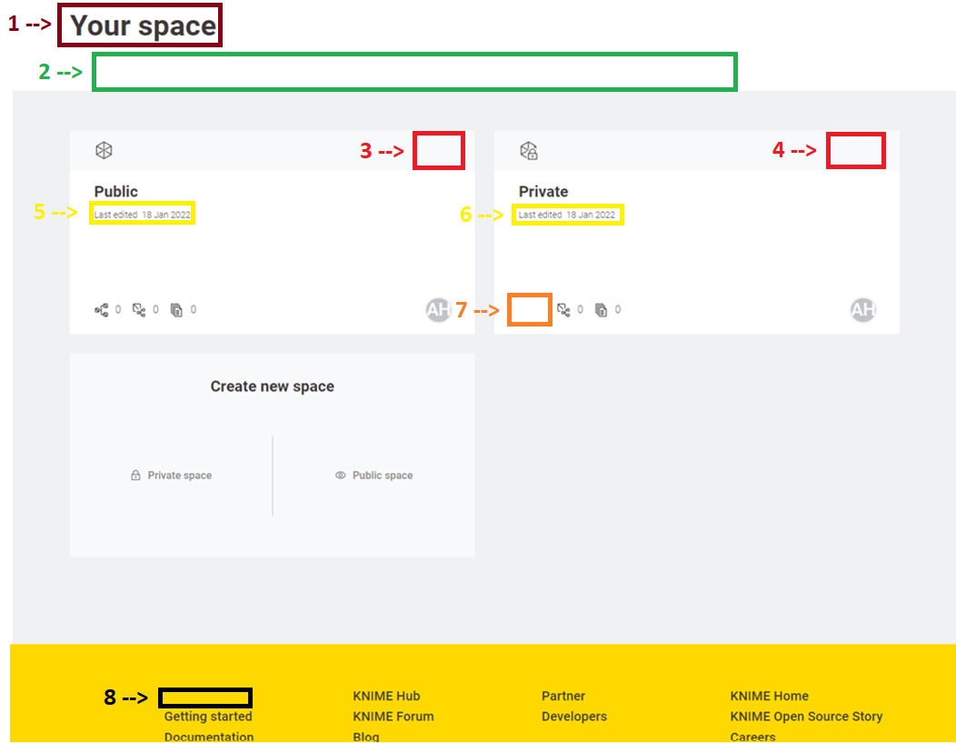

**\*\* Each box number represents the bug number.**

**\*\* Each box represents the web element(s).**

**Actual Result**

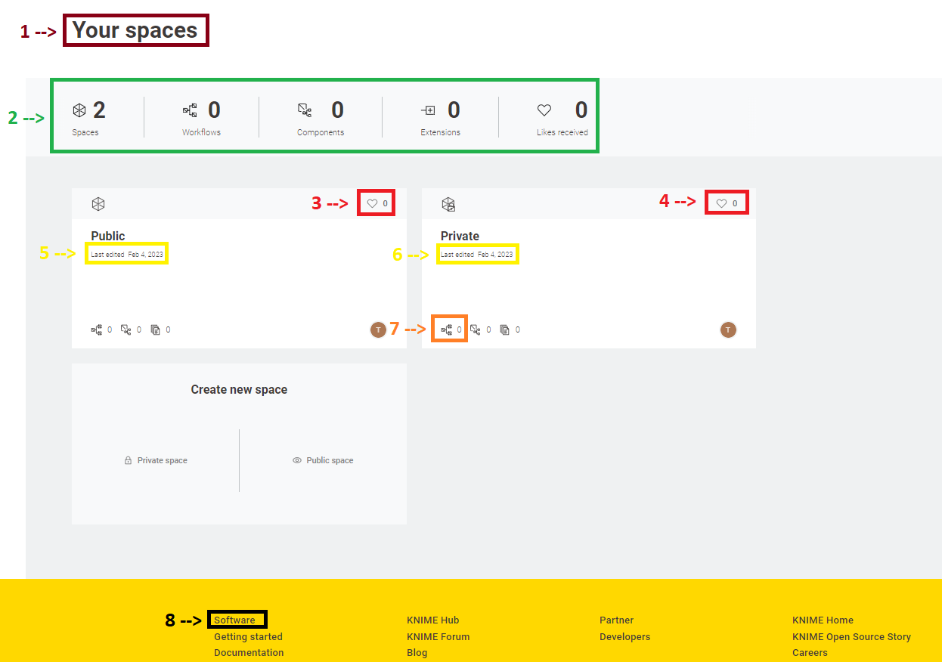

**\*\* Each box number represents the bug number.**

**\*\* Each box represents the web element(s).**

**Bug Reports**

1. Bug

Bug Number: 1

Bug Title: Character.

Environment: Chrome browser

Description: There is a difference between the “Your space(s)” web element in expected and actual results.

Expected and Actual Result: Expected Result 🡪 Your space, Actual Result 🡪 Your spaces.

Screenshot: Look at the number 1 both in the expected and actual results screenshots.

1. Bug

Bug Number: 2

Bug Title: Piece of the web page.

Environment: Chrome browser

Description: There is a block of web elements (Spaces, Workflows, Components, Extensions, Likes received) between the Your space(s) and created spaces in Actual Result but does not occur in Expected Result.

Expected and Actual Result: Expected Result 🡪 piece of the web page is not occurred, Actual Result 🡪 piece of the web page occurred.

Screenshot: Look at the number 2 both in the expected and actual results screenshots.

1. Bug

Bug Number: 3

Bug Title: Likes received icon and number of likes web element.

Environment: Chrome browser

Description: Likes received icon and number of likes occurred right top corner of every created space in actual result but it does not occur in the expected result.

Expected and Actual Result: Expected Result 🡪 Likes received icon and number of likes web element does not occur, Actual Result 🡪 occurred.

Actual Result 🡪 Screenshot: Look at the number 3 both in the expected and actual results screenshots.

1. Bug (Duplicate)

Bug Number: 4

Bug Title: Likes received icon and number of likes web element.

Environment: Chrome browser

Description: Likes received icon and number of likes occurred right top corner of every created space in actual result but it does not occur in the expected result.

Expected and Actual Result: Expected Result 🡪 Likes received icon and number of likes web element does not occur, Actual Result 🡪 occurred.

Actual Result 🡪 Screenshot: Look at the number 4 both in the expected and actual results screenshots.

1. Bug

Bug Number: 5

Bug Title: Last edited date format inside the created space.

Environment: Chrome browser

Description: There is a difference between the Last edited date format inside every created space. In expected result after the Last edited starts with the day month and year, but the actual result after the Last edited starts with the month day year and a comma between the day and year.

Expected and Actual Result: Expected Result 🡪 Last edited 18 Jan 2022, Actual Result 🡪 Last edited Feb 4, 2023.

Actual Result 🡪 Screenshot: Look at the number 5 both in the expected and actual results screenshots.

1. Bug (Duplicate)

Bug Number: 6

Bug Title: Last edited date format inside the created space.

Environment: Chrome browser

Description: There is a difference between the Last edited date format inside every created space. In expected result after the Last edited starts with the day month and year, but the actual result after the Last edited starts with the month day year and a comma between the day and year.

Expected and Actual Result: Expected Result 🡪 Last edited 18 Jan 2022, Actual Result 🡪 Last edited Feb 4, 2023.

Actual Result 🡪 Screenshot: Look at the number 6 both in the expected and actual results screenshots.

1. Bug

Bug Number: 7

Bug Title: Workflows icon and number of workflows web element.

Environment: Chrome browser

Description: Workflows icon and number of workflows occurred left bottom corner of every created space in the actual result, but it does not occur in the expected result.

Expected and Actual Result: Expected Result 🡪 Workflows icon and number of workflows web element does not occur, Actual Result 🡪 occurred.

Actual Result 🡪 Screenshot: Look at the number 7 both in the expected and actual results screenshots.

1. Bug

Bug Number: 8

Bug Title: Bottom menus of the web page.

Environment: Chrome browser

Description: There is a difference between the bottom menus of the web page which the background colour is yellow. Software menu occurred in the actual result but does not occur in expected result.

Expected and Actual Result: Expected Result 🡪 Software menu does not occur, Actual Result 🡪 Software menu occurred.

Actual Result 🡪 Screenshot: Look at the number 8 both in the expected and actual results screenshots.