SYSTEM AND METHOD FOR VIDEO-DRIVEN DATABASE DISCOVERY
AND AUTOMATED QUERY GENERATION USING A MULTI-AGENT PIPELINE
Utility Patent Application — Draft Specification

FIELD OF THE INVENTION
[0001] The present invention relates generally to automated database discovery and query generation, and more particularly to a multi-agent system that derives required database operations and data fields from a recorded business-process video and thereafter performs schema discovery and generates executable database queries against one or more discovered data sources.

BACKGROUND OF THE INVENTION
[0002] Conventional approaches to database integration and query generation begin with explicit database connection information together with a natural-language specification or transcript describing the desired behavior. Such approaches require that a human analyst first articulate, in textual form, the data interactions that an application performs, and then manually map those interactions onto a known schema.
[0003] These conventional approaches suffer from several disadvantages. First, they presuppose that the relevant data interactions have already been identified and described in text, which is labor-intensive and error-prone. Second, they require prior knowledge of the schema in order to author queries. Third, they do not capture data interactions that are implicit in observed user behavior but are not otherwise documented.
[0004] There is accordingly a need for a system that can infer required database operations and specific data fields directly from observed application behavior—before any schema information is consulted—and that can then autonomously discover the relevant schema and construct validated, executable queries. The present invention addresses this need.

SUMMARY OF THE INVENTION
[0005] The invention provides, in one aspect, a multi-agent system comprising a first agent and a second agent operating in a pipeline. The first agent receives a business-process video as input, analyzes observed application behavior, identifies user workflows and candidate business entities, classifies observed user actions, and infers a set of derived database requirements specifying (a) one or more database operations to be performed and (b) specific data fields to be selected from or inserted into an application.
[0006] The second agent receives, as input, the derived database requirements produced by the first agent together with database connection details. The second agent connects to one or more data sources, performs metadata discovery to determine schema including tables, collections, columns, data types, constraints, and representative sample values, analyzes explicit and inferred relationships, and constructs a schema graph in which nodes represent entities and attributes and edges represent relationships.
[0007] The second agent then matches the derived database requirements to nodes of the schema graph and generates one or more executable database queries—such as a query to retrieve records or to insert a record—by traversal of the schema graph in combination with the discovered metadata. In a preferred embodiment, query generation is performed deterministically at the second agent without invocation of a generative language model at query-construction time, the required reasoning having been resolved prior to query construction. Generated artifacts are accompanied by validation guidance and confidence scores.
[0008] A distinguishing characteristic of the invention is that the determination of required database operations and fields is derived from observed application behavior in the video and is performed before, and independently of, schema discovery; the schema discovery performed by the second agent is then driven by, and constrained to, the requirements so derived.

BRIEF DESCRIPTION OF THE DRAWINGS
[0009] FIG. 1 is a block diagram of a two-agent video-driven database discovery system according to an embodiment of the invention.
[0010] FIG. 2 is a flow diagram illustrating operation of the first agent (workflow and requirement extraction).
[0011] FIG. 3 is a flow diagram illustrating operation of the second agent (schema discovery and query generation).
[0012] FIG. 4 is a diagram of an example schema graph constructed in a worked embodiment, together with a query derived therefrom.

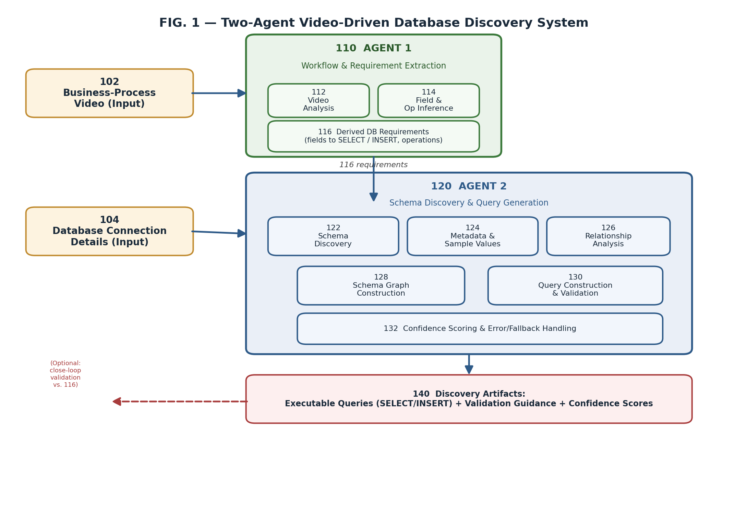
FIG. 1
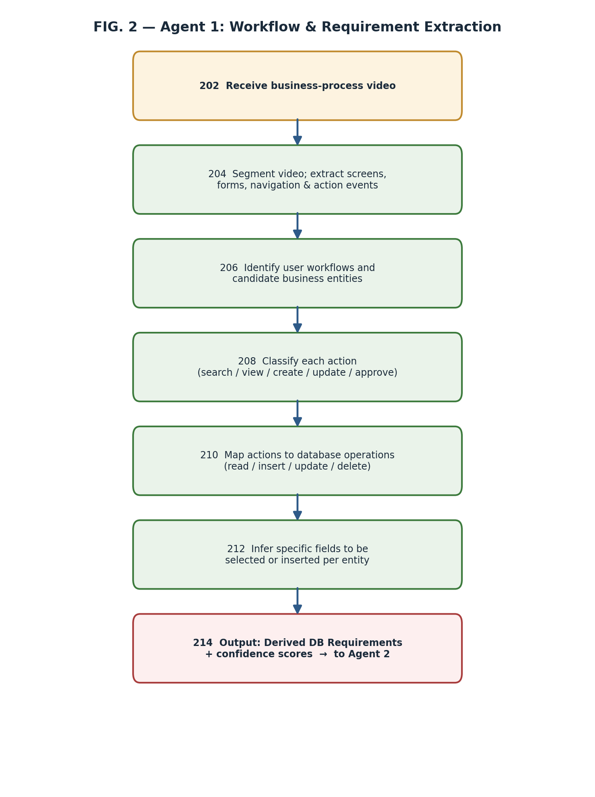
FIG. 2

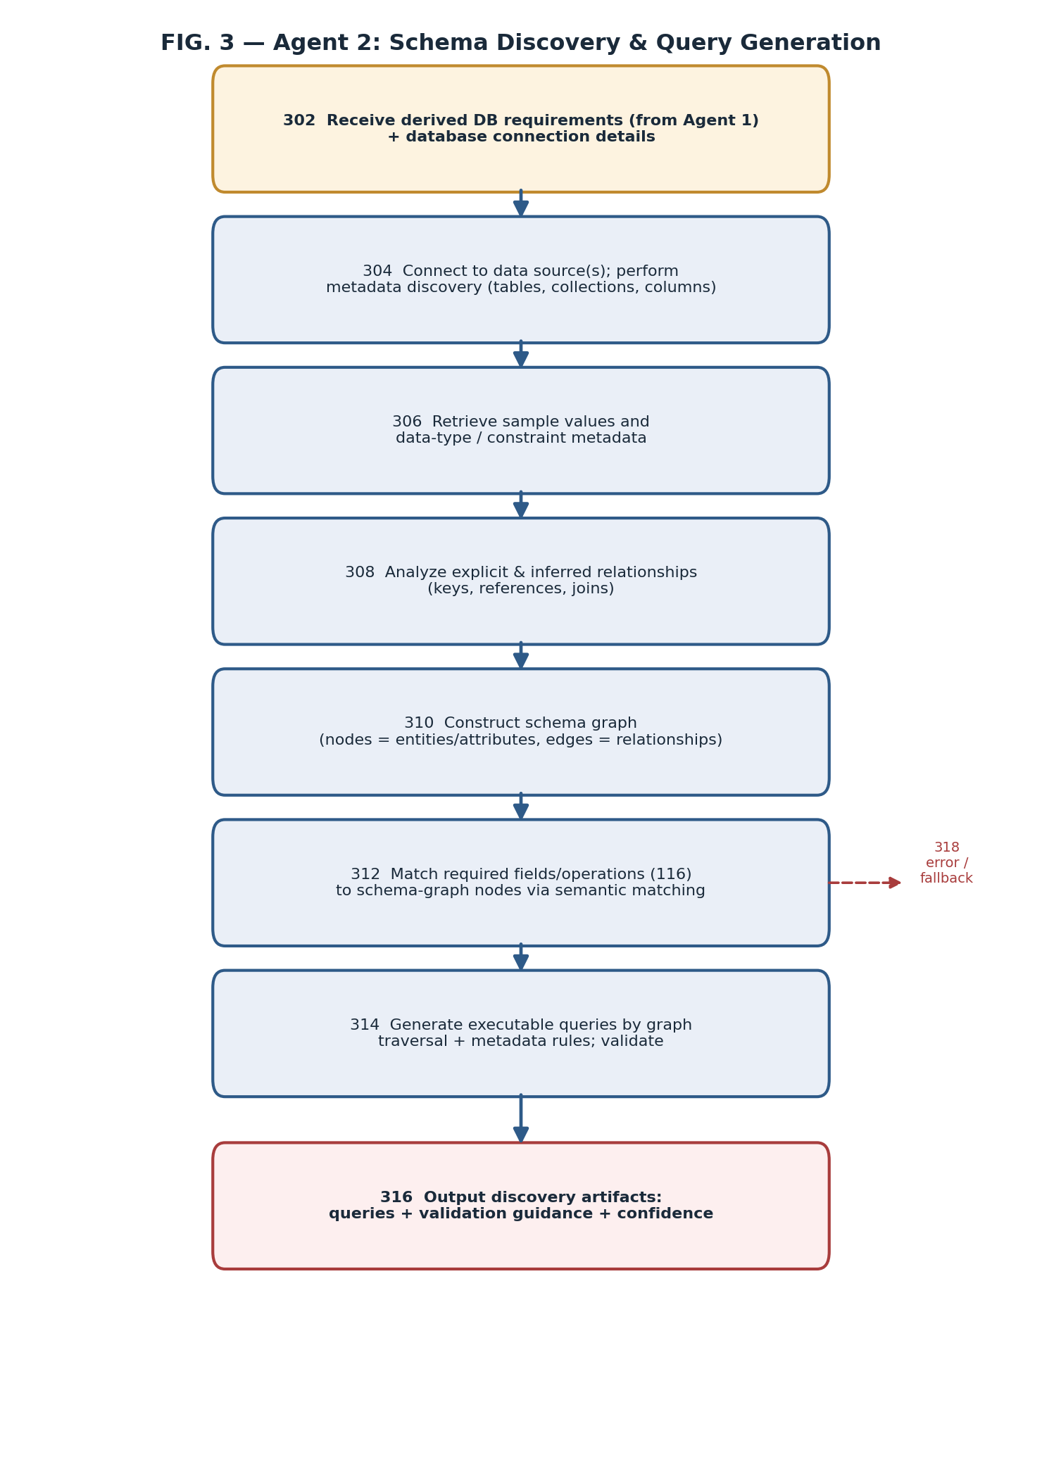
FIG. 3
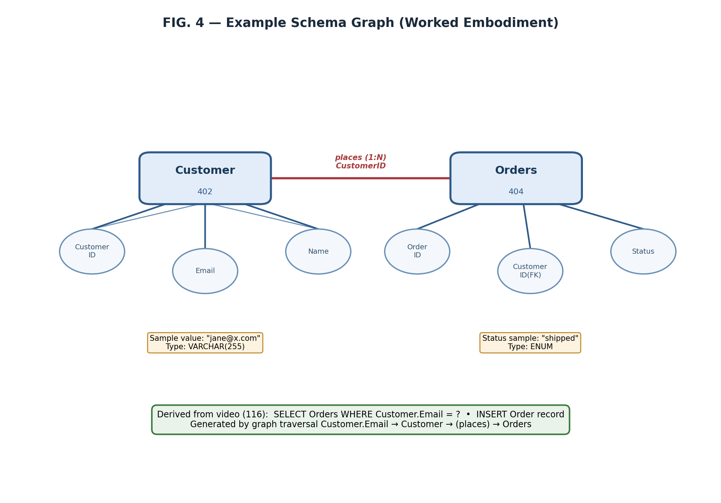
FIG. 4

DETAILED DESCRIPTION
[0013] Reference is now made to the drawings. The following description sets forth, by way of example and not limitation, specific embodiments of the invention. It will be understood that the invention is not limited to the particular frameworks, languages, or data-source types described, and that equivalents may be substituted without departing from the scope of the claims.

1. System Overview (FIG. 1)
[0014] With reference to FIG. 1, an input business-process video 102 is provided to a first agent 110. The first agent comprises a video-analysis component 112 and a field-and-operation inference component 114, and produces derived database requirements 116. The derived database requirements 116, together with database connection details 104, are provided to a second agent 120 comprising a schema-discovery component 122, a metadata/sample-value component 124, a relationship-analysis component 126, a schema-graph construction component 128, a query-construction-and-validation component 130, and a confidence-scoring and error/fallback component 132. The second agent emits discovery artifacts 140 comprising executable queries, validation guidance, and confidence scores.
[0015] In one embodiment the first and second agents are implemented as distinct software agents in a multi-agent orchestration framework (for example, a framework providing agent definitions, shared state, and inter-agent message passing). The agents may execute on the same or different computing devices, each comprising one or more processors and memory storing instructions that, when executed, cause the device to perform the operations described herein. The framework is not essential to the invention; the two-agent division of responsibility and the ordering of operations are the salient features.
[0016] The system maintains a shared state that captures, without limitation: video observations; discovered applications; workflow definitions; the inferred database requirements; discovered schema metadata; the schema graph; the generated queries; and generation reports. The shared state permits the second agent to consume the output of the first agent and permits optional close-loop validation of generated queries against the originally derived requirements 116.

2. First Agent — Workflow and Requirement Extraction (FIG. 2)
[0017] At step 202 the first agent receives the business-process video. At step 204 the agent segments the video and extracts screens, forms, navigation events, and discrete user-action events. Extraction may employ frame sampling, optical character recognition of on-screen text and form labels, user-interface element detection, and event detection corresponding to searches, record views, record-creation activities, updates, and approvals.
[0018] At step 206 the agent identifies user workflows (ordered sequences of actions accomplishing a business task) and candidate business entities (for example, a customer entity or an order entity) appearing in the observed screens. At step 208 each observed action is classified by type—for example, search, view, create, update, or approve.
[0019] At step 210 the agent maps each classified action to a corresponding database operation. By way of example, an observed search action on a search screen is mapped to a read (SELECT) requirement; an observed data-entry form submission is mapped to an insert or update requirement; and an observed approval action may be mapped to an update across one or more related entities.
[0020] At step 212 the agent infers the specific data fields implicated by each operation—for example, that records are to be retrieved by a customer email field, or that an order record having particular fields is to be inserted. At step 214 the agent outputs the derived database requirements 116, optionally each annotated with a confidence score, for consumption by the second agent. Significantly, steps 202–214 are performed without reference to any database schema or connection.

3. Second Agent — Schema Discovery and Query Generation (FIG. 3)
[0021] At step 302 the second agent receives the derived database requirements 116 and the database connection details 104. At step 304 the agent connects to one or more data sources and performs metadata discovery, enumerating tables, collections, entities, fields, and columns. At step 306 the agent retrieves representative sample values together with data-type, nullability, and constraint metadata for discovered fields.
[0022] At step 308 the agent analyzes explicit relationships (for example, declared foreign-key references) and inferred relationships (for example, relationships inferred from naming conventions, shared value domains, or co-occurrence in sample data). At step 310 the agent constructs a schema graph in which nodes represent entities and attributes and edges represent the explicit or inferred relationships; sample values and metadata are attached to nodes to support subsequent semantic matching.
[0023] At step 312 the agent matches the required fields and operations expressed in the derived requirements 116 to nodes of the schema graph by semantic matching of requirement terms against entity names, attribute names, attached sample values, and metadata. At step 314 the agent generates one or more executable database queries by traversing the schema graph between matched nodes and applying the discovered metadata and constraints; the generated queries are then validated against the discovered schema. At step 316 the agent outputs discovery artifacts comprising the generated queries, validation guidance, and confidence scores. At step 318, where matching is ambiguous, where required entities or relationships are unresolved, where metadata is missing, or where a connection fails, the agent produces a structured error report with confidence scores and remediation recommendations and may invoke a fallback procedure.
[0024] In the preferred embodiment, query generation at step 314 is deterministic and does not invoke a generative language model at query-construction time. The semantic reasoning required to associate observed behavior with required operations and fields is resolved earlier (by the first agent and by the matching of step 312), such that the construction of the executable query itself proceeds by graph traversal and the application of metadata-driven rules. This yields reproducible, auditable query artifacts. In an alternative embodiment, a generative model may participate in query construction, and the claims are not limited to the deterministic embodiment except where expressly recited.

4. Worked Example (FIG. 4)
[0025] In a worked example, the business-process video depicts a user searching for a customer by email address, viewing that customer's shipped orders, and creating a new order. The first agent derives the following requirements: a read operation retrieving orders filtered by a customer email field; and an insert operation creating an order record, including validation of required fields and relationships.
[0026] With reference to FIG. 4, the second agent discovers a Customer entity 402 and an Orders entity 404, attaches attribute nodes (including a customer email attribute and an order status attribute) and sample values, and identifies a one-to-many relationship by which a customer places orders (keyed on a customer identifier). Matching the derived requirements to the schema graph, the agent generates an executable query that retrieves orders by joining from the customer email attribute through the customer entity to the related order records, and an insert statement creating an order record with the required fields and relationships validated against the discovered constraints.

5. Supported Data Sources and Generalizations
[0027] The one or more data sources may comprise, without limitation, relational databases, data warehouses, document databases, graph databases, key-value stores, and enterprise platforms accessible through discovery connectors. The database connection details 104 may be obtained from enterprise configuration sources. The generated database operations may comprise read, insert, update, and delete operations. The invention is not limited to any particular query language, and the term 'executable query' encompasses statements expressed in a structured query language, document-store query interfaces, graph query languages, and equivalent data-access expressions.
[0028] Novel technical contributions of certain embodiments include, without limitation: video-first discovery; extraction of workflows from observed application usage; inference of database requirements prior to and independently of schema discovery; schema-graph-based entity mapping; automated detection of read and write operations from observed user behavior; and an end-to-end pipeline from user behavior to validated query generation.

CLAIMS
What is claimed is:
1. A computer-implemented method for database discovery and query generation, the method comprising:
receiving, by a first agent, a business-process video;
analyzing, by the first agent, application behavior observed in the business-process video to identify one or more user workflows and one or more candidate business entities;
classifying, by the first agent, one or more user actions observed in the business-process video and deriving therefrom a set of database requirements specifying (i) at least one database operation and (ii) one or more data fields to be selected from or inserted into an application, wherein the set of database requirements is derived independently of, and prior to, any discovery of a database schema;
receiving, by a second agent, the set of database requirements and database connection details;
connecting, by the second agent, to at least one data source using the database connection details and performing metadata discovery to determine schema information comprising tables or collections, columns or fields, and representative sample values;
constructing, by the second agent, a schema graph in which nodes represent entities and attributes and edges represent explicit or inferred relationships, with sample values and metadata attached to the nodes;
matching, by the second agent, the one or more data fields of the set of database requirements to nodes of the schema graph; and
generating, by the second agent, at least one executable database query by traversal of the schema graph in combination with the determined metadata, the at least one executable database query implementing the at least one database operation specified by the set of database requirements.
2. The method of claim 1, wherein the at least one database operation comprises a read operation that retrieves records filtered by a field corresponding to a value observed in the business-process video, and an insert operation that creates a record.
3. The method of claim 1, wherein classifying the one or more user actions comprises mapping a search action to a read requirement and mapping a data-entry form submission to an insert or update requirement.
4. The method of claim 1, wherein generating the at least one executable database query is performed deterministically by the second agent without invocation of a generative language model at a time of query construction.
5. The method of claim 1, wherein matching comprises semantic matching of terms of the set of database requirements against entity names, attribute names, attached sample values, and metadata of the schema graph.
6. The method of claim 1, wherein the edges of the schema graph comprise at least one inferred relationship determined from naming conventions, shared value domains, or co-occurrence in sample data, in the absence of a declared foreign-key reference.
7. The method of claim 1, further comprising generating, by the second agent, a confidence score and validation guidance accompanying the at least one executable database query.
8. The method of claim 1, further comprising, responsive to an ambiguous match, an unresolved entity or relationship, missing metadata, or a connection failure, generating a structured error report comprising a confidence score and a remediation recommendation.
9. The method of claim 1, wherein the at least one data source comprises one or more of a relational database, a data warehouse, a document database, a graph database, a key-value store, and an enterprise platform accessed through a discovery connector.
10. The method of claim 1, further comprising validating the at least one executable database query against the set of database requirements received from the first agent.
11. A system for database discovery and query generation, the system comprising one or more processors and memory storing instructions that, when executed, cause the system to:
provide a first agent configured to receive a business-process video, analyze application behavior observed therein, and derive a set of database requirements specifying at least one database operation and one or more data fields to be selected from or inserted into an application, the set of database requirements being derived independently of and prior to any database schema discovery; and
provide a second agent configured to receive the set of database requirements and database connection details, connect to at least one data source, perform metadata discovery, construct a schema graph having nodes representing entities and attributes and edges representing relationships, match the one or more data fields to nodes of the schema graph, and generate at least one executable database query by traversal of the schema graph and application of discovered metadata.
12. The system of claim 11, wherein the second agent is configured to generate the at least one executable database query deterministically without invocation of a generative language model at a time of query construction.
13. The system of claim 11, wherein the first agent and the second agent are distinct agents of a multi-agent orchestration framework communicating through a shared state that captures video observations, the set of database requirements, the schema graph, and the at least one executable database query.
14. The system of claim 11, wherein the second agent is further configured to generate a confidence score and validation guidance for the at least one executable database query and a structured error report with remediation recommendations responsive to an unresolved requirement.
15. A non-transitory computer-readable medium storing instructions that, when executed by one or more processors, cause the one or more processors to perform the method of claim 1.

ABSTRACT
A multi-agent system and method derive required database operations and data fields directly from a recorded business-process video and thereafter perform schema discovery and generate executable queries. A first agent analyzes observed application behavior, identifies user workflows and candidate entities, classifies user actions, and derives a set of database requirements—specifying operations and specific fields to be selected or inserted—independently of and prior to any schema discovery. A second agent receives those requirements together with database connection details, connects to one or more data sources, discovers schema metadata and sample values, constructs a schema graph of entities, attributes, and relationships, matches the requirements to graph nodes, and generates validated executable queries by graph traversal, optionally without invoking a generative model at query-construction time. Generated artifacts are accompanied by confidence scores and remediation guidance.

